Dora Ismailova
Essay 2
English 1101 (Pro. Scanlan)
November 9, 2015

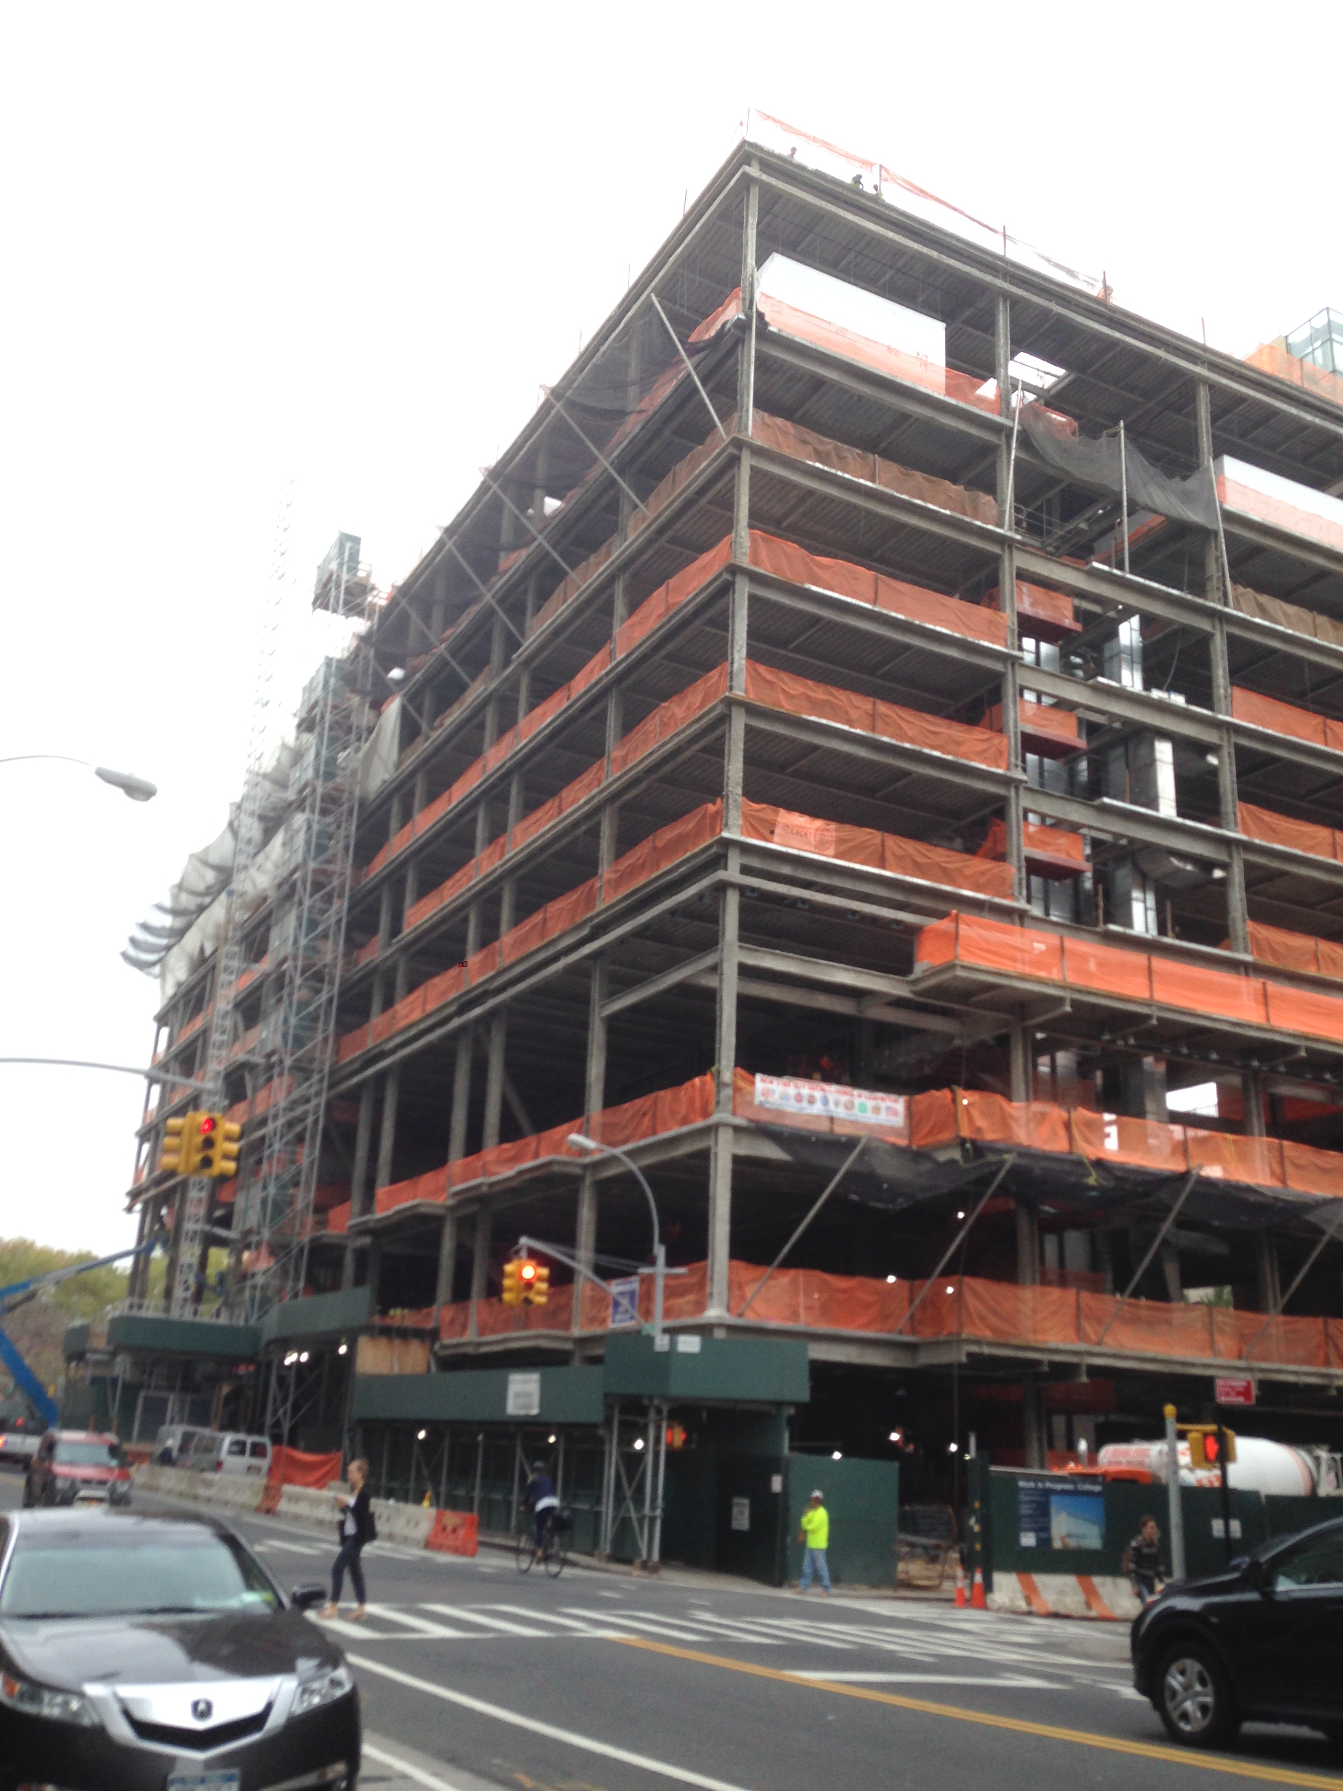
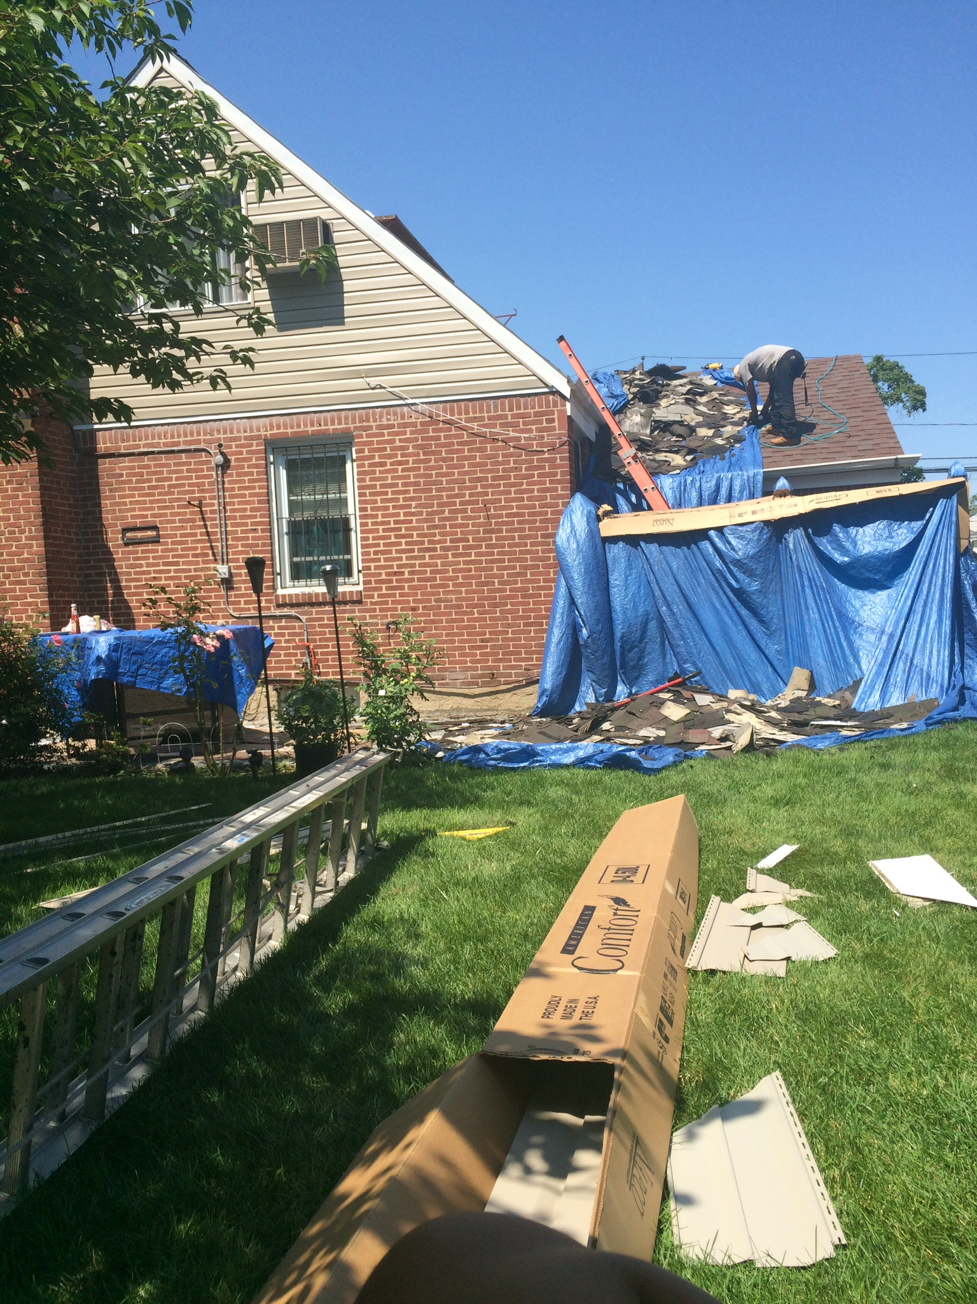
Describing and Comparing Photographs: Construction zone

Describing a photo is to show what is going on in the photo, and the scene, and creating a vivid image in your mind. A person, a thing, and even an idea can be made in a description of the photo. Comparing a photo is similar to describing a photo because you are describing the comparisons of the two images. The two images that I choose are Construction Men and Renovating Roof tops. While my photos that I had chosen for this essay has to do with men working with all sorts of construction. Construction has to do with many things especially when it comes to what is happening in the scene. I want to claim that the Pro- Filmic event and Studium fit well as terms to show the differences of the photos and how they look. I thought taking these photos would teach me how to read these images and tell me what is really happening.
This first photo was taken in Brooklyn across the street from CityTech right on Jay Street, this photo that I have chosen is a photo of a scene of men working in a construction zone. The Pro- Filmic event in this photo are men that are working on the last floor, and you can also see one worker walking on the sidewalk and his arm looks like his talking on the phone. You can see a crane that is on the frame of this photo that has cut off, and is heading towards the construction building. The Stadium of this building has many orange lace borders on each floor that protect the men from falling. In this photo, you can also see a woman crossing the road, and car crossing on the two-way lane. By looking at this photo, you can predict that it is a bit chilly because the girl is wearing a sweater. By looking at this photo, it’s not just a photo it is also a scene of a place, and there is things that are happening in it. “It now seems clear that photography deserves to be considered as though it were not a fine art. It looks as though photography (whatever kind of activity it may be) is going to outlive painting and sculpture as we have thought of them since the Renaissance.” These lines come from John Berger, I agree with his quote that art is not just art but it can be even some kind of an activity, as I said in my photo that I have taken it is not just a photo it is a scene of men in work.
The second photo that I took is also a photo that works with construction. A photo I took is at my friend’s house in Long Island. The Studium of this photo is men detaching a rooftop of a garage. The Pro- Filmic event in this photo that you see is a worker that is working hard, and there are roof pieces all over the grass. At the edge of this photo, you can see a tree branch and a ladder on the grass. There also a box that says comfort on it I believe its plastic pieces that attach on the roof. In this photo, you can see brightness of bright colors. The weather in this photo looks like it’s warm because the man is wearing a short sleeve shirt. You can also see a shadow of the tree on the grass. Susan Sontag talks about how a camera records everything. “In another version of its utility, camera record justifies. A photograph passes incontrovertible proof that a given thing happened.” She is trying to say that a camera records proof of any action that are taken like in my Renovating Roof top photo there is proof of a man constructing the roof. She is also trying to say that a camera captures the specific moment of what is happening at the scene. Like shown in my photo men working with construction. In this photo, the big capture is the scene of construction.
The comparisons of these two photos are that they both deal with some kind of construction. In the first photo, it shows how the men are working on building a building. In the second photo, it shows how the man is trying to redo the roof on the garage. These both photos deal with “Hard Hat” zones. “New York at Work” by Lewis Hines photo connects to mine because in his photo, the men are attaching a beam and they are working with construction site.
Overall, in my photos as seen the comparisons are workers, working in construction sites. The first photo shows a photo of men working on a building on a construction zone. My second photo is similar to the first but the only difference is that the person is reconstructing a new roof on a garage. These both photos show evidence of what is going on in the image and it is not just a photo for memory but it is a photo of actions. These both photos relate to the Pro – Filmic event and the Studiam, they have similar similarities. This both photos are similar because they both deal with construction and renovation.
(1,004)
Work cited

Berger, John. “Understanding a Photograph.” Classic Essays on Photography. New Haven:
Leete’s Island Book, 1980: Print. 291

Hines, Lewis. “New York at Work.” The Place When We Dwell: reading and writing about New
York City. Eds. Marx Noonan, Juanita But, and Sean Scanlan. Dubuque, IA: Kendal Hunt, 2014. Print.147

Ismailova, Dora. “Construction Men, Downtown Brooklyn, New York, 1:00 pm, 12 October.
2015.” Author’s photo. 12 October. 2015. JPEG

Ismailova, Dora. “Renovating Roof Tops, Long Island, New York, 3:00 pm, 30 September. 2015.”
Author’s photo. 30 September. 2015. JPEG

Sontag, Susan. “On Photography,” Susan Sontag Essays of the 1960’s & 70’s. New York: The Library of America, 2013. 531.

