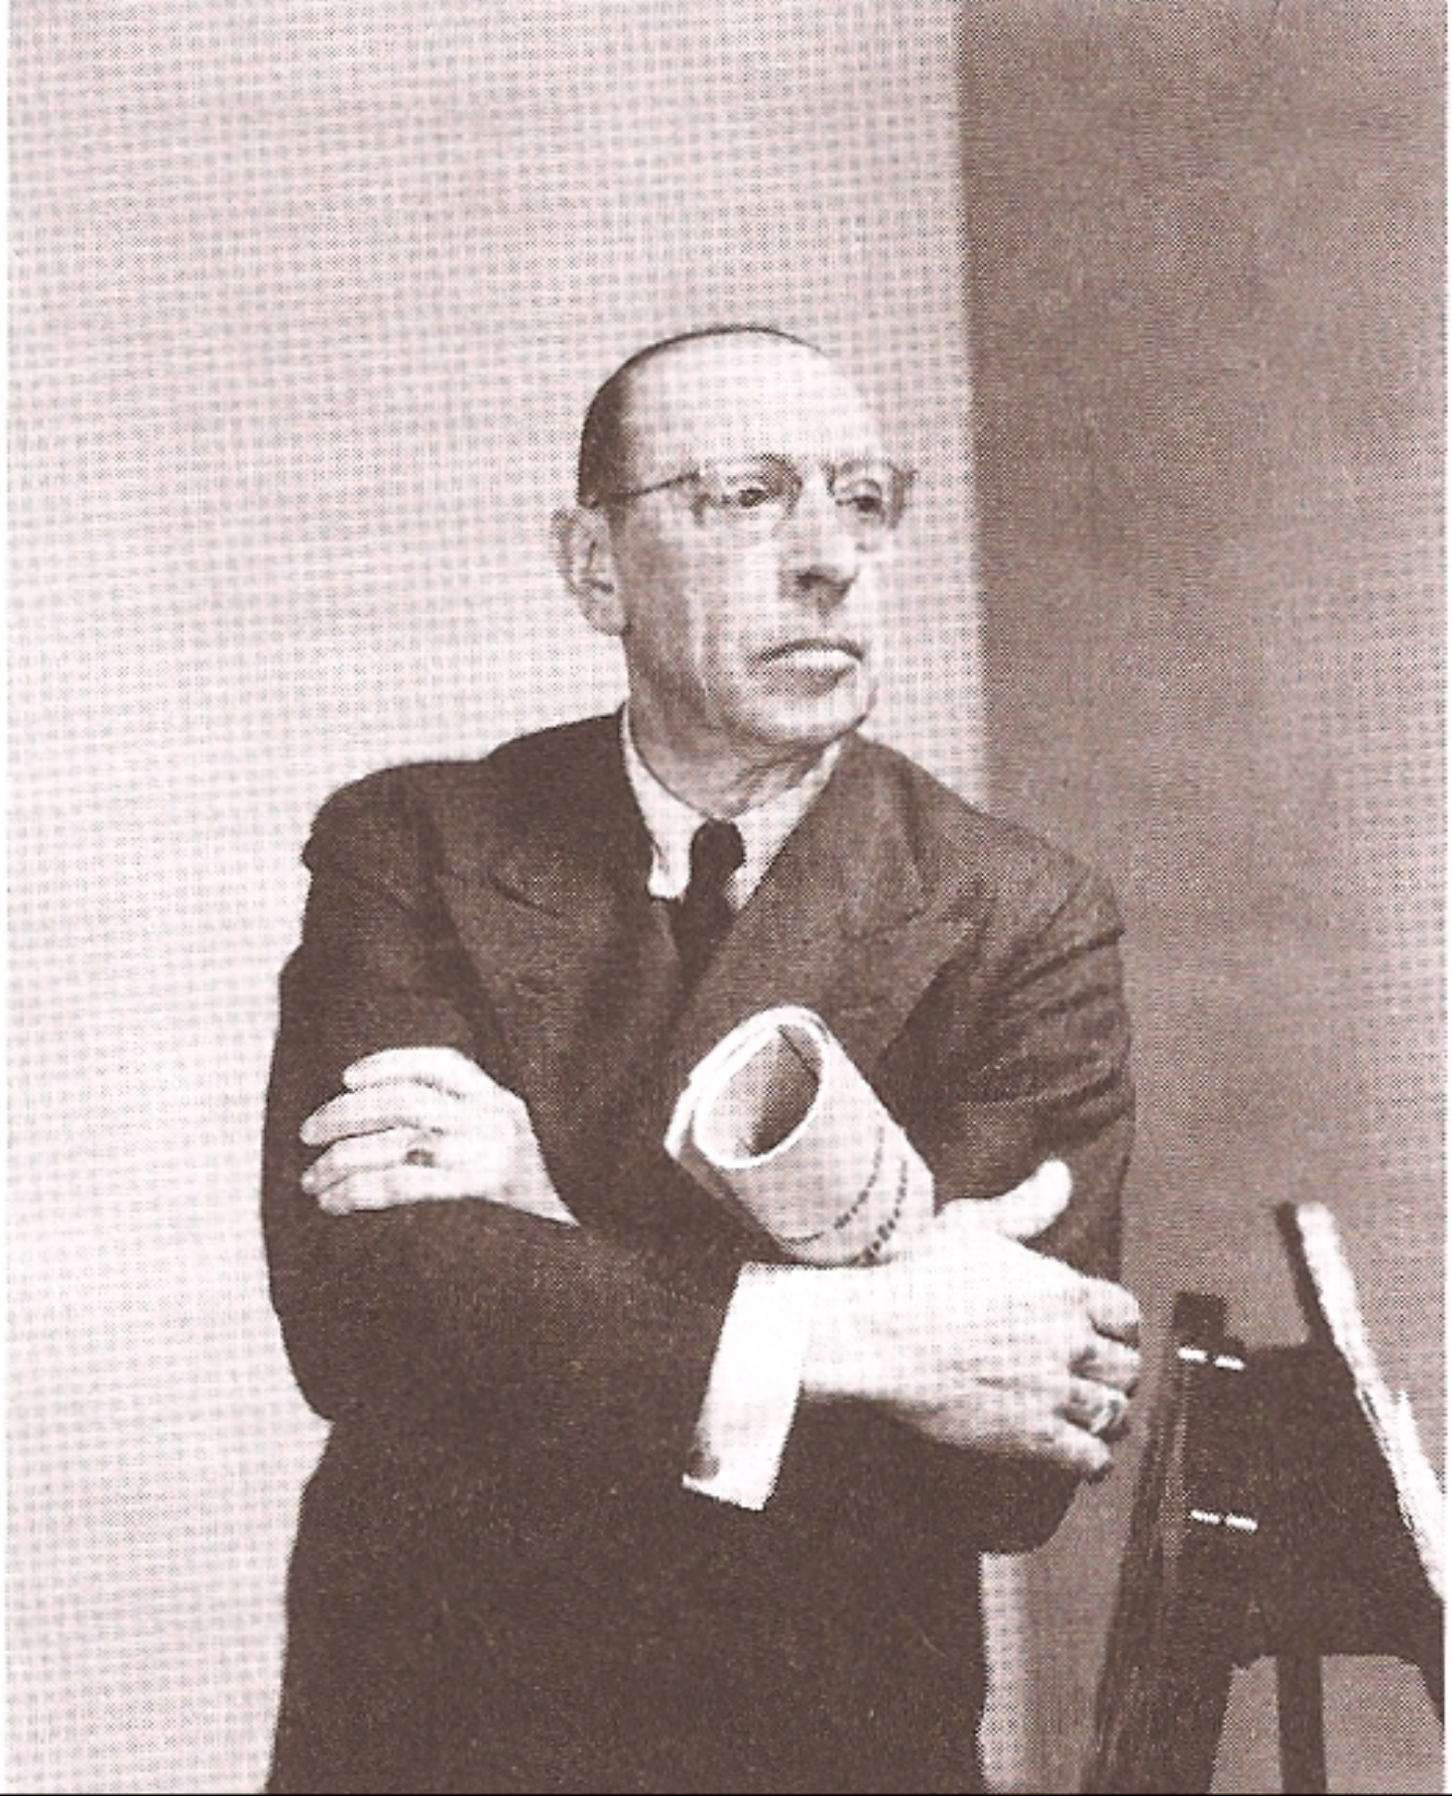

**Please keep Plimdale beautiful**

**Please don’t litter**

**Thank You Very Much**

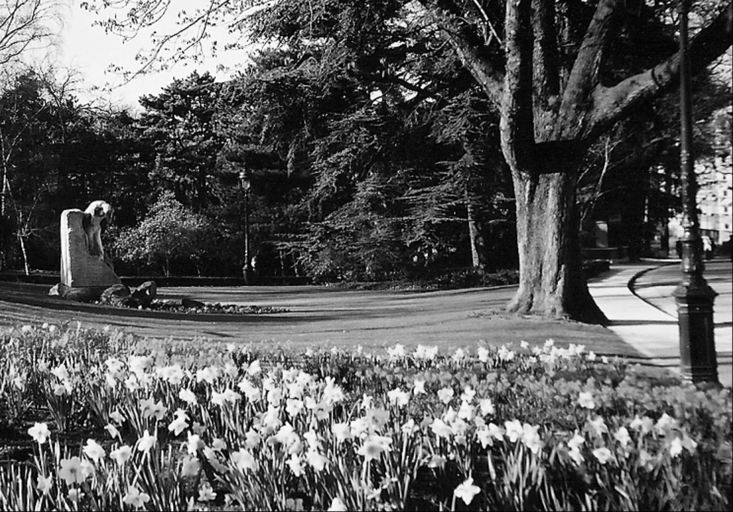

Mayor Headstrong says:

It is up to **you** to keep our fair city of Plimdale clean!

– Ignatious Scottsdale Headstrong IV