IPE CASE
About Betel Nut
Michelle
Betel nut quid is widely prevalent in many parts of Asia and migrant communities.
Many betel-quid products in different parts of the world are not chewed; rather, they are placed in the mouth or applied to the oral cavity and remain in contact with the oral mucosa

A ‘betel quid’ generally contains:
Betel leaf + areca nut + slaked lime (Calcium hydroxide) + tobacco
Slake lime is a dry, colorless crystalline powder manufactured by treating calcium oxide (quicklime) with water - so imagine using something that is used as a strong dissolvent in your mouth constantly and multiple times a day it will have negative effects on pts health.

Betel nut is a seed of the Areca catechu, a type of palm tree. It’s commonly chewed after being ground up or sliced and wrapped in leaves of the Piper betel vine that have been coated with lime.

Semah
Betel nut is psychoactive meaning it (causes changes in mood, awareness, thoughts, feelings, or behavior)
It is an oral carcinogen (causing cancer in living tissue)
A large amount of quid usage is from Southeast Asia it is used socially during celebrations and on a daily level.
- It is used for taste, enjoyment, and addiction.

In Asia, 50% of cancer is known to be oral cancer that is caused by betel nut and it causes stain on teeth (which is removable)
Submucous fibrosis - is a result of the consumption of betel nut with tobacco leaves and it creates fibrotic tissue on the location that the quid is placed on, this lesion is a precancerous disorder and can become malignant.

Medical History
Pt is a well-controlled diabetic - diabetes is linked to periodontal disease and for this reason, we need a full set of x-rays on the patient
He uses betel nut quid 4-5 times a day but we don’t know how long he has used it for?
Pt also has high blood pressure and has hyperlipidemia (fatty deposits in arteries and the risk of blockages) and is all well controlled.

Medications
Even without looking into the mouth we can tell that
Lisinopril can cause dry mouth
Metformin which is used for diabetes and diabetes can cause periodontal disease. Sometimes this medication can cause a metallic taste but not to all individuals.
Atorvastatin can cause dry mouth
Michelle
- As a routine in our clinic every patient gets an oral cancer screening, we follow guidelines from the American Dental Association and oral cancer foundation and use visual and tactile process

- we can show them how it looks
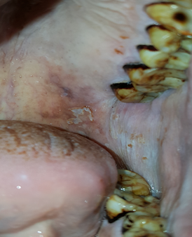
Keratinization on the buccal mucosa, all the dark areas you see around the teeth are from the betel nut staining the teeth

Staining is very difficult for the patient to remove on their own
This picture was taken in our clinic but we did not take it

Many of these patients develop a condition called submucosal fibrosis - which occurs before patient developing cancer in the area we do not know if the patient has submucosal fibrosis but it can lead to the patient not being able to open their mouth well because tissues in this area become fibrotic
THIS PATIENT WAS NOT TREATED- because we saw this abnormality and we referred them for further evaluation. Once it is under control they can get treatment at our facility.

PRESURGICAL
Semah
THE GOAL: What we want is for the patient's oral health to be stable

- The goal is to bring the patient to optimal health as soon as possible before radiation therapy and chemotherapy.
- The first thing that should be done before anything is x-rays such as (FMS, PAN, ETC)for:
- teeth extraction or if a
- A root canal is needed
- restorations.
X-rays before treating because x-rays are part of the treatment plan.
Carcinogen
Give them SRP (scaling and root planing) that way they are as clean as can be

Dental progress report states :

an oral lesion 10 mm in length and 12 mm width located on the left soft palate and left pharynx.
Color: leukoplakic center with erythroplakia borders.
The hard palate and left buccal mucosa are hyperkeratinization.
Immediate Referral was made to ENT. b/c he had a neck lesion. The ENT performed a biopsy which revealed squamous cell carcinoma.
There are two ways you can stage a stage III tumor

- One is the tumor is larger than 4cm in size and no cancer cells are present in nearby structures and it has not spread to nearby lymph nodes

- Or it can also mean that the tumor is any size and has not gone into nearby structures but there are cancer cells present in one lymph node on the same side - because he is going to receive a neck dissection we know that there is lymph node involvement when there is a lymph node involvement patient needs immediate treatment so that the lesion does not spread to other locations in the body through the lymph nodes

It is also important that the pt is evaluated to rule out HPV because it will increase the pts chance of redeveloping a 2nd tumor.
HPV infection is now considered a validated risk factor for oral cancer in both men and women, even in the absence of smoking and alcohol consumption. The patient will have a better prognosis if he stops using betel nut and quid with tobacco. However if the patient chooses to continue the usage, the prognosis will get worse because HPV has a higher recurrence rate.
17% of patients who quit smoking after developing a primary intraoral carcinoma will develop a second tumor
31% of patient who doesn’t quit smoking will have a higher chance of developing a second tumor

Patient referred to head and neck surgeon who is now ordering selective neck dissection and surgical reconstruction and chemo and radiation therapy

MICHELLE
DURING CHEMO and radiation therapy
- Possible salivary gland sparing radiation can be done this is very important for the pt because it will help minimize xerostomia and gland dysfunction - (it is a model of the pts head with a lining that absorbs radiation is added where your salivary glands are) - once the gland is destroyed they will have chronic dry mouth(which leads to caries or cavities) - this helps prevent damage to salivary glands

DURING RADIATION or Chemotherapy WHAT YOU CAN EXPECT:
- Radiation-induced mucositis usually occurs -
Mucositis is local erythema and pain
- Aphthous ulcer
- Xerostomia
- Candidiasis
- Necrosis
We can suggest they use either an over-the-counter mouthwash or a magic mouthwash which is compounded by the pharmacist. Prescription mouthwash that's geared to the patient would be more beneficial than an over-the-counter one- RINSES WITH ALCOHOL SHOULD BE AVOIDED!

RECOMMENDED TO USE
- Mucositis can be treated with the use of magic mouthwash
Magic mouthwash is a treatment some doctors prescribe to treat oral mucositis

It’s composed of a compound containing Nystatin suspension, an antifungal medication with xylitol - sugar-free version

- Ora care - activated chlorine dioxide, aloe vera, and xylitol
- Sloan Kettering uses a combination of 1 to 1 to 1 ratio of tetracycline suspension, betamethasone suspension which is a liquid steroid, nystatin suspension
- Liquid lidocaine - to help with pain
- Maalox helps coat the area

They must use these products multiple times a day and when their mouth gets sore they can place a gauze containing one of these products in the affected area and it should be changed throughout the day

Basic oral care is considered the foundation of care for oral mucositis- the purpose is to reduce the amount of microbial flora to reduce bleeding and to prevent infection

SEMAH
- To prevent candidiasis- topical antifungal clotrimazole and nystatin in mild or systemic antifungal agents and more severe cases oral fluconazole is recommended dry mouth has resulted after radiation therapy which causes rampant caries. Pts need a decent home care regimen and regular dental visits. It is also recommended that pts eat less sugar and chew on cheese to harden softened enamel. The use of Fl. gel(1.1% sodium fl.) is important.

POST RADIATION
- A major concern is that the patient doesn’t develop trismus( SHOW PICTURE)- They must follow up with a physical therapist and occupational therapist b/c trismus can be ruled out or treated if it’s present
Pt also needed to follow up with
- speech and language therapist
- a nutritionist
MICHELLE
- Refer them to a Prosthodontist (Prosthodontists handle complex dental cases, including jaw surgery, dentures, implants, etc.) - they can make them an obturator - fills the area where the tumor was so that when they eat the food doesn’t come out their nose and speech isn’t impaired
SEMAH
- Less oxygen in the blood can be an effect after chemotherapy solution is oxygen dive 15-30min or- 1hr breathing pure oxygen $15,000 a dive - very expensive however it is an option that we wanted to inform the pt about

MICHELLE
- Dry mouth results after radiation therapy which causes rampant caries. Pts need a decent home care regimen and regular dental visits to maintain optimal oral health
Xerostomia -Biotene (good for people on chemo)

Salivary substitute- for when they have a very dry mouth
- Biotene toothpaste
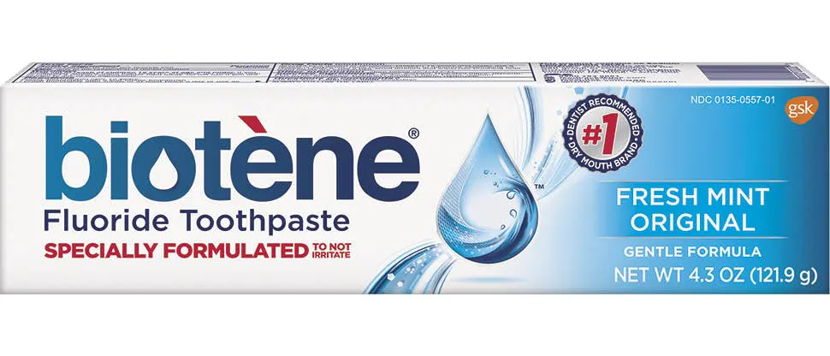
- Biotene gel
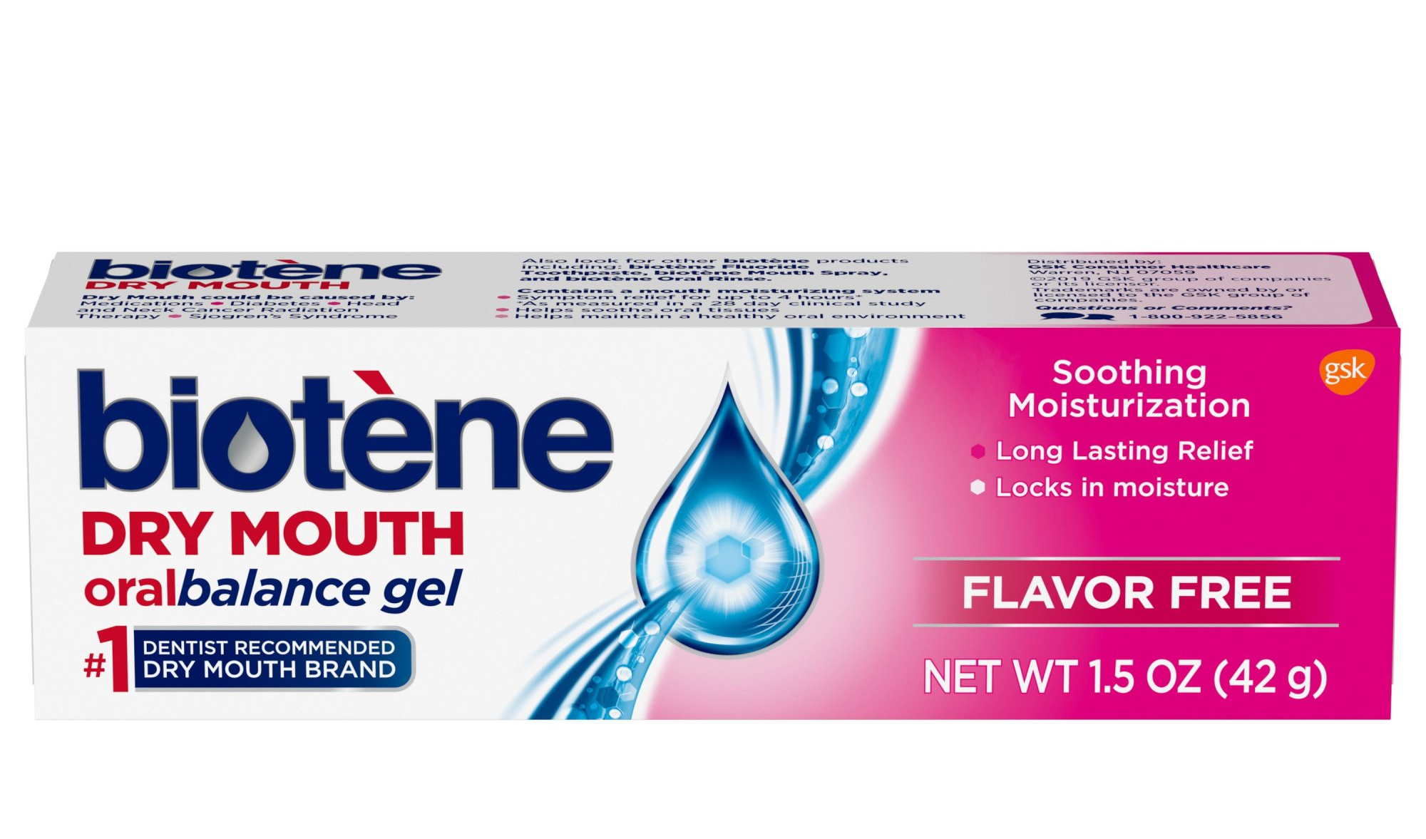 - It contains humectants and lubricants to provide dry mouth symptom relief
We can show them a picture of these products

QUESTIONS WE CAN ASK-

Did they develop submucous fibrosis?
What was the pt dental health and experience like before his latest visit?
What emergencies do we need to take into consideration for post-operation? necrosis
Why do we want to do work before surgery?
We are not sure if the pts will start surgery and we are not sure how much work he needs it depends on the work needed?
How much time do we have between the surgery to provide treatment?
How Long has he been using quid? When did the pt notice the black color?
Will we be able to use the salivary gland sparing to save the salivary glands during radiation?

NUTRITION
- A bidirectional relationship exists between oral health and diet and nutrition. Diet and nutrition affect the health of the tissues in the mouth, and the health of the mouth affects nutrients consumed.
- The consumption of sugars has been associated with an increased risk of developing dental caries.
- The complex nature of the periodontal disease makes it difficult to determine its relationship with diet and nutrition.
- Frequent consumption of acidic food and beverages is associated with an increased risk of erosive tooth wear.

HPV-related oropharyngeal cancer
T3: The tumor is larger than 4 cm or has spread to the epiglottis, which is the flap of cartilage that keeps food from entering the airway during swallowing.

Tumor | Non-HPV (Size) | HPV (Size)
T0 |  | No tumor can be found
T1 | 2 cm or less | 2 cm or smaller
T2 | 2 cm or less(depth 5 & 10mm) or larger than 2 cm but not larger than 4 cm(depth is 10 mm or less) | Larger than 2 cm but not more than 4cm
T3 | larger than 4 cm, or (depth greater than 10 mm) | Larger than 4 cm
T4 | moderately advanced or very advanced local disease (lips, jaw, sinuses, skin, muscles, and bones that form the mouth or the base of the skull) | The tumor has invaded the larynx, muscle of the tongue, muscles in the jaw, the roof of the mouth, or jawbone.

