Ryan Mohammed
Remote Sensing EET 3132
Ch.4 HW

1) $ω=\frac{v}{r}=\frac{2π}{84,164 sec}=7.29 x {10}^{-5}Rad/s$

2) If $R_{Earth}=6.38 x {10}^{6} m=Altitude of Earth$, then the period of the circular orbit is:

$$τ=\frac{2π}{R_{Earth}}\sqrt{\frac{r^{3}}{g_{o}}}=\frac{2π}{6.38 x {10}^{6} m}\sqrt{\frac{(6.38 x {10}^{6})^{3} m}{9.8 m/s^{2}}}=5069 seconds$$

3) Period of a Circular orbit @ Earth's surface:

$$τ=\frac{2π}{R_{Earth}}\sqrt{\frac{r^{3}}{g_{o}}}=\frac{2π}{6.38 x {10}^{6} m}\sqrt{\frac{(5.1 x {10}^{14})^{3} m}{9.8 m/s^{2}}}=3.62 x {10}^{15} seconds$$

Velocity:
$$v=\sqrt{\frac{g_{o}}{r}}R_{Earth}= \sqrt{\frac{9.8 m/s^{2}}{5.10 x{10}^{14}}}x 6.38 x {10}^{6} m=0.88 km/s$$

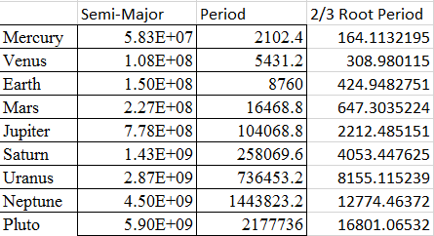
4)

It obeys Kepler's 3rd law, which states that $τ^{2}∝r^{3}$.

6) No, You cannot see Antarctica from a Geo orbit because the earth's gravity would pull the satellite and eventually crash to the surface.

7) Radius @ Perigee= $R_{p}=$ 1.5$R_{Earth}$= 9.57$x {10}^{6} m$
Radius @ Apogee= $R_{a}=$ 3$R_{Earth}$= 19.14 x${10}^{6} m$

Velocity @ Apogee = 3.73 km/s
Velocity @ Perigee= $v_{p}=\sqrt{\frac{2GMR_{a}}{R_{p}(R_{a}+R_{p})}}=\sqrt{\frac{2(3.98 x {10}^{14})(19.14 x {10}^{6})}{9.57 x {10}^{6} (19.14 x {10}^{6}+9.57 x {10}^{6} )}}=$7.44 km/s

