EET 3132 Remote Sensing ETET/NYCCT/CUNY Prof. Viviana Vladutescu Spring 2016
Final Test Ryan Mohammed

1A).Look up the orbits for the nine planets and plot the period vs the semi major axis. Do they obey Kepler’s third law? This is best done by using a log-log plot. (10 points)
B).Plot the two thirds root of the period vs. the semi-major axis (or mean radius) (5 points)
1A)
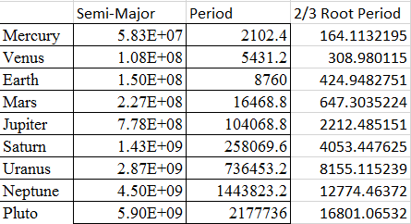
They do obey Kepler’s Third Law, which states that the square of the orbital period of a planet is directly proportional to the cube of the semi-major axis of its orbit.
1B)

2).For a scene with 4 pixels calculate the correlation between pixels and the covariance. (10 points)
 | Red(DN) | Green(DN) | Blue(DN)
1 | 40 | 50 | 60
2 | 20 | 25 | 28
3 | 30 | 30 | 30
4 | 15 | 16 | 14

A=[40 50 60; 20 25 28; 30 30 30; 15 16 14];
C= corr(A)
c= cov(A)
C =
1.0000 0.9693 0.9397
0.9693 1.0000 0.9949
0.9397 0.9949 1.0000
c =
122.9167 154.5833 201.6667
154.5833 206.9167 277.0000
201.6667 277.0000 374.6667
3).Plot 72 hours HYSPLIT backward trajectories starting at NYCCT or CCNY at 500m, 1500m, 3000m on May 15th , 2016 (4 pm UTC time). (10 points)

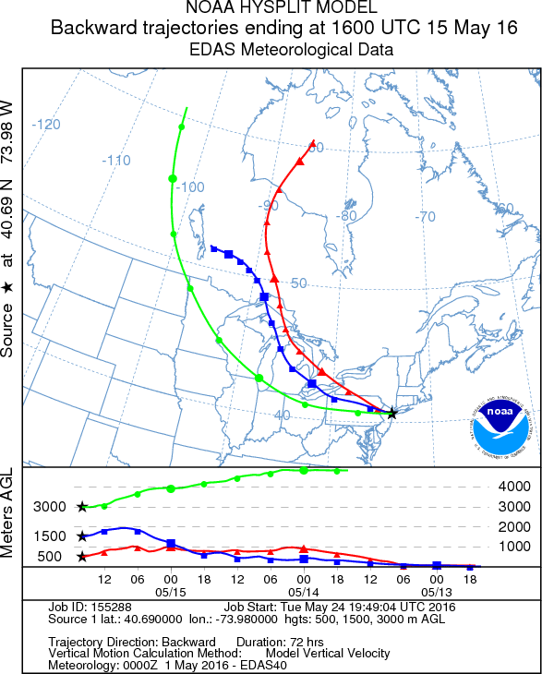
From this plot we can see winds from the lower altitude, 500m, come from over a body of water. This air was most likely polluted when flying over industrialized areas and cities. The winds coming at altitude 1500m travel over land and started off at altitudes below 500m, gaining height as it traveled. The highest altitude winds started at heights well above 3000m and stayed consistently high. These winds were most likely not polluted because they did not come in close enough contact with sources of pollution.

Bonus
4).Download a MODIS file for the month of May 2016 over NYC area and plot an image of the LWP or Cloud fraction available in the .hdf file. Make sure you use the HDF Viewer to open the file much easier. (10 points)
May 23, 2016 Cloud Fraction N:41 S:40 E:-72 W:-73
load ('Cloud_Fraction_Ryan.txt')
figure(1)
imagesc(Cloud_Fraction_Ryan)
colorbar
title('Cloud Rraction', 'Fontsize',18)
ylabel('latitude', 'Fontsize',14)
xlabel('longitude', 'Fontsize',14)
figure(2)
histogram(Cloud_Fraction_Ryan)

