Homework 2
2-11

a. Draw a conceptual graph to show total revenue and
total costs that this company is experiencing.
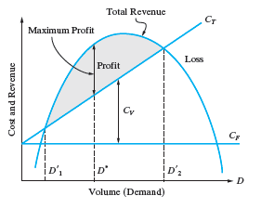

b. Identify three types of fixed costs that the airline
should carefully examine to lower its breakeven
point. Explain your reasoning.

- Rent
- Insurance
- Loans
These are fixed costs an airline would have to pay.
The rent, insurance and loan expenses will remain the same each month.
These costs will remain fixed for any sort of business so it is a general assumption.

c. Identify three types of variable costs that can
possibly be reduced to lower the breakeven point.
Why did you select these cost items?

- Aircrew salaries
- Number of employees
- Cost of fuel
The variable costs have fluctuations. The cost of labor is too high they need to reduce it. Also it might be number of employees, if more people employed than is necessary.
Cost of fuel will change with time. One of the solution is to buy in large ammounts.

2-12.

a. Determine optimum demand for this product.

Cf= $42,000 per month
Cv= $53 per circuit board
P = 150 – 0.02D
Max Output = 4000 units per month
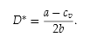
$\frac{150-53}{2(0.02)}$ = 2,425 units per month.

b. What is the maximum profit per month?

Profit = Total Revenue – Total Costs =
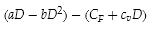

(150(2425)-0.02(2425)²) – (42,000+53(2425)) = $75,612.50

c. At what volumes does breakeven occur?
d. What is the company’s range of profitable demand?
Break Even : Total Revenue = Total Cost
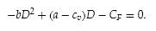
(-0.02D²) + (150-53)D – 42,000 = 0

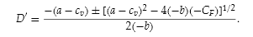

$$D=\frac{-97±\sqrt{{97}^{2}-4(-0.02)(-42,000)}}{2(-0.02)}$$
c) Break even points
481 and 4369

d) The domain of profitable demand is 480 – 4369.

2-13

a. What is the optimum number of units the defense
contractor should produce in order to maximize
profit per week?

Cf= $0
Cv= $40 per circuit board
P = 180 – 5D

$\frac{180-40}{2(5)}$ = 14 units per week

b. What is the profit if the optimum number of units
are produced?

Profit = Total Revenue – Total Costs

(180(14)-5(14)²) – (0+40(14)) = $980 per week

2-14.

a. For this situation determine the optimal monthly
sales volume for this product and calculate the profit
(or loss) at the optimal volume.

Cf= $900,000 per month
Cv= $131.50 per circuit board
P = 600 – 0.05D
Max Output = 4000 units per month

$\frac{600-131.5}{2(0.05)}$ = 4685 units per month.

Profit = Total Revenue – Total Costs

(600(4685)-0.05(4685)²) – (900,000+131.5(4685)) = $197,461.25 per month

b. What is domain of profitable demand during a
month?

Break Even : Total Revenue = Total Cost
(-0.05D²) + (468.5)D – 900,000 = 0

$$D=\frac{-468.5±\sqrt{{468.5}^{2}-4(-0.05)(-900,000)}}{2(-0.05)}$$

Break even points
2697.8 and 6672.3

d) The domain of profitable demand is from 2697.8 – 6672.3.

2-17.

Cf= $100,000
Cv= $140,000
P = 40
Revenue = $280,000

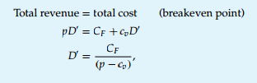

D = $\frac{100,000}{40-140000}$, = -0.7

70% capacity.

