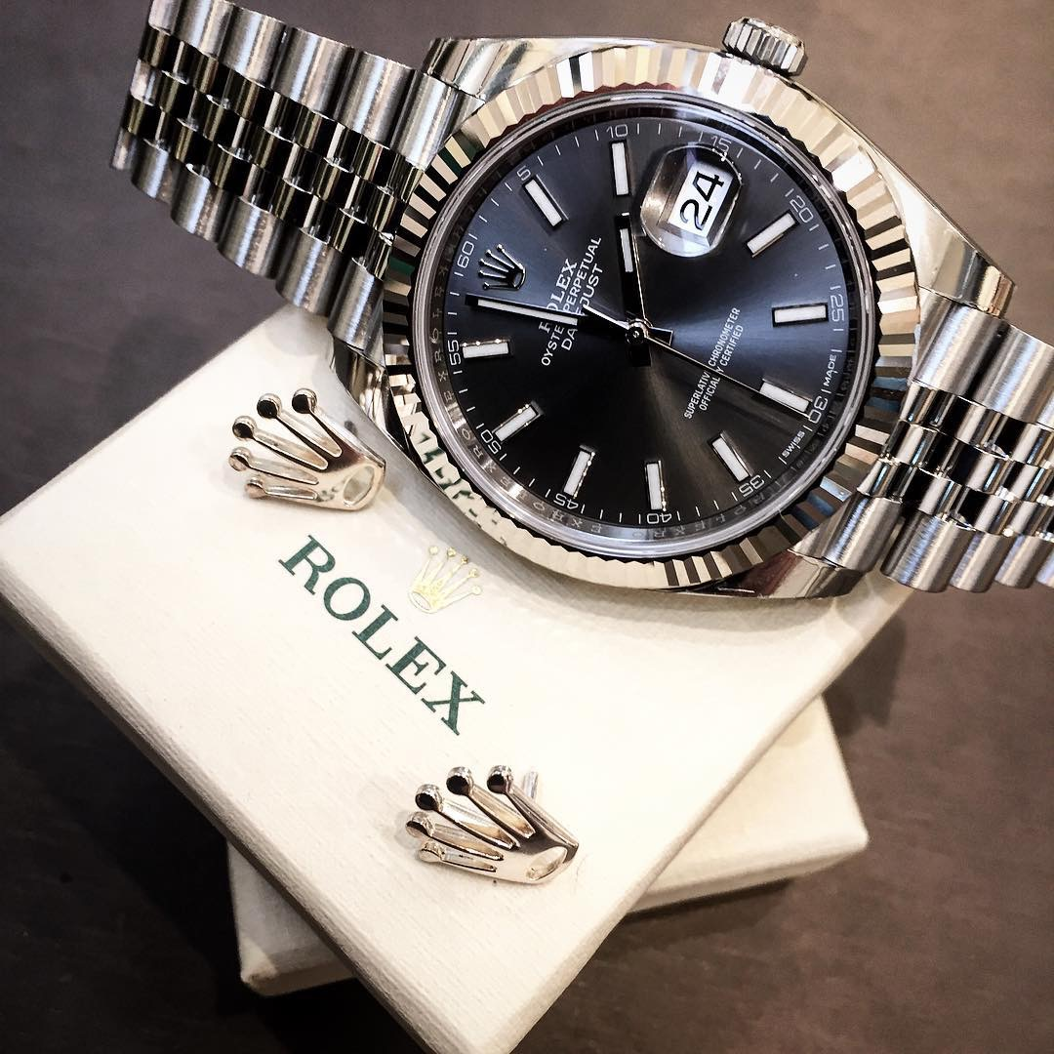

Table of Contents:
- Team profile
- Marketing Review
- Situation Analysis
- Research Foundation
- Proposed Target Consumers
- Advertising Objectives
- Media Plan and Schedule
- Budget
- Creative Rationale
- Creative Supplement
- Reference

We are composed of 6 members. We have an account executive, a media planner, two media/market researchers, a graphic designer and a copywriter.

Below is a brief summary of our member along with their tasks and responsibility in corresponding to our agency.

Team Profile:
Account Executive: Gabriel Fernandez is enrolled in Marketing & Sales at New York City College of Technology with an interest in cars and distribution businesses. His goal is to start and own a business. His role is the overall management of the advertising campaign and completion of the project.

Graphic artist: Crystal Llerena is currently enrolled in Fashion Marketing at New York City College of Technology. She originally has an associates degree in Fine Arts from LaGuardia Community College. Her role in this campaign plan is to illustrate our product in terms of a magazine advertisement geared to our target population.

Media/Market researcher: Ryan Cruz is a Business & Technology of Fashion major with an interest in the entertainment and fashion industry. His goal is to graduate college and pursue several high risk ventures while learning from all of them, until one succeeds and takes him to the top.
Research Foundation: Anderson Vieira is a Marketing management & sales major at New York City College of Technology. His goal is to work in the marketing field in the entertainment industry. His responsibilities in this campaign are to research objectives and data analysis; To summarize all research data to develop the advertising campaign.

Media Planner: Ruth Jordan is a Business & Technology of Fashion major at New York City College of Technology. Her goal is to become a fashion buyer or apparel product developer. Her responsibilities in this campaign are to identify the various media platforms that would best advertise the product at hand, and maximize the impact of the campaign through the use of media range. Also allocating the expenses of the campaign to utilize the given $100,000,000 budget and identifying a sales promotion.

Copywriter: Itzel Lazaro is enrolled in Business & Technology of Fashion at New York City College of Technology. Her goals is to become a Creative Director and be part of the Fashion industry. Her responsibilities in this campaign are creating all the writing which includes the words for all of the ads. She collaborates with the account executive, Graphic artist, and media planner.

Marketing Review
About Rolex
Rolex is the largest Swiss luxury watch brand, producing about 2,000 watches per day. The company and its Subsidiary Montres Tidor SA manufactures, distribute and service wristwatches under the Rolex and Tudor Brands. Rolex was founded in 1905 by Hans Wilsford and Alfred Davis in London, England who specializes in the distribution of timepiece. According to Forbes, Rolex is ranked 64th on its 2016 list of the world’s most powerful global brands. Rolex moved its headquarters to Geneva, Switzerland in 1919, a city renowned internationally for watchmaking. Later in 1920, Montres Rolex S.A. was registered and finally Rolex S.A.
The Founding of the Rolex
In 1905 by Hans Wilsford and Alfred Davis in London, England who specializes in the distribution of timepiece. During that time, watches were very explicit and to convince the public of his innovation he equipped them with a small manufactured by a Swiss watchmaking company in Bienne.
Rolex Brand is Created
In 1908, Hans Wilsford wanted his watch brand’s name to be short, easy and can be easily pronounceable in any language. As he stated, “ I tried combining the letter of alphabet in every possible way. This gave me some hundred names, but none .of them felt quite right. One morning, while riding on the upper deck of horse-drawn omnibus along cheap side in the City of London, a genie whispered ‘Rolex’ in my ear.”
In 1914, Kews Observatory in Great Britain awarded a Rolex watch a Class A Precision Certificate, which had been reserved exclusively to Marine Chronometers.
Rolex moved its headquarters to Geneva, Switzerland in 1919, a city renowned internationally for watchmaking. Later in 1920, Montres Rolex S.A. was registered and finally Rolex S.A.
Along with creating Rolex, Hans Wildford also founded a high-quality yet lower priced Tudor Brand of watches which became a subsidiary company founded in 1946. Both company continued to grow and produce quality and innovation timepiece till his death in 1960.
The Hans Wilsford Foundation
After the death of his wife in 1944, Wilsford established The Hans Wilsford Foundation, a private trust which he left all his shares to his company insuring that some of the company’s income would go to charity. The Rolex company is owned by trust and does not pay corporate tax.
Awards
Rolex Awards for Enterprise launched to honor individuals who takes major challenges. Each Rolex Awards for Enterprise is given for those who initiate on extraordinary projects anywhere around the world –individuals who has an impact improving lives and communities and protecting the world's natural and cultural heritage. The award is designed to develop humanity by expanding knowledge or improving life on the planet.
Innovation
The Rolex company has a long history of innovative and successful watch designs since 1905. Rolex was the most company that had many first such as the first watch that was waterproof up to 10hrs, the first to automatically change the date and day on the dial, first wristwatch to earn chronometer certification, etc.
Rolex production
Rolex produced many watches over its long term history. Some models are considered collectible and vintage, but others are still offered and growing to the public. Rolex offers a wide range of models that are geared towards specific types of wearers like for swimming and diving, the Rolex Submariner is a the best choice because it is designed to withstand water pressure and remain in good condition or for racing, Rolex Daytona is designed for racing enthusiasts. Each model is designed based on its own characteristics of adventures, success and power and features in any sizes, metals includes gold, stainless steel, white gold, two-tone, diamonds or pearls and are guaranteed to satisfy its consumers.
To this day, Rolex still continues to expand their Rolex line by producing the greatest timepiece.

Situation Analysis
Rolex S.A is a Switzerland privately held company owned by Hans Wilsdorf Foundation, which was a foundation of Hans Wilsdorf and was left with all the rolex shares after his death. We are constantly looking forward to improving ways to help our consumers in their day and night lives. We are happy when our customers are happy that's true success. With thousands of consumers on the globe Rolex products are sold all over the world, North America, Latin America, Europe, Asia, Middle East and Australia/New Zealand and they keep expanding.
Rolex’s Chance has many competitors of watches such as Hublot, Audemars Piguet, Cartier, and Patek Philippe. We believe the market for watches is at a high with the maturity level of the product cycle. Rolex has been around for many decades, the product never seems to fail our target market. It provides people with the needs and leaves them with a positive feeling afterwards.
Key points about Rolex watches
- Rolex makes watches for men, women, and children
- The top watches are from platinum, diamonds, and 18k gold
- A great balance of time that never gets old. An automatic watch style and the date so you will always be up to date
- Rolex Submariner and Presidential range from young adults to older people, which is why Rolex is ranked 64th in the most powerful brands.

Rolex Submariner and Presidential has been featured in many prestigious magazines like
- Times
- Vogue
- GQ
- Sports Illustrated
Research foundation
When we undertook this AD campaign, we researched to learn more about the Rolex brand and watches. We made research objectives through our data analysis. In our ad campaign for the Rolex brand, we concluded that visual brand identity captures the consumer’s interest. As they project their personality to the brand and product. Essentially making the brand and product feel more personal. The visual appeal and identity of the watch and brand is important to establish familiarity and a common identifiable brand imagery. The visual brand identity is the brand personality. To reinforce this idea, a verbal interview was done across NYC.
Focus Group:
· In person; three groups of males aged 21-30, 31-40, 50-65 were interviewed.
Delphi Method:
· Expert Test: Marketing and advertising, Entertainment, Fashion.
· An in-depth interview was given to 60 males, different nationalities from North to South America, the United-kingdom and parts of Europe. Etc.
Conclusion of the study:
1. Young Males between the ages of 21-30 on average currently values cell phones as their primary way to tell time.
2. Men aged 21-35 who have recently landed a high-paying job, earned a promotion or received a bonus; young men who want to show off their new found status. They have bought their expensive suits and shoes to wear to their job, but they need to complete the look with the sophistication of a Rolex watch to show that they have “made it.”
From the result of the Studies; our target market currently values cell phones as their primary way to tell time and they do not yet appreciate the value of a watch. They need to be educated on why they should be wearing a watch as opposed to checking their cell phones for the time. Watch sales have dropped considerably by as much as 30% in the past several years among young men. This is a market that needs to be shown how owning a watch is a sustainable competitive advantage. The newer generation is highly active on the internet and is influenced by advertising and postings on Facebook, Twitter and YouTube.
Rolex AD campaign three major objectives:
1. Make young men between the ages 21 and 35 to purchase Rolex brand watches. To convince the newer generation that mechanical watches are a more luxurious and viable option as opposed to smart watches.
2. Rolex is a luxury item with a premium price, the labor cost is very high as Rolex only employs the best craftsmen for assembly and design. The brand has targeted consumers from the wealthy class to whom money does not matter but exclusive items do.
3. Reinvigorate hype and interest in the Rolex brand with young men, especially in the higher income brackets.

Proposed Target Consumers
For our campaign we will be showcasing the Rolex Submariner Date model. The company Rolex itself is a high end company that is based on quality and elegance, and this model exhibits just that. This model is the most common bought model in our target market, which are middle class to upper class men in the ages of 21 to 55. We are mainly targeting the men who enjoy showcasing their wealth, and find pleasure in treating themselves to a very exotic and elegant watch that could potentially boost their lifestyles. Although our target market stretches all the way to those of the age of 55, we would still like to aim to target a younger audience and tap into the new norms of social media to keep brand awareness amongst the younger consumers.

Sales Promotion
We at the Rolex Advertising Agency have a budget of $10,000,000 for sales promotion. Sales promotion is a marketing activity that adds to the original value proposition behind our product for a limited time in order to stimulate consumer purchasing sales. Methods such as sampling and special pricing will be used as our sales promotions to reach more consumers and new audiences that haven’t yet been familiar with the brand.
Sampling: Providing free samples is a technique used in order to introduce new products to the marketplace. Samples are given to the consumer in order to see how well they like the product, or try something that they normally wouldn’t go for. In our case we would give samples of our watch at a high-end event of our choice in a gift bag to guests.
Special pricing: Providing an offer of a lower price to customers for a period of time or to a purchase of multiple quantities. This can be lowering the price of the watch by 5% the week before Father’s day and two weeks prior to the Christmas Holiday for gifting. On a purchase of multiple quantities of three or more watches, 8% off the purchase for the week before Father’s day and two weeks prior to the Christmas Holiday.

Celebrities
Our budget for talent/celebrity is $2,511,588.50. The celebrities that we will be using in order to promote the campaign will be Lionel Messi at $1,000,000, Lewis Hamilton at $900,000 and ASAP Rocky at $611,588.50.
Lionel Messi, is an athlete that is currently acknowledged as the best football player in the world. Coming from a poor background and rising to the challenge to show his strengths on a worldwide platform. His down to earth demeanor and cool disposition is a great relatable personality for the Everyman that falls into the middle to upper class market as a face for Rolex.
Lewis Hamilton, is a British Formula 1 racing driver. He’s achieved legendary status in his sport and has a rockstar, larger than life personality that has worked hard to obtain. Always striving for excellence just like Rolex consumers.
ASAP Rocky, is a rapper is at the forefront of fashion mixing uptown street styles of New York City with high fashion which will open up a unique market for Rolex, being the Urban male in the middle to upper class and those aspiring to reach there.

Media Plan and Schedule
Since our target market is middle class to upper class men ranging from the ages of 21 to 55. Targeting the men who enjoy showcasing their wealth, and find pleasure in treating themselves to a very exotic and elegant watch that could potentially boost their lifestyles. We chose the top men’s magazines such as GQ, Esquire, Maxim, Sports Illustrated, with the addition of more high end fashion magazines that the target market fits, who’s customer base is fashionable and find pleasure in treating themselves.

Magazine Rates 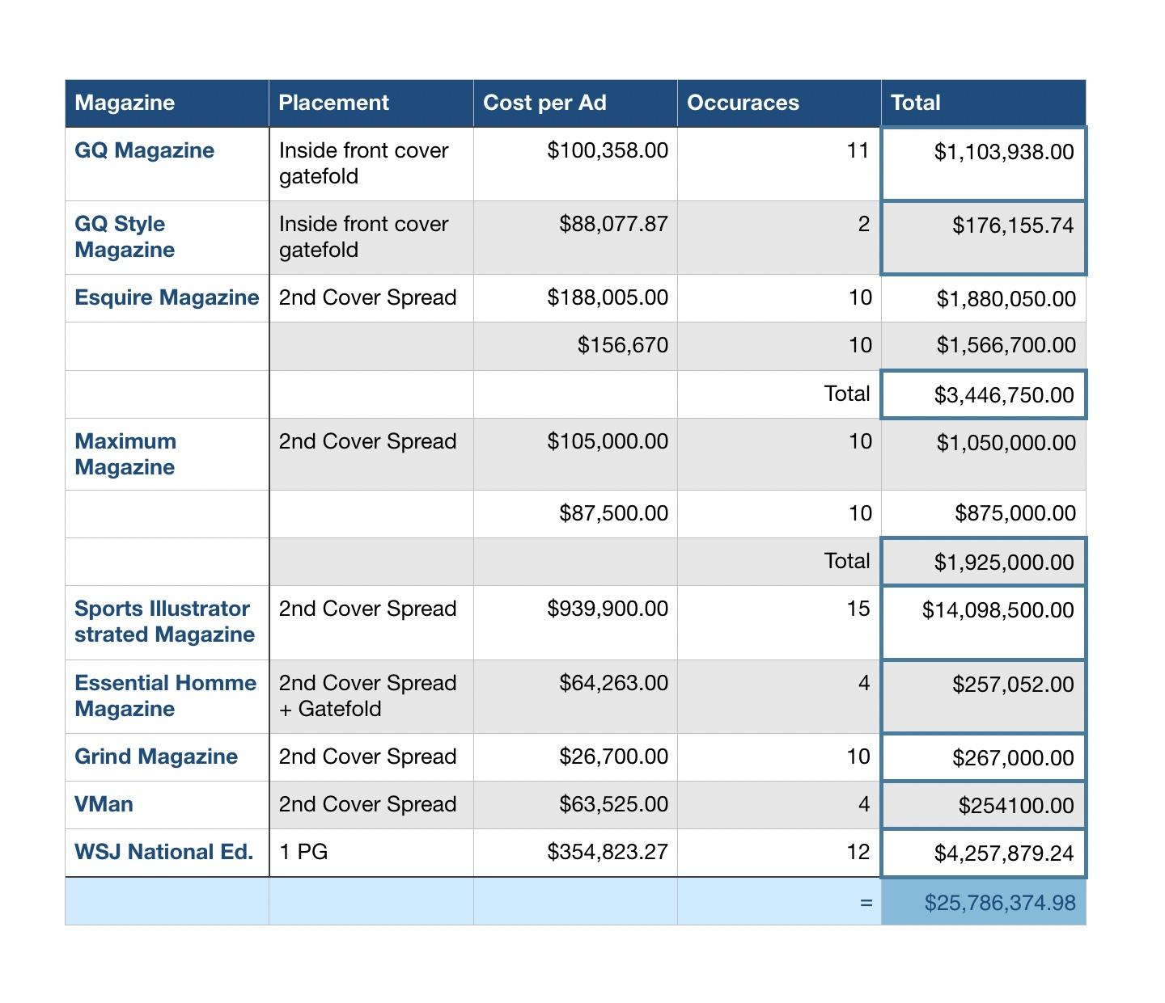

Billboard Rates
For the man on the go, driving to and fro, we have billboards. Billboards are noticed because their messages are in bright bold colors and creative graphics. A billboard in a great location for example a major city, interstate, or major highway will reach more people faster and easier than any other type of media. Pricing provided from Lamar billboard services.
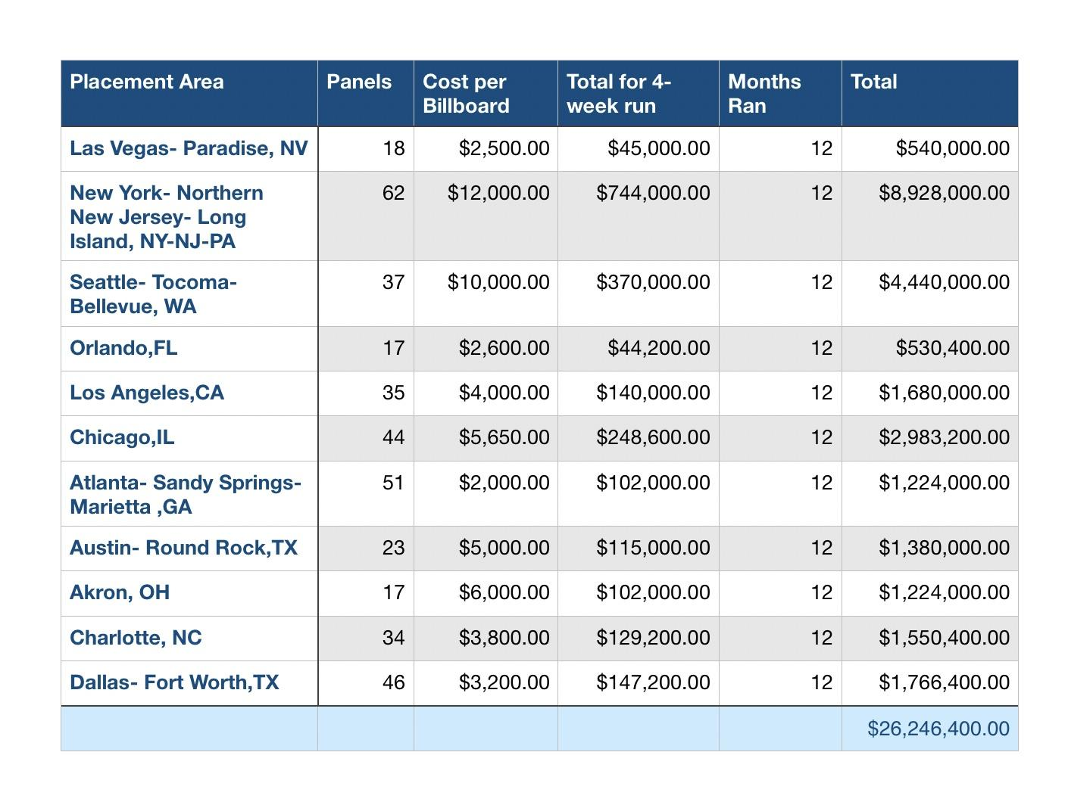
Airport Billboard Rates
Once again, for the man on the go, we have airport billboards for our jetsetters to remind them that our watch is timeless elegance.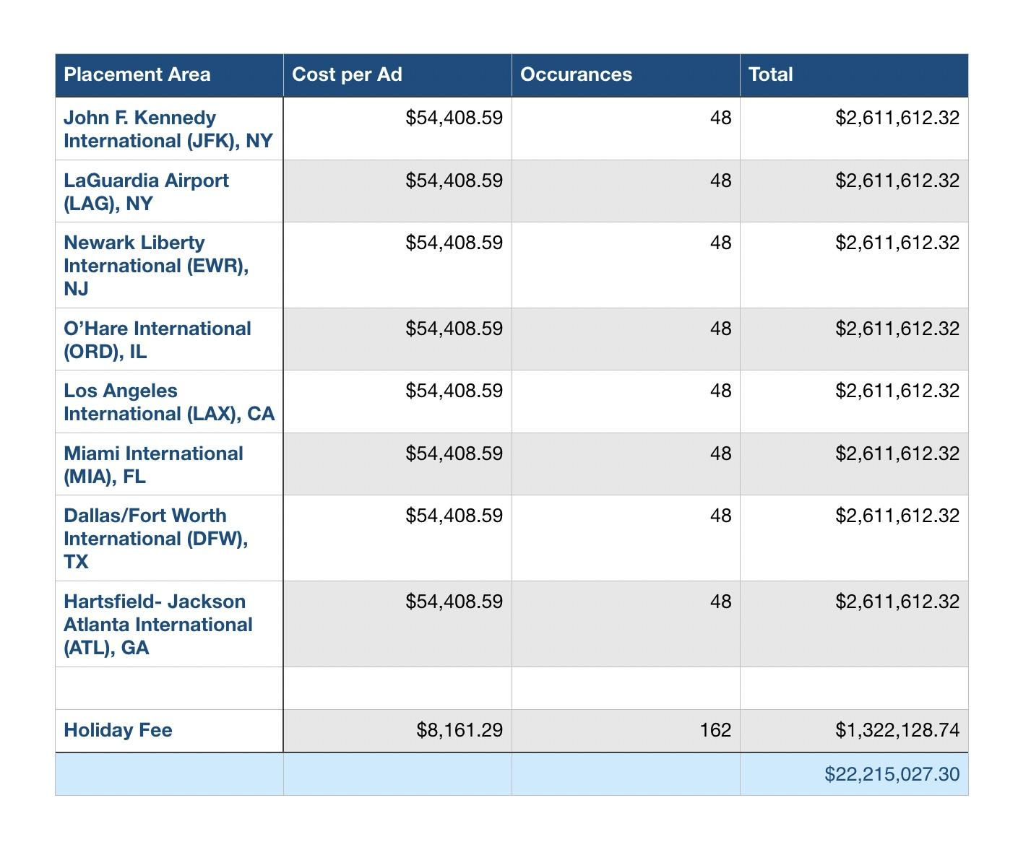

Budget
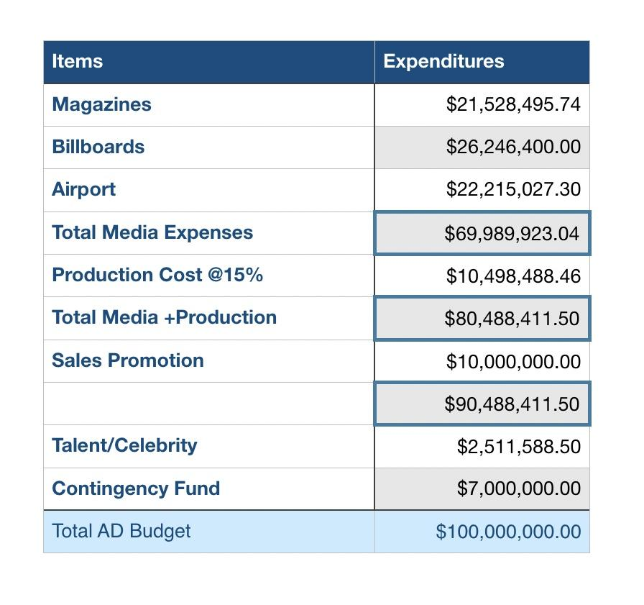

Creative Rationale
- The creative theme for our advertisement campaign will be focused on our specific demographic which is; young middle class male. Our product, Rolex watch has maintained a steady theme in pervious magazine advertisements. Many included famous athletes sporting the watch and and men in business suits checking the the time in their rolex watch. This high quality watch has been promoted in different media vehicles as a luxury brand that is reserved for a specific type of target market, usually wealthy men who are 35 and older. However in our theme, we decided to target a younger demographic, young men (21-35) with a profitable occupation.
- Our creative theme will be more geared towards a younger demographic, it will be a total different concept than previous Rolex watch advertisements in the past. In the Ad campaign the Rolex watch will be the centerpiece of a comic style illustration that will be featured in magazines suchs GQ and Esquire. Shown in bright primary colors ,in the likes of famous pop art artist, Roy Lichtenstein. This illustration will be composed of characters, bright colors and the product in a pop art version.The title of our creative theme is Rolex, the watch with classic style.
- The slogan for this ad campaign is “Timeless Elegance.” we decided to use this slogan because it seems to fit with our creative theme and also keeps true to the brand itself. Since our product is a watch, a high quality one, we wanted to attach the slogan with its luxury style be reflecting a message that it can be worn for a long time because of its premium materials used to manufacture the watch.

Reference

Essential Homme, (2017). Magazine Advertising . [ONLINE] Available at:
http://essentialhommemediakit.com/magazine_advertising.html. [Last Accessed 20
November 2017].
Esquire, (2017). Esquire Media Kit. [ONLINE] Available at:
http://www.esquiremediakit.com/hotdata/publishers/esquireme2036297/esquiremedia697
5/pdfs/2018/EsquireRateCard2018.pdf. [Last Accessed 20 October 2017].
Grind, (Grind Mag). Media Information. [ONLINE] Available at:
http://grind-mag.com/download/grind.pdf. [Last Accessed 20 November 2017].
GQ, (2017). Media Pack 2018. [ONLINE] Available at:
http://digital-assets.condenast.co.uk.s3.amazonaws.com/static/mediapack/gq_media_pack
_latest.pdf. [Last Accessed 20 October 2017].
Lamar, (2017). Lamar Bulletins. [ONLINE] Available at:
http://apps.lamar.com/demographicrates/content/salesdocuments/nationalratecard.xlsx.
[Last Accessed 1 December 2017].
Maxim, (2017). Maxim Media Kit. [ONLINE] Available at:
http://www.maximmediakit.com/downloads/Media_Kit_2017.pdf. [Last Accessed 1
November 2017].
MBAskool, (2015). Lionel Messi. [ONLINE] Available at: https://
www.mbaskool.com/personalities/celebrity-brands/9779-lionel-messi.html.
[Last Accessed 5 December 2017].
Mehta, Mithila & Shah, Kunal, (2017). Formula One: Lewis Hamilton's charisma
combined with his racing talent makes him real champion. [ONLINE]
Available at: http://www.firstpost.com/sports/formula-one-lewis-hamiltons-
charisma-combined-with-his-racing-talent-makes-him-real-
champion-3949847.html. [Last Accessed 5 December 2017].
Rolex, (2017). History Of Rolex. [ONLINE] Available at:
https://pressroom.rolex.com/en/corporate/history-and-corporate/history-of-rolex.html.
[Last Accessed 18 October 2017].
Sanchez, Karizza, (2017). The Best-Dressed Men of 2017 (So Far). [ONLINE]
Available at: http://www.complex.com/style/best-dressed-men-2017/. [Last
Accessed 5 December 2017].
Sports Illustrated, (2017). Magazine Rates. [ONLINE] Available at:
https://www.simediakit.com/home/magazine/rates/. [Last Accessed 20 October 2017].

