Haute & Hoot Product Line
Yelissa Vasquez, Amy Chen, Khalifa Francois, Vivienne Liang, Ruth Jordan
New York City College of Technology

Table of Contents
- About Haute & Hoot
- Target Market
- Competitors with Comparable Products
- The Design of the Line
- The Coats
- The Inner Shells
- Construction Specifications
- About the Fabric
- Polyester
- Primaloft
- Nylon
- Faux Fur
- Quality Control and Merchandising

About Haute & Hoot
Haute & Hoot is a winter coat company in New York City focusing on making their customers look their best, feel warm, and adding a little hoot of laughter to their cold day. The company specializes in making various styles of two-shelled coats, each coat including inner and outer shells having different levels of warmth. Each coat will have a tag attached indicating the warmth level with funny and unique names that are easy to remember allowing customers to identify which one they’ll need to grab in the morning. Haute & Hoot offers three levels of warmth that can be added onto each outerwear. They would consist of “Super cozy”, “Roasting by the fire”, and finally “The Oven”.

Target Market
Designing a coat for everyone is essential. However, Haute and Hoot keeps it exclusive and only directs their brand to certain individuals. Especially in the Fall and Winter Season those who live in New York City makes coats one of their main property to have. During the cold temperature in NYC traveling isn’t easy. Which is why we found a need for our company that provides a great style and affordable coats. Overall, we intend our customers to be a Female or Male who is between the ages 20-25. They are millennials who are college students that also have entry level jobs. Our customers make minimum wage however, still being able to afford our coats. According to an article, a nationwide study, three out of four college kids hold down jobs while they’re in school. It shows that 40% of their money is labeled discretionary spending, which is what they use for shopping.
With the stress of assignments, or frequent parties it is likely for our customers to go shopping. Location is very important, which is why we are located in New York City. The weather in New York City represents why we name our inner shells cozy,toasty and fuego. Our customers will be a person who has a great sense of fashion not living beyond their needs . Very fashion forward and understands different aesthetics and attributes of certain designs. Haute and Hoot will be a great asset to those
Creating and developing our company to be successful is significant. Marketing will be the first strength to our success and a huge competitive edge. Haute and Hoot will always remain professionalism. Which includes everything from maintaining great quality and creating our very best designs. Instead of having our customers purchase our coats with impulsive shopping, we will target each customer with individual attention. Weather it may be with grabbing their attention with personality, fashion sense or a need for our coat. Each client's experience will be tailored to his or her’s preference. Giving the kind of service that brings people wanting to keep shopping with us. Located in NYC however, Pop-up shops will be introduced in other states that are necessary. Even if we expand and venture on to other items of clothing they will have loyalty to our company.

Advertising and Promotion
With the emergence of social media outlets such as Snapchat and Instagram the fashion industry is constantly being advertised. Whether it’s a “how-to style a garment” video or “how-to place an online order,” fashion is everywhere. For our jacket company, We will have a lot of my advertising done through social media and online. Also during the grand opening there will be a lot of coupons and promotion. We will also advertise through YouTube fashion bloggers in the area and offer meet-and greets with them to draw more clients to our jacket collection.
Competitors with Comparable Products
Among the many coat brands competing with Haute & Hoot, Canada Goose is one of two brands Haute & Hoot aspires to be and observes what can be done better. Canada Goose is a designer priced winter coat brand known for focusing on keeping customers warm and protected by combining down, a natural insulator, and fur (Canada Goose, 2017). By using down as an insulator, their jackets become three times warmer than if they used a synthetic insulator (Canada Goose, 2017). They also decided to use fur trimming on the coats hood because they believe it is best for protecting the face against frostbite and other harsh weather conditions (Canada Goose, 2017). Because the brand uses real fur and down made of goose feathers, there are some shoppers who openly oppose the materials being used for the jacket (Canada Goose, 2017; Roberts, 2017). Haute & Hoot does not have this problem because the company uses synthetic materials such as faux fur and heat technology to keep the customer warm. This choice in material makes it less expensive to produce and for the customer to purchase.
Another designer priced brand competing with Haute & Hoot is Moncler. This brand makes it their priority to create fashionable winter wear such as coats in their warmest and lightest form (Moncler, 2017). These Moncler coats are filled of goose down that completely insulates the jacket and and makes it very comfortable to wear (Moncler, 2017). Nylon is used to hold the down and create the design of the coat while making it weigh less than a sweater (Moncler, 2017). Unlike Moncler, Haute & Hoot will have a variety of coat styles because a thinner fabric made of heating technology is used throughout all coats. Because of this technology, the fabric can be manipulated to create a thin or voluminous coat without having to trade style for warmth.

The Design of the Line
The basis of the design of the Haute & Hoot coat line is to create interchangeable 3-in-1 jackets, allowing customers to mix and match their style with levels of added warmth.
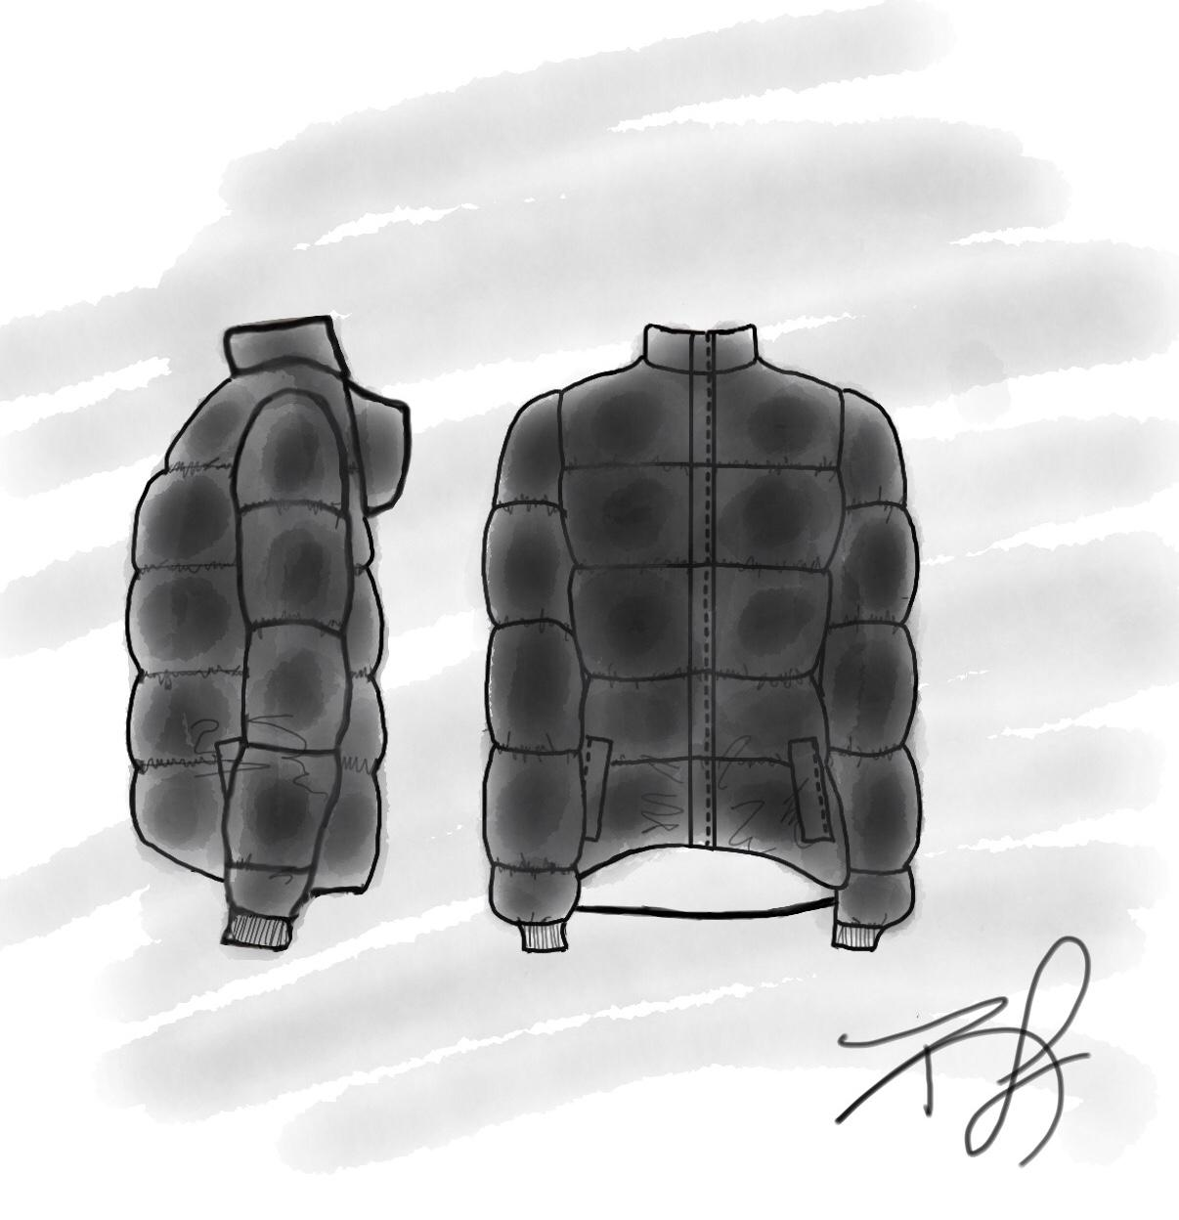
The Coats
Crop Bubble Puffer Jacket
The Cropped Bubble Puffer Jacket, is for our trendy woman that believes in all things cropped no matter the season. It comes in black to be easily combined with anything she wears. The key components for this jacket are warmth retention, and how it handles wet conditions.
For achieving a handle on the wet elements of snow, sleet, and rain the material of the outer shell is water resistant Nylon. For warmth retention we chose the usage of Primaloft, a compressible, lightweight, water repellent fiber to fill our outer shell. Primaloft is a polyester material that is used as a luxury alternative to down feathers, allowing us to keep the price moderate for production as well as for the consumer. This jacket as an outer shell can be worn alone, or with the option of adding a inner shell for extra warmth through the seasons. Our Fuego inner shell paired with this jacket creates what we like to call “The Oven” because you get double the warmth.
This jacket has the features of a front zipper for easy wear access, with an additional piece of fabric to cover it to block wind and cold air, and zippers located inside on both sides to zip in the inner shell of your choice. Ribbed elasticated cuffs to ensure minimal escape of warmth and sealing out wind and cold air. There is hooded neckline and zipper protected fleece lined pockets for colder conditions.
Pricing for the garment is as followed:
For material using 1 yard of Primaloft of filling $19.75, 2 yards of Dusty Olive Nylon at $19.98, ⅕ yard of solid fleece at $1.59, ribbed knit at $2.30, care labels, size tags and hang tags at $1.00, 2 zippers at $15.58, and an estimated cost of $20.00 for the labor of cutting and sewing, the total cost will be $80.20. Using the rule of markup being double the total cost plus $10 the jacket will be priced at $170.40, at Haute & Hoot retailed for $175.
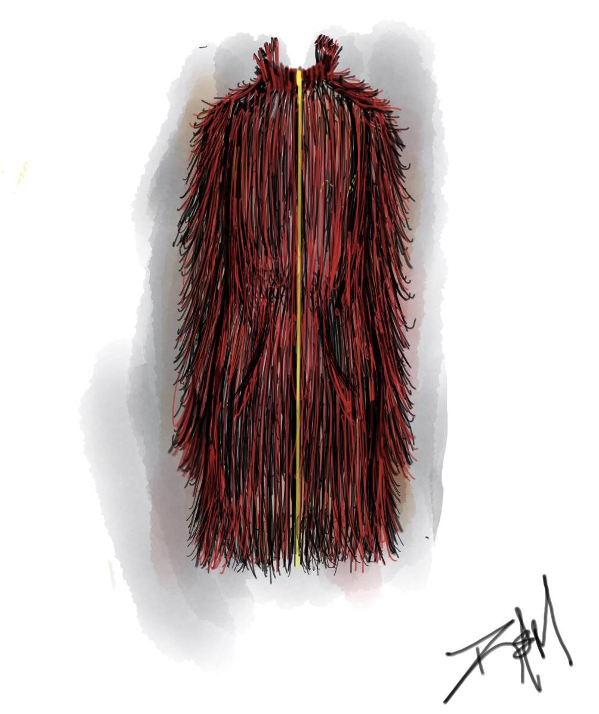
The Faux Fur Coat “Super Cozy”
This coat is your trendy woman’s statement piece in the color of the season, red. This a stand alone jacket is what we call the “Super Cozy”, where the outer fabric is heavyweight super soft faux fur, and the inner lining is a breathable waterproof polyester. This coat has the features of a front zipper for easy wear access, and fleece lined pockets to keep warm. It comes in waist length, and thigh length, because it can be reversible in order to act as an inner shell for our other coats. When reversed as an inner shell, it can be paired with our Deconstructed Trench Coat, which creates what we like to call “Roasting by the Fire”.
Pricing for the garment is as followed:
For material using 2 yards of Faux Fur at $58.86, Polyester lining at $10.98, ⅕ yard of solid fleece at $1.59, care labels, size tags and hang tags at $1.00, 1 zipper at $7.79, and the addition of an estimated cost of $20.00 for the labor of cutting and sewing, the total cost would be $100.19. Using the rule of markup, the jacket will be priced at $210.38, at Haute & Hoot retailed for $215.
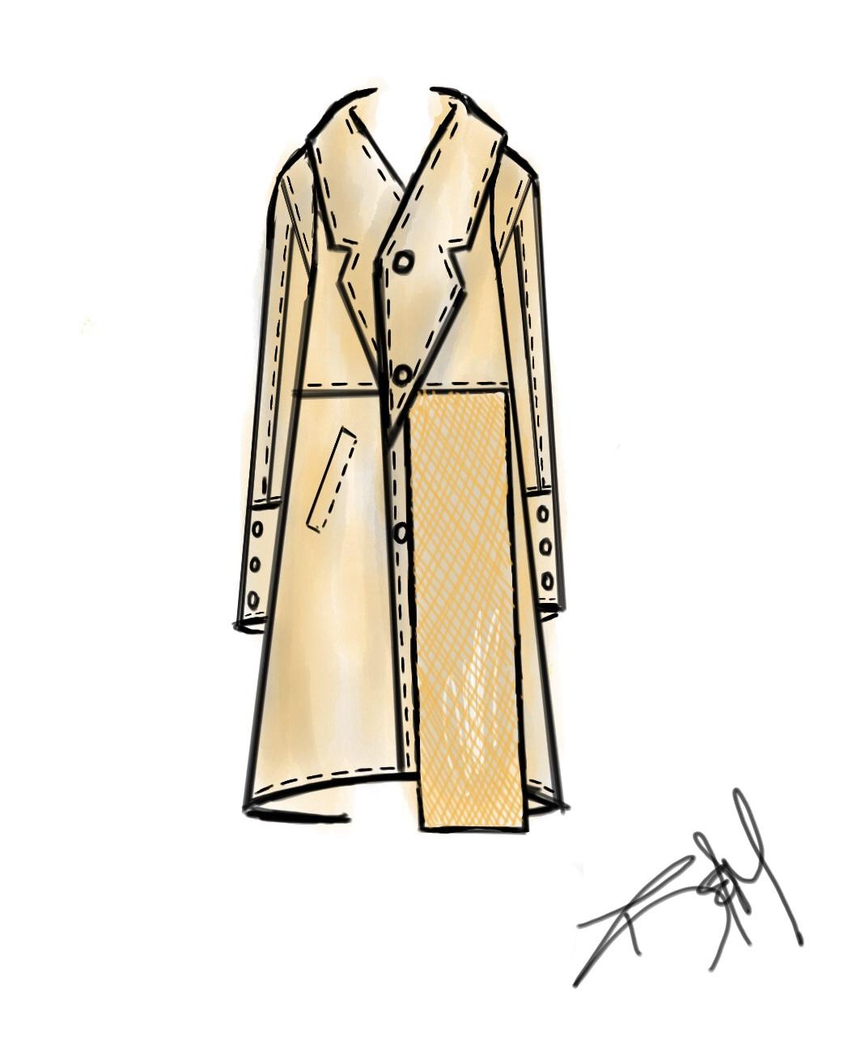
Deconstructed Trench Coat
This jacket is for our high end luxury lover who loves minimal style for an affordable price. It’s feature is its light weight and feel, being deconstructed it doesn’t carry a lining. This coat will be made out of a waterproof material such as Nylon. It has a larger collar and double breasted panels than the normal trench, and three buttons down the front as closures. Just like our crop bubble piece, this coat can be worn alone, as well as mixed and matched with the inner layers for extra warmth due to the zippers located inside the coat on both sides to zip in the inner shell. We at Haute & Hoot recommend the “Super Cozy” reversed as an inner shell for a great pairing as we call it“Roasting by the Fire”.
Pricing for the garment is as followed:
For material using 2 ⅔ yards of Silnylon at $15.86, 9 buttons at $8.46, ⅕ yard of solid fleece at $1.59, care labels, size tags and hang tags at $1.00, 1 zipper at $7.79, and an estimated cost of $20.00 for the labor of cutting and sewing, the total cost will be $30.38. Using the rule of markup the jacket will be priced at $70.76, at Haute & Hoot retailed for $75.
The Inner Shells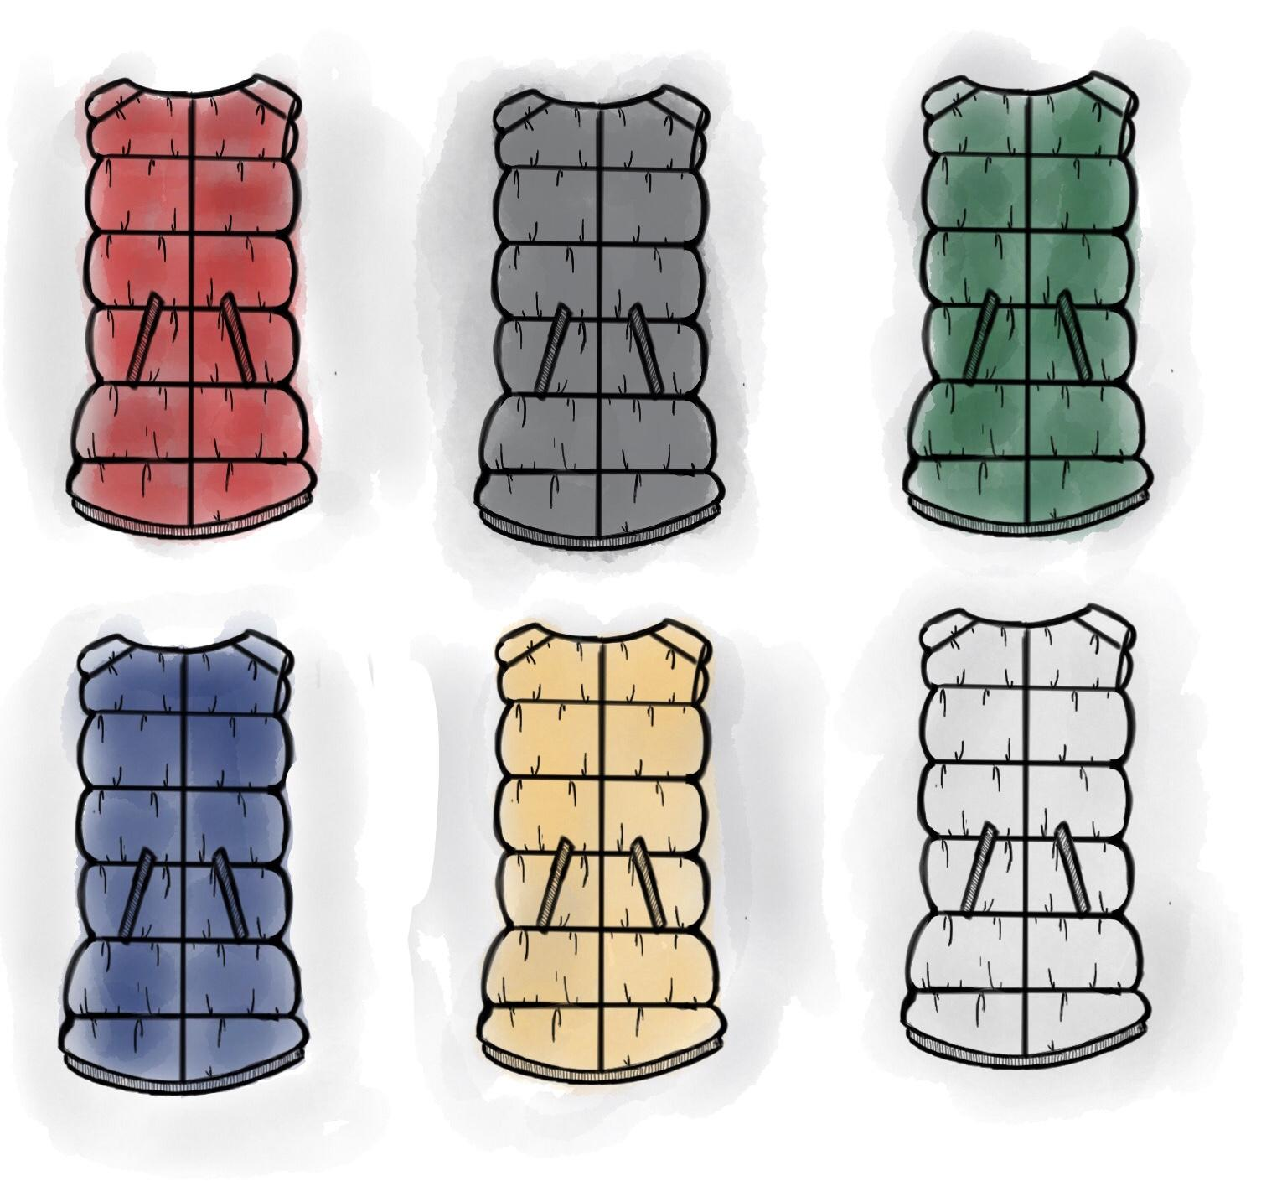

The inner shells created for our product line can be used solely by themselves, but the main feature they possess is the ease of layering their coat or jacket to be warmer. The ‘Cozy’ inner shell is our Faux Fur Jacket in its reversed stage. The ‘Toasty’ inner shell is made of a nylon outer shell and filled with Primaloft Gold 3 oz per sq. yard for a lighter feel. It features elasticated ribbed material and an open-end zipper. The elasticated ribbed material at the opening of the pocket and at the waist is to ensure the retention of heat, and the open-end zipper to allow for seamless transition into the jacket or coat of the consumer’s choice. The ‘Fuego’ inner shell is much like the Toasty, consisting of the same construction, but filled with Primaloft Gold 6 oz per sq. yard. It allows for a denser product allowing for more warmth.
Pricing for Toasty:
⅔ yard of Primaloft 3oz at $7.66, 1 ½ yard of Dusty Olive Nylon at $14.98, ⅕ yard of solid fleece at $1.59, ribbed knit at $6.94, care labels, size tags and hang tags at $1.00, 1 zipper at $7.79, and the addition of estimated cost for the labor of cutting and sewing at $20.00, the total cost will be $59.96. Using the rule of markup the jacket will be priced at $129.92, at Haute & Hoot retailed for $130.

Pricing for Fuego:
⅔ yard of Primaloft 6 oz at $13.16, 1 ½ yard of Dusty Olive Nylon at $14.98, ⅕ yard of solid fleece at $1.59, ribbed knit at $6.94, care labels, size tags and hang tags at $1.00, 1 zipper at $7.79, and the addition of estimated cost for the labor of cutting and sewing at $20.00, the total cost will be $68.46. Using the rule of markup the jacket will be priced at $146.92, at Haute & Hoot retailed for $150.

About the Fabric
Polyester
Polyester is a widely used material in common sportswear and casual wear, from t-shirts, tights, swimwear, jackets, trousers and so on.
So why is polyester used in clothes? It is a man-made synthetic fiber, allowing the surface to be smooth and non-porous. In addition, it is a fabric that is not easily ruptured, wrinkled, or shrinked. Compared to natural fibers such as cotton and hemp, traditional polyester fibers are hard and non-absorbent (water absorption is about 0.4%). However, today, with advanced textile technology, mixing polyester with other materials will greatly improve the comfort and feel of the fiber material.
Primaloft
Primaloft is a super soft water repellent microfiber, which is a good alternative to down fiber. It is light weight, with the same soft and warm feather fiber feel. The fibers are manufactured by Albany International Crop., a company that produces Primaloft products in 35 factories of 14 countries around the world. The product was developed because the U.S. military needed a replacement for down fibers that will dry quickly after being damp and in staying warm when it was wet. To this end, the inventor started to study the physical and thermal properties of down fibers and finally developed a product that can be replaced by down fibers, composed of millions of microfibers, which can be polymerized together like feather fibers.
Primaloft is ideally suited for use in wet and snowy weather conditions and is therefore widely used in high quality ski gloves, sleeping bags and apparel paddings used by some top apparel brands as garments. It not only improves the feeling of wearing gloves, but also improves the comfort and insulation of the gloves, but also gives the gloves flexibility.
Nylon
Nylon is a natural synthetic fiber, it is very suitable for interweaving with other fibers, with the durability of the composite fiber. The level of use is also very wide, from wetsuits, slimming clothes, surfing clothes, fishing pants, cold clothing, backpacks, bags, beverage cans, and even building materials and so on. The advantages of nylon is it’s tough nature, being wear-resistant, smooth, lightweight, insect-resistant, anti-mildew and it’s resistance to produce static electricity, deformation, pilling ball and so on. But the disadvantage is it being less heat-resistant, so customers will have to be careful of the ironing temperature. To identify the quality of nylon, nylon to see the number of "Denier" is the most direct way. "Denier" is a way of calculating nylon. Different from the "count" of other textile fabrics (knowing the density of cotton bedding), the Denier number does not equal the count density. For example, the weight of 70 grams of nylon, as seventy Denier, take the original wire finer, weaving the thinner the nylon fabric. Therefore, the number of low-denier nylon fabric is thinner and softer, while the denier nylon fabric is thicker and harder, the common nylon fabric on the market can be divided into 70 denier, 210 denier, 420 denier, 840 denier and so on. Taiwan's textile industry has developed ten denier ultra-thin breathable nylon fabric.
Most people who wear clothing consisting of nylon felt that it is not ventilated, airtight, uncomfortable. But after the transformation of modern textile technology, the advantages of good nylon, comfort can be greatly enhanced. Especially, if nylon is drawn into thin filaments and woven into very thin clothes, there are many voids in the middle so that air can easily be circulated so that it is cool to wear and can be used as summer clothing.
Nylon is not heat-resistant, as long as near the flame or heat source, it will quickly curl into a white gel, and blisters. So when cleaning nylon clothes, remember to avoid using high temperature washing, drying or ironing.
Faux Fur
Faux fur looks just like animal fur, it is divided into two layers, the outer layer is bright and rough bristles, the inner layer is a soft velvet. Faux fur is commonly used in coat, clothing lining, hats, collars, toys, mattresses, interior decoration and carpets.
Manufacturing methods are knitting and weaving, weft knitting method the fastest growing, the most widely used. In knitting, the carding mechanism disperses the tops into single fibers. After the needles grasp the fibers, the knitting needles are knitted into the bottom yarn and knitted into a loop. Since the velvet is "V" shaped in the loops, the knitted bottom cloth is shaped so as not to lose the fur.
Faux fur is an artificial fur which is made with Acrylic, modified acrylic, vinyl chloride, etc. can be used as artificial fur raw materials to nitrile chloride more appropriate. Nowadays, a new generation of faux fur surface uses wool and polyester fiber, viscose and other blended, ordinary combustion method is difficult to distinguish between man-made or natural, because after burning it will not produce sintering phenomena.

Quality Control & Merchandising

. For the quality control portion of Haute & Hoot, there would be tools to help measure the quality and the garment standard using defect guides to ensure the quality of the garment is what was asked for. Closed specifications would be used in the process, it may cost more, but it would make sure that the right materials are used efficiently, and that the requirements are met. Along with the raw materials and product specifications, labeling standards must also be established. On each garment label, the fiber content, manufacturer, and the country of origin will be listed. Any material greater than 5% will have to be listed under the content’s name, anything under 5% may be labelled as “other”.
In the process of merchandising the coats, depending on the location, different sizes, colors, and assortments of styles will be considered for placement. The goal would be to offer the right styles in the right colors and sizes in the right amount of quantities to the right target market. In order to offer the products to a wider audience, we would hopefully expand to online retailing giving access to different consumers with varying demographics. We would also hope to have our products being offered to department stores, and retailers such as Urban Outfitters to further increase exposure of the brand. Social media is increasingly being the channel where customers can find new and unique brands with styles that are not offered in fast fashion. With the help of social media, it would be a cost-effective way of advertising and offering perks such as special promo codes, or flash sales to those loyal to our brand.

References
A Guide to Insulated Jackets. (2017). December 08, 2017, Retrieved from https://www.backcountry.com/explore/insulation
Canada Goose. (2017). Canada coat. Canada Goose. Retrieved from https://www.canadagoose. com/us/en/canada-coat-1957L.html?cgid=shop-womens-outerwear#start=1&cgid=shop-womens-outerwear
Canada Goose. (2017). Fur and down policy. Canada Goose. Retrieved from https://www.canadagoose.com/us/en/fur-and-down-policy/fur-and-down-policy.html
Deconstructed Jackets for Men ::: Alpha Male Style. (2015). Retrieved December 08, 2017, from http://www.alphamalestyle.com/blog/deconstructed-jackets-for-me
Hakuir. (2015, April 13). Shannon Faux Fur Mongolian Red. Retrieved December 08, 2017, from https://www.fabric.com/buy/0260786/shannon-faux-fur-mongolian-red
Moncler. (2017). Merging of fashion and high performance. Moncler. Retrieved from http://www.monclergroup.com/en/brand#merging-fashion-and-high-performance
Moncler. (2017). Selection of the best materials. Moncler. Retrieved from http://www.monclergroup.com/en/brand#selection-of-the-best-materials
Newbold, A. (2017, July 18). Autumn/Winter 2017 Trend Guide: Red. Retrieved December 08, 2017, from http://www.vogue.co.uk/gallery/vogues-guide-to-the-key-colour-of-autumnwinter-2017-red
Roberts, A. (2017, January 27). Confused about cruelty: The Canada Goose story. HuffPost. Retrieved from https://www.huffingtonpost.com/adam-m-roberts/confused -about-cruelty-th_b_14421002.html
Wikipedia. (2017) PrimaLoft. Wikipedia. Retrieved from https://en.wikipedia.org/wiki/PrimaLoft
PrimaLoft. (2017) PrimaLoft fabric. PrimaLoft. http://www.primaloft.com/performance-fabrics
Encyclopedia Britannica (2014). Polyester. Encyclopedia Britannica. Retrieved from
https://www.britannica.com/science/polyester
Encyclopedia Britannica (2014). Nylon. Encyclopedia Britannica. Retrieved from
https://www.britannica.com/science/nylon
How Products are Made (2017). Fake fur. How Products are made. Retrieved from
http://www.madehow.com/Volume-3/Fake-Fur.html

