Elements of Art and Design:
Saks 5th Ave. Chanel Visual Display v. Summer Night by Albert Bloch
Ruth Jordan

BUF 2203 Visual Merchandising
Professor Kat Roberts
New York City College of Technology (CUNY)
Abstract
Given the task of selecting a visual display and comparing it to a artwork from the Metropolitan Museum of Art, Saks 5th Avenue’s Chanel visual display was chosen to be compared to the oil canvas painting Summer Nights by Albert Bloch chosen at the MET. Dissecting the definition of design elements and the principles of design one will apply the usage of each term to the respective visual display or art work to gain greater understanding of the relationships between the chosen images.
- Discuss the color of window visual
The window display chosen was Saks Fifth Avenue’s April Chanel window. This window explores pastel and neutral colors, with the addition of red what belongs to the brights color group. The pastel colors in the display used are tints according to Bell & Ternus (2017), “the lightening of a color by adding white”(p. 47) to, red, and blue-green and yellow-green. All colors listed have been tinted to create the color on the floor, walls and one of the garments. The use of red in the accessories in its primary form, acts as a vivid pop of color to the window, and is in the same color family as the pastel pink used in one of the garments and accessories. The neutral colors being used in the window display are beige and black. The beige found in the garments are tinted in order to create the color off-white in other garments in the window. The value stated by Bell & Ternus (2017) being the “apparent lightness or darkness in a color”(p. 47), the use of various shades of black your able to see the range of intensity in garments. These neutrals blend with the pastels and bright color used creating a visually pleasing window.
The art work chosen while visiting the Metropolitan Museum of Art was Summer Night by Albert Bloch. The colors expressed in this art works is a combination off the muted/dusty, earth tones, and neutrals color groupings. Being that muted/dusty tone colors are actually mid tone colors that have the addition of grey added to them (Bell & Ternus, 2017), these pinks, greens, blues and purples seen are classified as shades. In the artwork Summer Night, earth tones like rusty red, brown, and deep forest green are present, and create a different level of intensity compared to the muted/ dusty tones present in their respective color families. In addition neutral colors like tan and grey are used to highlight certain areas in the artwork.

B. Discuss texture or the appearance of texture and juxtaposition.
“Texture is known as how a surface actually feels to the touch or how it may appear that it might feel if touched” (Bell & Ternus, 2017). In the window display the floors mimic a 3D topography map and has various levels that house the soft forms that display the garments (Jordan, 2018). Every level looks slick and smooth to the touch very modern. Meanwhile the garments displayed on the soft forms seem rough & rigid because of the classic woven Chanel tweed, as well as the additive fringe design, but the construction of the garments have such delicate silhouettes it brings a softness to the the window. The juxtaposition in the window display would be the modern, sleek 3D topography floor created as a platform for these rough and rigid seeming textiles used in the garments displayed.
In the artwork Summer Night, Albert Bloch creates the appearance of a lush forest with variations in objects like trees, plants and shrubbery used, as well as the different hues of colors using muted/dusty colors in unison with earth tones. There is also the use of the color white for the rolling clouds that pass through the image, these clouds create levels to the image as if the figures in the image are on different parts of a mountain (Bloch, 1913). The juxtaposition in the artwork would be the minimized mountain placed in the far right upper corner looking awfully rigid, compared to the enlargement of the mountain in the rest of the image used to show the lushness and variations of what the mountain possesses.

C. Line formations.
The window display makers at Saks were conscious of line formations in the construction of the Chanel window on 5th Avenue. Rhythm within the display, “is achieved by repetition of design elements that can create a unique sense of visual cadence or emphasis for the viewer. The eye travels along the paths of repeated items and the merchandising message is reinforced.” (Bell & Ternus, 2017, p. 69). Display makers designed the topography floor of this display with repetitive curved horizontal lines which elevated vertically in the direction of the soft forms used to display the merchandise. This allows for a created direction for the viewer, they will look upwards from the line of sight towards to displayed garments above. A visual pattern of repetition is created, not only with the layers of topography and the gradient from pastel blue-green and yellow-green from the floor up, but also with the positioning of the soft forms. The soft forms are placed in a balanced visual pattern of alternating upstage/downstage, giving each their own moment of clear vision to the viewer allowing for a unified display. Within the unification of the display, point of contrast are introduced with the use of the intensity of the color red. The use of the red fanny pack accessory on the first soft form that contrasts with the beige and black garment it’s paired with, create a line that draws your eye to the right to fourth soft form that has another contrasting moment with another styled red accessory bag against the beige soft form that is draped with a black a beige scarf. Proportion can be found in the relationship between the soft forms displaying accessories against the larger garments they are paired with, as well as the scale of the length of the outfits created on each soft form and their alternating relationships to the neighboring soft form. The alternating use of proportion in the scale of the garments, also create a curved line mimicking that of the display they’re housed on. The garments in this display are a combination of vertical, horizontal, diagonal, and curved lines creating a rhythm within themselves. The vertical lines project dignity and strength much like the ideal Chanel woman, horizontal lines reminiscent of land and seascapes tie back to the modern topography floor, diagonal lines are those of action used in the contrasting red accessories, and curved lines giving gracefulness and a feminine touch to what visual seem so be a rough and rigid garments (Bell & Ternus, 2017). The dominating element of the composition is repetition, creating multiple pathways of direction for the viewer to take in the entire display.

D. How art influences life and vice versa.
Its a give and take between life acting as an influence for art and vice versa. In order to create art, the artist has to draw from a physical visual image they have experience, and/or a created perception in the mind. Artist Albert Bloch used the image of a physical mountain which he painted in the background of the image, as well as his personal perception of the make up of the mountain in the mid and foreground of the image. Being that Bloch joined a Munich based art group that sought after a spiritual art prior to making this painting, with a metaphysical aspiration being the goal, the image’s intent was to transcend the laws of nature (Bloch, 1913).
The the mid and foreground was purely made of Bloch’s perception that he had to draw from his life experiences and thoughts of spirituality. Mean while the ability to relate this same painting to a window display found while walking on 5th Avenue is a way that art influences real life. The composition of the window is used to draw the consumer in and purchase the product they saw in the display, and encourage additional purchasing as well.

E. How this assignment assisted with my understanding of of both color and texture, as well as a deeper sense of art and visual display.
This assignment assisted with my understanding of of both color and texture by dissecting each element and their respective definitions. By applying these definitions to a real life display it allows one to see how closely related the creation of a display, is to the process of creating art. The selection of color is most important, and mood you want to convey to the viewer is furthered through texture. Overall every single detail and placement is thought through and intentional.

F. Compare the art to the visual display
Both the visual display and painting have similar color stories using white reds blues and greens in different tints and shades. The Saks Chanel window’s floor mimics a 3D topography map and has various levels and sizes as it elevates, which relates to the rolling hills connecting to the mountain created by Bloch in Summer Night. While in the visual display a simplistic gradient of two colors is used to relate the topography, shades of reds, blues, greens and browns with the addition of white are used to create the levels of topography as well as the additional texture of the mountain. Though the figures on the mountain are spirits, they seem to be females with their own identity, communicating though their gestures due to the poses that Bloch gave them (Bloch, 1913). Much like these figures on the mountain, the soft forms in the display all have their own unique identity. All wearing Chanel, they are able to communicate their different identities through being minimal, conservative, fresh, fun, and daring. The notable difference between the two are that the painting uses more earth tones opposed to the the pastels and use of black in the visual display.

G. What did you learn from this assignment and course.
Through this assignment I’ve learned to be more confident in my decision making. Deciding between which window and artwork was a very daunting task, because there were so many options to choose from I felt overwhelmed to make the right choice, but in the end result I feel I made the right choice as I began to describe the images.
From this course I’ve learned the importance of color choice. Through the assignment of creating colors from scratch, the addition of too much of one color when mixing can throw off the entire vision you have. Being vigilant of everything your doing is very important to the overall aesthetic of the end result, and merchants have to be aware of that while working.

H. Define all Element of design terms and apply an example to each.
“Color is the first and most critical of the design elements. Its based upon primary colors, secondary colors, tertiary colors, shade, tint, value, hue and intensity”.
Ex. Muted/dusty tone colors are actually mid tone colors that have the addition of the color grey added to them to make them into shades (Bell & Ternus, 2017).
“Texture is how a surface actually feels to the touch or how it appears that it might feel if touched ‘(Bell & Ternus, 2017).
Ex. The earth tone forest green used in the Summer Night painting with the addition of the artist’s brush strokes creates a texture of lush greenery.
“Proportion is the relationship between the apparent size, mass, scale, or optical weigh of two or more objects” (Bell & Ternus, 2017).
Ex. Proportion can be found in the relationship between the soft forms displaying accessories against the larger garments they are paired with in the visual display.
“Direction in retail, refers to the design element or tool that leads the shopper’s eye form one place to another. A directional arrow that points to a particular destination and leads the shopper from one spot to another (Bell & Ternus, 2017).
Ex. The use of the topography starting at the sight line of the viewer and becoming gradually smaller as it moves vertically upward forces the direction of the viewer to look upward.
“Line guides the eye to a feature, or is a linear element that sets a mood. Long horizontal lines can suggest calm and stability” (Bell & Ternus, 2017).
Ex. Curved lines giving gracefulness and a feminine touch to what visual seem so be a rough and rigid garments (Bell & Ternus, 2017)
“Shape is a standard or universally recognized spatial form like a circle or a triangle that helps the viewer identify various objects” (Bell & Ternus, 2017).
Ex. When you step back and view the formation of the soft forms and their floor they almost mimic a triangular shape.
“Size all about proportion, ratio, mass, or scale” (Bell & Ternus, 2017).
Ex. Though the cross bag on the 4th soft form is small in person, its size ratio to the soft form make its look larger for visual effect.
“Sequence is the particular order in which items are presented for viewing. In addition to numerical order, presentation may rely on gradation of items from small to large, or large to small, to emphasize that particular item is available in a variety of sizes “(Bell & Ternus, 2017).
Ex. The sequence of soft forms are placed in a balanced visual pattern of alternating upstage/downstage, giving each their own moment of clear vision.
“Tension is an arrangement of elements that causes the viewer to wonder if opposing forces will disturb balance or equilibrium in a display” (Bell & Ternus, 2017).
Ex. Tension is created by placing each soft form in very opposing outfits though the are all wearing Chanel.

Work Cited

Bell, J., & Ternus, K. (2017). Silent Selling (5th ed.). Fairchild Books & Visuals.
Bloch, A. (1913). Summer Night. The Metropolitan Museum of Art, New York.
The MET. Retrieved April 19, 2018, from https://www.metmuseum.org/art/collection/ search/648354
Jordan, R(2018). Saks 5th Ave. Chanel Visual Display [Photo taken of Saks 5th Avenue store Chanel window in April 2018] . Saks 5th Avenue, New York, NY
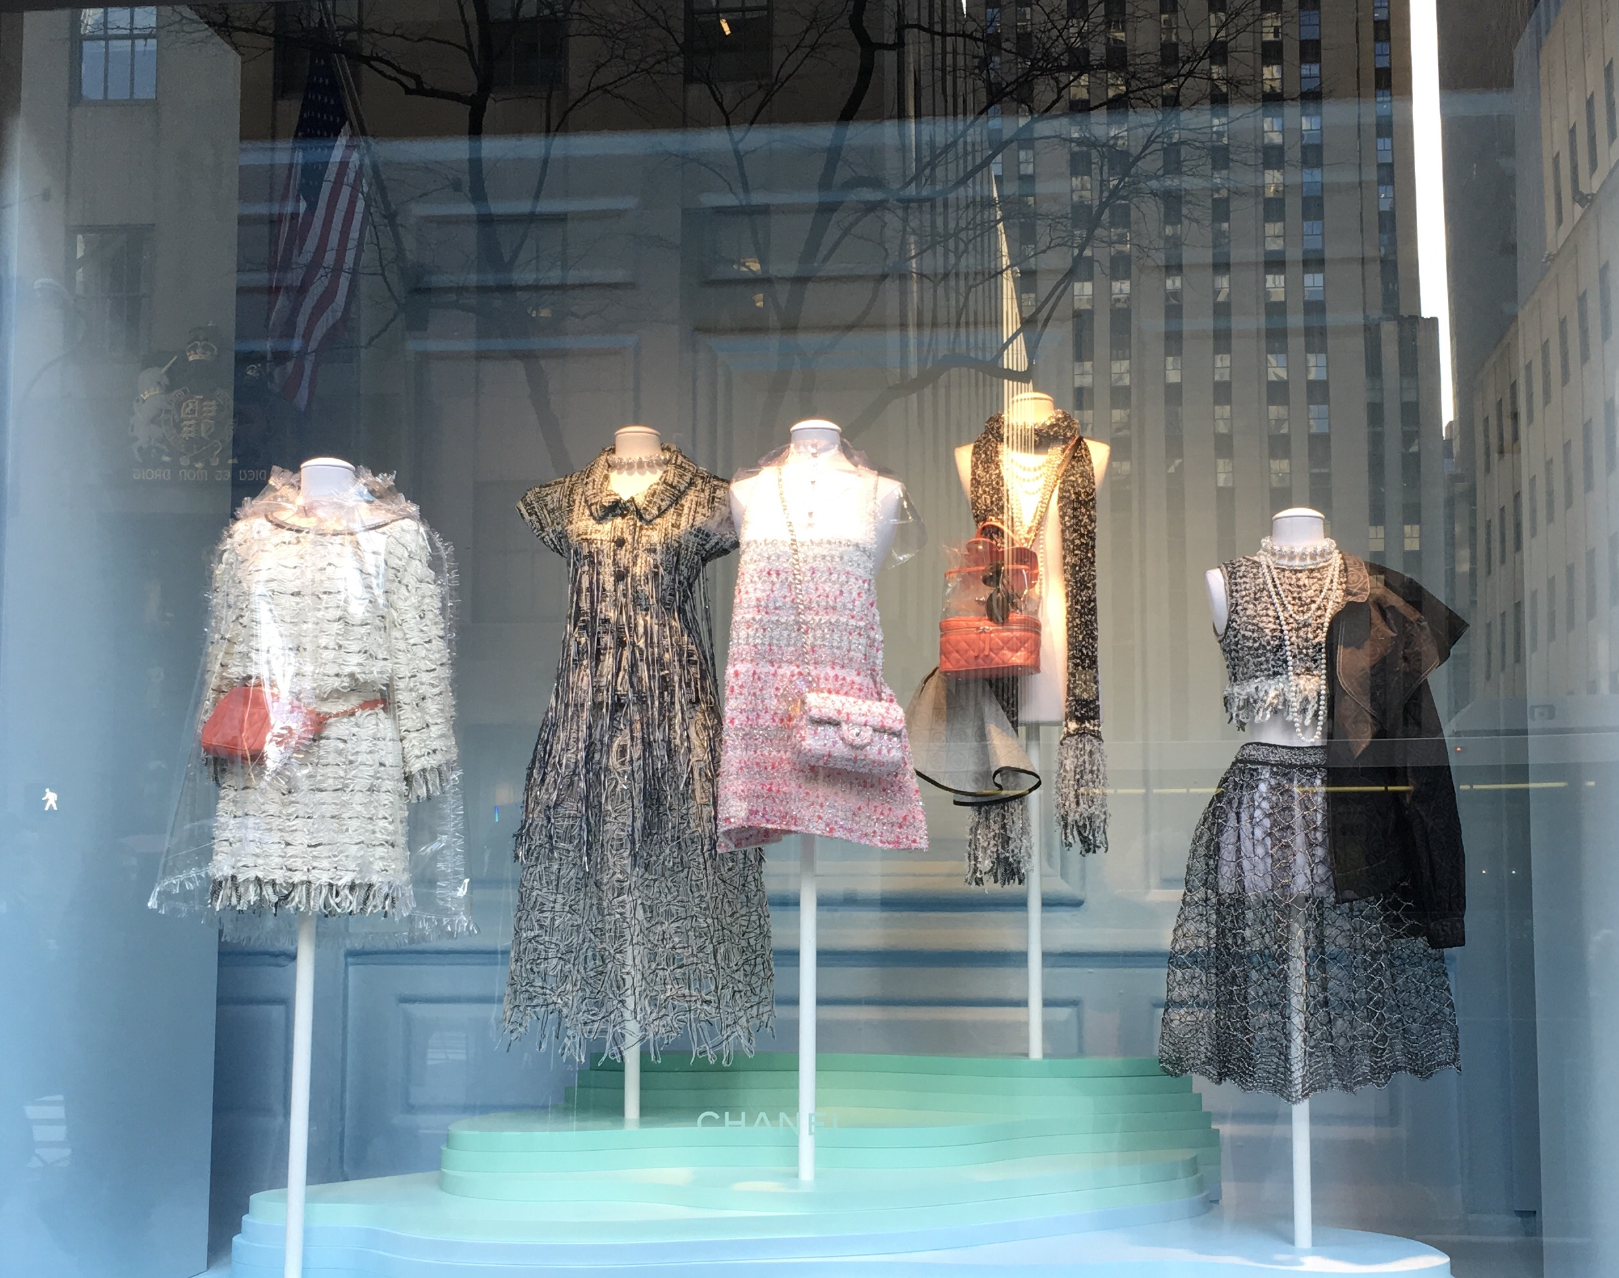
Jordan, R(2018). Saks 5th Ave. Chanel Visual Display [Photo taken of Saks 5th Avenue store Chanel window in April 2018] . Saks 5th Avenue, New York, NY
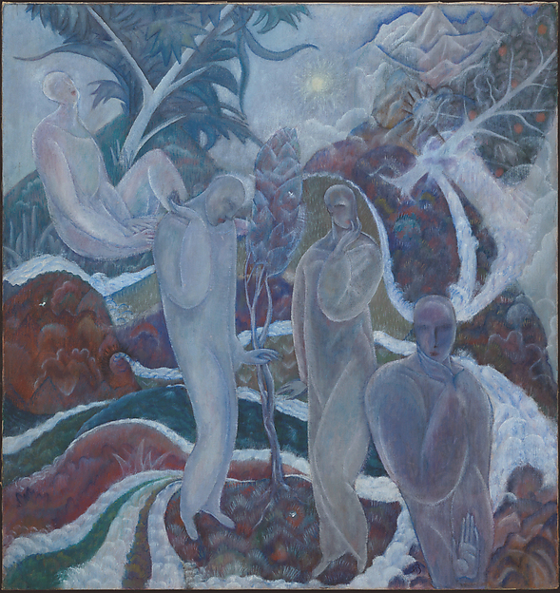
Bloch, A. (1913). Summer Night. The Metropolitan Museum of Art, New York.

