Installing through terminal
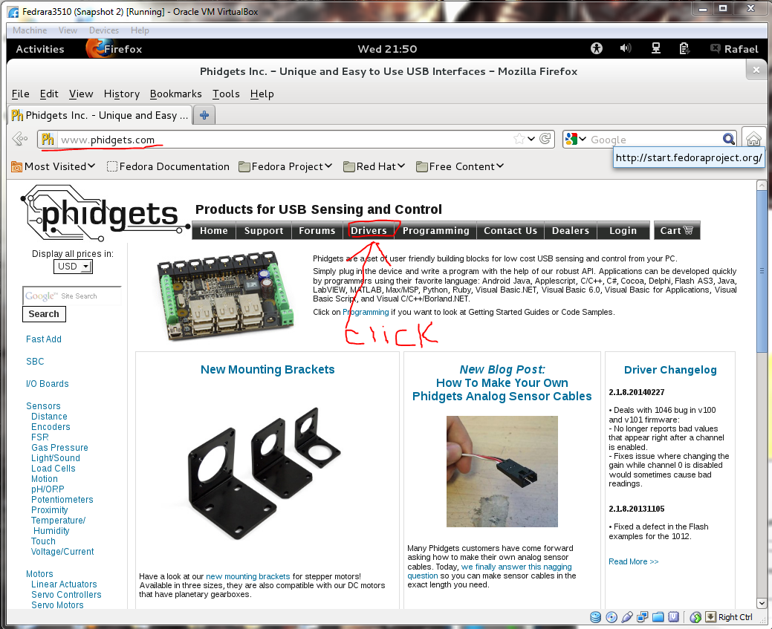
Just go to www.phidgets.com and click the drivers section
Now scroll down and click the linux link
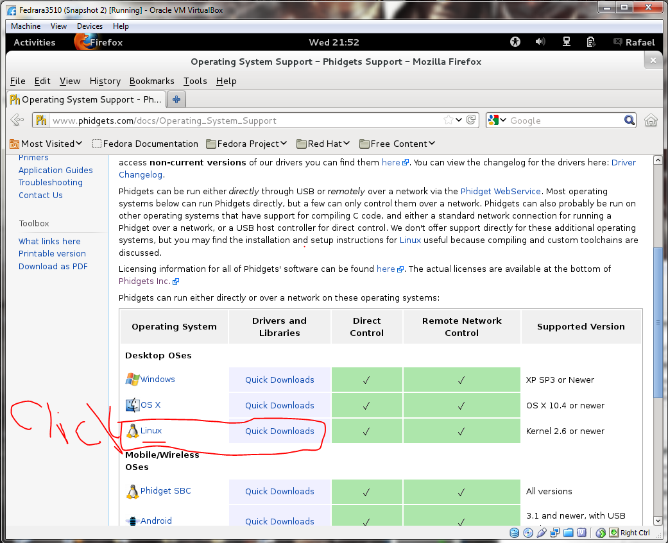
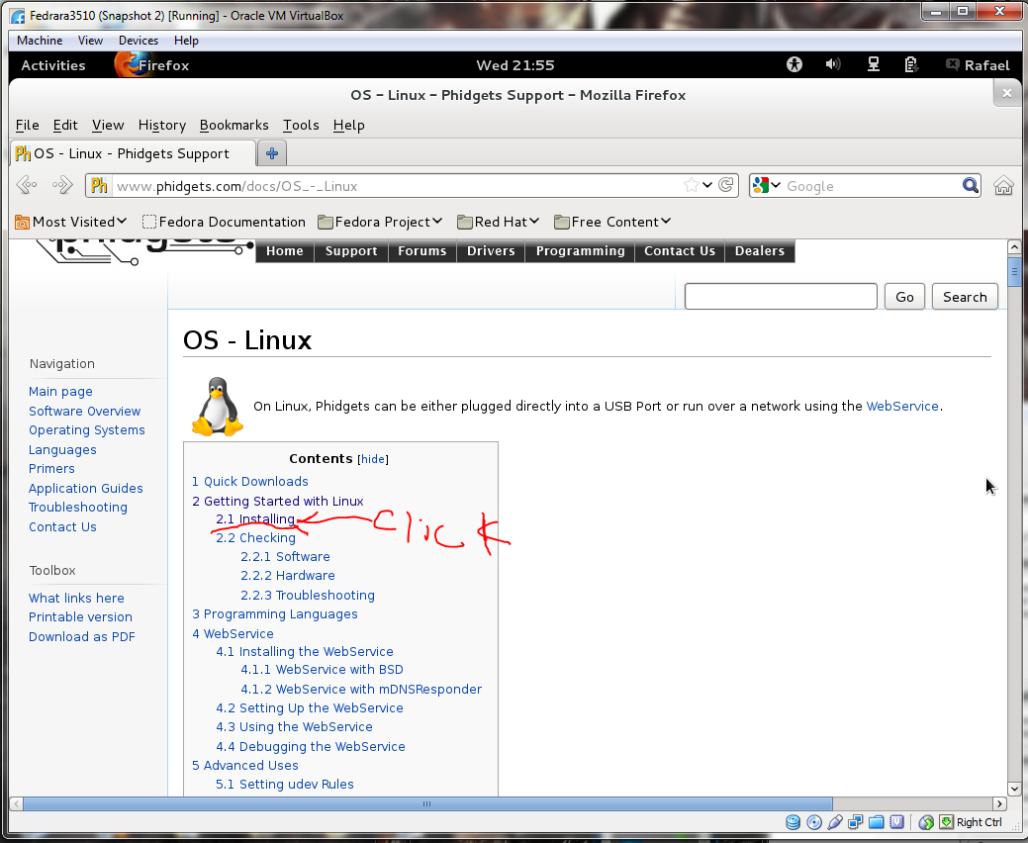
After which click the installing
After this is click you have to click on two more links

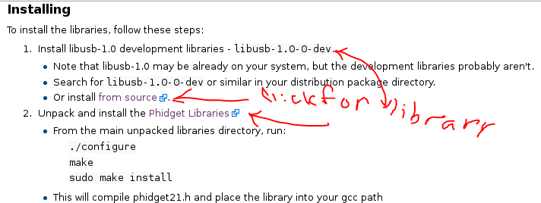
Just download both of the libraries

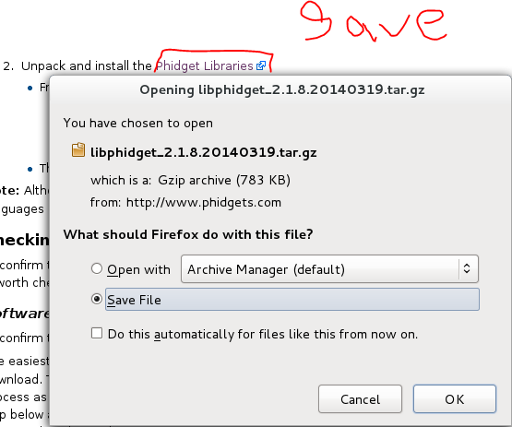
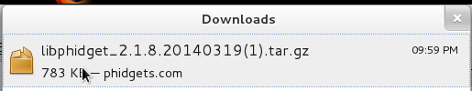
For the libusb will send you to this after clicking one
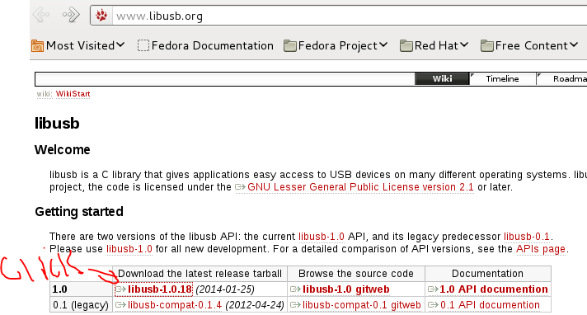
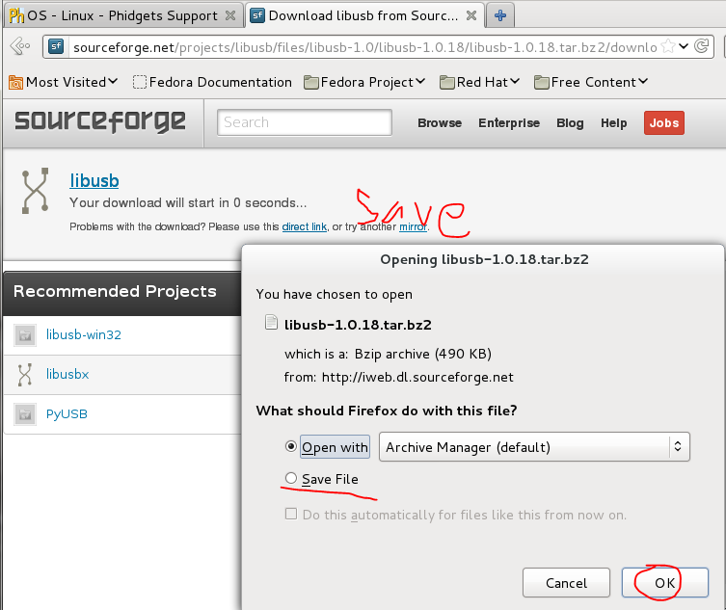

Now OPEN a terminal on the linux OS by holding and pressing Ctrl+Alt+T
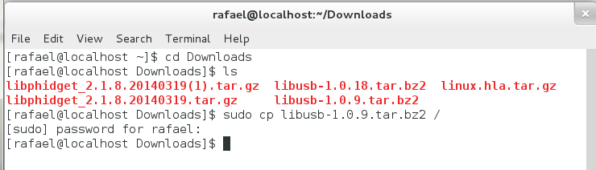
Type in the above

Now you must type in the bottem part aswell.
The only difference could be if you have a 64 bit system you will copy the libraries to lib64 instead of lib
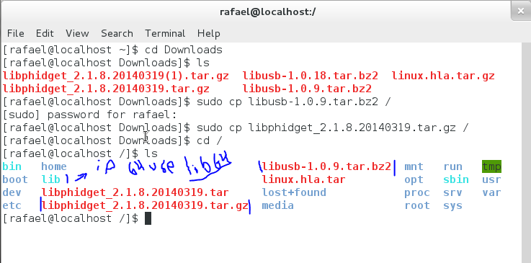
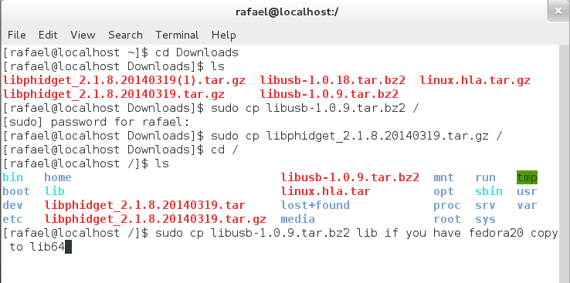
So just follow what I typed bellow.

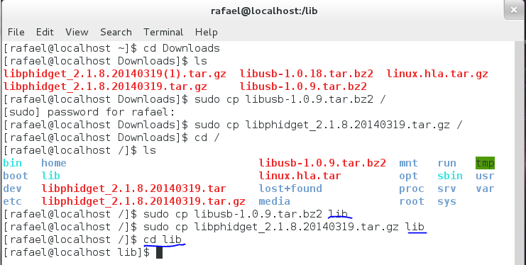
Type the following to unpack the library
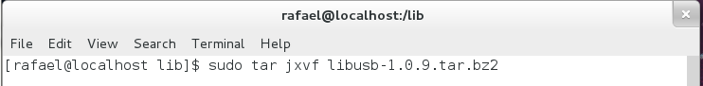
Now type the following to unpack the other library
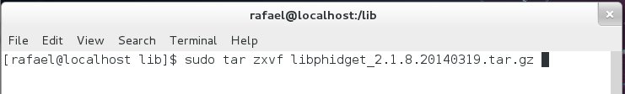
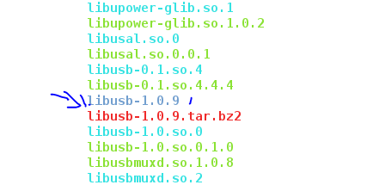
If you type ls and scroll up and around you should have the following unpacked
You don’t need to look for it if you followed the steps above its just to double check the lib unpacked
h

ok now you type the following
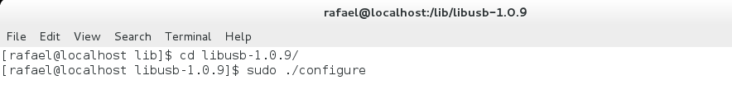
Make sure you type sudo before typing “./configure” “make” and “make install”
After the sudo ./configure runs type “sudo make” if it ask for a password just enter your regular log in password
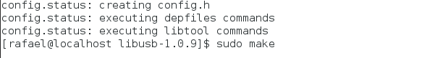
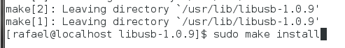
Finally now after you typed the three commands type the following
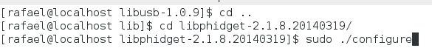
And now just follow the same three commands after ./configure runs do “sudo make”
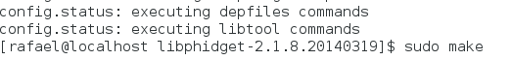
Now “sudo make install”
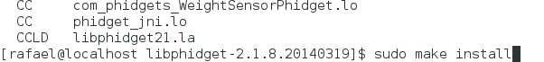
And you are done!!! CONGRATS XD
Now all you need to do to run an example is download the example codes and unpack them then compile using
gcc filename.c -o filename -lphidget21
and to run you must always put sudo in ex) sudo ./RFID-simple to run it sudo is needed because you have to acces the usb interface.

