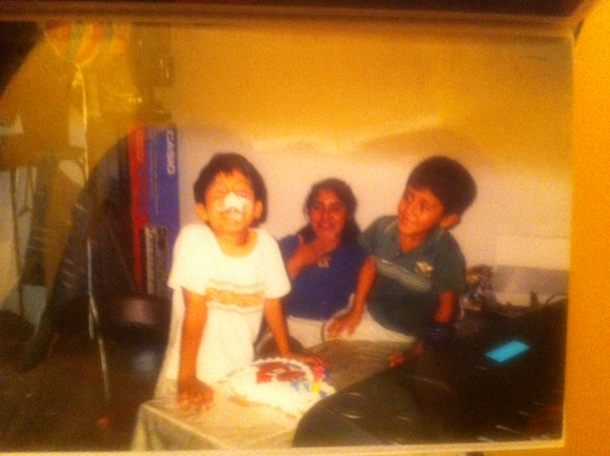
This is a picture taken by my mother of my sister, my brother and me on my 7th birthday, September 9, 2001. It was my first time celebrating my birthday in New York and without my father. (This was my first ice-cream cake with an Elmo design) we had recently moved to New York from Mexico. Before I used to live in Mexico for two years I used to live in Houston Texas (where I was born and my brother). We all moved back to Mexico, but within a year later my dad decided to come back to get a better job to give us better life. He took the risk to come back again. 6 months later my mother decided to come back as well to give my sister, my brother and me a better education and a life style than Mexico would have afford us. So my mother and my sister took the risk again to come back but all the way to New York this time where her brothers are at. All I remember was that my bro and I arrived to New York with my uncle and stood at his place. It took almost 2 weeks from them to arrive. Know that my birthday was coming up all I wanted for them to get here as fastest they could of. They arrived a week before my birthday (made me happy) and my mother started to work a double shift. We were already in school it was my second day of class and it was my birthday I had no buddies because I was new to the school and the neighborhood. All I remember was my mother and my sister picking me up from school (it was random since my mother was working a double shit where she didn’t get paid well) then we picked up my little brother and went home. When I got home I ran upstairs rushing to the bathroom and all the lights were off. All I saw was my uncle holding the cake with a bright 7 candle on it. I forgot all about the bathroom and everyone sang the happy birthday in Spanish. My brother and I did not know that the cake was an ice-cream cake so he shoved my face into the cake (shoving people into the cake is like a tradition). This was the best birthday I have ever had. And the best memory (of that two scary weeks from not knowing when your mother and sister are coming and going to a school, a jungle of kids).

