Naiomi Ramos
Project 2 Part 2
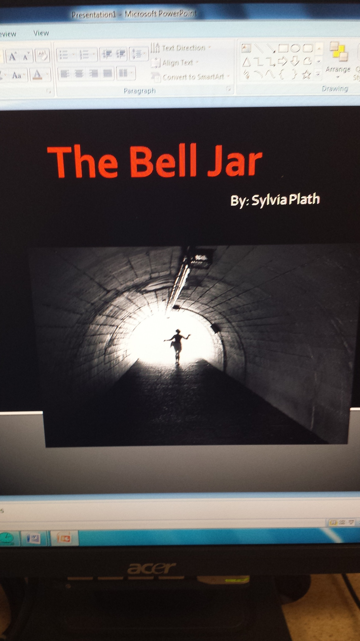
This over shows a women in a long dark tunnel walking towards a light at the end of it . I feel like this cover represents Esther very well because throughout the story we are aware that she feels like she is a dark place. A place that she doesn’t find the light she needs to escape from it. A scene that this cover represents is when she wakes up in the hospital after her suicide attempt. Esther states “A cool wind rushed by. I was being transported at enormous speed down a tunnel into earth” Esther is in complete darkness, and she feels as if she is being transported at enormous speed down a tunnel into the earth as it states. Esther is unconscious due to the sleeping pills that she took. She feels as if she is in an underground chamber, lit by blinding lights, and that people are holding her down. She cries out that she can't see, and hears a voice say that she'll marry a nice blind man someday. This scene after she tries to commit suicide after taking her mother sleeping pills. At this moment was a turning point for Esther after she regain her consciousness she capable of showing her emotions towards people. This is when she finally shows the hatred against her mother. The women walking towards the tunnel is the representation of the freedom Esther felt after she finish shock therapy she know feels like the bell jar as lifted off.

