Naiomi Ramos
Project #2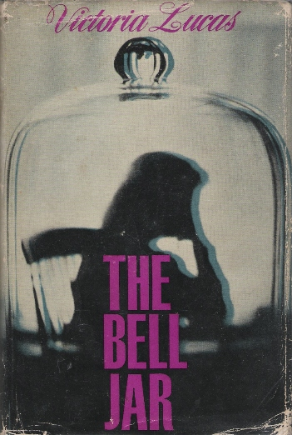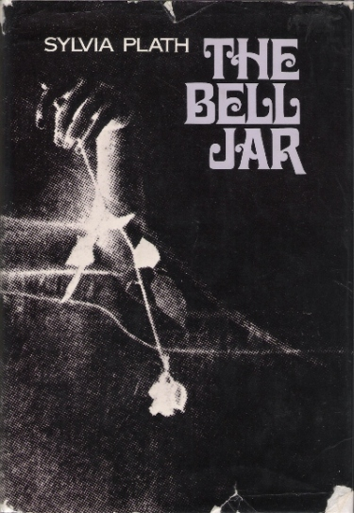
Sylvia Plath the author of “The Bell Jar”; a story about a young woman named Esther who throughout the story has difficulty finding her own identity. Esther gets overwhelmed when she realizes everything that she has and still feels unhappy. This causes her to question her future and what she really wants. The result of this causes Esther to plunge into depression. Feeling under pressure she goes through a mental illness that makes her want to take her life away in multiple unsuccessful occasions. Not being able to handle her daily life and pressure she enters a mental facility. This novel has had many different illustrations for the cover since it was first published trying to represent the theme of The Bell Jar which is lack of self-identity and depression. Two covers that show this is the first edition of The Bell Jar which was published in London in 1963 by a company called Heinemann and the First Harper and Row ( American) Edition.
The first cover created by Victoria Lucas in 1963, is a dark shadow of a women not showing any facial details. The woman is sitting down on a chair resting her head on her arms, which it’s on top of a table. The woman has a contemplative posture as if she is thinking deeply about something. The whole image is inside of a glass bell jar with a nob on top. The bell jar has an effect that clearly shows that the women inside is completely trapped in it. A bell jar is a bell shaped usually glass vessel designed to cover objects or to contain gasses or a vacuum (Merriam-webster).
. This cover over all represents Esther’s depression in the story. The dark shadow of the woman is a representation Esther’s dark period in her life where she believed that taking her life away was the only solution. She has attempt in committing suicide by different forms but the one that this cover depicts is when she decides to take her mother’s sleeping pills. “Then I went downstairs and into the kitchen. I turned on the tap and poured myself a tall glass of water. Then I took the glass of water and the bottle of pills and went down into the cellar. A dim, undersea light filtered through the slits of the cellar window, behind the oil burner, a dark gap” (page 89) This scene represents the cover well because we also see a light behind the jar. Esther is in a dark room thinking about whether or not she should take the sleeping pill.
The shadow represent when she states “most beautiful thing in the world must be shadow” (chapter 12). This is the moment when Esther becomes more than ready to try to commit suicide she has had enough of the thought that been hunting her this whole time that she wants to end her life.
The lack of facial details could represent Esther’s lack of self-identity. At the beginning of the story we see that Esther wishes to be more like her friends, such as Doreen, Jay Cee and Besty. Doreen is the side of Esther that to wishes to be more open and risk taken her rebellion side. Jay Cee is the side of Esther that wishes confidence and the eager for success and Besty is which Esther relates the most is the side of goodness and purity. Esther is having a hard time since the beginning of the novel to accept who she really is and this is why she tries to find herself through others personality instead of learning to create her own.
The bell jar we see over the shadow represents the part of Esther that feels trapped within her own thoughts. Throughout the story we see that she feels as if she’s suffocating and needs a way out The “bell jar” is a symbolic object we see throughout the novel. By the end of the novel Esther finally feels that the jar has been lifted and is able to see the world with a new perspective, but somehow doubts how long this new view of life will last. Esther questions herself by saying “How did I know that someday—at college, in Europe, somewhere, anywhere—the bell jar with its stifling distortions wouldn’t descend again?”(Page 123) This quote clearly demonstrates Esther’s fear that she will suffer from this illness again. At this point the bell jar had been lifted and Esther could now function what normally. Esther’s knows that she has gotten better but has a doubt in her mind that she isn’t completing cure. Also if she will be able to handle what life has in store for her if she is released. This goes back to the Esther always questioning everything about her life.
The second cover created by The First and Row (American) editions shows a very delicate hand posture holding a lifeless flower. The hand looks like its lacking some type of energy but it’s still sitting up straight. The hand that is shown in the cover has a white reflecting light a little above the wrist it could be considered to be a cut. There is a shining light in the one side of the cover compare to the other. The cover itself is black and white and has a design in the edges that makes it look like it’s an old picture.
The cover also represents different events that occurred in Esther’s life throughout the novel. Esther’s mother decided to take her to the hospital she tries to commit suicide numerous of times. One of the events that come to mind was when Esther was receiving her shock treatments were she use to feel weak afterwards. Esther states, “But each time I would get the cord so tight I could feel a rushing in my ears and flush of blood in my face, my hands would weaken and let go, and I would be all right again” (Chapter 13) Here we see Esther’s hopelessly reaction to the treatment where she describes the weakness that she felt. The hand posture in the cover shows the reaction that she had to the treatment where she says “ her hand will weaken and let go”. This goes back to the depressions that she is feeling in her life that causes her to receive the shock therapy in order to get better.
The dead rose that we see in the cover represents how lifeless Esther felt in the book. Rose could represent life because it’s something that grows from nature and need sunny and bright days in order to survive, which was the total opposite of Esther state of being. The fact that the cover represents a dead rose perfectly matches Esther’s feelings because she felt dead. Esther states “That afternoon my mother had brought me roses… Save them for my funeral id said My mother’s face puckered, and she looked ready to cry.. But Esther don’t you remember what day it is today?..”When Esther mother brought her flowers as a birthday gift she told her to save them for her funeral depicting the disconnection she was feeling for the world. Esther was becoming so overwhelmed with her thought that she attempted to kill herself in many occasions.
The light that is seen in the cover could represent her desire to live. Esther has attempted to commit suicide multiple times but was unsuccessful in all. If she truly wanted to kill herself she would of made drastic decisions and actually do it. This only conveys that although she believed it was the only way out of her misery deep down instead that’s not was her body wanted. One scene of the story that is represented by this is when she tries to drown herself. Esther states “ I thought I would swim out until I was too tired to swim back. As I paddled on, my heartbeat boomed like a dull motor in my ear. I am I am I am” This quotes shows that Esther mind wanted her to kill herself but her body was refusing her to do so. Every time thought-out the stories Esther suicide attempts will fail. This shows that she really didn’t want to end her life she was just going through a dark situation that that was her way out. The light represents her still living after every attempt.
This two covers are similar in showing the dark and weak state of mind that Esther had throughout the novel they differ in the way that one shows some type of light that could represent her getting better at the end of the story.
In conclusion both of these covers are similar because they show Esther pain and struggles throughout the whole novel. Both having dark colors showing her inability to find herself in the darkness she feeling while she wasn’t able to make decisions for her own life. This causes her to fall into a deep depression state. Although at the end of the novel Esther finally overcomes her mental illness or at least that something she believes she has overcome. Interesting how the author committed suicide after the novel was published. I asked myself did she get trapped in the bell jar once again?

