Keila Torres
Professor Rosen

ENG 2150

22 April 2014

Project 2: Part 2

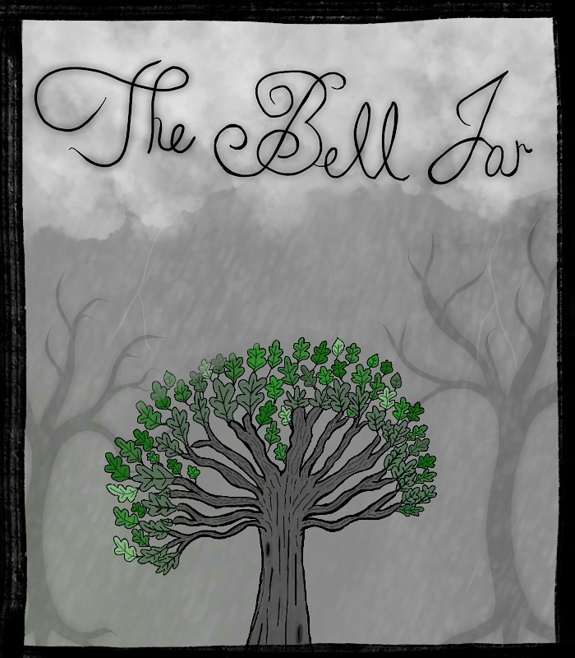

This portrayal of The Bell Jar cover that I created (via the procreate app) has a lot to do with the overall themes of the novel. The dark skies represent the depression and suicide themes within the novel, while the fig tree can be seen as hope, life, nature, and survival. The fig tree is purposely the most colorful image in the cover. Nature and especially the fig tree are important to the story, as they play an important role in Esther’s mindset. The fig tree in my cover is symbolic of all of the possible outcomes Esther dreams her life may turn out to be, each vivid and bright as the leaves on the tree. However there is darkness surrounding the beauty of the fig tree, which can be seen as the dark rainy skies and dark trees to the sides. This dark imagery is overwhelming in the cover; as to demonstrate the darkness of the future themes the reader is to come across when reading The Bell Jar. The darker trees on the sides seem larger and scarier, representative of the overwhelming despair that Esther feels. Although the fig tree is light and full of life, it is teeny in comparison to the darkness. This connects to the major theme of depression, as Esther knows the options in the fig tree of her future seem all bright, but choosing one results in the loss of all others. The rainy weather in my cover is a model of the figurative storm taking place in Esther’s life. Esther is facing serious issues in life and struggling with finding the willpower to survive, however the fig tree still stands strong and nature prevails. Esther’s heart continues to beat even when she has lost all hope. My cover of The Bell Jar novel hopes to be illustrative of the beauty of life, and the insignificance of it in the midst of depression.

