Research Annotation
Great Migration
Quotation: “Soon she was able to reflect with a flicker of amusement on that constant feeling of humiliation and inferiority which had encompassed her in Naxos. Her New York friends looked with contempt and scorn on Naxos and all its works. This gave Helga a pleasant sense of avengement. Any shreds of self-consciousness or apprehension which at first she may have felt vanished quickly, escaped in the keenness of her joy at seeming at last to belong somewhere. For she considered that she had, as put it “found herself””
Annotation: Helga’s leaving Naxos for Chicago then Harlem can be symbolic of the migration of African Americans from the southern United States to the northern part to escape the tyranny that Jim Crow laws enabled their counterparts to inflict upon them in addition to seeking better employment opportunities in the rising industrial economy. As evidenced in the book “When Harlem was in Vogue” by David Levering Lewis “From late 1915 onward, the South was full of agents recruiting labor for northern industry…..it’s powerful reinforcement of the lure of high wages in the North there is no doubt. On average, Afro Americans workers earned between $3.00 and $3.60 per day; steelworkers could make as much as $4.50. In the South only 4 percent ever made more than $3.00 daily. The top pay for Afro-American steelworkers in Birmingham, Alabama, was $2.50 for a nine-hour day” there were opportunities arising in the north that could provide better living conditions for African Americans. By making more money, they can generate more income and then afford to live more comfortably or at least not totally impoverish. This migration is also known as the Great Migration. This movement occurred between 1916 and 1970. According to Blackpast.org, at the time of the book k (1920s-1930s) between 400, 000 800,000 people took part in the migration.
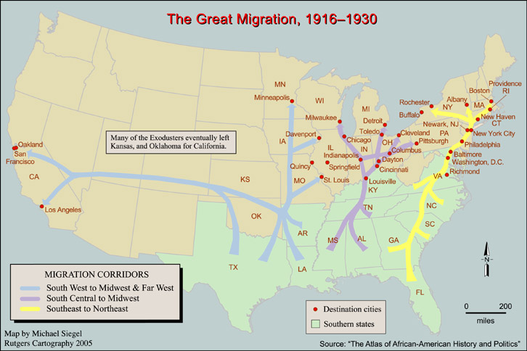
The map is displaying the way in which people migrated base on the location of their native homes. For example the map shows that people from the Southeast (ex. Georgia, Virginia) would have most likely migrated to Washington D.C or Philadelphia or New York. However we can assume that Naxos was probably located in the South Central due to the fact that Chicago is located in the Midwest.

Analysis Helga’s “constant feeling of humiliation and inferiority” can attest to the feelings that African Americans felt due to the deplorable living conditions they experienced in the south. They were made to feel less then and threatened whenever they tried to make their lives better. They were subjected to be the scapegoats of their counterparts. Helga felt this too in her childhood and again when a white preacher had visited and given an insulting lecture at Naxos. The migrants and Helga were both driven by a desire to find self esteem and happiness. African Americans who participated in the Great Migration wanted to be in a place where they can live comfortably, embrace their culture and even find success. This also applies to Helga in that she wanted to be in a place where she wasn’t forced to conform to standards that go against her values and beliefs. The migrants like Helga were made to feel like they didn’t belong. But in Harlem they can prosper.
Works Cited
St. Clair, Stephanie. The Great Migration. The Black Past Remembered and Reclaimed. http://www.blackpast.org/aah/great-migration-1915-1960. Accessed May, 7, 2018
Lewis, David. When Harlem was In Vogue. New York, Penguin Books, 1981.

