Richard Matos
TCET 4140
11/14/13
Homework 4

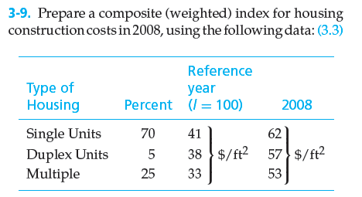
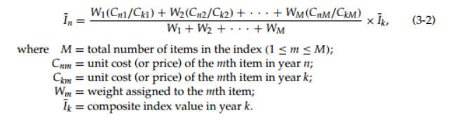
K = Reference year (previous year)
N = Future year
Ik = reference year index
$$In =\left[ \frac{W1\left(\frac{Cn1}{Ck1}\right)+W2\left(\frac{Cn2}{Ck2}\right)+ · · · +WM\left(\frac{CnM}{CkM}\right)}{W1 +W2 + · · · +WM} \right]*Ik$$
I₂₀₀₈ =$\left[ \frac{0.7\left(\frac{62}{41}\right)+0.05\left(\frac{57}{38}\right)+ 0.25\left(\frac{53}{33}\right)}{0.7+0.05+ 0.25} \right]*100$ =
$\left[ \frac{1.058+0.075+ 0.4}{1} \right]*100$ = 153.3
I₂₀₀₈ ₌ 153.3

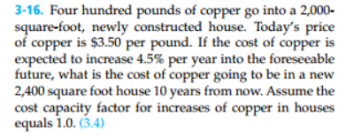

Inflation in 10 years = 10*(0.045) = 45% increase

Future Price per pound = [($3.50 *0.45) + $3.50] = $5.075 per pound

Pounds needed for 2,400 square feet = 400lbs [ $( \frac{2400}{2000} )$] = 480lbs

Cost of copper in 10 years for a 2,400 square foot house = 480 lbs * $5.075 = $2436

3-17. The structural engineering design section within the engineering department of a regional electrical utility corporation has developed several standard designs for a group of similar transmission line towers. The detailed design for each tower is based on one of the standard designs. A transmission line project involving 50 towers has been approved. The estimated number of engineering hours needed to accomplish the ﬁrst detailed tower design is 126. Assuming a 95% learning curve,

a. What is your estimate of the number of engineering hours needed to design the eighth tower and to design the last tower in the project?

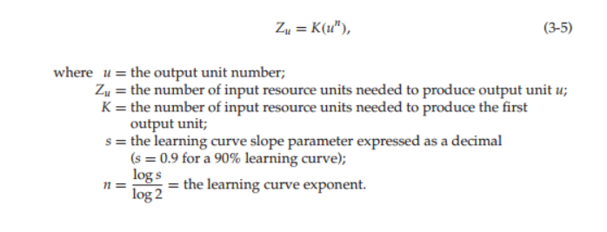
K = 126
U = 8 then 50
Learning Curve = Log s = 0.95

Z₈=126 (8^($\frac{log 0.95}{log2}$))= 108.03 engineering hours

Z₅₀=126 (50^($\frac{log 0.95}{log2}$ ))= 94.33 Engineering hours

b. What is your estimate of the cumulative average hours required for the ﬁrst ﬁve designs? (3.4)

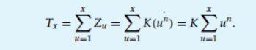

T5= $126\sum_{u=1}^{5}{u^{(\log{0.95/log2)}}}$

126(1^{-0.074}+2^{-0.074}+3^{-0.074}+4^{-0.074}+5^{-0.074}) = 587.43 hours

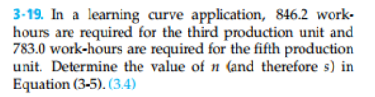

Zu = K ($u^{n}$)

n= Log(s)/ Log(n)

Zu= 846.2 – 783= 63.2

