Romuald Ilboudo
Transmission System
05/13/2013

Load Pull

In transmission system, load pull is the process of constantly varying the impedance of a device under test (DUT). Load pull doesn’t require the variation impedance at the load port since the impedance can vary at any port of the DUT. Load pull is a very important technique and it is the most widely used technique for estimating device performance in a non-linear domain.
Most of the calculation needed for load pull can be done using the Smith Chart. As I said, load pull requires the variation impedance of the load port. This means that load pull can be use to estimate (calculate) the impedance of a device. Also, load pull is used for coefficient reflection calculations. Load pulls are effective tools to precisely and rapidly determine the optimize matching parameters for a transistor device.
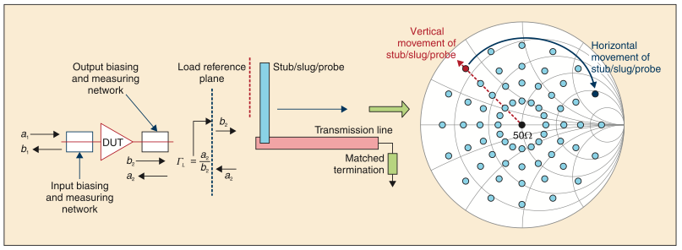
Fig. 1 A load pull system shows with a Smith chart.
Credit of this picture to Mohammad S. Hashmi and Fadhel M. Ghannouchi

According to Mohammad S. Hashmi and Fadhel M. Ghannouchi, a load pull system is composed of an active or passive impedance-tuner, the controlling mechanism to precisely set the tuner impedance to achieve desire impedance, and equipment to measure the traveling wave at the input and output port of the DUT.
They are two types of system used by load pull applications. Theses are the active load pull system and the passive load pull system. These two applications have different properties and using them depends of the type of issue we need to solve, more precisely, it depends of the type of impedance tuner used.
An active load pull system is usually used for applications requiring high reflection coefficient value. While the passive load pull is used for application that required high-speed measurements. Note that there are frequency limit for any of the type of load pull used.
The figure below shows an active load pull system. The figure shows two closed loop in the load pull system: an active open loop (a), and an active closed loop (b). In a closed loop structure of the load pull, they are oscillations. The oscillations are due to the reflective traveling input wave. The oscillations can be overcome with an amplifier with high gain and high linearity in the feedback loop.

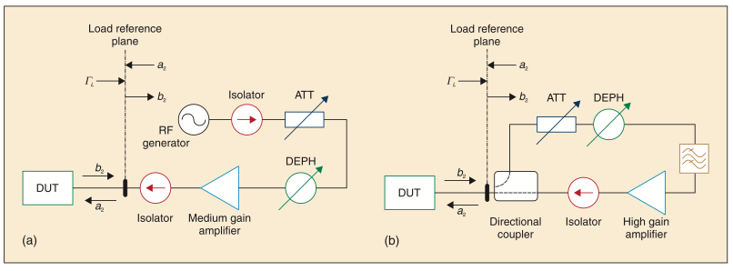
Fig. 2 Active load pull (a) active open loop load pull, (b) active closed loop load pull. Credit of this picture to Mohammad S. Hashmi and Fadhel M. Ghannouchi

Active and passive load pull can be combined to create what is called a hybrid load pull.
When applying load pull with a Smith chart, sometimes, they are the need to reduce the Smith chart coverage to provide the ideal match between the wave transformer and the load pull tuner. This is done by adding a λ/4 in the load pull system.
In load pull, we have to differentiate between the λ/4 transformer and the Klopfenstein transformer. The main difference between the Klopfenstein and the λ/4 is that the Klopfenstein covers much bigger distances than the λ/4. But both the Klopfenstein and the λ/4 are used to reduce the size of the Smith chart.
Nowadays, they are two developments is load pull configuration. These two developments are the loop passive load pull and the envelope load pull. The loop passive load pull is the most worldwide technique used in load pull.

View all that have been said above, load pulls are very important and indispensable in transmission line. Load pull was created more than 40 years ago, but still they are commonly used nowadays. As a student in telecommunication, transmission systems are a very important topic, and load pull is important in transmission system. The paper also allowed us to see a practical example of the Smith chart in real life.

Sources:
M. S. Hashmi, F. M. Ghannouchi, P. J. Tasker, and K. Rawat, “Highly reflective load pull,” IEEE Microwave Mag., vol. 12, no. 4, pp. 96–107, June 2011.
F. M. Ghannouchi and M. S. Hashmi, Load-Pull Techniques with Applications to Power Amplifier Design, Springer Series in Advanced Microelectronics, New York, NY: Springer, 2012.
F. M. Ghannouchi, M. S. Hashmi, S. Bensmida, and M. Helaoui, “Loop enhanced passive source- and load-pull technique for high reflection factor synthesis,” IEEE Trans. Microwave Theory and Techniques, vol. 58, no. 11, pp. 2952–2959, Nov. 2010.
F. Secchi, R. Paglione, B. Perlman, and J. Brown, “A computer controlled microwave tuner for automated load pull,” RCA Review, vol. 44, no. 4, pp. 566–583, Dec. 1983.
Introduction to Load-Pull Systems
And their Applications
Part 43 in a series of tutorials on instrumentation and measurement
Mohammad S. Hashmi and Fadhel M. Ghannouchi

