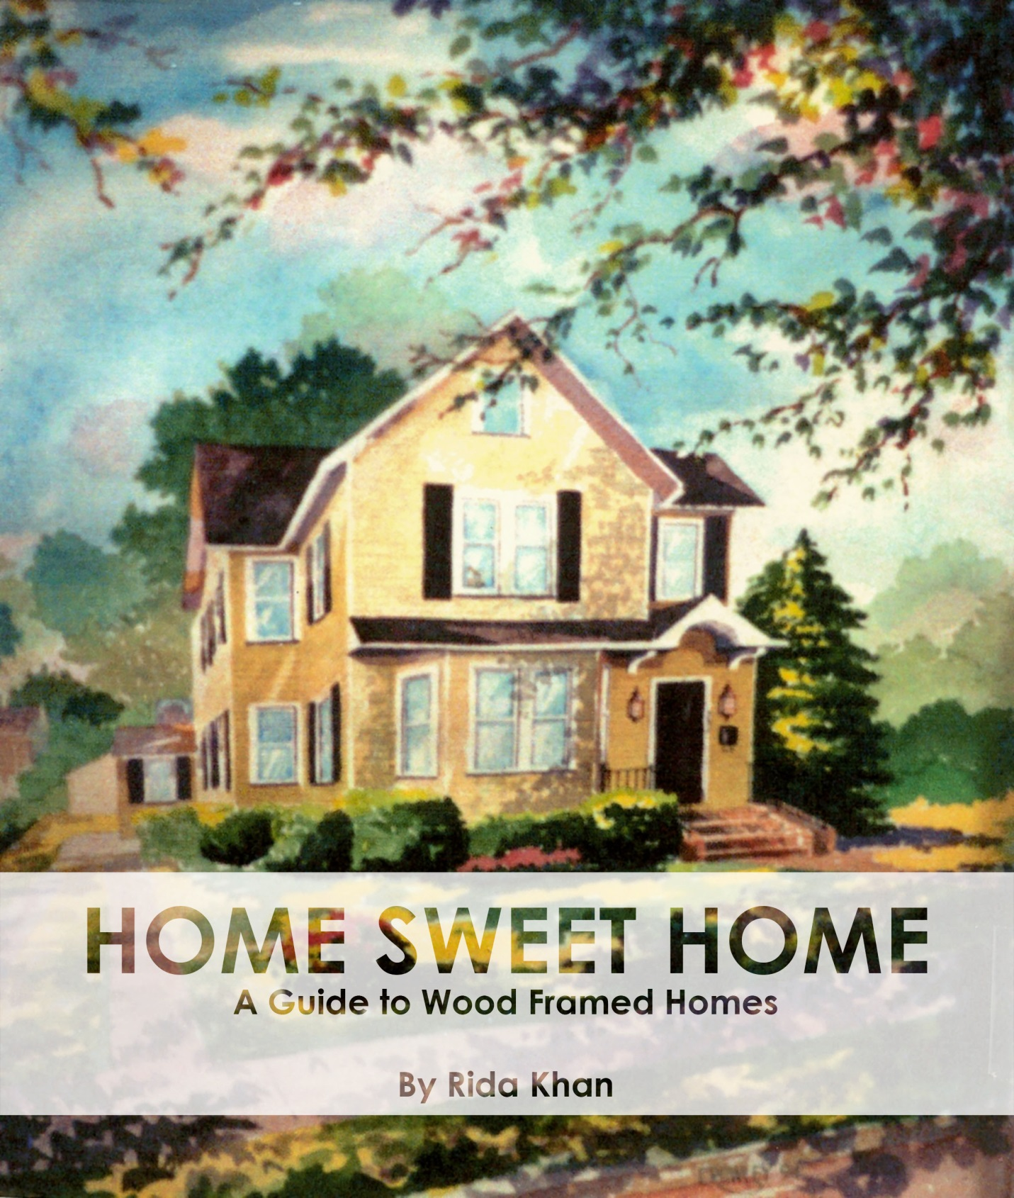
TABLE OF CONTENTS

Front Cover PG 1
Table of Content PG 2
Introduction PG 3
Chapter 1: Floors
Composition of a Wood Framed Floor PG 4
Material Selection Guide PG 5
Illustrating in Revit PG 6
Chapter 2: Walls
Composition of a Wood Framed Wall PG 7
Illustrating in Revit PG 8
Exterior Housing Material PG 9
Illustrating in Revit PG 10
Chapter 3: Roofs
Types of Roofing Systems PG 11
Composition of a Wood Framed Hip Roof PG 12
Material Selection Guide PG 13
Illustrating in Revit PG 14
Chapter 4: Rendering in Revit
Components PG 15
Camera & Views PG 16
Site Placement PG 17
Sunlight Manipulation PG 18
References PG 19
Back cover PG 20

As humans evolved, their living spaces evolved with them. A journey that started within caves grew to Jericho’s mortar plastered walls and floor, braved through the mud houses of Catal Huyuk, transformed into two story homes in Sumer, and through tried and tested methods, developed the wood framed home we so popularly known today in America. Wood is a material that humans have used for almost every aspect of life from building, to creating, providing fuel sources, tools, and even weapons. From the Trojan horse, to monumental bridges all over the world, to within the walls of the places you spend the most time in, wood has become a reliable and important material that and over time proven again and again it’s important to the development of our societies.
While appreciating the exterior beauty of houses is something anyone can do, learning what processes, sciences, and methods are used to create the outcomes is a major insight for someone who owns, or dreams of owning a house. During this book allow me to break the “4 walls” of wood framed homes down for you piece by piece and help you build a stronger foundation for your Autodesk Revit adeptness while helping you create and assemble your very own 3D wood framed home concept.
As you explore this book, and learn what makes wooden framed home so special. I hope you go on to reference and apply your new found knowledge freely and confidently.

Rida Khan
Author

PARTS OF A WOOD FRAMED FLOOR
All standing, and lasting structures have been built from the ground up, following this model this guide will start from the Floor.
Floors are separated into two categories: Subfloor & Finished Floor.
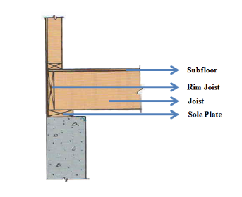
The subfloor is defined as the foundation of flooring in any structure. It is comprised of 4 main parts including the Subfloor, Rim Joist, Joists, and Sole or Sill Plate.

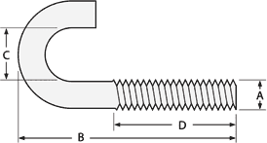
As indicated in Image (1-1) the SOLE PLATE sits directly above the foundation and allows a resting place for the joists. The purpose of a sole plate is to provide support to vertical members most commonly known as studs and also secures house to the foundation. The sole plate is secured to the foundation using a J bolt, as seen in Image (1-2), that is screwed through the plate and the foundation creating a tight bond between the members.
IMAGE 1-2
IMAGE 1-1

The JOIST is a supporting member that runs between foundation and walls to support flooring. Long sturdy pieces of wood are placed around 16” off center to create a platform for the subfloor and finished floor.

The RIM JOIST is another framing component that rests on the sill and connects to the joist. It caps the end of a row of Joists keeping them aligned.

The final piece is the layer of SUBFLOORING. The subfloor is usually made up of ¾” plywood or sheeting. It is installed for support and a rough finishing creating a platform for the finished floor to rest on.

Atop the subfloor lays the finished floor, which is the final piece of the flooring system.
FINISHED FLOORING MATERIALS
Finished Floor is a layer who thickness depends on the material you ultimately choose to cover the floor with. Choosing a flooring type can be stressful and a time consuming and expensive process.
To make it a little bit easier, we will focus of the most basic finished floor types that can be found in almost any home: Hardwood, Tile, Carpet, & Laminate.

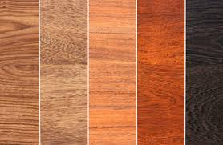
The most common flooring is Hardwood. Hardwood is the wood from a broadleaved tree such as oak, ash, or beech. Easy to clean and maintain it is one of the most sought after finish in homes. Hard wood is not only a homely looking decoration; it is a great insulator which makes it comfortable to walk on living areas. The only major flaw is it’s weakness toward humidity and moisture which may cause warped boards.
IMAGE 1-3
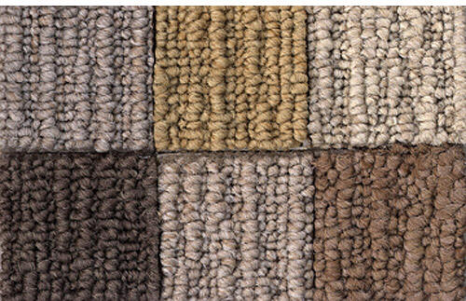
Carpeting is desirable for rooms such as bedrooms and living rooms in which the sole purpose is to relax. Carpeting is easy enough to clean especially with technology advancing with stain resistant materials. Carpeting is also a great sound barrier as it reduced the sound of conversation, TV, and noises from below. The cons of carpeting can be limited to its capability of retaining moisture and dust as well as staining, and over all wear and tear over the years.
IMAGE 1-4

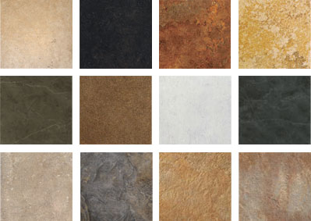
Tile is a great material for rooms with any type of plumbing. Not only is Tile a beautiful flooring that is easy to maintain and timeless, it increases a home’s resale value after installation. Tile is a great material to have in kitchens and bathrooms especially because of how durable they are with the newer floor heating systems. Some draw backs include, difficult installation, and if you do not have a heating system underneath tiling can be very cold and uncomfortable during certain seasons and times of the day.
IMAGE 1-5
HOW TO CREATE A FLOOR IN REVIT
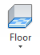
- In the BUILD tab Select the FLOOR icon
- In the properties panel select EDIT TYPE
- Using the material browser, select the materials to create the subfloor & finished floor. The edit assembly table should look like this:
Note: For this example we used Walnut, feel free to use whatever finish you prefer!
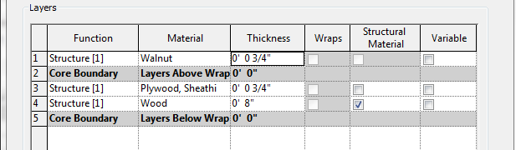

IMAGE 1-6

- Revit will then prompt you to create a boundary line within the drawing space to indicate where you’d like your new flooring to go. Using the Modify/Create Floor Boundary. Let’s make a 20’ x 20’ square.
IMAGE 1-7
Note: This is not a permanent layout; throughout the project you can manipulate the boundaries to fit your needs. This step does not have to be perfect.
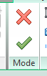
- Once you are confident with your space, click the green check mark to finalize your floor layout.

Using the Shade and the 3D view, let’s look at what we have just created!
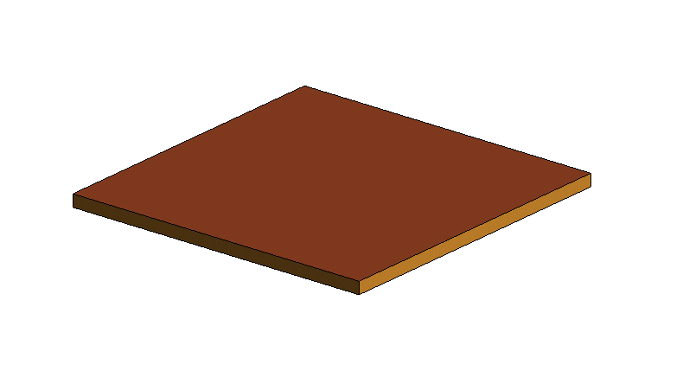
Congratulations!
You have just successfully created your very own flooring system in revit.
How do you know you’re on track?
You should see a clear color difference which represents the material change we designated in the Edit Assembly Window. PARTS OF A WOOD FRAMED WALL
IMAGE 1-8
Following the pattern of building from ground up, the next feature we will be discussing is walls. Walls are the body or structure of the end result. It is the component that give height to your end result, and ultimately character.
The wall has five main parts; Top Plate, Stud, Sheathing, Sheetrock, & the sole plate
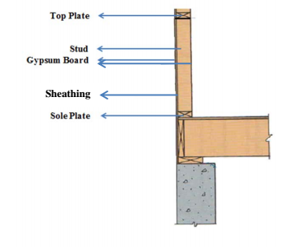
The SOLE PLATE as discussed in the previous chapter has a similar function in the wall structure. Instead of providing support to the joists, it supports the STUDS.

The STUDS are usually 2”x4” pieces of wood that are the main structural member of the wall. They are placed at a spacing of 16” on center. They provide a nailing surface for sheathing or paneling and a base for GWB.
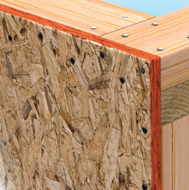
SHEATHING is a layer of wood that is nailed to the studs to provide a platform or surface area for the finished/ smooth layer of GWB to be adhered too. Sheathing is primary done with plywood which is layers of wood veneer that is glued together and pressed flat as seen in Image 2-2.

Sheetrock or DRY WALL is plaster that has been pressed together to create a sooth flat surface on which the home owners can paint/decorate.
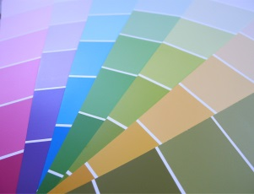
The final part for a finished wall is decoration, or in most cases PAINT. Not only does paint come in many colors but it has several different finishes including but not limited to Acrylic Flat, Acrylic Eggshell
Acrylic Satin, Acrylic Gloss the differences between them can vary between wash ability, durability, shininess, or their base material being oil or other.
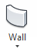
HOW TO CREATE WALLS IN REVIT
- In the Build tab select the WALL button
- In the Properties panel select the EDIT TYPE
- Under the construction tab, select the EDIT option next to structure to open the Edit Assembly window.
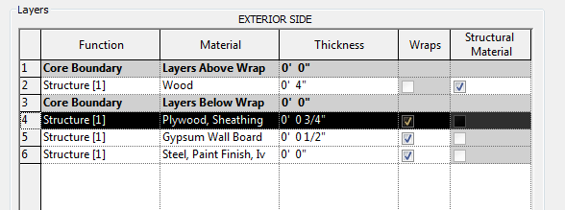
- Following the description given in the earlier chapter create the build of a wood framed wall as follows:
Note: Be careful to build AWAY from the exterior side, as Revit will use exterior/interior to specify how to draw the walls later on.

- Press okay
- Focusing on the Modify/Place Wall tool bar; adjust settings to reflect the following

- In order for the wall to be drawn correctly start from the top left corner of our flooring and move towards the right,
- Completely encase the flooring and press enter
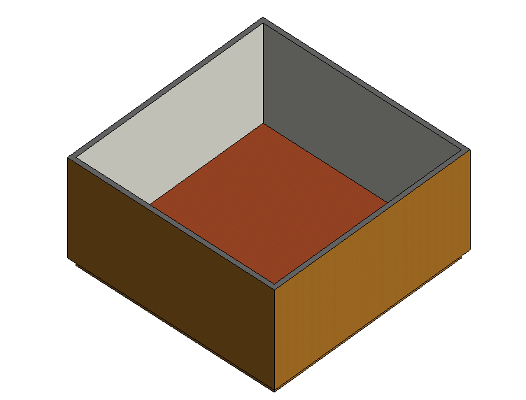
Congratulations! You just completed creating walls for your wood framed home.

Your end result will be our walnut flooring surrounded by the wall.

However, one part is missing; The Exterior Material.
Types of Exterior Wall Materials

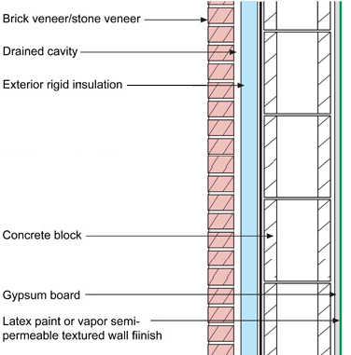
Interior walls are limited to gypsum and paint in most cases, where the exterior of your home is a great way to express your personal style because of the variety of choices, and combinations.
Brick is a material type that is very widely used because of its durability and strength. It has very strong in terms of wear and tear and if built properly it can last centuries. Brick Houses themselves provide insulation enough, whereas brick veneer homes as illustrated in Image (2-6) needs extra insulation and drainage.

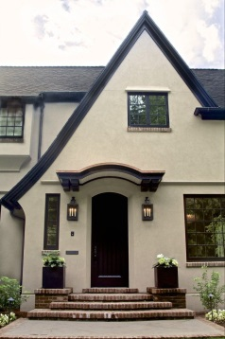
Stucco is a material that is made up of cement lime and silica and is applied in layers to form a shell over the house. Stucco is a very clean finish to have on the exterior walls, and is customizable by painting. Stucco homes are great for throughout the year weather as it retains heat in the winters and cools in the summers. Stucco is also an easy installation process making it very desirable.

Siding or Vinyl Siding is the most commonly used exterior covering for homes since 1955. Siding is easy to install and guarantees lasting color. Not only is the material cost effective but an attractive feature to up the value of your home. Some draw backs that homeowners should take into consideration is the siding is not waterproof, just water resistant, this can open doors to water damage which is almost every home owners nightmare. Over time siding can become a victim of dents/cracks, and fading
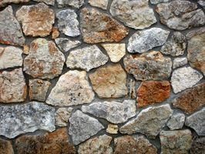
Stone is a very classy option for exterior materials. With a large variety of patterns, shapes, and colors stone exteriors add a touch of character to any home. However, installation is expensive and if done incorrectly can severally damage your home.
How to add Exterior Material to Walls

- Select one of the walls in the project
- In the properties Panel select the Edit Type button
- Continue to open the Edit Assembly Window by selecting “EDIT”
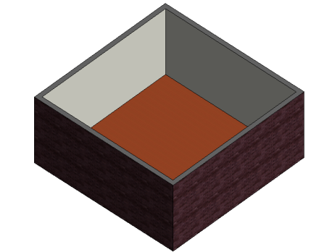
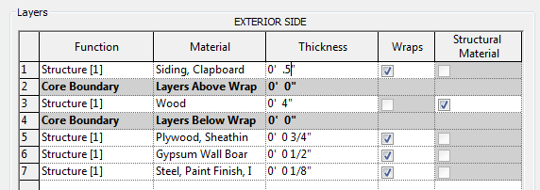
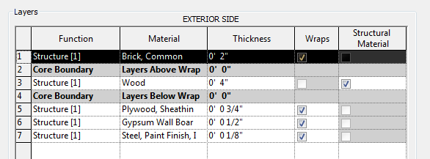
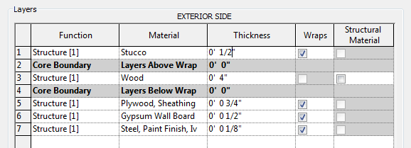
- Insert a layer for the window to display one of the following :

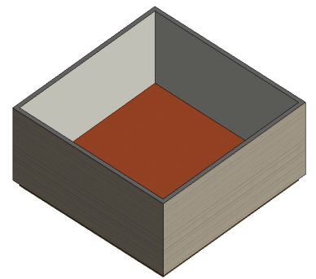

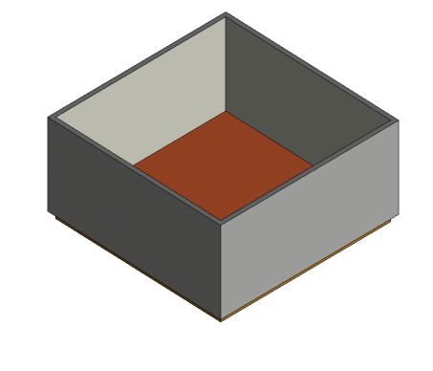

- After you complete the table and exit out of type properties to look at your updated house.

Types of Roofing Systems PG 11
Composition of a Wood Framed Hip Roof PG 12
Material Selection Guide PG 13
Illustrating in Revit PG 14
Chapter 4: Rendering in Revit
Components PG 15
Camera & Views PG 16
Site Placement PG 17
Sunlight Manipulation PG 18
References PG 19
Back cover PG 20

