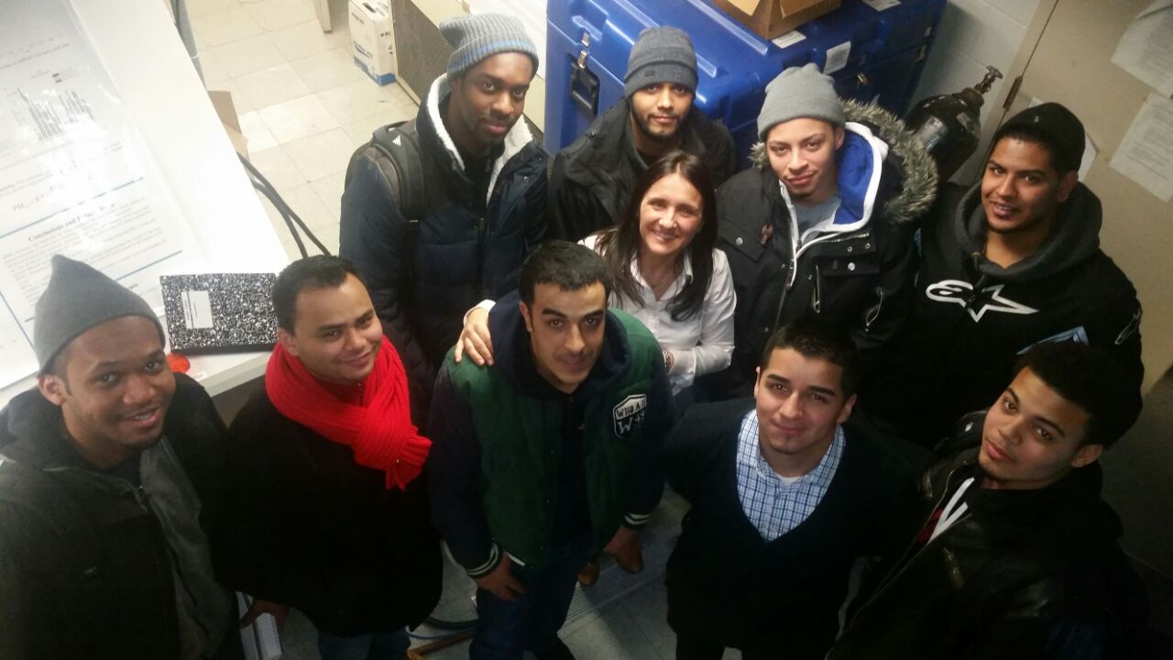
Figure1: The Spring 15’ Class of EET 3132 with Prof. Viviana Vladutescu at the Grove School of Engineering at CCNY (Courtesy: Karlvrin Williams)

What is remote sensing? Well by definition remote sensing is the acquisition of information/imagery or phenomenon without making contact with the environment if the area/item (remote area). In our class EET3132 Professor Viviana Vladutescu discusses the different types of remote sensing and its different sensing devices. On 3/9/15 we were scheduled on a trip to CCNY to explore the different remote sensing devices there and it was quite an experience.
When we arrived at CCNY I was quite confused because of all the different buildings but soon after we entered the Grove School of Engineering at met up on the 5th floor. We then rendezvoused and entered the remote sensing room where we were introduced to the LIDAR system at CCNY. The LIDAR is short for light detection and ranging system and is a very effective way of remote sensing the sky. This LIDAR system consist of two lasers, a Q-switched coherent 40-100 nd-YAG (1064, 532, and 355 nm) and a Q-switched quanta ray pro 230nd-YAG (1064, 532,355 and 387(for nitrogen) nm) .The LIDAR emits a laser beam at a certain wavelength the measures parameters with measuring the scattered light from the emitting light into the air. Fortunatelt we were able to see the lidar on, but due to incliment weather we were not able to see the LIDAR make a reading (snow storm). http://sky.ccny.cuny.edu/wc/Lidar/Img/LidarTelescopesm.jpg
After we studied how the LIDAR worked we then went up to the roof and observed the other instruments that are placed on the roof for atnospheric observations: the celiometer, MFRSR Shadowband, Microwave Radiometer, and the Sun Photometer. The celiometer(CL31) is a sensor that is used to measure cloud height,layers , cloud fraction, and wator vapour profiles. We observe the measurements through a 10m x 770 samples, 15 second interval parameter. The MFRSR is the most interesting of all the sensors we observed in the roof I believed because it rotates all the time. The MFRSR Shadowband is a sensor that measures different forms of irradiance at 6 wavelengths (415,500,615,673,and 940nm) which is observed through the rotation at different angles of an arc that covers the main sensor.
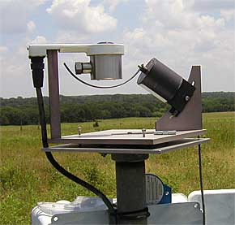
Figure 2: An MFRSR Shadowband
The Microwave Radiometer produces vertical profiles of up to 10 km for relative humidity, temperature, wator vapour and liquid in air. It is done by inserting two readio frequency systems (51-59,22-30 GHz) incorporated with the same anttenae and is considered a “passive sensor” because it does not emmit any detectable radiation. Last but not least was the CIMEL Sun Photometer (CE318 #237), the microprocessor is a sensor that measures incoming solar energy at different wavelengths (340,380,440,670,870, and 1020nm). With the CIMEL we are measuring Aerosol optical depth, mixed gas optical depth, water vapor optical depth, aerosol optical depth, rayleigh optical depth and total optical depth. The CIMEL is unique because it tracks the sun throughout the day and the information is directly linked to NASA.
Overall it was a great experience. Towards the end of our tour we got to go inside the satellite room where CCNY recieves satellite imagery and we saw a couple of pictures which were awesome. I would like to thank Professor Viviana Vludutescu for the experience and my colleagues for experiencing what the atmospheric department is like at CCNY.

