Downloading remote sensing data:
- Sunphotometer data (CIMEL instrument)

http://aeronet.gsfc.nasa.gov/new_web/data.html

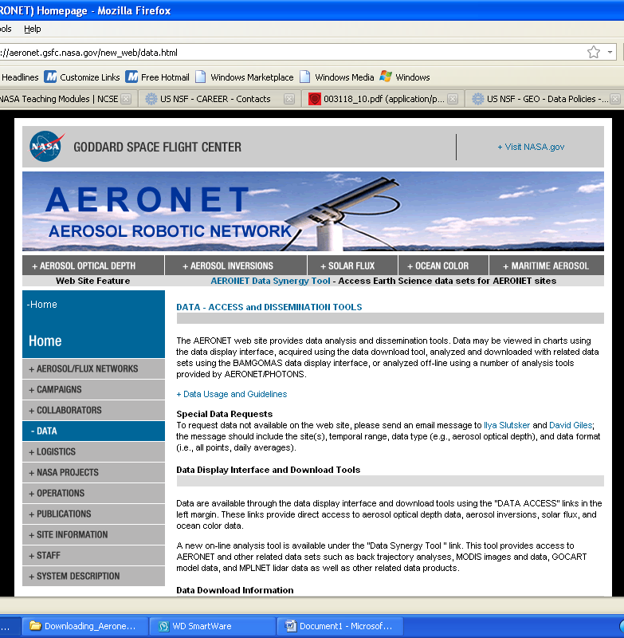
Scroll down until you see:

Here select Download tool.
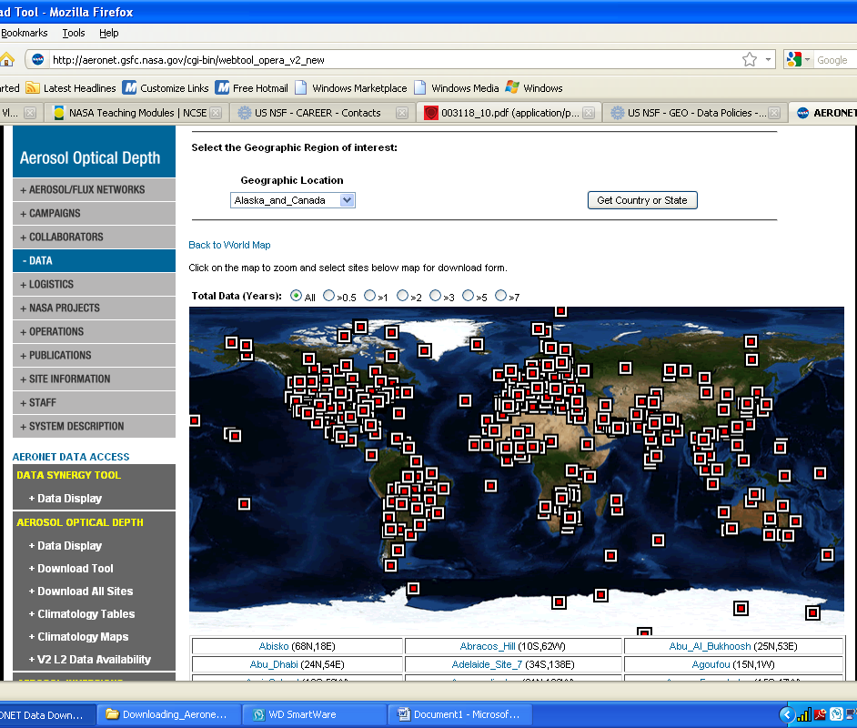
On this page you can select the site of interest from the map directly, from the list underneath the map or by clicking the top right hand corner button to select the country and city. In my selection below I clicked on CCNY in the list below the map 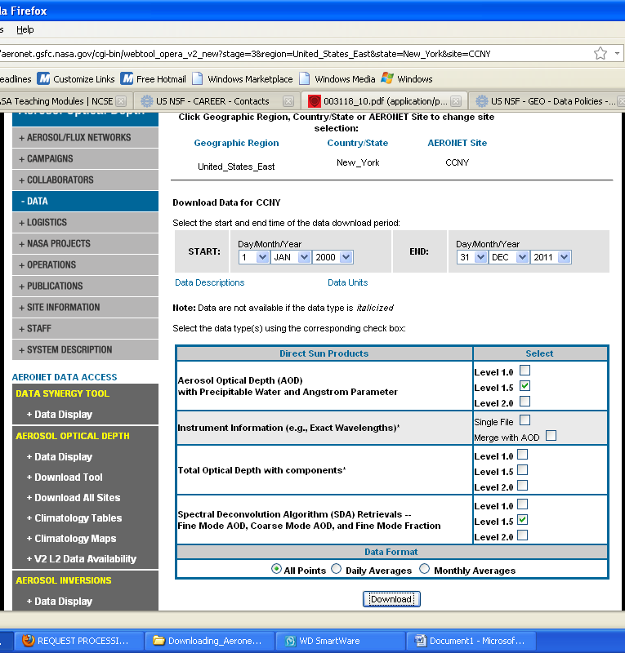
Here you can select the dates and items of interest. In the pop up window below accept the conditions
When the save window pops up save the file in a folder where you will process the data.
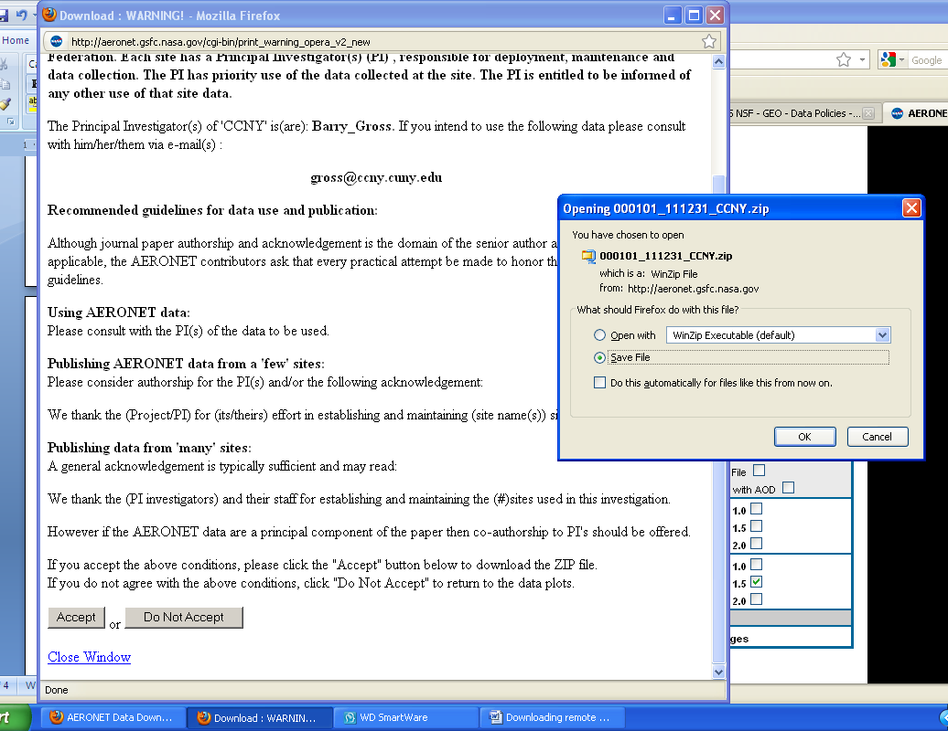

- Hysplit profiles: http://ready.arl.noaa.gov/
Once the arl site is on the screen select Get/Run Hysplit
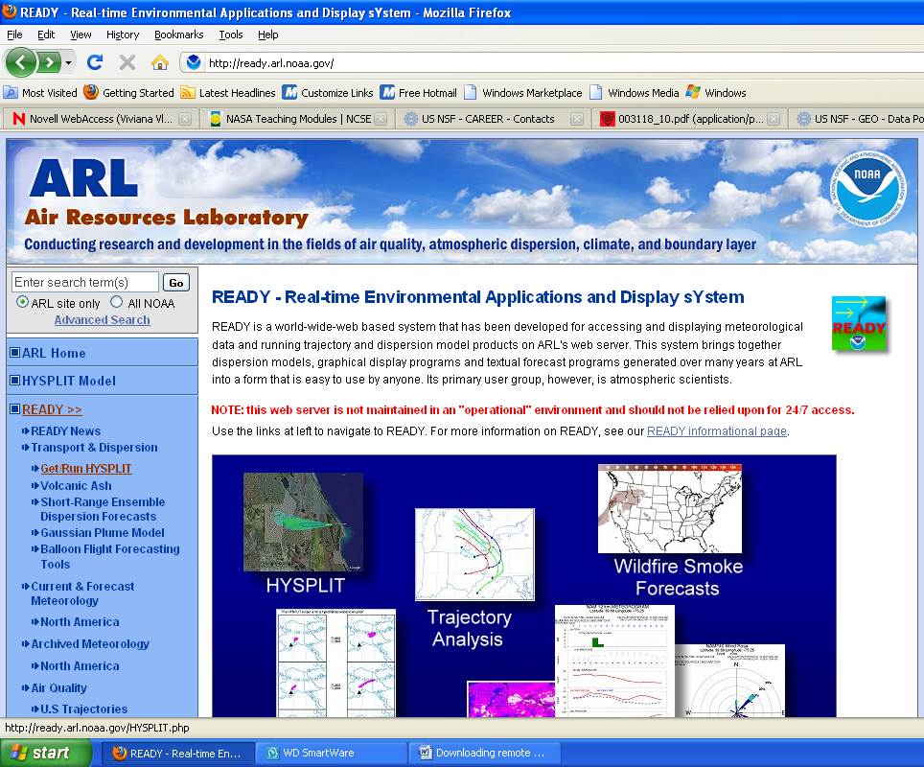
Once the page opens, select Run Hysplit Trajectory
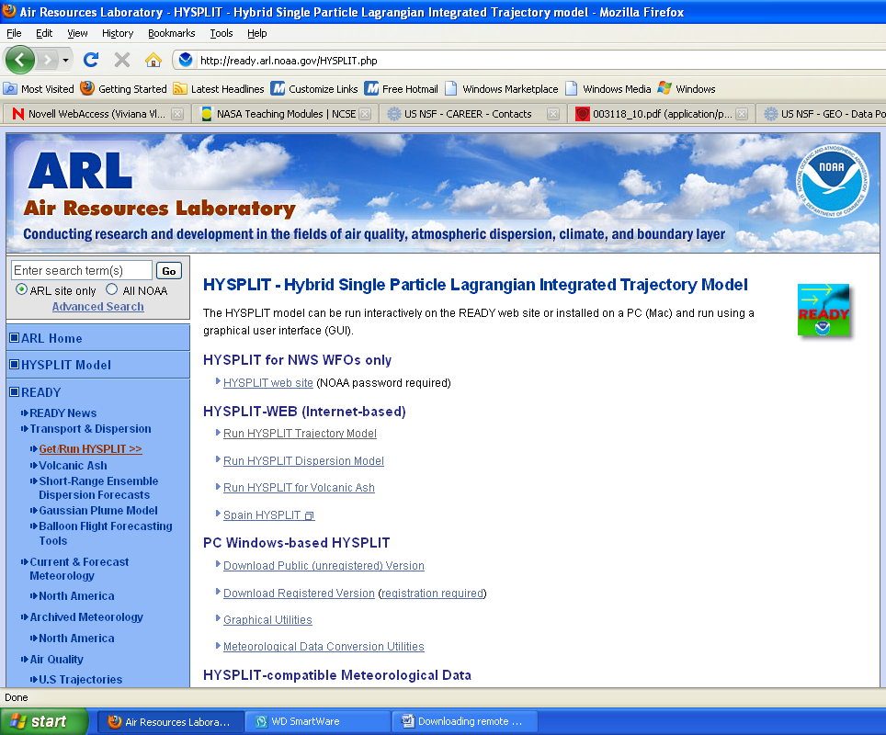
In the run hysplit window select the trajectory of interest
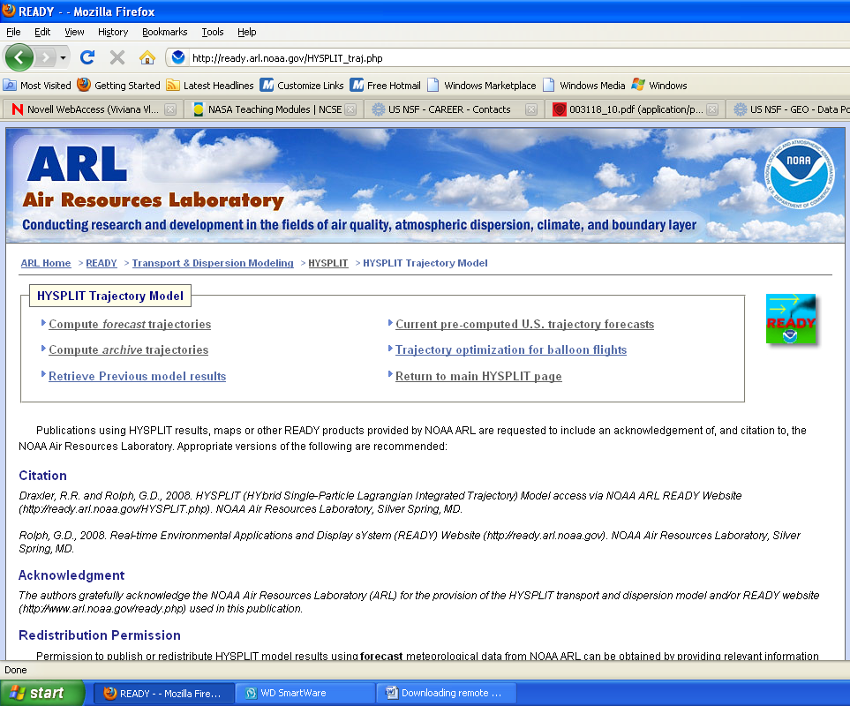
I selected here Compute archive trajectory and the system opened the page below. On this page select the number of trajectories and type (for this lab select 1 trajectory and normal type). When you are done click next.
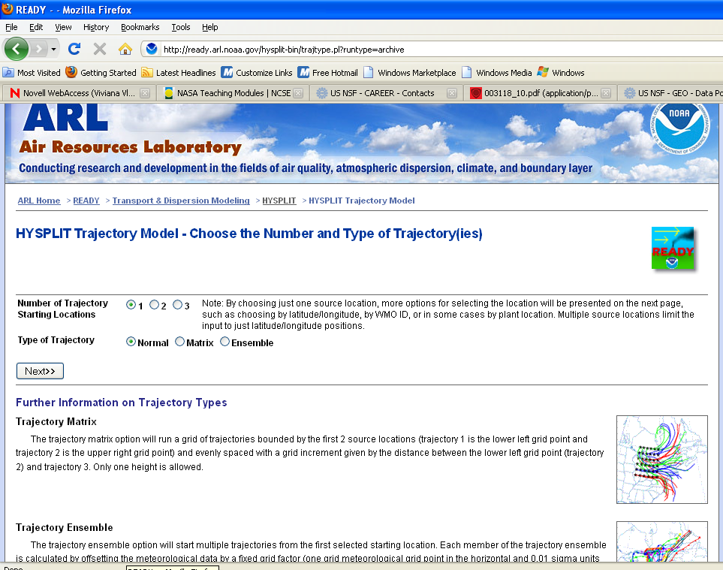
By clicking next you will be sent to the page below where you need to enter the meteorological data and location. In the In the meteorological press the scroll button on the right and select EDAS (40km) then enter the geographical coordinates of interest.
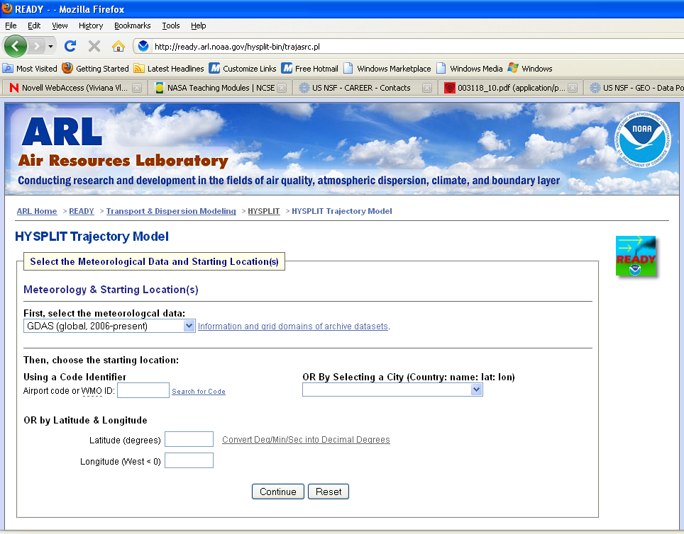
By clicking Continue you will be sent to the page below. Here you need to select by scrolling down the interval of time in which your day of interest can be found. After selection click Next.
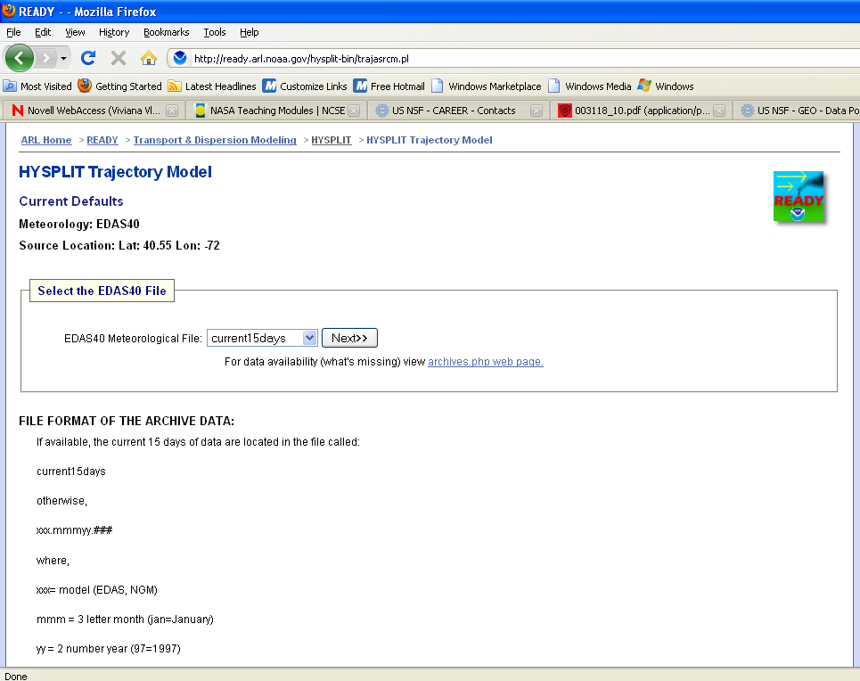
Once the time interval is selected you need to enter the model parameters.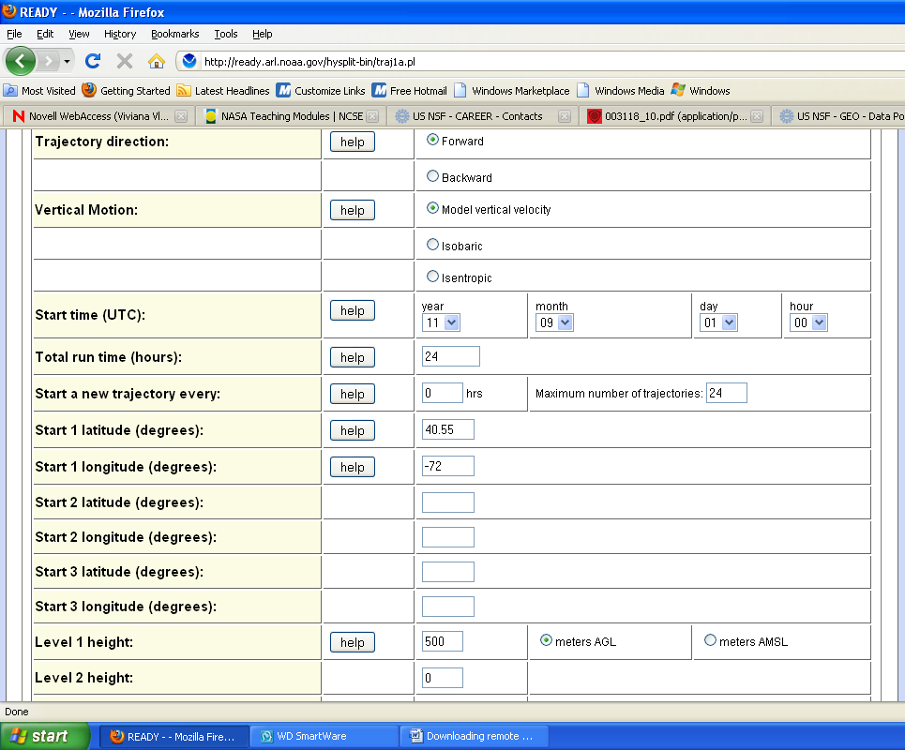
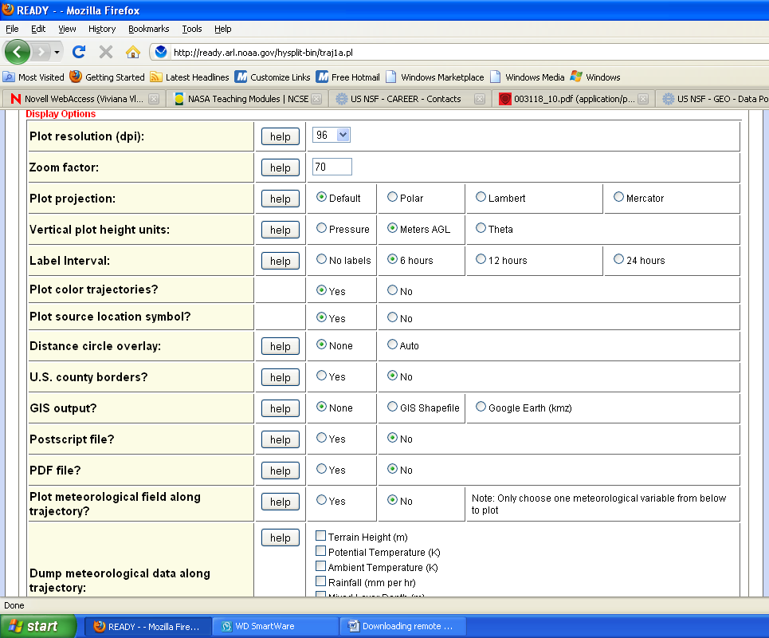
After entering all the model parameters select Request Trajectory on the bottom of screen. Please note in the window below that you need to wait until the file is ready
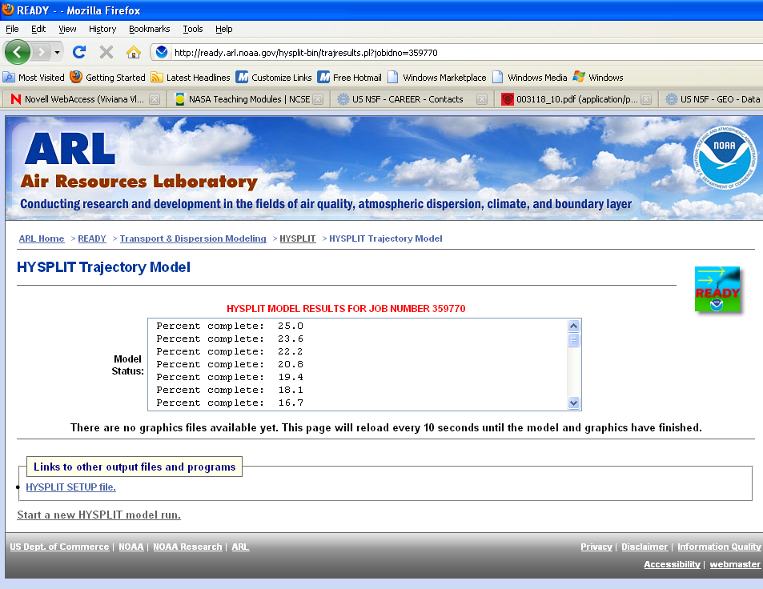
Once the file is ready for visualization you can see it by clicking on the GIF option below
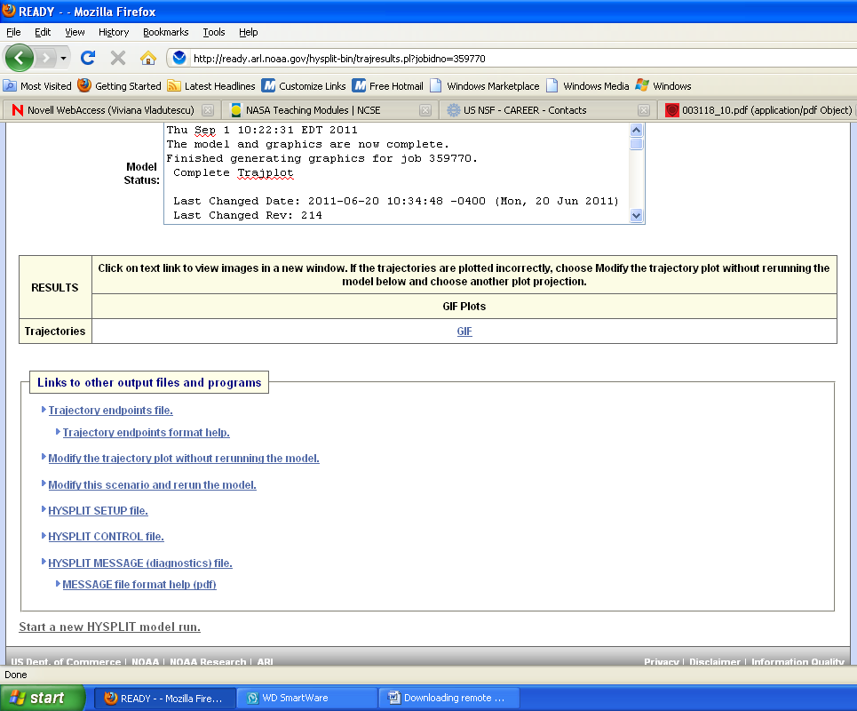
The wind trajectories at the 3 different altitudes are shown in the GIF plot and the data requested in the model parameter window can be seen in a table format (that can be saved in notepad or wordpad ) by selecting trajectory endpoints file.
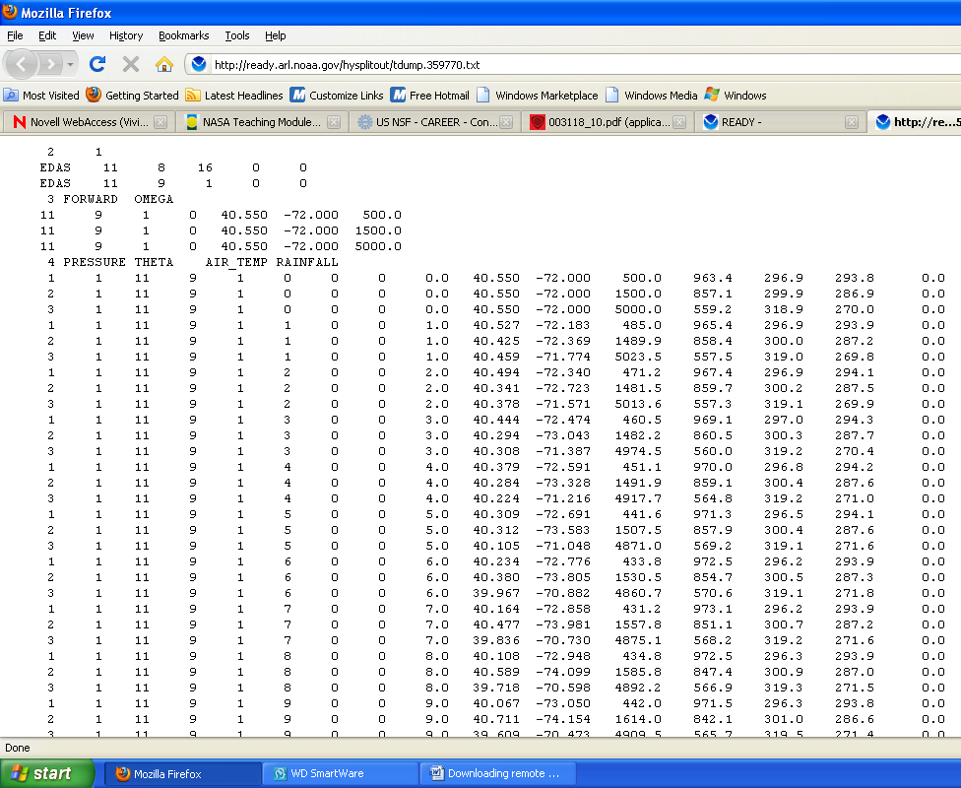
- Atmospheric Soundings by radiosondes:

http://weather.uwyo.edu/upperair/sounding.html

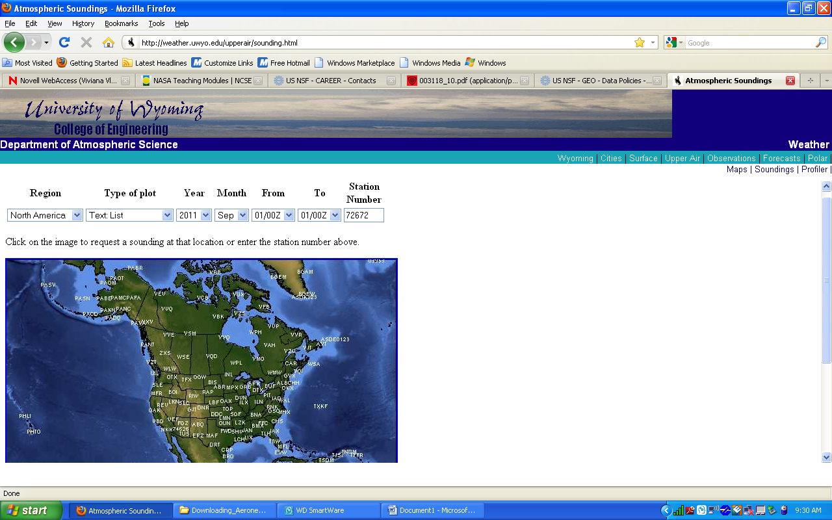

For NY area select OKX. Please note that the time is UTC (so 12am UTC time means 8pm east coast time during the summer and 7pm during winter)

