Midterm Essay Examination

Rokiatou Bah
Institution: New York City College of Technology
Course: Internship BUF 4900
Date: 04/07/2022

Understanding Minimalism
Minimalism is a concept that continues to be relevant in the different spheres of people today. From the fashion sense, minimalism means reducing what is not needed. Thus, it is more than design since it is an idea and lifestyle that advocates for conscious consumption when creating a wardrobe consisting of versatile, timeless and high-quality fashion pieces (Martin-Woodhead, 2020). Minimalism is properly depicted by the Claire McCardell Cotton fashion exhibit selected for analysis in this essay (Figure 1). The exhibit consists of a cotton hostess dress accessorized with a red sash, green velvet sling-back shoes, a red-orange leather shoulder bag, red and white hand gloves, and plastic sunglasses with blue lenses.
From a design point of view, the dress explores minimalism first through its classic, basic and monochromatic beige color. The red sash, the red-orange bag and the green velvet sling-back shoes also bring out the monochromatic minimalist element of the fashion exhibit. Besides, minimalism is also brought out by the hand gloves' simplistic and subtle polka dots. While the overall look has been accessorized, the accessories are few and subtle, depicting that less is more, as opined by Botzem and Schimmer (2021). Therefore, Claire McCardell’s exhibit depicts how a few quality items can be coordinated to achieve a classy and powerful look, thus depicting slow fashion philosophies.
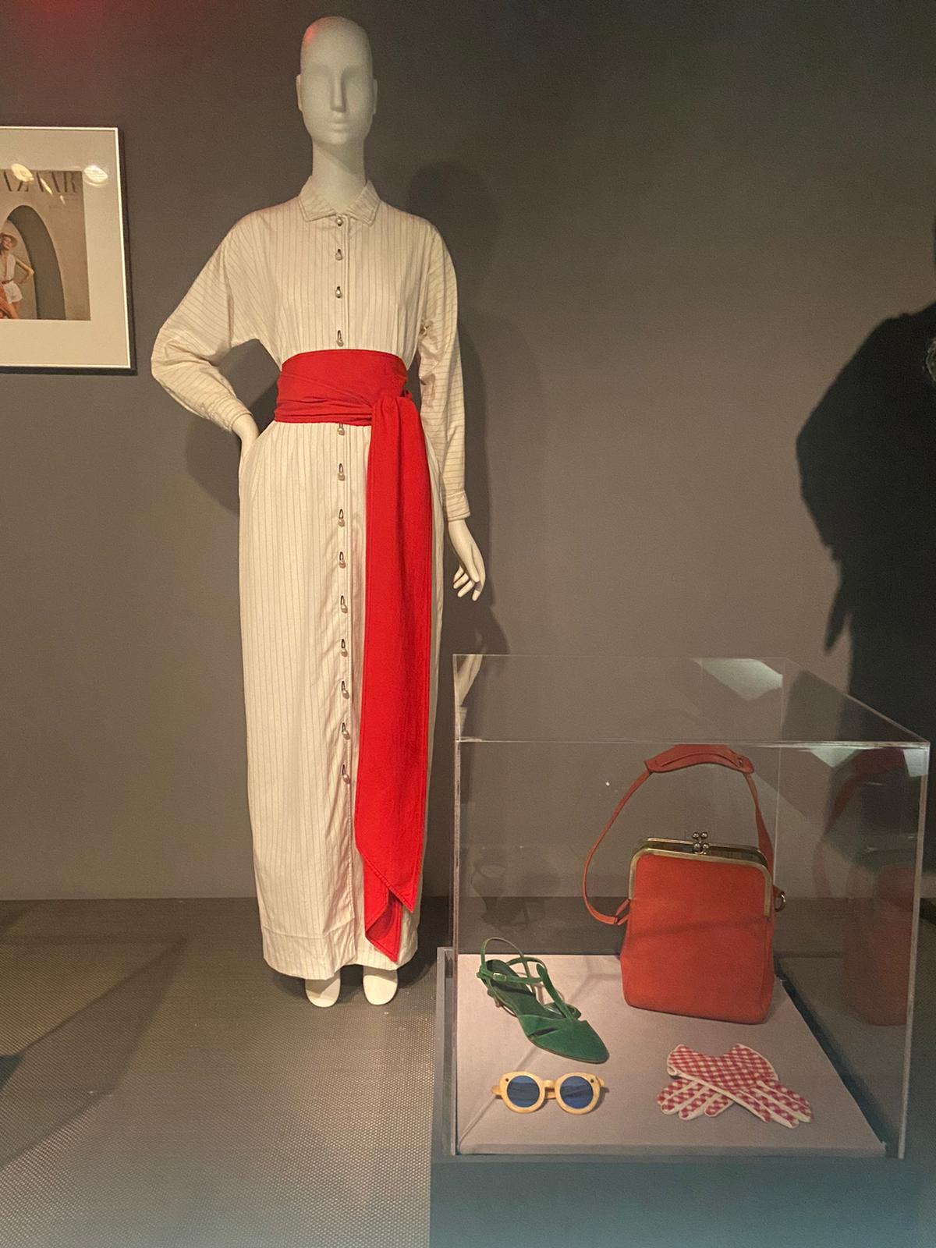
Figure 1: Claire McCardell Cotton Hostess Dress with Red Sash
Significance of colour
Color plays a crucial role in clothing. Most people buy colour before they buy design, fit, or price (Adomaitis, 2022, p. 22). Therefore, it is important to consider colour when designing clothes. The dress comes in neutral beige, which further emphasizes the popularity of this color choice in the 1990s. It has an earthy tone that pairs well with the red sash. The earthy tone makes the dress look classy yet simple. It has grey horizontal stripes. The value of the garment is light. It is a shade of beige, which makes it look sophisticated. The colour makes it easy to pair it with the red sash and the red-orange bag. Adding the green shoes makes the look more dramatic yet simple and classy.
Line
Line is the direction in which the presentation is arranged, the presentation’s effectiveness is determined by how the items are arranged (Adomaitis, 2022, p. 50) . The lines can be vertical, horizontal, curved, or diagonal (Cant & Wiid, 2020). Each of these lines shows different elements. For example, vertical lines show strength, height, pride, dignity and majesty while horizontal lines show easygoing, restful, and calm. In the image, the lines on the dress are vertical. This means that the look signifies strength and makes the dress appear longer. The lines on the arms are horizontal, which makes them appear wider.
Rhythm
Rhythm can be defined as a self-contained movement between elements. Rhythm leads viewers from the dominant element to the subordinate (Adomaitis, 2022, p. 58). The mannequin is the main object in the image, directing the viewers to the dress. From the dress, the viewers move to the display of accessories paired with the dress. The first thing a person sees is the dress on the mannequin, followed by the sash and then towards the display containing the gloves, shoes, bag and sunglasses.
Form
Form can be defined as the visible shape of an item. Different items come in different shapes and sizes. The form of the mannequin makes the dress appear straight. If the dress was tight, it would have clung to the mannequin's shape. The whole look and the form of the dress make it classy and calm. Most middle-class women wore such dresses to appear classy. The dress may appear boring and undecorated, but its form suits its target audience.
Balance
There are two types of balance which include symmetrical and asymmetrical balance. Symmetrical balance is the mirror image, while asymmetrical balance is the sides with equal weights but are not the same (Cant & Wiid, 2020). In this case, the balance is seen between the dress and the accessories. Even though they carry the same weight, they are not exact replicas. Since the dress looks dull on its own, it has to be paired with bright colours for balance.
Contrast juxtaposition
Contrast is the sharp difference between elements and different items or line placements (Adomaitis, 2022, p. 56). The dress has an earthy tone and is beige, while the colour paired with it is red. The shoes are green. These colours have sharp differences but are paired together to form a complete look. The placement of the mannequin is centered on drawing attention, while the glass display is small so as not to steal away the dress's attention.
Dominance
Dominance is seen when one part of the composition has more power than the other. In most cases, the mannequin is the dominant element (Cant & Wiid, 2020). The mannequin holds dominance over the dress in the picture because it makes the presentation more effective. Without it, the dress would not look as presentable. It gives the viewers a perfect picture of how the dress would look on a person’s body.
Proportion
Proportion is the relationship between the size and weight among the elements of a composition (Adomaitis, 2022, p. 58). The proportion in the image shows a long dress paired with simple shows and a medium-sized bag. The sash size is big but not big enough to steal the dress's attention. The shoes are simple, which complements the look by making it more elegant and classy. Gloves were a major part of fashion and were used to show elegance and glass. Gloves are small and simple, which keeps the attention on the dress.
Repetition
Repletion is the reiterating of an idea or a motif (Adomaitis, 2022, p. 58). The designer used lines on the dress (Cant & Wiid, 2020). The repetition applies because the gloves also have lines. Red is also a reaped colour on the presentation. Even though several items are red, they do not overshadow the dress. Instead, they make it look even classier and simpler. Adding more colours would take the attention away from the dress.
The texture of the dress appears smooth and soft. The buttons running from the top to the bottom of the dress are shiny. The red sash paired with the dress is smooth, and the material is heavy. The sash is not shiny or silky, which contrasts the dress well because the dress is soft and light. The material of the dress looks light and sheen, but the dress fabric is Cotton (Textile Kit). The red sash is not shiny and looks like a plain heavy material. The soft and smooth materials are a representation of class and elegance. Velvet was also a material used to make classy and luxury fashion.
Figure 2: Cotton Fabric from Textile Kit
In conclusion, besides minimalism, the nineties Zeitgeist is also a reflection of the dress. According to Ritch and Siddiqui (2020), Zeitgeist fashion is a trend mainly characterized by representations of the past. For instance, the dress depicts past representations through its beige color which is a neutral tone that was popularised in the 90s by many celebrities and fashion designers (Marrone, 2021). Marrone (2021) also highlights that the 90s were also characterised by minimal accessories mainly consisting of baguette bags and oval sunglasses popularised by celebrities such as Halle Berry. Therefore, Zeitgeist principles are evident in the fashion exhibit since. Lastly, the dress became a 1990s dress because of evolution of fashion, people started going for simple but sophisticated look.

References
Adomaitis, A. D. (2022, April). Visual Merchandising: Chapters 1-4. [Lecture Notes, Powerpoint]
Botzem, L., & Schimmer, S. (2021). Less is More-Minimalism as an Approach to Sustainable Business-Making in the Fashion Industry.
Cant, M. C., & Wiid, J. A. (2020). Visual Merchandising Elements: Drivers Of Retail Strategies?. Journal of Applied Business Research (JABR), 36(5), 197-204.
Marrone, O. (2021). What you need to know about 90s minimalist fashion. Madame Blue. Retrieved April 7, 2022, from https://themadameblue.com/blog/history-of-90s-minimalist-fashion/
Martin-Woodhead, A. (2020). Unbegun circular economies: Minimalist fashion and fashion challenges. In Sustainable Apparel & Textiles (SAT) in the Circular Economy.
Ritch, E., & Siddiqui, N. (2020, October). Examining the Zeitgeist of fashion, influencers and concepts of value. In Global Fashion Conference: The Legacy of Fashion: Past, Present and Future.
Textile Kit. The Texttile Kit Eco LOGIN. (n.d.). Retrieved April 4, 2022, from
http://www.thetextilekit.com/online_kit_eco/cross_ref_samples.php

