Paige Zambito, Den 2315-D250 Pharmacology, 10 December 2015: Turmeric
Turmeric, the English name, is also known as Curcuma in Spanish and Italian, saffron des Indes in French, Yu Chin in Chinese, Haldi in India and Zholty Imbir in Russian. Turmeric is most commonly available as a 500mg capsule, but it can also be used as a powdered turmeric root form. The powder form of Turmeric is used to flavor or color curry powders, mustards, butters and cheeses. The root form is what is used to make medicine. Curcumin is thought to be the primary pharmacologic agent in Turmeric. The labeled use of Tumeric or Curcumin (root form) is to treat arthritis, heartburn, stomach pain, diarrhea, intestinal gas, stomach bloating, loss of appetite, jaundice, liver problems and gallbladder disorders. It can also be used for headaches, bronchitis, colds, lung infections, fibromyalgia, leprosy, fever, menstrual problems and cancer. The chemicals found in the Turmeric root might decrease inflammation. Some people also apply Turmeric to the skin to treat ringworm, bruising, leech bites, eye infections, sores inside the oral cavity and infected wounds.
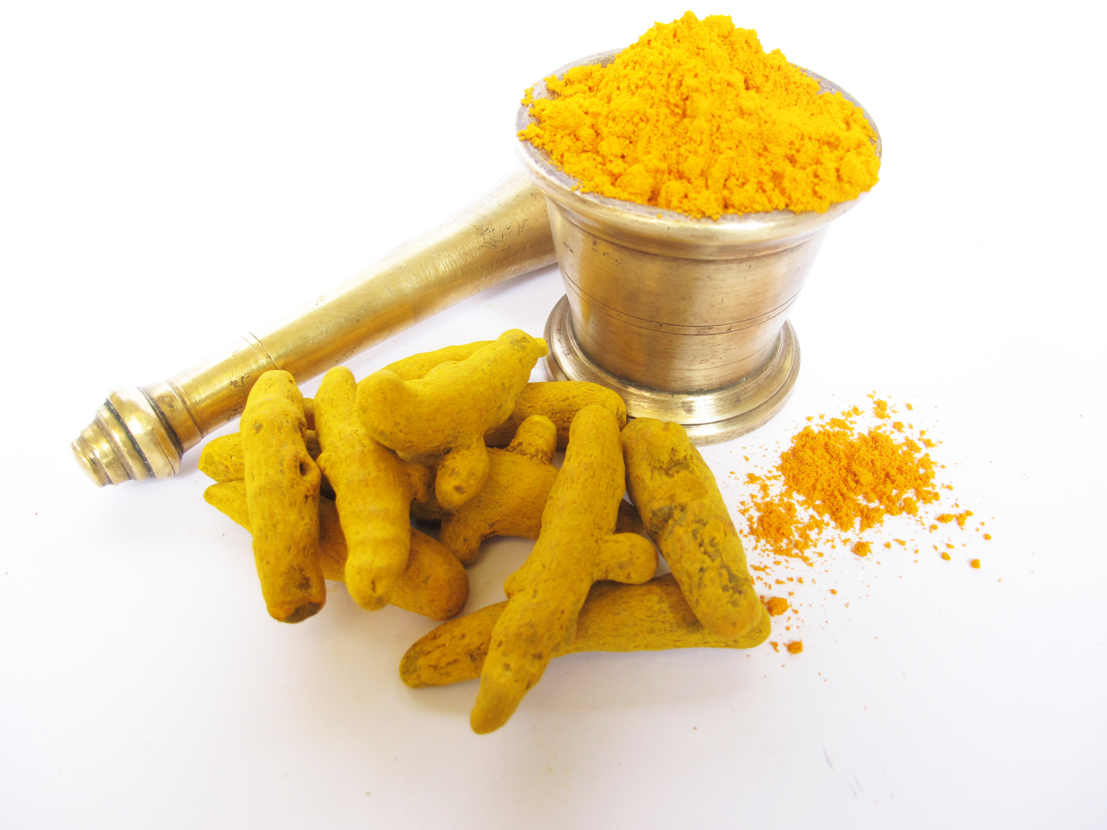
Turmeric is a rhizomatous herbaceous perennial plant of the ginger family Zingiberaceae. It is found mainly in southwest India, Sri Lanka, parts of China, Peru, Bangladesh, El Salvador, Thailand, Taiwan and Indo-China. It requires temperatures of 20-30 degrees Celsius or 68-86 degrees Farenheight. India is the largest producer, exporter and consumer of Turmeric. Indian Turmeric is said to be the best in the world because of its high curcumin content. About 80% of Turmeric production comes from India and exports Turmeric to about 60% of the world.
In one study, Curcumin, the pharmacological agent in Tumeric, was effective in the treatment of Inflammatory Bowl Disease. The mice used in this study had curcumin added to their diet five days prior. Mice were then given an inflammatory agent that normally induces colitis (mucosal ulceration and thickening of intestinal cell wall). The mice receiving curcumin lost much more weight than the control group, and when researchers checked their intestinal cell function, all signs of typical colitis were reduced. Researchers are not exactly sure of how curcumin achieves its protective effects but believe it is due to the antioxidant activity and inhibition of a major cellular inflammatory agent called NF kappa-B. The component of Turmeric used in this study was as low as 0.25%, which is the small amount that is used in curry. However, using Turmeric at very large doses is safe because it has no toxic effects.
Turmeric may cause some adverse effects such as an upset stomach, nausea, dizziness or diarrhea. Any medication that slows blood clotting, such as Aspirin, Plavix, Ibuprofen and Warfarin, interact with Turmeric. Turmeric should not be used during pregnancy, lactation, in patients with gall bladder stones or if you are hypersensitive to any components of curcumin. In one study, turmeric worked just as well as Ibuprofen for reducing osteoarthritis pain. Turmeric can cause GERD (gastroesophageal reflux disease) in some people. GERD can cause acid erosion on the lingual or buccal aspect of the teeth. Some people have found ways to utilize Turmeric in the oral cavity. It has been used to relieve aching, pain and swelling around teeth by massaging roasted, ground turmeric directly on the tooth and gingiva. Others create a mouth rinse by mixing 5 grams of turmeric powder, two cloves and two ground leaves of guava in 200 grams boiled water to provide instant relief from dental problems.
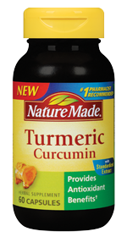
A dental hygienist should know about Turmeric and its anti-inflammatory properties so that if a patient comes into the office explaining why they take it, the hygienist would understand. A consumer might be attracted to this product because it can be used to treat a variety of problems with no toxic effects or risk of toxicity. Also, the adverse effects are much less than that of most medications. A consumer can regulate the product on their own because of the many uses of Tumeric, either medical or in cooking recipes.

Citations
1) "Alphabetical Listing of Natural Products." Drug Information Handbook for Dentistry. Ed. Richard L. Wynn, BSPharm, PhD, Timothy F. Meiller, DDS, PhD, and Harold L. Crossley DDS, MS, PhD. 21st ed. Hudson: Lexi-comp, 2015. 1559. Print.

2) Shishodia S, Amin HM, Lai R, Aggarwal BB. Curcumin (diferuloylmethane) inhibits constitutive NF-kappaB activation, induces G1/S arrest, suppresses proliferation, and induces apoptosis in mantle cell lymphoma. Biochem Pharmacol. 2005 Sep 1;70(5):700-13. 2005. PMID:16023083.

3) "Turmeric." Turmeric. Therapeutic Research Faculty, 2009. Web. 29 Nov. 2015.
http://www.webmd.com/vitamins-supplements/ingredientmono-662-turmeric.aspx?activeingredientid=662&activeingredientname=turmeric

4) "Turmeric World - Turmeric | Turmeric India | Turmeric Erode | Turmeric Name in Other Languages." Turmeric World - Turmeric | Turmeric India | Turmeric Erode | Turmeric Name in Other Languages. Web. 29 Nov. 2015.
http://turmericworld.com/other-names.php

5) "Why Turmeric Is Fantastic for Oral Health and Hygiene." Turmeric for Health. 2015. Web. 29 Nov. 2015. http://www.turmericforhealth.com/turmeric-benefits/why-turmeric-is-fantastic-for-oral-health-and-hygiene

