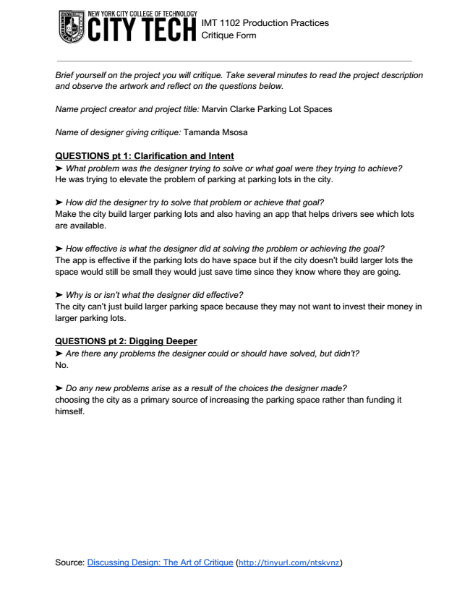
IMT 1102 Production Practices Critique Form
Brief yourself on the project you will critique. Take several minutes to read the project description and observe the artwork and reflect on the questions below.

Name project creator and project title: Marvin Clarke Parking Lot Spaces
Name of designer giving critique: Tamanda Msosa
QUESTIONS pt 1: Clarification and Intent ➤ What problem was the designer trying to solve or what goal were they trying to achieve? He was trying to elevate the problem of parking at parking lots in the city.

➤ How did the designer try to solve that problem or achieve that goal? Make the city build larger parking lots and also having an app that helps drivers see which lots are available.

➤ How effective is what the designer did at solving the problem or achieving the goal? The app is effective if the parking lots do have space but if the city doesn’t build larger lots the space would still be small they would just save time since they know where they are going.

➤ Why is or isn’t what the designer did effective? The city can’t just build larger parking space because they may not want to invest their money in larger parking lots.

QUESTIONS pt 2: Digging Deeper ➤ Are there any problems the designer could or should have solved, but didn’t? No.

➤ Do any new problems arise as a result of the choices the designer made? choosing the city as a primary source of increasing the parking space rather than funding it himself.
)

