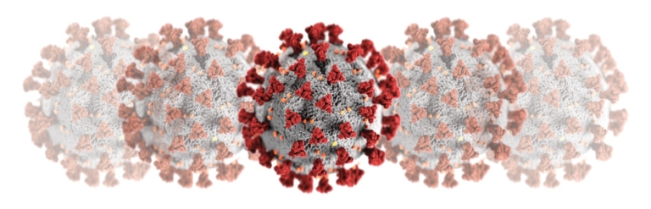
Design for The Homeless
In the midst of the COVID-19 pandemic, many people are suffering a lot of financial and psychological problems. As a technology student, our one clear mission is to make our society better through technology. One of the vulnerable groups near our neighbors is the homeless. In the NYC, thousands of homeless would face with an unprecedent harsh season this winter, particularly because of the virous. One of the issues for the homeless in NYC is bathing to prevent the virus. You are working in a group of excellent engineers and decide to develop a creative solution for the homeless. Use your knowledge in STEM (science, technology, engineering, and mathematics) and present a brief design idea with a sketch.

Design goal: Design a bathing system to help the homeless.
Constraints:
- The budget of the design solution will no more than $100.
- Time limitation: 45 minutes.

