Computer

Networking:

The Basics

Pauline Richard

Contents
Chapter 1: Intro to Computer Networking 3
What is a network?
What is the CCNA?
Why are computer networks so important?
Chapter 2: Network Devices 5
Hubs
Switches
Routers
Chapter 3: Network Models / Ethernet Networking 8
The Hierarchical Network Design
Ethernet Cabling
- Making an Ethernet Cable
Chapter 4: Configuring Routing Protocols 10
How to configure RIPv2 on your router
How to configure EIGRP on your router
How to configure OSPF on your router
Chapter 5: Things to Always Know 17
Important Vocabulary
Chapter 6: Test your Knowledge 20

Intro to Computer Networking CH 1
What is a network?
A network is an arrangement of computers and systems that are interconnected and working together to enable communication amongst each other. This allows the sharing of data between all of the devices.
An excellent example of a network is what we know as the internet, connecting millions of people around the world. And it grows with the use of technological devices such as phones, computers, etc.
What is the CCNA?
The CCNA (Cisco Certified Network Associate) is an IT Certification from Cisco. The certification test is based on computer networking. It tests someone’s knowledge on being able to support and install medium-sized networks. When someone has acquired this certification, it opens up doors to numerous opportunities. These can include internships, jobs, or even a starting a small business of your own.

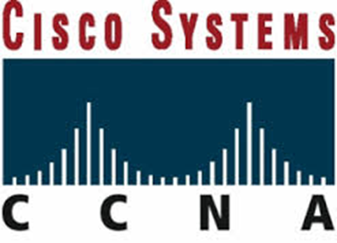
Cisco Logo
CCNA - CISCO Networking Training & Courses in New York, NYC. (n.d.). Retrieved from http://www.acecareer.edu/InterNetworkDevices.php

FUN FACT: The name Cisco Systems is often thought to be an acronym, but it actually derives from San Francisco -- another Silicon Valley-inflected name. This is the reason why, during the company's early days, they insisted on the lowercase cisco.

Why are computer networks so important?
There are numerous obstacles when it comes to communicating information between people and especially in businesses. To be able to communicate efficiently can result in success, something everyone wants. A solution to this issue is computer networks. Computer networks can manage to put down the barriers between information held on several (not only computer) systems. Only with the help of computer networks can a borderless communication and information environment be built.
Computer networks allow the user to access remote programs and remote databases either of the same organization or from other enterprises or public sources. Computer networks provide communication possibilities faster than other facilities. Because of these optimal information and communication possibilities, computer networks may increase the organizational learning rate, which many authors declare as the only fundamental advantage in competition.
Currently, we are literally surrounded by technology. Computers, phones, laptops, routers, etc. are everywhere now and it is unavoidable. Because this is the case, it allows us to communicate efficiently with friends, family, and associates around the world. We are all interconnected through technology and technology has been proven extremely helpful in our everyday life.

Network Devices CH 2
Hubs
A hub is a Layer 1 (Physical Layer) devices that are just multiple port repeaters. They are commonly used to connect segments together in a LAN. A hub is constructed of multiple ports. When a packet is received at one port, it gets copied to all other ports so that all segments of the LAN can see all packets.
Hubs have been primarily replaced by switches. Hubs and switches serve as a central connection for all your network equipment and handles a data type known as frames. Frames carry data. In a hub, a frame is transferred or broadcast to all other ports. It’s sent to every port even though it has only one destination. The hub cannot distinguish the port a frame should be sent to. If frames are sent to each port, it will ensure that it will reach its proper destination.
Advantages of using hubs:
- Cost: Less expensive than switches
- Simplicity: They simply broadcast information received, to all ports on the network
- Speed: They do less processing, since they can’t analyze received data.
Disadvantages of using hubs:
- The more devices there are, the slower the network becomes.
- Traffic problems and collision problems arise easily, due to the splitting of bandwidth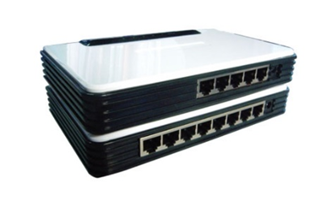
(Hubs)
fast switch hubs ,switch. (n.d.). Retrieved from http://www.bombayharbor.com/Product/18214/Fast_Switch_Hubs.html
Switches
A switch in networking, is a device responsible for multiple functions such as filtering, flooding, and sending frames. It operates by using the destination address of individual frames. Switches operate at the Data Link Layer (Layer 2) of the OSI model. A switch can replace a hub, breaking up collision domains.
Advantages of using a switch:
- Packet Handling: Designates specific destinations, preventing collisions for occurring
- Collision Management: Improves performance and efficiency, increasing bandwidth
- Bandwidth Utilization: Enables switches to send and receive data at the same time
- Problem Isolation: Makes it easy to pinpoint a problem and allows normal functionality
Disadvantages of using a switch:
- It can be difficult to install and use
- Often require extensive repair if the network goes down
- If configuration is necessary, it can be complicated
(Switch)
Cisco Catalyst Express 520 Series Switches - Cisco. (n.d.). Retrieved from http://www.cisco.com/c/en/us/products/collateral/switches/catalyst-express-520-series-switches/product_data_sheet0900aecd8060aee4.html
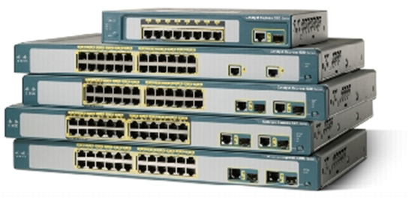

Routers
A router is a physical device that connects various networks together. Routers take data/information, decipher it and deliver it to either your computer, phone, or its destination. They enable a quick transfer of information by choosing the best route for the data to be sent. They are also the primary devices used to join networks due to their efficient methods of transferring data. Routers can also be referred to as a gateway, which work at the Network Layer (Layer 3) of the OSI model.
There are many types of routers, but two main ones are broadband routers and wireless routers. A broadband router is “a device that provides access to the Internet for multiple computers. It typically includes a network switch with four or more Ethernet ports for wired connections to desktop and laptop computers.” They can be used to connect different computers, two computers to the internet, or even create a phone connection.
A wireless router is a device that acts just like a router, but it includes a wireless access point. It is generally used to access the internet or computer networks and it allows for greater mobility for portable computers and hand held devices.
Some benefits of using a router in your network:
- They don’t forward broadcasts by default
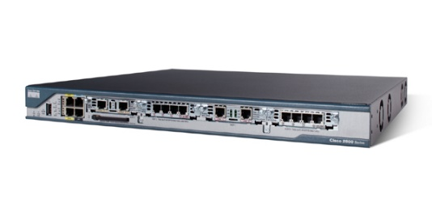
- They can filter the network based on Network Layer (Layer 3) information.

(Cisco Router)
Network-Guarantee,. (2011) Cisco Routers CISCO2801-SHDSL-V3/K9 | network-guarantee.co.uk. (n.d.). Retrieved from http://network-guarantee.co.uk/network/products-page/cisco-router/cisco-2800-series-services-routers/cisco-routers-cisco2801-shdsl-v3k9/

Network Models/Ethernet Networking CH 3
The Hierarchical Network Model
This network design is a divided network of discrete layers. The three layer design provides major functional responsibilities that define their role in the network. This design represents their roles in any network and provides a basis for understanding a scalable network.
Access Layer
This layer provides local and remote user access by connecting end users to the network. This occurs with the use of hubs or switches to which PC’s are connected, a wireless access point, a remote office connection, etc.
Distribution Layer
This layer helps control the flow in data between the access and care layer. It provides packet filtering, QoS (quality of service), routing and WAN access.
Core Layer
This layer is all about high-speed. Here, usually fast switches transfer data from the distribution layer to centralized resources such as database servers.
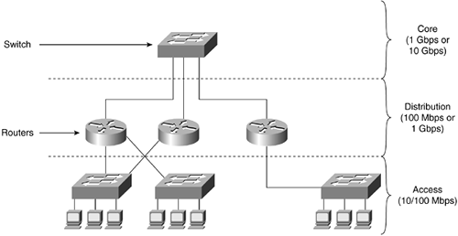

Switched LAN Network Design Principles - Retrieved from https://encrypted-tbn1.gstatic.com/images?q=tbn:ANd9GcRBuSyStrHNpn710xU2WDW9xbN_LwZ_rlrHXqR_zamfRb9ZOdCO
Ethernet Cabling
Three types of Ethernet Cables are available:
- Straight-through cable
- Crossover cable
- Rollover cable
Straight-through Cable
The straight-through cable is used to connect:
- A host to switch or hub
- A router to switch or hub
Four wires are used in straight-through cables to connect Ethernet devices. It’s quite simple to create this type of cable.
Crossover Cable
The crossover cable is used to connect:
- Switch to switch
- Hub to hub or switch
- Host to host
- Router direct to host
Rollover Cable
The rollover cable isn’t used to connect any Ethernet connections together. It can be used to connect a host to a router console serial connection port. Eight wires are used in this cable to connect serial devices, even though not all eight are used to send information.
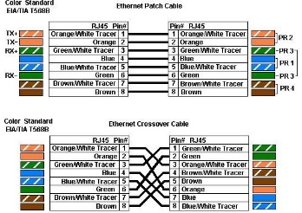

This is the standard color charts of a straight-through and crossover cable. This diagram is used when creating these cables. To make this cable, you will need CAT-5, non-plenum Ethernet wire, RJ-45 (Ethernet) male connectors, wire cutters, and a crimping tool for RJ-45 connection.
Making an Ethernet Cable
First, we need tools! The tools/items you need to make an Ethernet cable is a CAT-5, non-plenum Ethernet wire, RJ-45 (Ethernet) male connectors, scissors, measuring tape, wire cutters, and a crimping tool for RJ-45 connection. Once we have all these things we can get started. It’s actually quite simple and once you get the hang of it you can do it in 2 minutes or even less!
- Take the CAT-5 Ethernet wire and measure the length you need it to be using the measuring tape. It could be 5 feet or 20 feet. It all depends on the distance between the two devices you plan on connecting. So you measure the amount you need with a little extra just in case then with the pair of scissors cut it at that end of measurement.
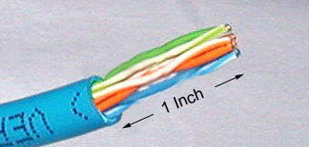
- Now you’re going to take the crimper and it also has two blades part of the tool just for removing the outer jacket of the cable. One of the blades are adjustable because cable sizes can change. To cut the outer jacket you can turn the tool with the razors about twice and that should be enough. You don’t want to cut the wires that are inside. Cut into the plastic sheath about 1 inch (2.5 cm) from the end of the cut cable. Then remove the plastic.
- Inspect the wires for any cuts or scrapes. If there are cuts or scrapes on any wire you need to cut that whole part off and redo the first two steps. This is why you add a little extra length to the wire.
- Untwist the pairs and straighten them out using your fingers. The white piece of thread you’ll see can be cut off even with the jacket and disposed. 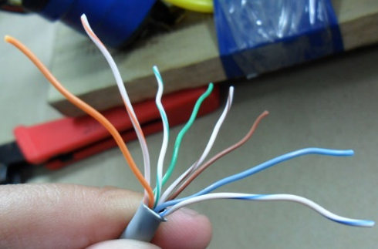
- Arrange the wires based on the wiring specifications you are following. There are two methods set by the TIA, 568A and 568B. Which one you use will depend on what is being connected. The difference between the two is that a straight-through cable has both ends wired identically with 568B, while a cross-over cable has one end wired 568A and the other end wired 568B.
-Using the chart above, you’ll arrange the wires of 568B in the following order, left to right as: White Orange, Orange, White Green, Blue, White blue, Green, White Brown, Brown.
-You’ll arrange the wires of 568A in the following order, left to right as: White Green, Green, White Orange, Blue, White Blue, Orange, White Brown, Brown.
- Straighten out all the wires and pinch them between your fingers. Verify that all the colors remain in the right order. Use scissors to make a straight cut across the wires 1/2 Inch (1.3 cm) from the cut sleeve to the end of the wires. 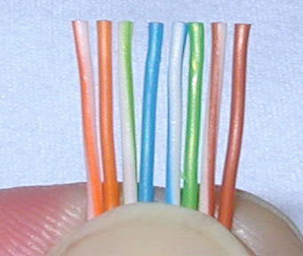
- Keep the wires flat and in order as you push them into the RJ-45 plug with the flat surface of the plug on top. The white/orange wire should be on the left if you're looking down at the jack. You can tell if all the wires made it into the jack and maintain their positions by looking head-on at the plug. You should be able to see a wire located in each hole, as seen at the bottom right. You may have to use a little effort to push the pairs firmly into the plug. The cabling jacket should also enter the rear of the jack about 1/4" (6 mm) to help secure the cable once the plug is crimped. You may need to stretch the sleeve to the proper length. Verify that the sequence is still correct before crimping. 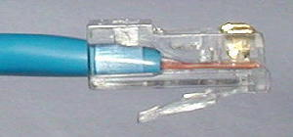 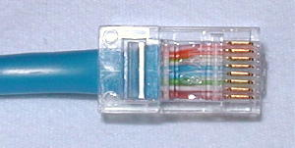
These images show what the correct way looks like.
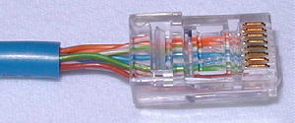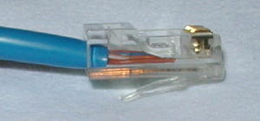
These images above is what it should NOT look like. In the picture on the left the wires are too long and the Blue plastic sleeve isn’t in the connector where it would be locked in place. On the right, the cables did not reach the front on the connector.
- Place the wired plug into the crimping tool carefully. Get a good handle, give a firm squeeze and you should hear a ratcheting noise as you continue. Once you have completed the crimping correctly, the crimper will reset to an open position. If not, it will stay closed until the connector was crimped correctly. 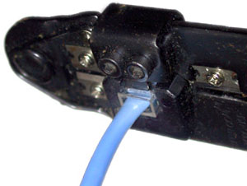
- Repeat all of the steps above at the other end of the wire. The way you wire the other end (568A or 568B) will depend on whether you're making a straight-through, rollover, or cross-over cable.
- Make sure to test the cables before installing them. An inexpensive Ethernet cable tester does this quite well.
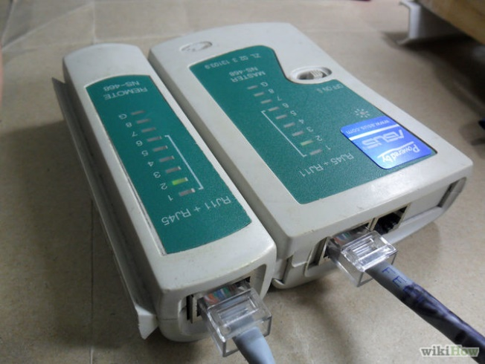
Configuring Network Protocols CH 4
How to RIPv2 on your router!
Both versions of RIP, RIPv1 and RIPv2, are Distance Vector Routing Protocols that use router hop counts as their metrics. They support a maximum hop count value of 15. Any router farther than 15 hops away is considered to be unreachable.
The main enhancement of RIPv2 over its ancestor is the fact that it first sends the subnet mask with the updates; hence it is considered to be a classless routing protocol in the sense that it is able to distinguish among different subnets – which is something that is not found in RIPv1.
Configuring RIP routing protocol consists of three basic steps:
- Enabling RIP routing protocol on the router
- Specifying the RIP version to run
- Configuring the network addresses to be included in routing updates or specifying the interfaces to participate in routing updates
Using the Cisco IOS, the command to enable RIP routing protocol is router rip. The version command is used to specify which RIP version to use (either 1 or 2). If the version command is omitted then the router defaults to sending RIPv1 but can receive both RIPv1 and RIPv2.
The network command is used to specify the directly connected subnets on the router to be configured and that are intended to be included in the routing updates. This is a good time to point out that you still specify classful networks with the network command.
According to the classful, network specified, the subnets of that network are automatically identified and participate in the routing update. By default routing updates are summarized at network boundaries.
In RIPv2 this auto summarization behavior can be turned off using the no auto-summary command. Moreover, manual summarization can be configured on a per interface level.
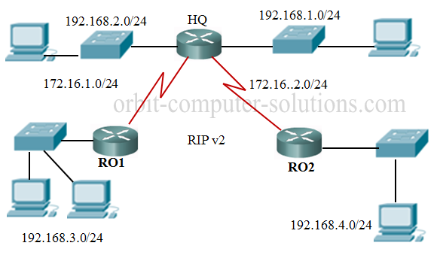
For example, using this diagram we will configure RIPv2:

You need to go into the router HQ and you will type in:
HQ#configure terminal
HQ(config)#router rip
HQ(config-router)#version 2
HQ(config-router)#network 192.168.1.0
HQ(config-router)#network 192.168.2.0
HQ(config-router)#network 172.16.1.0
HQ(config-router)#network 172.16.2.0
HQ(config-router)#end
From the configuration above, the router rip command activates the protocol, version 2 defines the RIP version in use and the networks directly connected to the router HQ network were all declared. All routers on the network must be configured the same way, each router must declare its directly connected network to be seen by other routers on the network.

How to Configure EIGRP on your router!

Sources
Valentine, M., & Barker, K. (2013). Cisco CCNA routing and switching 200-120 (4th ed.). S.l.: Pearson Education.
Johnson, A. (2012). 31 days before your CCNA exam (2nd ed. ed.).
Lammle, T. (n.d.). CCNA Cisco Certified Network Associate Stdy Guide (6th ed. ed.). SYBEX Serious Skills.
Beal, V. (n.d.). Hub. Retrieved October 15, 2014.
Cisco Catalyst Express 520 Series Switches. (n.d.). Retrieved October 15, 2014.
Network Switches vs. Hubs: Advantages and Disadvantages. (2013, August 7). Retrieved October 15, 2014.
Fast switch hubs. (n.d.). Retrieved October 15, 2014.
Cisco Routers CISCO2801-SHDSL-V CCNA:How to Configure RIP v2: step-by-step. (n.d.). Retrieved from http://www.orbit-computer-solutions.com/How-to-Configure-RIP-v2.php3/K9. (2009, July 9). Retrieved October 31, 2014.
How to Configure Routing Information Protocol: RIPv2. (n.d.). Retrieved from http://blog.pluralsight.com/cisco-how-to-configure-rip-2
How to Make a Network Cable: 11 Steps (with Pictures) - wikiHow. (n.d.). Retrieved December 5, 2014, from http://www.wikihow.com/Make-a-Network-Cable
How to Make an Ethernet Cable - Cat5, RJ45 Connectors - VSAT Installation Training. (n.d.). Retrieved from http://www.groundcontrol.com/galileo/ch5-ethernet.htm

