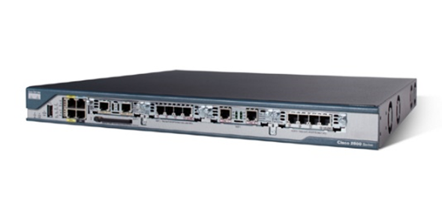
Network-Guarantee,. (2011) Cisco Routers CISCO2801-SHDSL-V3/K9 | network-guarantee.co.uk. (n.d.). Retrieved from http://network-guarantee.co.uk/network/products-page/cisco-router/cisco-2800-series-services-routers/cisco-routers-cisco2801-shdsl-v3k9/

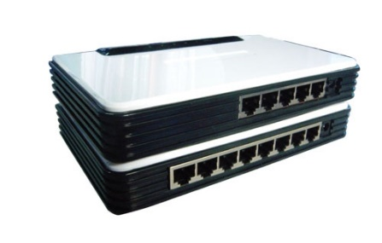

fast switch hubs ,switch. (n.d.). Retrieved from http://www.bombayharbor.com/Product/18214/Fast_Switch_Hubs.html

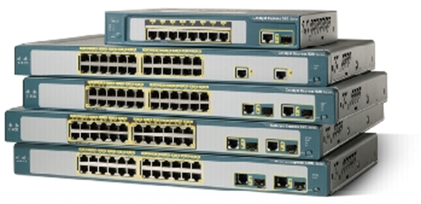

Cisco Catalyst Express 520 Series Switches - Cisco. (n.d.). Retrieved from http://www.cisco.com/c/en/us/products/collateral/switches/catalyst-express-520-series-switches/product_data_sheet0900aecd8060aee4.html

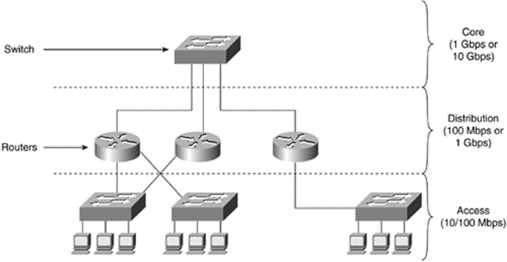
Switched LAN Network Design Principles - Retrieved from https://encrypted-tbn1.gstatic.com/images?q=tbn:ANd9GcRBuSyStrHNpn710xU2WDW9xbN_LwZ_rlrHXqR_zamfRb9ZOdCO

