This is a graphic representation of a network so that the readers can see/understand what a network is, remember it and relate it to real life.
-Network Setup, Diagnostics and Troubleshooting for Your Home or Office. (n.d.). Retrieved October 10, 2014.
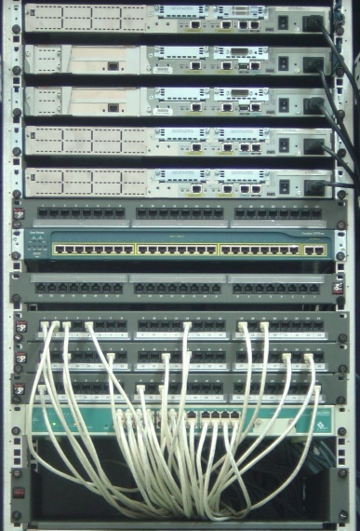
This is a real world image of an arrangement of Cisco routers and switches. This is often how they are set up so all ports can be viewed and easily accessible.
Cisco Routers And Switches. (n.d.). Retrieved October 10, 2014.

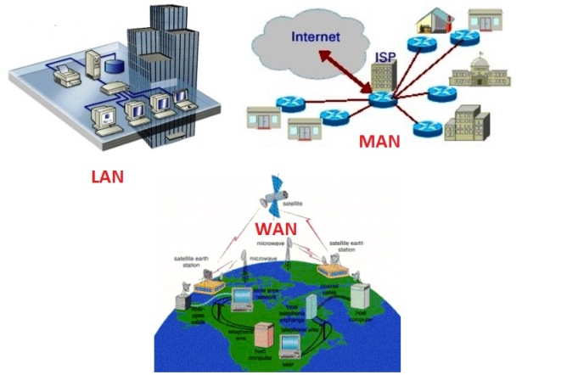
This image helps represent the different types of area networks (WAN, LAN, MAN).
José crispim. (n.d.). Retrieved October 10, 2014.

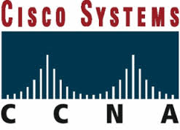
I’d use this when I introduce what the CCNA is. I’ll also provide a little fun fact.
CCNA - CISCO Networking Training & Courses in New York, NYC. (n.d.). Retrieved from http://www.acecareer.edu/InterNetworkDevices.php

