HOW TO CREATE THE BASIC SLOPERS
A GUIDE FOR CREATING THE BASIC TEMPLATE SET
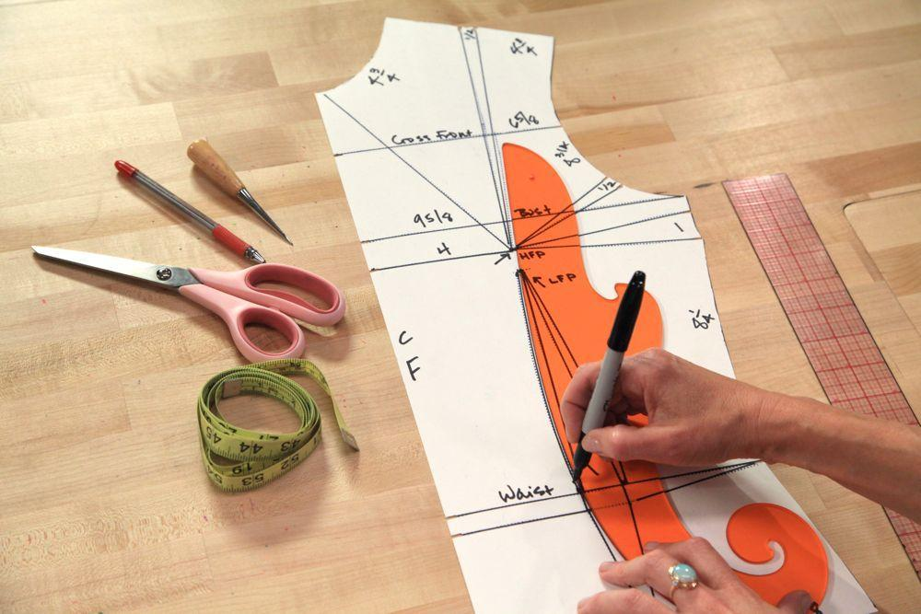

Patricia C. Paulino
Table of Contents

What is a sloper? – Page 3

Tools and functions - Page 4 through page 6

Measurements - Page 7 through page 10

Drafting the front and back bodice sloper – Page 11 through page 12

Drafting the front and back skirt sloper – Page 11 through page 13

What are slopers?
Slopers are the basic templates used to create patterns. They are the master pattern and include ease for body movement but not seam allowance for sewing. Once seam allowance is added, it becomes a pattern. Slopers are created through body measurements. The basic sloper set includes a front waist bodice, a back waist bodice, a front skirt, and a back skirt sloper as displayed below in figure 1.
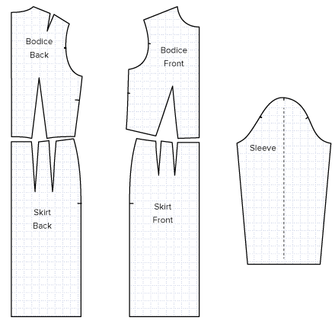
Figure 1 Wordpress

Tools and Functions
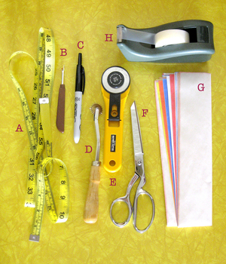
- MEASURING TAPE
Figure 2 Haynes 1
- used to measure body and
curved areas
- SEAM RIPPER
- used to cut seams
- MARKER
- to make defined lines on the muslin
- SHORT TOOTH TRACING WHEEL-
- to puncture patterns and transfer
info
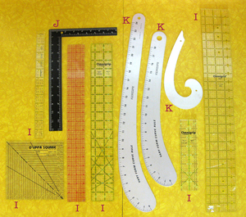
- ROTRATRY CUTTER
Figure 3 Haynes 2
- to cut fabric
- FABRIC SHEERS
-to cut fabric
- TRACING PAPER
- to transfer information from one
pattern to another
- TAPE
- to tape down the pattern paper
when manipulating
- C-THRU RULERS
- to mark measurements as well
as create straight lines
- L-SQUARE
- to create perpendicular lines
in patterns
- VARY FORM CURVE/ FRECH CURVE-
- to create well defined and
smooth curved lines on
pattern (hip, armhole or necklines)
- PATTERN PAPER
- light weight dotted paper to
make patterns
- SEWING MACHINE
- to sew muslin
- THREAD
- to attach the muslin
- WAXED CHALK
- to mark fabric, can be removed
using steam
- PINS
- to fit muslin and attach muslin or paper
- GRADE ONE MUSLIN
- thick but flexible muslin, very
forgiving for stitching
- PAPER SCISSORS
- to cut paper, interchanging
scissors for fabric and paper
can damage them
- BOBBIN
- threaded to create bottom stitch
on sewing machine
- BOBBIN CASE
- to hold bobbin
- DRESS FORM
- model size used to create slopers
- STYLING TAPE
- to mark style lines on dress form
- MIRROR
- will help with fitting
- PENCIL
- to mark paper or muslin
- OAK TAG
- to transfer final pattern

- IRON
- to press and steam out wrinkles

Measurements
When creating a sloper, you can either make one for yourself using your own measurements or you may use the standard measurement chart shown on the page 10. *Standard measurements can change at anytime due to industry aesthetics.
Taking measurements:
When measuring your body or a dress-form you will need a mirror and a measuring tape. Always reference back to the mirror to make sure you are holding the tape measure straight. Use the reference below and chart on the next page to guide you in which measurements to take.
*Only measurements from one half of body are necessary, if measured around completely, divide by half.
Center front (green line)- from neckline to waistline
Neckline (orange line)- measure from shoulder to center front
Bust line (purple line)- measure from side seam to center front
Waistline (yellow line)- measure from side seam to center front
Side seam (black line)- measure from bust line to waist line
Princess line (red line)- measure from center of shoulder slope to waist
Shoulder Slope (blue line)- measure from neckline to shoulder blade *shoulder blade is where the shoulder stops and arm begins

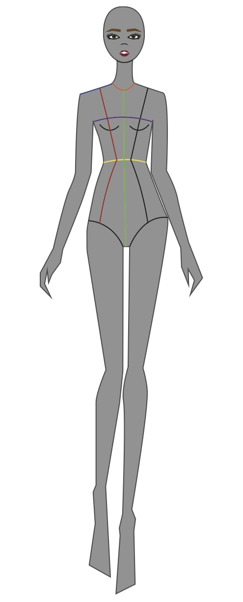
Figure 4 Paulino

Name Description Measurement Add/ Sub Total
Front Measurements
Front Length | Shoulder/ Neck pt. thru apex to waist
Bust width + ½ | Mark 1” below armhole plate. Measure from CF thru Apex to 1” mark curving up towards SS
Front Neckline Curve (length) | Should/ Neck pt. to waist minus CF from neckline to waist
Front Neckline Curve (width) | CF/ Neckline to shoulder tip minus shoulder length
CF to Apex
Apex to waist
Underarm seam | 1” below armhole plate to waist
Front Waistline + ¼
Waistline to shoulder + 3/8 | Measured along SS through armhole plate up to shoulder ridge
Shoulder length
Front Princess | Measured from CF to princess line along waist line

Back Measurements
Back Width + ¾ | Measured at 1” below armhole level
Back length +1/8 | High shoulder / Neck pt. to waist
Back Neckline curve (length) | Difference between back length and CB to waist at neckline
Back Neckline curve (width) | Same as front neckline width
Back waistline + ¼
Shoulder blade + 1/8 | One fourth on CB measurement down from neckline then measure across
Back princess line | Measured from CB to princess line along waist line
Back Bust line | Measure across from front bust line to back princess and determine the measurement from the waist up

Bibliography
Basic Slopers. (2012, March 7). Retrieved May 5,2015

Figure 5 Armstrong
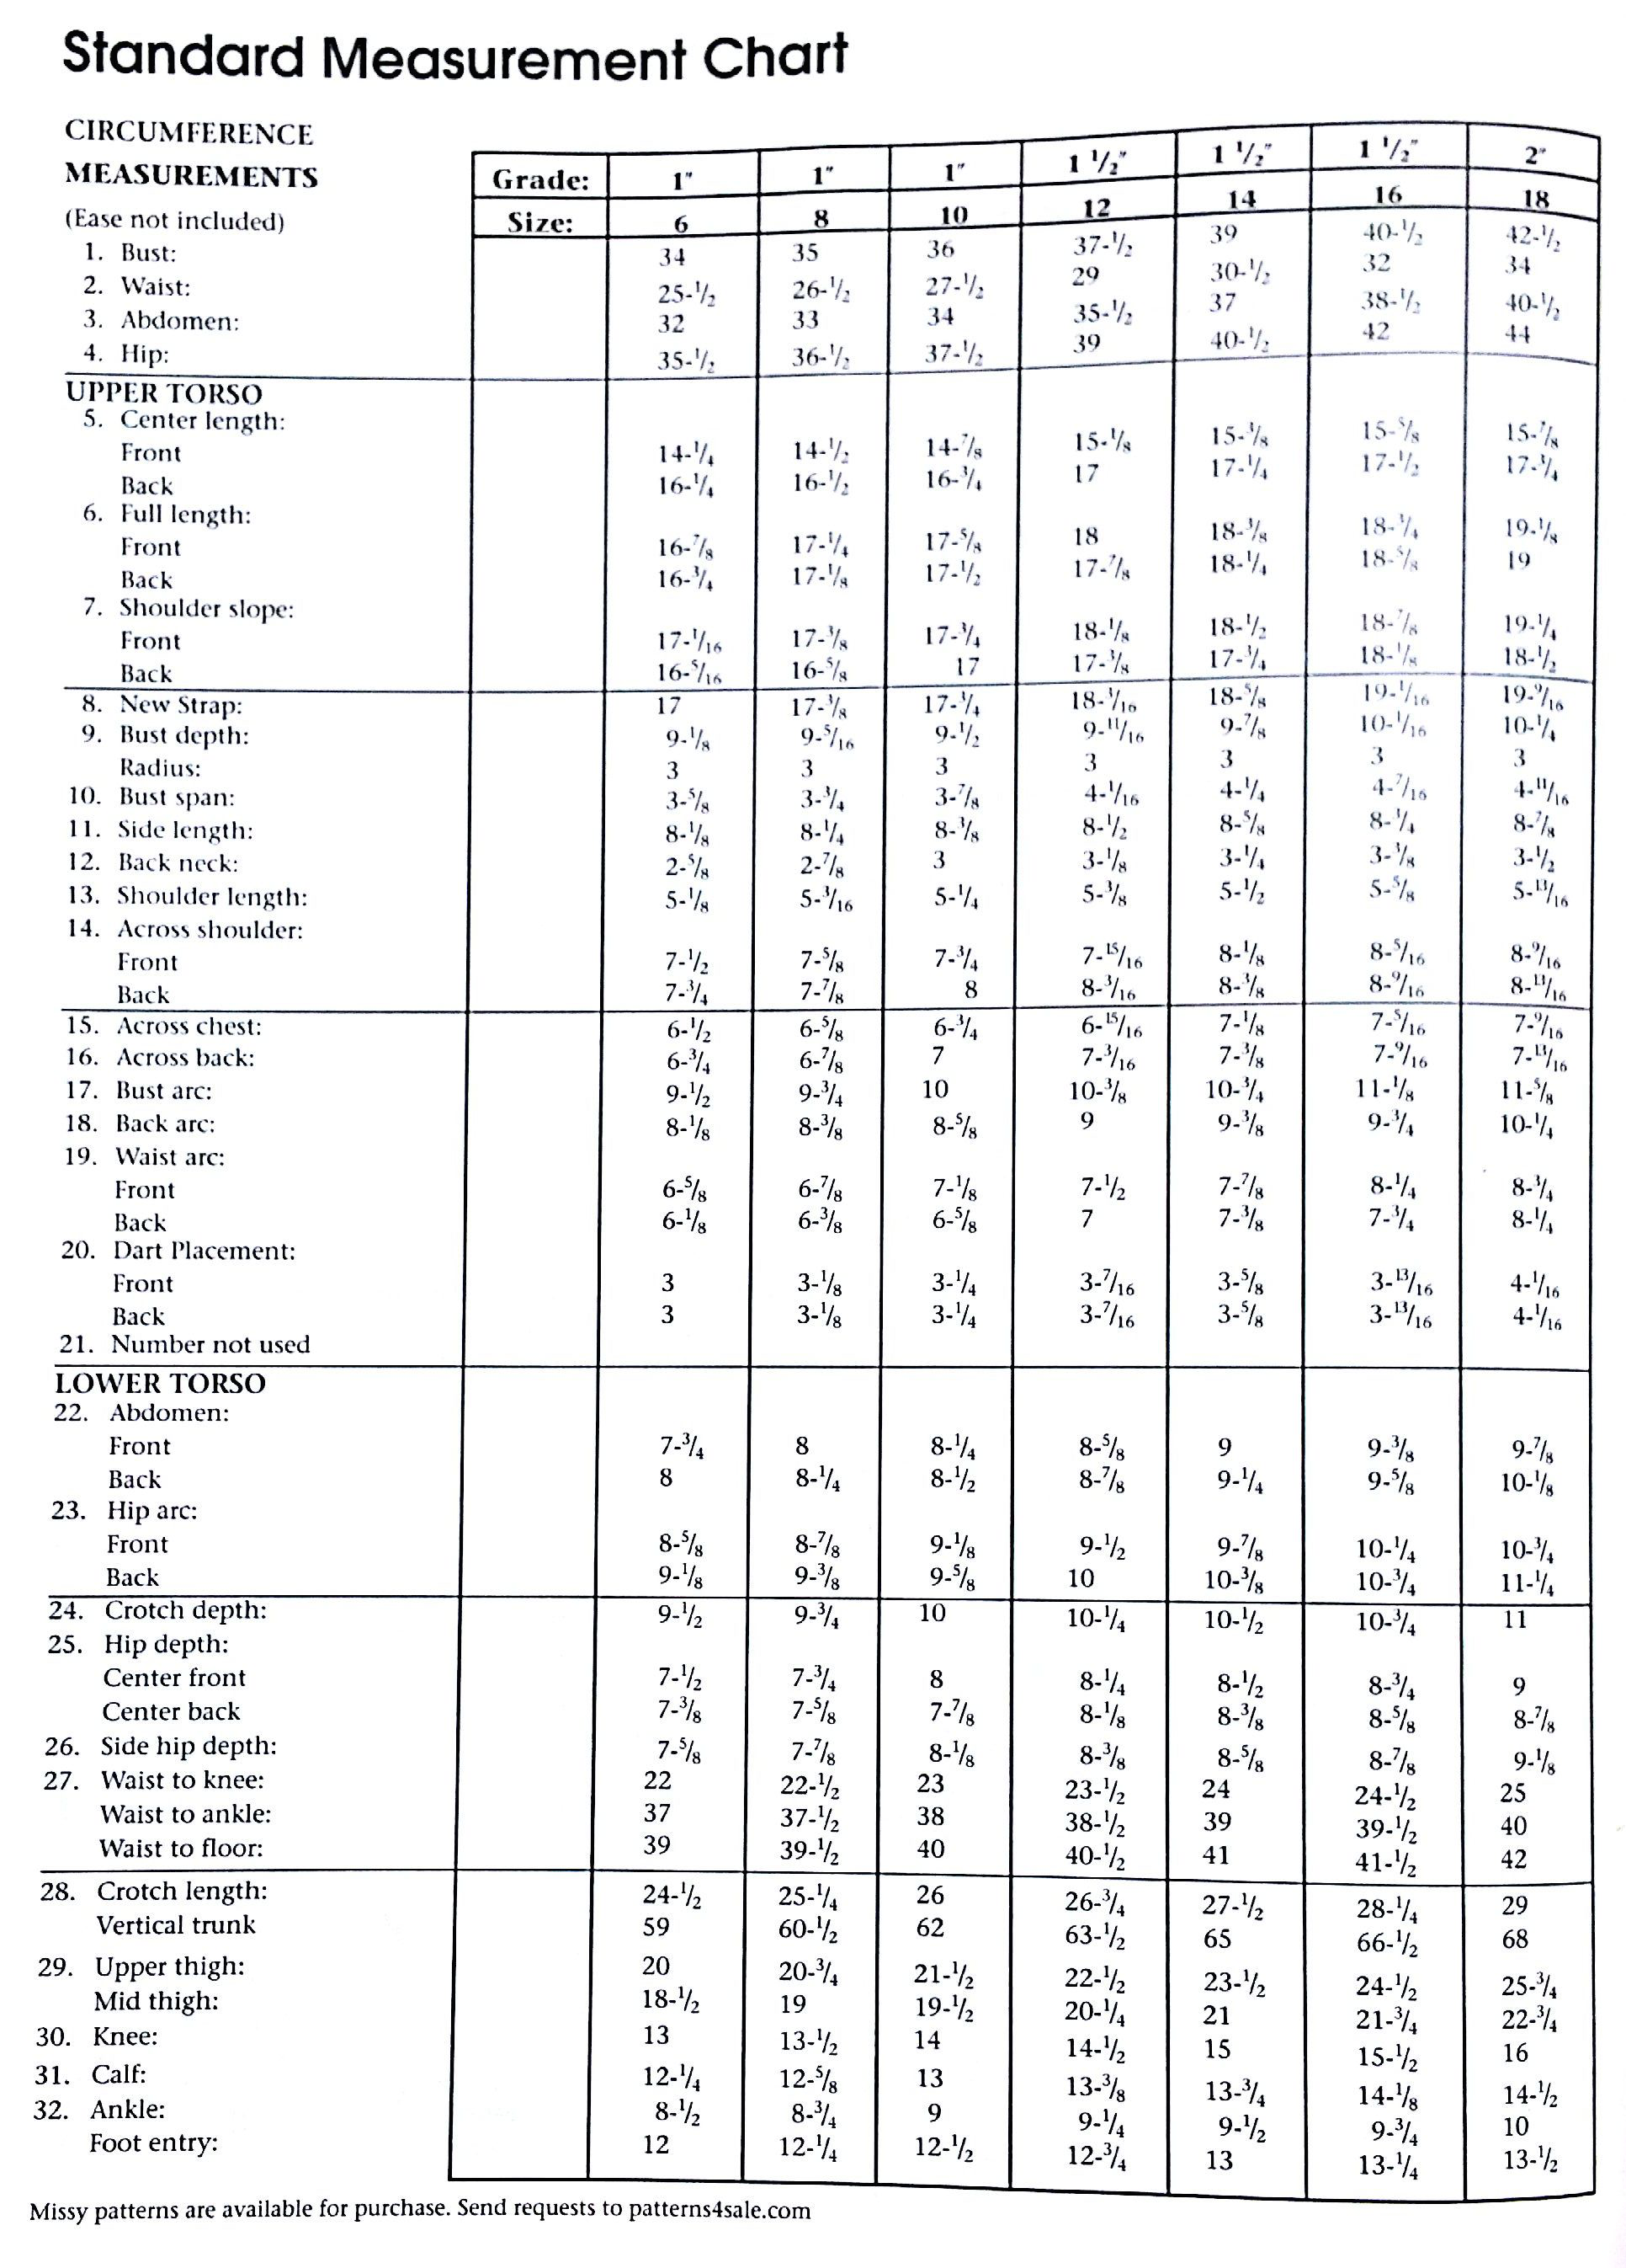

Drafting the Front and Back bodice sloper
- Cut a 30” x30” sheet of pattern paper
- Mark 3 inches down and draw a line across (high shoulder tip)
- Fold paper in half with line overlapping *work with fold towards yourself
- From fold, mark total bust width measurement and draw a perpendicular from the 3” mark (creating center front)
- From the high shoulder tip, go down the front length and draw a line across
- Go in 1 ¼ “ at waistline and mark it.
- On CF at waistline measure up apex to waist measurement and draw line across
- Draw line connecting 1 ¼” point to apex to waistline at the fold.
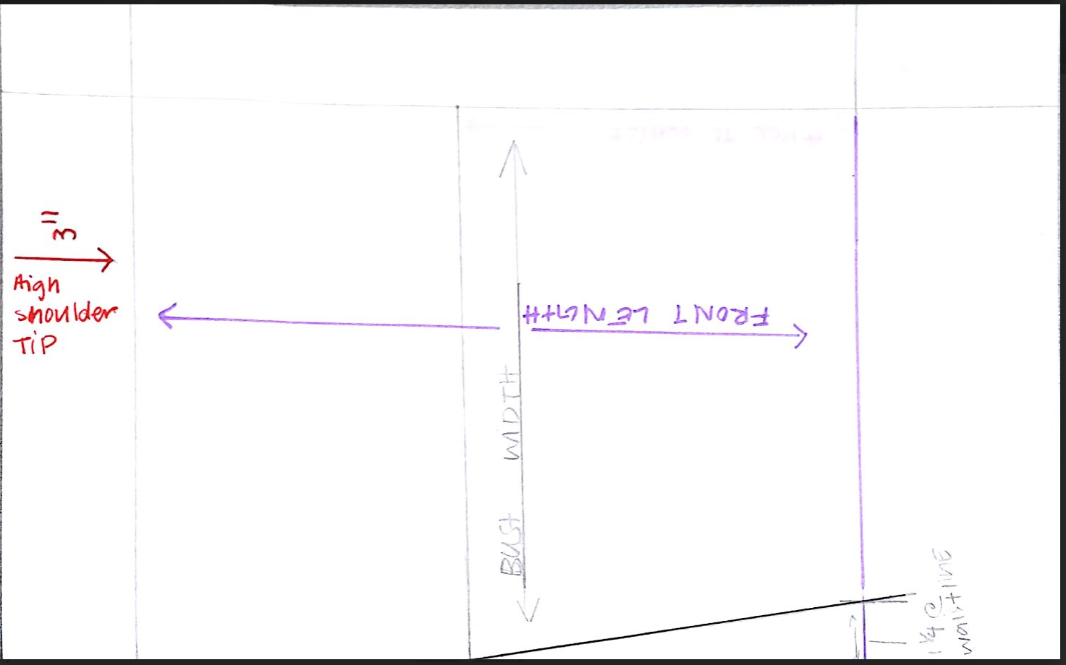
Figure 6 Paulino sloper draft
- From CF line, come in front neckline curve (width)
- From CF line, go down front neckline curve (length)
- Connect points from steps 9 and 10 with French curve
- Mark 1” long line ½ “ from fold
- Connect high shoulder tip to the point on steps 12 with a ruler
- Connect the cross point on step 13 with side seam line at apex with French curve
- Measure half of entire shoulder measurement from either side of shoulder tips and mark. Connect point to apex.
- Mark front princess o waist and connect to apex.
- From side seam at waist, mark the remaining measurement and connect to apex.
- Close all darts and true.
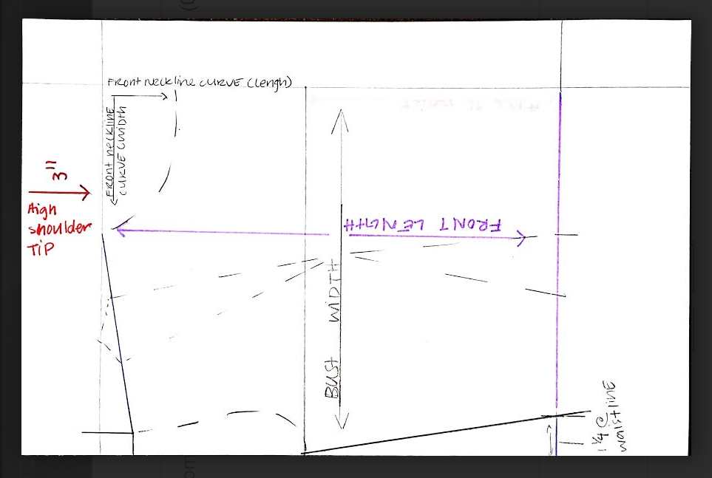
Figure 7 Paulino front bodice
For Back bodice Sloper:
- Flip paper and trace waist, bust and side seam lines.
- Measure from fold to back width and draw a line parallel to your fold (center back).
- On Center back go down neckline curve length and in neckline curve width.
- Connect measurements with French curve
- Unfold paper. From the tip of the neckline, connect to the low point of the front shoulder.
- Mark shoulder length.
- Connect from low shoulder to top of side seam to create back armhole.
- Mark from center back to back princess
- From side seam at waist, mark the remaining measurement and connect to 6 ½”- 7”
- Close dart and true waist.
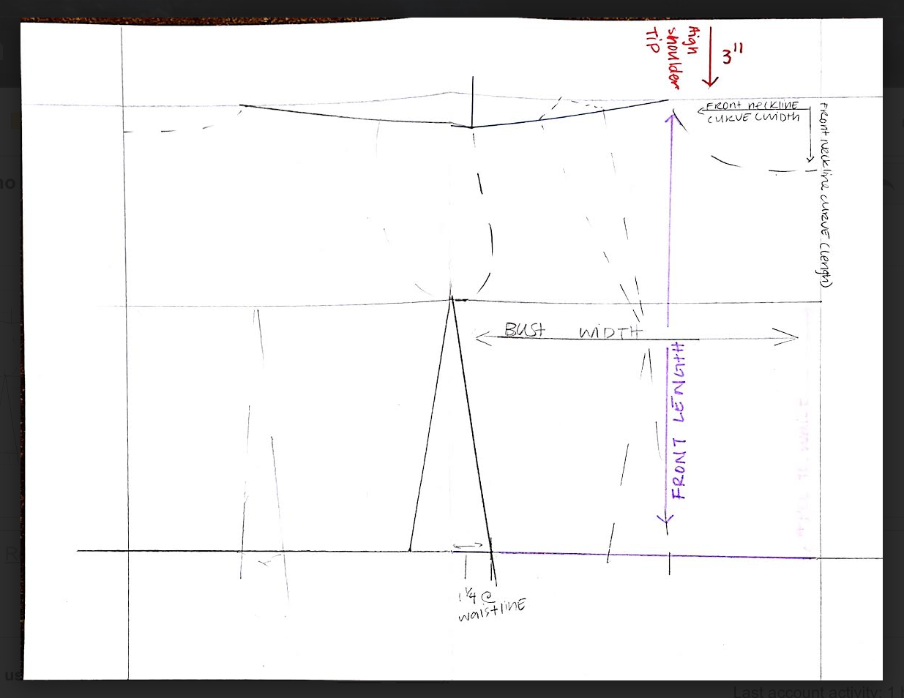
Figure 8 Paulino bodice set
Cut sloper drafts and transfer to oak tag. Use the notcher to mark dart legs.
Drafting the Front and Back skirt sloper
- Cut a 30” by 30” sheet of paper
- Draw a line 10” down from the top (hip line)
- Fold paper in half with the line overlapping on itself.
- Go out however much the hip measurement is plus 3/8” and draw a line parallel to the fold
- Go up 7 inches from your hip line (waistline)
- From hip line, go down 20” (hemline)
- From CF go out princess to waist measurement
- From the side seam, go in the remaining waist measurement
- In the middle of the two points, go down 5½ ” and connect two both points (Dart)
- With Hip curve, connect from the hip line to waistline.
For back skirt sloper:
- Trace waist, hip, side seam and hemlines
- Mark from center back to back princess line
- Using back waistline measurement, go in from side seam and mark remaining measurement.
- Draw line in between the two spaces 6” down and connect.
- Close dart and true waistline with hip curve.
- Cut both sloper and transfer to oak tag.

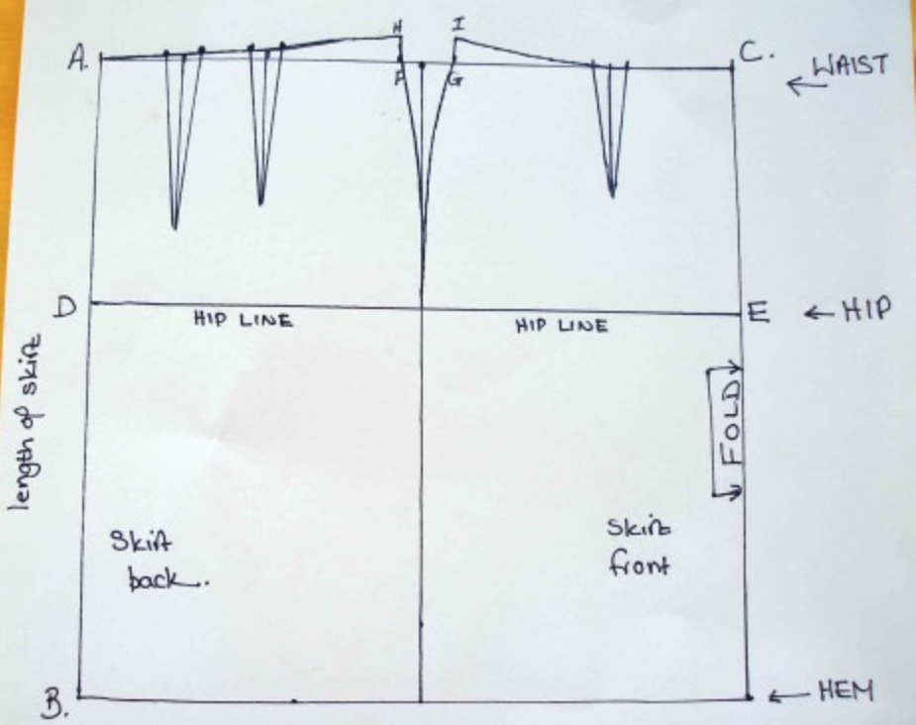
Figure 9 Sew easy

Bibliography
Basic Slopers. (2012, March 7). Retrieved May 5,2015
Armstrong, H. (1987). Patternmaking for fashion design (5th ed.) New York, New york: Harper & Row
Lo, D. (2011). Patternmaking. London: Laurence King.
Making a pencil skirt sloper and the resulting skirt- So Sew Easy. (2013, March 28). Retrieved May 7, 2015, from http://so-sew-easy.com/making-a-pencil-skirt-sloper/

