APPLICATION OF BERNOULLI’S EQUATION IN FLUID DYNAMICS

One very real-world application of differential equations can be found in solving problems in fluid dynamics.
Bernoulli’s equation helps us to solve fluid pressure equations in the real world. These equations can include variables of height, velocity, cross sectional area, density, etc.
One example I found interesting was fluid flowing through a pipe with varying cross- sectional area and height. It was stated that the we needed to find two unknowns (velocity and pressure) of a fluid exiting the pipe if given the density, pressure and velocity of the fluid entering one side and also the cross sectional-area of both openings of the pipe.
In the real world we can visualize this as a firehose that has a big opening at one end to attach to a hydrant and then tapers off at the tip to a nozzle of a smaller cross-sectional area than that of the inlet. The water flowing from the hydrant into the hose will have an initial velocity (V₁) and pressure (P₁). However, we need to find the velocity at the nozzle (V₂) and pressure (P₂), while accounting for the change in cross sectional area of the hose. Keep in mind also, that the nozzle of the hose is elevated as its attempting to extinguish a fire in the upper levels of a building.
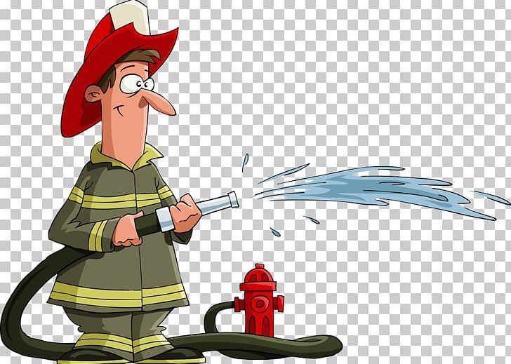
So, how do we find two unknowns? Bernoulli’s equation helps in this regard and it states:
P₁+pgh₁+1/2pv₁² = P₂+pgh₂+1/2pv₂²
If we rearrange the equation since we need to find P₂, the new equation derived reads:
P₂ = P₁+pg(h₁-h₂) +1/2pv₁²-1/2pv₂²
First, we need to consider delta v/ delta t (amount of fluid per unit time) = constant at any point in the hose.
Secondly, we must realize that delta v/ delta t (amount of fluid per unit time) = v x A (cross-sectional area).
Therefore, we can construct the following equation:
V₁A₁ = V₂A₂
V₂ = V₁ (A₁/A₂).
Now we have solved for the velocity of the water exiting the nozzle (V₂), leaving us with one unknown, pressure (P₂).
We can now apply Bernoulli’s equation to solve for the pressure exiting the nozzle.

