Jennifer Agudelo, Denny Caisaguano
MAT 2680
Hurricane Forecasting – Differential Equations
Introduction to weather
The weather is part of our day-to-day and although thanks to modern technology we always know what to expect from it although till this day our predictions aren’t 100%. This was not always the case, what people used to do was almost guess the weather then await them by looking at the sky, and as a shock the predictions were quite accurate at times but as well there were times were the guesses were completely wrong. Later scientists found the relationship between temperature, air pressure and the weather and by using limited tools they began to come up with predictions that were even more accurate. Scientist came to the conclusion that in order to make climate forecasts they had to understand the routines that were presented, and this led to the creation of weather observation centers and weather maps, which allowed scientists to spot and comprehend complex storm systems and wind patterns as well as comparing the present meteorological situation to past ones, this helped the certainty of each forecast be more exact. From the new understanding of accuracy gained by these studies, the forecasts were created. However, factors such as Mathematics are crucial to understand something as complex as the weather. Bjerknes and Richardson were some of the few to start in applying physical law techniques to the atmosphere to understand how our climate worked, all this by also using computers and new technology to help predict the weather. Although the method that Richardson used for his first forecast model is still used by many meteorologists, where the atmosphere is divided into small parcels of air through a grid, this is not the only method that solves the primitive equations since there are also methods such as the spectral method and the finite element method. In primitive equations, scientists need to know the values of temperature, pressure, density, humidity, and wind velocity and three components of wind velocity. The spectral method is used around the globe, and within this method the primitive equations can be solved in terms of global functions rather than in terms of approximations. The finite method is very similar to the spectral method, both methods are competing to see which one will provide the best results and accurate forecasts.

The important laws of thermodynamics and hydrodynamic turn into the primitive equations that help us determine our weather.

PRIMITIVE EQUATION = EQUATION OF MOTIONS

One for each of the 3 wind directions.

- Continuity equation
- Ideal gas law
- Law of thermodynamics

The equations of motion come from the Newton’s second law.

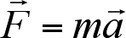
Force is equivalent to mass multiplied by acceleration.

This shows how objects move
The movement of air parcels are anticipated with the following equation

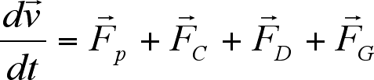

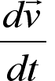Stands for the change of velocity with respect to the time t .

The rest of the terms indicate the forces (movement) in the atmosphere.
- Pressure gradient force
- Coriolis force
- Drag force
- Gravitational force.

Pressure gradient force

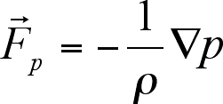

ρ represents the density
p represents the pressure
The symbol ∇ is a vector differential operator (nabla)

The Coriolis force 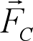 (the difference between centrifugal force and gravitation)

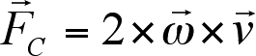

- being the angular velocity of a revolving system. being the velocity of an object corresponding to the system.

The Drag force FD increases the speed of wind, but acts against the wind direction, so it’s ends up in general slowing down the wind.

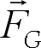 Signifies the gravitational force.

With all the information given the Equation of motion is created below.
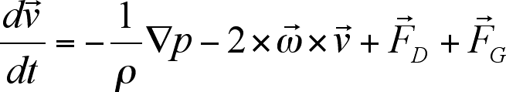

The 3 components of wind velocity

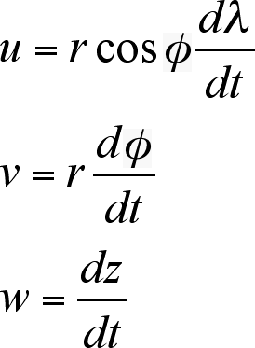
U is for the zonal wind
V is for the meridional wind
W is for the vertical wind

Their changes are with respect to time.

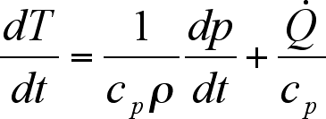
Change of temperature equation with respect to time

Weather Forecasting is involved with many equations that may require knowledge beyond MAT 2680. That is to say that people around the world were able to come up with an equation that can be calculated through the help of computers. The main reason is that it is easier to calculate data through computers rather than doing it by hand because miscalculation may occur during the process, meanwhile in computers it is relatively easier to set up a program that can calculate it for you with the inputted data. There many methods in calculating the weather that can predict what may happen within certain areas for example, it can predict how the temperature, wind or if a natural disaster may occur that can give a heads up to the people living in those areas.

The numerical method that are used for weather forecasting are such as Newton’s Second Law, The Law of Conservation of Mass, and the First Law of Thermodynamics to name a few. The Law of Conservation of Mass is applied in weather forecasting by determining how much force is being conserved over time. For example, Hurricanes are natural disasters that form on the ocean, when the path is predicted for the storm it is calculated that from where it first touches land, it has the most amount of force. As time passes, the storm becomes less severe because of The Law of Conservation of Mass states that mass cannot be created nor destroyed. Meaning that the Hurricanes aren’t created from nothing instead they are formed by meeting certain conditions like being surrounded by warm waters, moist and humid air, and after a certain time period Hurricanes don’t magical disappear, they dissipate back into the atmosphere because they are far from the source that helped it form. When the hurricane is further away from its source it tends to become weaker because as it continues its path the warm air within the hurricane begins to blend into the surround air which is relatively cooler.

References:
https://sites.google.com/view/201601159daiict/
https://mathshistory.st-andrews.ac.uk/HistTopics/Weather_forecasts/
https://www.eolss.net/sample-chapters/C02/E6-04-05-05.pdf
https://courses.lumenlearning.com/introchem/chapter/the-law-of-conservation-of-mass/
https://scied.ucar.edu/learning-zone/storms/how-hurricanes-form#:~:text=For%20one%20to%20form%2C%20there,air%20in%20a%20hurricane%20rotates.

