- Describe an algorithm that takes as input a list of n distinct integers and finds the location of the largest even integer in the list or returns 0 if there are no even integers in the list.

- Show that x² + 4x + 17 is O(x3) but that x3 is not O(x² + 4x + 17).

- Give a big-O estimate for the number of operations, where an operation is a comparison or a multiplication, used in this segment of an algorithm (ignoring comparisons used to test the conditions in the for loops, where a₁, a₂, ..., a_{n} are positive real numbers).
m := 0
for i := 1 to n
for j := i + 1 to n
m := max(a_{i}a_{j},m)
- Use Prim’s algorithm to find a minimum spanning tree for the given weighted graph.

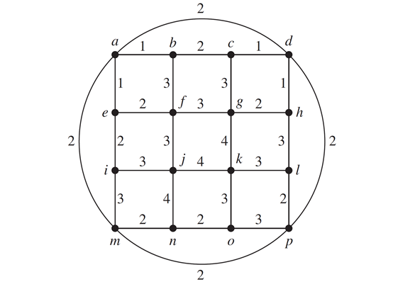
- Solve these recurrence relations together with the initial conditions given.
a_{n} = 5a_{n−1} − 6a_{n−2} for n ≥ 2, a₀ = 1, a₁ = 0

- Find a closed form for the generating function.
0, 2, 2, 2, 2, 2, 2, 0, 0, 0, 0, 0, . . .

- Prove that f₁ + f₃ +· · ·+f_{2n−1} = f_{2n} when n is a positive integer.

- Give a recursive algorithm for finding the sum of the first n odd positive integers.

