- Use quick sort to sot this list {3,5,7,8,1,9,2,4,6}
- Count the number of comparisons required in part a

- Describe an algorithm for finding both the largest and the smallest integers in a finite sequence of integers.

- Build a binary search tree for the words oenology, phrenology, campanology, ornithology, ichthyology, limnology, alchemy, astrology using alphabetical order.

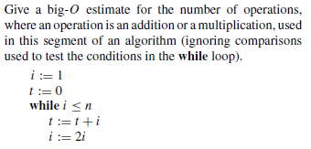
- Show whether the function f(x) = $x^{2}+x+1$is O(x)

- Give a big O estimate of the function f(n) = 2 f ($\frac{n}{3}$) + 4

- Solve this linear recurrence relation with initial conditions a_{n} = 7a_{n−1} − 10a_{n−2 for} n ≥ 2, a₀ = 2, a₁ = 1

- Find a closed for the generating function with this sequence -3, 3, -3, 3, -3, 3, -3, 3 ….

