11.4
#15)
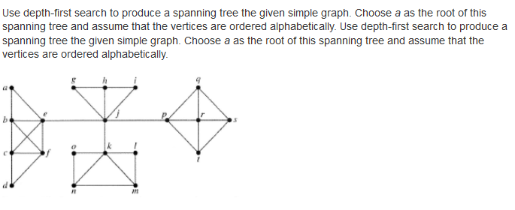

Step 1:
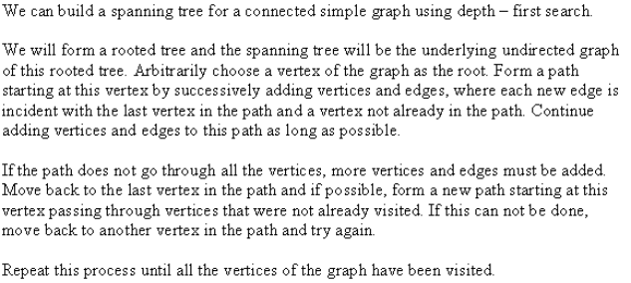

Step 2:
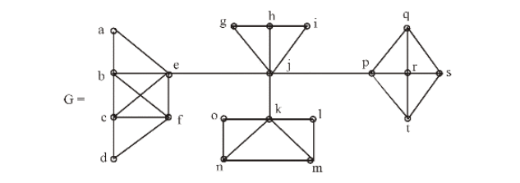

Step 3:

The steps used by depth- first search to produce a spanning tree are shown below:

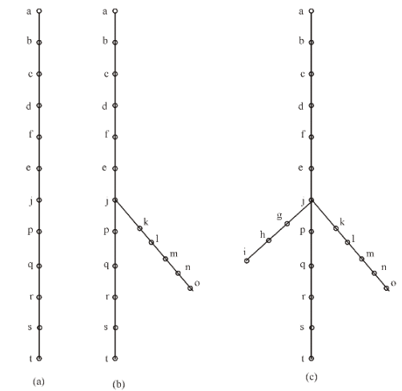

Step 4:
We start with vertex ‘a’ and a path is built by successively adding edges incident with vertices not already in the path as long as possible. This makes path a,b,c,d,f,e,j,p,q,r,s,t. Next back track
to s. There is no path beginning at s containing vertices not already visited. Then, back track to r, then q, then to p and then j created the path j,k,l,m,n,o and also form the path j,g,h,i.

Thus, the spanning tree is shown below:

