Mitchel Final Exam Review

1. Solve the inequality. Express the solution both on the number line and in interval notation. Use exact forms (such as fractions) instead of decimal approximations.

A. 6x + 5)/(7x − 13 ≥ 0

A. 6x − 2x^2 > 0

1. Solve the exponential Functions

A. In 2022, the population of a colony is 10, 000, and is decreasing exponentially at 1.5% per year.In what year will there be half of the population left?

B. In 2021, the population of a city is 80, 000 people, and is growing at a rate of 4% per year. What will the population be in 2033?

1. State the amplitude, period and phase shift, and then sketch one complete cycle of the graph. Label all maxima, minima and x-intercepts.

A. y = 2 sin(4x − π)

B. y = −4 sin (x − π/ 2)

1. Find the inverse for the following function.

A. y = 5 − 7x

B. y = x +14/x + 5

1. A complete graph of the rational function y = f(x) is displayed below. The numerator and denominator of f are polynomials of degree 2, and all asymptotes and intercepts of f are at integer values.Find all intercepts, asymptotes, and the domain of f. Find a formula for the function f.

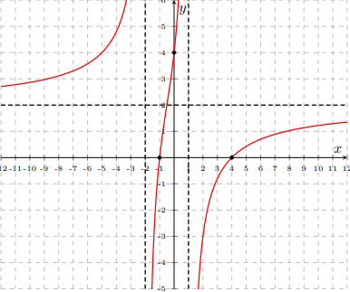

1. Find following terms for these 2 arithmetic sequences

A. Find the sum of the first 70 terms of the arithmetic sequence: 22, 19, 16, 13, . . .

B. Find the sum of the first 95 terms of the arithmetic sequence: −17, −12, −7, −2, . .

1. State the amplitude, period and phase shift, and then sketch one complete cycle of the graph. Label all maxima, minima and x-intercepts.
2. y = 2 sin(4x − π)
3. Solve for x.
4. 3^(5x+2) = 9^(x−4)
5. 5^(x+3) = 7^x
6. For each polynomial, find a real number C so that the polynomial has the indicated root. For this C, find all remaining roots of the polynomial algebraically and write the roots in simplest radical form. Sketch a complete graph of the polynomial, indicating the roots.
7. f(x) = x^3 + 3x^2 − 16x + C has a root at x = 3
8. Find the magnitude and the direction angle.
9. v = ⟨2, −2√3⟩
10. v = ⟨−3, −3⟩