Jayden M Final Exam Review Sheet

1. Find the quotient and write the result in $a+bi$ form:

$$\frac{8∙cos\left(200°\right)- i \sin\left(200°\right)}{3∙cos\left(50°\right)- i \sin\left(50°\right)}$$

Answer:

1. Solve for $x:{5x}^{2}+14x-24≤0$

*Identify roots:*

${5x}^{2}+14x-24≤0$ has root(s) at $x=$

$f\left(x\right)= x^{3}-x^{2}-33x+C$

The constant $C$ has to be: $C=$

The function $f\left(x\right)$ is equal to $f\left(x\right)=$

The quotient $f\left(x\right)÷(x+5)$ is equal to:

List all roots of $f\left(x\right)$:

1. Rewrite the following logarithms in expanded form by applying the properties of logarithms.

$\log{(\frac{x^{9}z^{7}}{\sqrt{y}})}$ =

$\log{(x^{5}\sqrt[7]{y^{9}})}$ =

$\log{(\frac{\sqrt[7]{x}}{y^{9}z^{3}})}$ =

1. Consider the function $f\left(x\right)=\ln{(8x-9)}$.
2. The domain of the function is
3. The asymptote of the function is
4. Our function has an $x$-intercept at
5. Sketch a graph of the function.
6. Solve for $x$:

$$2\sin^{2}\left(x\right)-\sqrt{3}\sin\left(x\right)=0$$

Give expressions to represent all solutions to the equation:

$$x=$$

1. Solve for $x$

$$\tan^{2}\left(x\right)-\tan\left(x\right)=0$$

Give expressions to represent all solutions to the equation:

$$x=$$

1. In **2019**, the population of a country is **763,000**, and is growing at **3.6%** per year.
2. What will the population be in **2072?**
3. In what year will the population be double?
4. In what year will the population be triple?
5. Find the magnitude and direction angle in degrees for: $v =$ $〈6\sqrt{3}, 6〉$

Magnitude: $\left\|v\right\|$ =

Direction angle: $θ=$

1. Let $f\left(x\right)$ be a rational functional whose numerator and denominator are polynomials of degree 2. All of the roots and asymptotes are at integer values.

The graph of $y=f\left(x\right)$ is shown below. The roots are indicated with green dots. The asymptotes are indicated with dashed red lines.

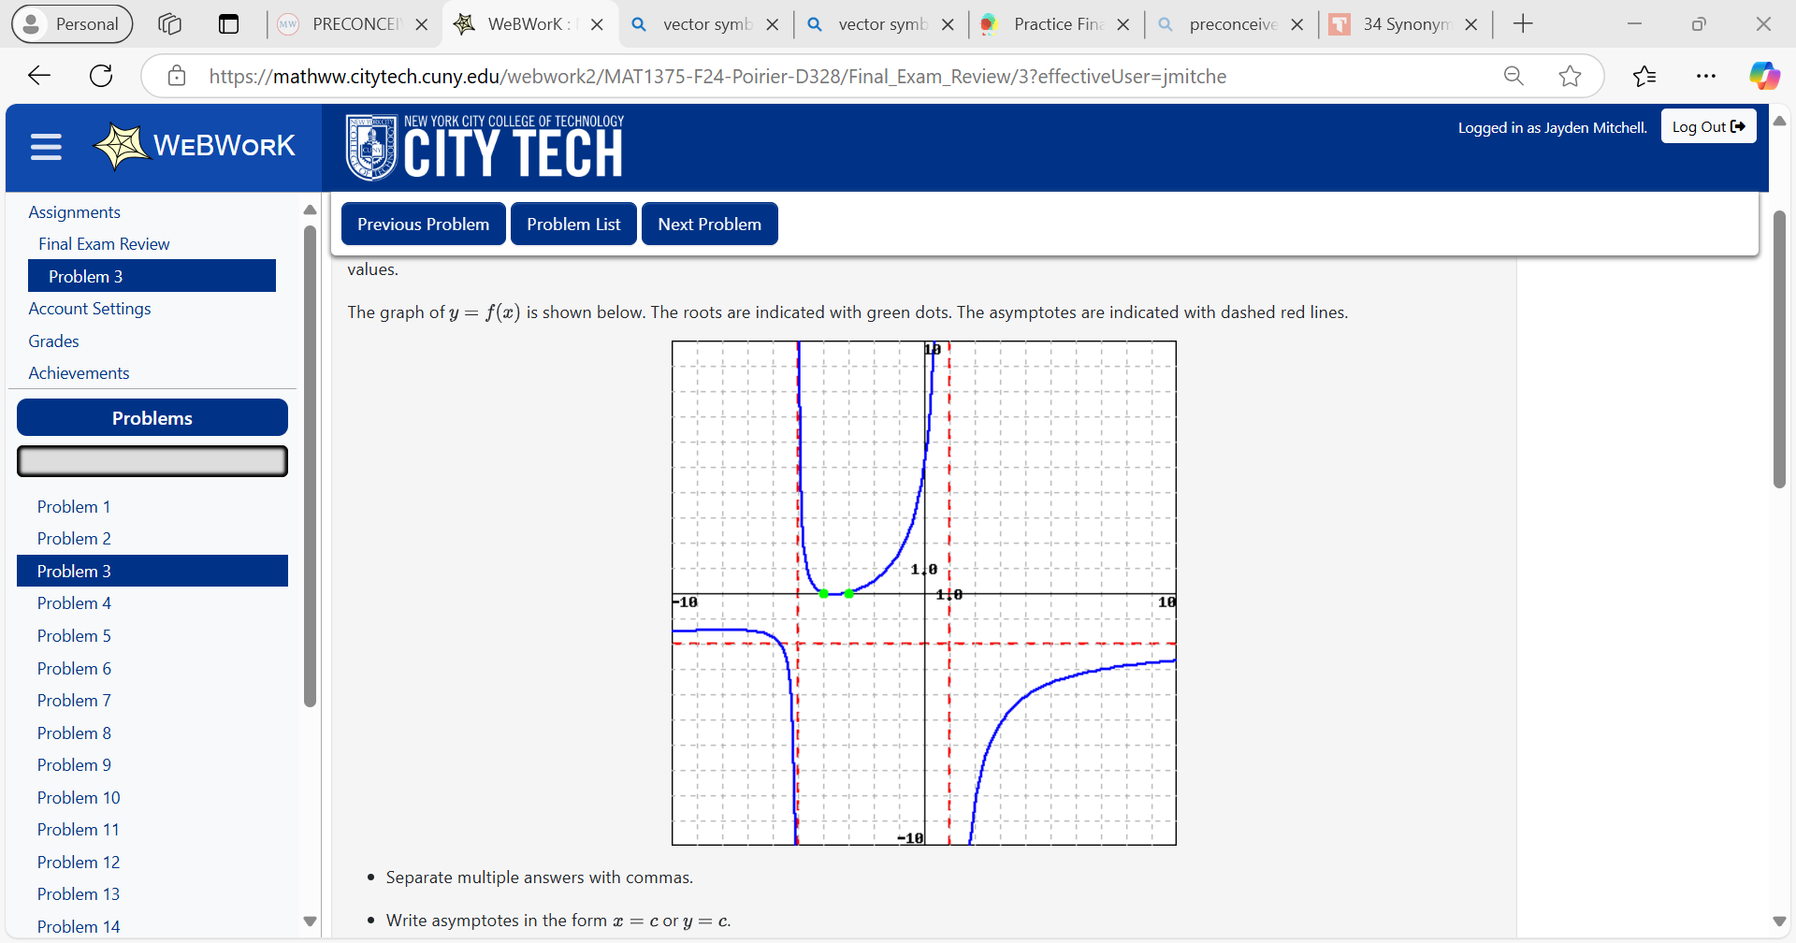

1. What are the roots of $f\left(x\right)?x=$
2. What is the horizontal asymptote of $f\left(x\right)?$
3. What are the vertical asymptotes of $f\left(x\right)?$
4. What is the domain of $f\left(x\right)?D=$