Graphics/Images Week #8
Series Circuit………………………………….…………………………Page 4-6
Where: On page 4, under the subsection, How is a series circuit constructed?
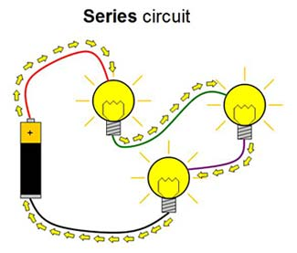
Why: The reason I chose this image is to demonstrate visually how the circuit will look once completed using method 1 for series circuit construction.

Squishy Circuits Project 2: Add Even More Lights [Series Circuit]. (n.d.). Retrieved March 12, 2016, from http://www.cdn.sciencebuddies.org/Files/4890/7/series-circuit-diagram-2_img.jpg
Where: On page 4, under the subsection, How is a series circuit constructed?
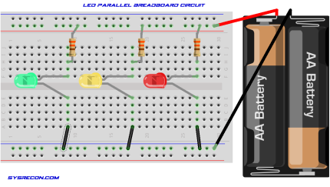
Why: The reason I chose this image is to demonstrate visually how the circuit will look once completed using method 2 for series circuit construction.

SysRecon. (2014, August 13). SysRecon. Retrieved March 14, 2016, from http://www.sysrecon.com/tag/resistors/
Where: On page 5, under the subsection, How is voltage affected in a series circuit?
Why: The reason I chose this image to represent how voltage is affected in a series circuit is because it visually illustrates the formula for voltage in a series circuit.

BBC. (2014). BBC- Higher Bitesize Pysics- Resistors in Circuits Revisions [Digital image]. Retrieved March 14, 2016, from http://www.bbc.co.uk/staticarchive/3e2fc6e6c5581b62ab7420303a351cc9e3499759.gif
Parallel Circuit……………………………………………………………Page 7-9
Where: On page 7, under the subsection, How to construct a parallel circuit?
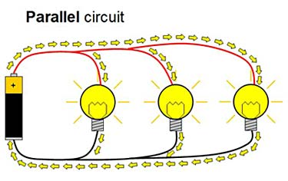
Why: The reason I chose these images to represent the construction of a parallel circuit is because it clearly identifies how the circuit should look like once constructed, and the different pathway of current flow.

Squishy Circuits Project 2: Add Even More Lights [Parallel Circuit]. (n.d.). Retrieved March 12, 2016, from http://www.cdn.sciencebuddies.org/Files/4889/7/parallel-circuit-diagram_img.jpg
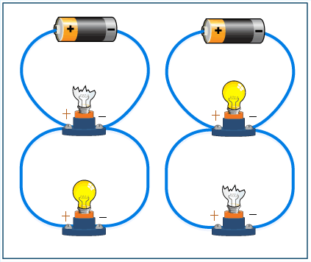

ThingLink. (n.d.). Parallel Circuit [Digital image]. Retrieved March 14, 2016, from http://s4.thingpic.com/images/mn/AM7rKnhpFgKmAbdzUYTkvC5Q.gif

