Graphics/Images Week #7
Types of Circuits………………………………….…………………………Page 1
Where: On page 1, under the subsection, What is a Simple Circuit?
Why: The reason I chose this image to represent a simple circuit is because it illustrates all the necessary components required to make a circuit a simple circuit.
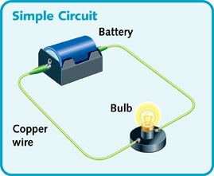
Simple Circuit [This simple circuit in one loop lights one bulb.]. (n.d.). Retrieved March 08, 2016, from http://science.jrank.org/kids/article_images/light_p25.jpg
Where: On page 1, under the subsection, What is a Series Circuit?
Why: The reason I chose this image to represent a series circuit is because it illustrates all the necessary components required to make a circuit a series circuit. It demonstrates a clear distinctive difference between a simple and series circuit.
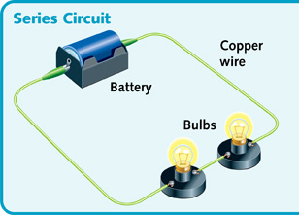
Series Circuit [A series circuit has only one path of electricity. It provides power for more than one electrical load.]. (n.d.). Retrieved March 08, 2016, from http://science.jrank.org/kids/pages/232/All-in-Circuit.html
Where: On page 1, under the subsection, What is a Parallel Circuit?
Why: The reason I chose this image to represent a parallel circuit is because it illustrates all the necessary components required to make a circuit a parallel circuit. It demonstrates a clear distinctive difference between a simple, series and parallel circuit.
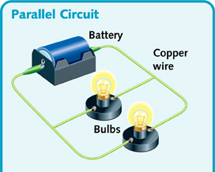
Parallel Circuit [In a parallel circuit, electricity can pass along different paths to power different loads.] (n.d.). Retrieved March 08, 2016, from http://science.jrank.org/kids/pages/232/All-in-Circuit.html
Ohm’s Law…….………………………………….…………………………Page 2
Where: On page 2, under the subsection, What is Ohm’s Law?
Why: The reason I chose these images to represent ohm’s law is because it’s a clear, easy to understand image of Ohm’s Law formula. In some electronics mathematical problems, voltage can be represented as E or V. Both images present this fact clearly for students to understand.

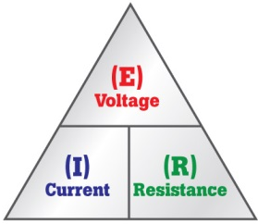
What's Ohm's Law? [Ohm's Law Formula]. (n.d.). Retrieved March 08, 2016, from http://media.fluke.com/images/6004178-dmm-whatis-ohm-top-715x360.jpg
Ohm's Law and How to Solve It [Ohm's Law Formula]. (n.d.). Retrieved March 08, 2016, from http://tinkernow.com/wp-content/uploads/2014/12/OhmsLaw.gif

