Graphics/Images Week #11
Digital Multi-Meter…………………………….………………………Page 14-15
Where: On page 14, under the subsection, What is a digital multi-meter?
Why: The reason I chose this image is to demonstrate the two different styles of DVOM that can be used for testing.
SlideShare. (n.d.). How to use a Digital Multi-Meter [Digital image]. Retrieved March 21, 2016, from http://image.slidesharecdn.com/howtouseadigitalmultimeter-100726083407-phpapp01/95/how-to-use-a-digital-multimeter-3-728.jpg?cb=1280133295

Where: On page 14, under the subsection, What are the purposes of the test leads on the digital multi-meter?
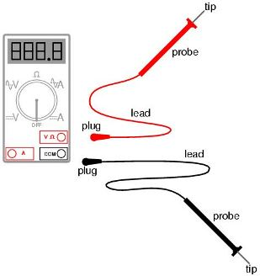
Why: The reason I chose this image is to demonstrate the location and name of the parts on a DVOM test leads.

Safe MultiMeter Usage: Electrical Safety [Digital image]. (n.d.). Retrieved March 21, 2016, from http://www.zrd.com/faq/01.jpg

Where: On page 15, under the subsection, What are the settings on the digital multi-meter?
Why: The reason I chose this image to illustrate the different settings on the DVOM.
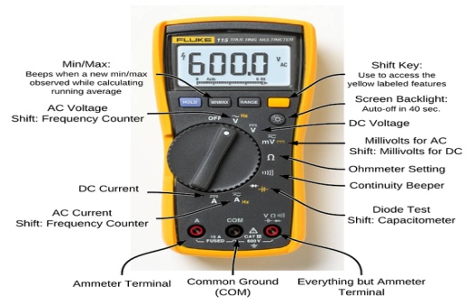
How to use a Multi-Meter when Troubleshooting a Fire Alarm [Digital image]. (n.d.). Retrieved March 21, 2016, from http://2.bp.blogspot.com/-iOx35Jz-xeE/Uzrj4uq50lI/AAAAAAAADuM/jP22mzkeNVQ/s1600/575px-Multimeter.png

Breadboards……………………………………………………………Page 13
Where: On page 13, under the subsection, What are the frameworks of a breadboard?
Why: The reason I chose this image is to show the numbers and letters on the breadboard.

Sparkfun. (n.d.). How to Use a Breadboard. Retrieved March 14, 2016, from https://learn.sparkfun.com/tutorials/how-to-use-a-breadboard
Where: On page 13, under the subsection, What are the frameworks of a breadboard?
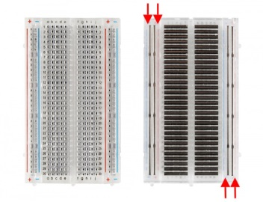
Why: The reason I chose this image is to show the metal strips that connects the power rails on the breadboard.

Sparkfun. (n.d.). How to Use a Breadboard. Retrieved March 14, 2016, from https://learn.sparkfun.com/tutorials/how-to-use-a-breadboard

