Graphics/Images Week #10
Series Circuit………………………………….………………………Page 11-12
Where: On page 11, under the subsection, How is a parallel circuit constructed?
Why: The reason I chose this image is to demonstrate visually how the circuit will look once completed using method 2 for a parallel circuit construction.
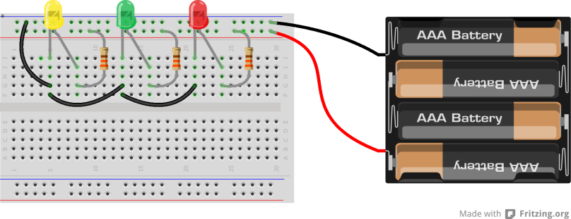
Hunt, W., & Phillips, J. (2013). The LED – Christmas Lights. Retrieved March 14, 2016, from http://www.backward-workshop.com/electronics/breadboard-curriculum/led/

Where: On page 12, under the subsection, How is a resistance affected in a parallel circuit?
Why: The reason I chose this image is to demonstrate visually the reciprocal formula for solving resistance in a parallel circuit.
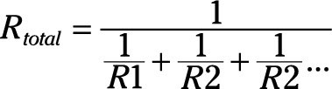
Dummies. (n.d.). Electronics Components: Parallel Resistors. Retrieved March 14, 2016, from http://www.dummies.com/how-to/content/electronics-components-parallel-resistors.html
Where: On page 12, under the subsection, How is resistance affected in a parallel circuit?
Why: The reason I chose this image to represent how resistance in a parallel circuit can be calculated when there are only two loads present.
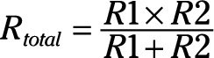
Dummies. (n.d.). Electronics Components: Parallel Resistors. Retrieved March 14, 2016, from http://www.dummies.com/how-to/content/electronics-components-parallel-resistors.html

Breadboards……………………………………………………………Page 13
Where: On page 13, under the subsection, What is a breadboard?
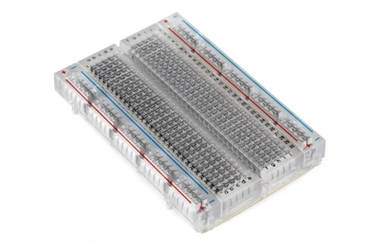
Why: The reason I chose this image is to show how a breadboard looks like.

Sparkfun. (n.d.). How to Use a Breadboard. Retrieved March 14, 2016, from https://learn.sparkfun.com/tutorials/how-to-use-a-breadboard
Where: On page 13, under the subsection, What are the frameworks of a breadboard?
Why: The reason I chose this image is to show the metal strips behind the breadboard. This creates a visual to how components are connected on the breadboard.

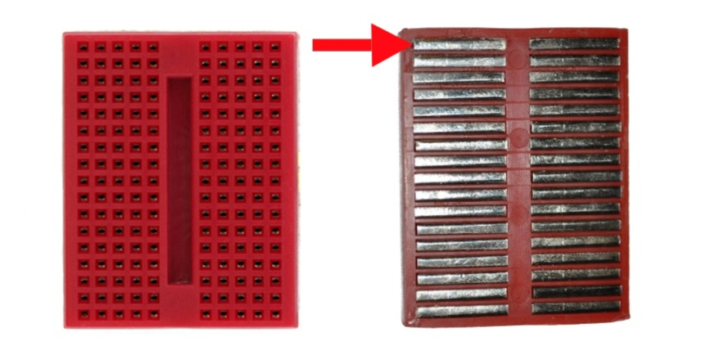
Sparkfun. (n.d.). How to Use a Breadboard. Retrieved March 14, 2016, from https://learn.sparkfun.com/tutorials/how-to-use-a-breadboard

