Circuit Construction and Testing
A guide to building and testing basic electronics circuits

By: Praya N. Jafar

Table of Contents

Chapter 1: Types of Circuits--------------------------------------------------------Page 4
- What is a Simple Circuit?
- What is a Series Circuit?
- What is a Parallel Circuit?

Chapter 2: Ohm’s Law---------------------------------------------------------------Page 5-6
- What is Ohm’s Law?
- How does Ohm’s Law affect the voltage in a simple circuit?
- How does Ohm’s Law affect the current in a simple circuit?
- How does Ohm’s Law affect the resistance in a simple circuit?

Chapter 3: Series Circuits------------------------------------------------------------Page 7-9
- How is a series circuit constructed?
- How is voltage affected in a series circuit?
- How is current affected in a series circuit?
- How is resistance affected in a series circuit?

Chapter 4: Parallel Circuits----------------------------------------------------------Page 10-12
- How is a parallel circuit constructed?
- How is voltage affected in a parallel circuit?
- How is current affected in a parallel circuit?
- How is resistance affected in a parallel circuit?

Chapter 5: Breadboards--------------------------------------------------------------Page 13
- What is a breadboard?
- What are the frameworks of a breadboard?

Chapter 6: Digital Multi-Meter---------------------------------------------------Page 14-15
- What is a digital multi-meter?
- What are the purposes of the test leads on the digital multi-meter?
- What are the settings on the digital multi-meter?
- What are the symbols on the digital multi-meter?

Chapter 7: Measuring Voltage with a Digital Multi-Meter------------------Page 16
- How voltage is measured using a digital multi-meter?
- How to measure voltage in a series and parallel circuit?

Chapter 8: Measuring Current with a Digital Multi-Meter------------------Page 17
- How is current measured using a digital multi-meter?
- How to measure current in a series and parallel circuit?

Chapter 9: Measuring Resistance with a Digital Multi-Meter---------------Page 18
- How resistance is measured using a digital multi-meter?
- How to measure resistance in a series and parallel circuit?
- How continuity is measured using a digital multi-meter?

Note from the Author/References--------------------------------------------------Page 19-20
- Summary for circuit constructions and testing
- References of Pictures
- Work Cited

Chapter 1: Types of Circuits
What is a Simple Circuit?
A simple electrical circuit contains the minimum requirements needed for an electric circuit to function. In a simple circuit, there are only three keys requirements needed for the circuit to correctly function. Those three requirements are as follows (Regents Prep):
- A battery: The source of electrical voltage.
- Conductive wires: Creates a conductive pathway that will allow the charges to move.
- An electrical resistance: An object that uses electricity to perform work. This object is typically a resistor or a light bulb.
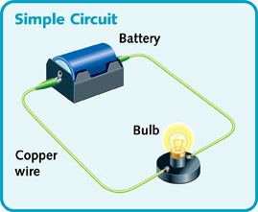
Figure 1: Simple Circuit with a battery, bulb and copper wires. (Science Rank, "Simple Circuit", Retrieved 03/2016)
What is a Series Circuit?
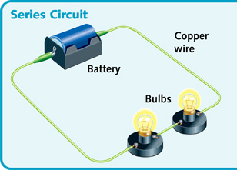
A series circuit has only one pathway for current to flow through all the components within the circuit. The purpose of a series circuit is to connect different components that all require the same current.
Figure 2: Series Circuit with a battery, bulbs and copper wires. (Science Rank, “Series Circuit”, Retrieved 03/2016)

What is a Parallel Circuit?
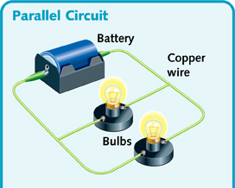
A parallel circuit has multiple pathways for current to flow through all the components within the circuit. The purpose of a parallel circuit is to supply different amount of current to different components.
Figure 3: Parallel Circuit with a battery, bulbs and copper wires. (Science Rank, “Parallel Circuit”, Retrieved 03/2016)

Chapter 2: Ohm’s Law
What is Ohm’s Law?
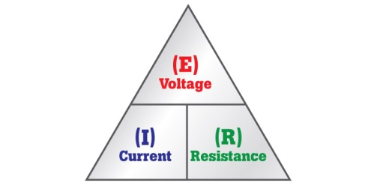
In an electrical circuit, voltage (V or E) is the measurement of potential energy stored in a battery, current (I) is the measurement of the charges (electrons) that flow through the components and resistance (R) is the measurement of the material’s tendency to resist the flow of current. Ohm’s Law which was discovered in 1827 by George Simon Ohm represents the mathematical relationship between voltage, current and resistance in an electrical circuit. The law can be defined the voltage of an electrical circuit is equal to the current multiplied by the resistance of the same electrical circuit. The formula for Ohm’s Law can be written two different ways: V= I*R or E=I*R. The figures below provide a visual representation of the formulas or their unit of measurements. (Grob, Ohm's Law, 1997)

Figure 5: Ohm’s Law Formula (Tinker Now, “Ohm’s Law and How to Solve It”, Retrieved 03/2016)

Figure 4: Formula for Ohm’s Law (Media Fluke, “What’s Ohm’s Law”, Retrieved 03/2016)

How does Ohm’s Law affect the voltage in a simple circuit?
The voltage in a simple circuit is directly proportional to the resistance and current. This means, if the voltage increases in a simple circuit, the current and resistance will also increase. If the voltage decreases then the current and resistance also decreases. The formula for Ohm’s Law is used to calculate the voltage in a simple circuit. Let’s take a look at a problem.
In a circuit, the resistance is 144 ohms while the current is 5 amperes. Find the voltage.
In order to find voltage, use the formula E (volts) = I (amperes) * R (ohms).
Now, substitute given values, E = (5A) * (144 ohms).
Then voltage, E = 720 volts.
How does Ohm’s Law affect the current in a simple circuit?
If the current in a simple circuit increases then the voltage will increase. But, if the current decreases then the voltage will decrease. If the current in a simple circuit decreases then the resistance will increase. But, if the current increases then the resistance will decrease. In order words, the current is directly proportional to the voltage and inversely proportional to the resistance. The formula for Ohm’s Law can be manipulated to calculate the current in a simple circuit. Let’s take a look at a problem.
How much current flows through a 3,000 ohms resistor when it is connected across a 9-volt battery?
In order to find current, manipulate the Ohm’s law formula to solve for current.
The formula for current would be I (amperes) = E (volts) / R (ohms).
Now, substitute given values, I = (9V) / (3,000 ohms).
Then current, I = 0.003A or 3mA
How does Ohm’s Law affect the resistance in a simple circuit?
If the resistance in a simple circuit increases then the voltage will increases. But, if the resistance decreases then the voltage will decrease. If the resistance in a simple circuit decreases, then the current will increase. But, if the resistance increases then the current will decrease. In order words, the resistance is directly proportional to the voltage and inversely proportional to the current. The formula for Ohm’s Law can be manipulated to calculate the resistance in a simple circuit. Let’s take a look at a problem.
Calculate the resistance of a circuit with a 12-volt battery and a current of 3mA.
In order to find the resistance, manipulate the Ohm’s Law formula.
The formula for resistance would be R (ohms) = E (volts) / I (amperes).
Now, substitute given values, R = (12V) / (3mA). Remember that 3mA = 0.003A.
Then resistance, R = 4,000 ohms or 4K ohms
Chapter 3: Series Circuit
How to construct a series circuit?
A series circuit can be constructed by connecting one electrical resistance component after another so that current can flow in one direction. Figure 2 in “Types of Circuit”, illustrates this concept. There are two methods that can be used to construct a series circuit. ( All About Circuits)
First Method: Parts/Materials
6- Volt battery 3 6-Volts incandescent lamps Jumper Wires Terminal Strips
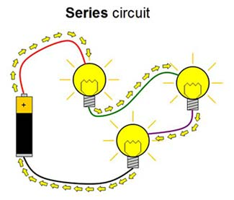
Directions: This is the easiest method used to construct a series circuit. Connect the lamps to the battery using the jumper wires and terminal strips. Your circuit should look like figure 6 below.

Figure 6: Series Circuit (Science Buddies, “Squishy Circuits Project 2: Add Even More Lights”, Retrieved 03/2016)

Second Method: Parts/Materials
Breadboard Three LEDs Three 330 ohm resistors Two AA batteries Jumper wires
Directions: In any electronics course, this method would be the correct way to construct a series circuit. This circuit is constructed under the assumption that you apply the rules of a breadboard.
- Place two jumper wires on the power terminals on the breadboard; one on the positive terminal and the other on the negative terminal of the power terminals.
- Connect the three resistors and three LEDs to their respective power terminals.
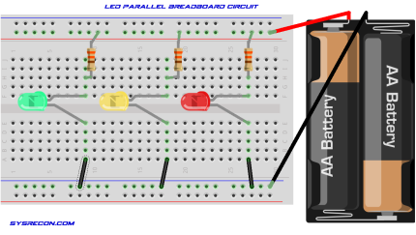
- Connect the jumper wires on the power terminals of the breadboard to the AA batteries. Your constructed series circuit should look like figure 7.
Figure 7: Series Circuit on a Breadboard (SysRecon, “How to use Light Emitting Diodes (LED’S)”, 13 August 2014)

How is voltage affected in a series circuit?
Even though the components in a series circuit share the same amount of current, they don’t share the same amount of voltage. The total source voltage in a series circuit is equal to the sum of all the voltage drops of each component. The voltage drop reduces the potential energy stored in the battery available for the remaining resistance in the circuit. (Grob, Series Circuit, 1997)
The formula used to solve for total voltage is E_{T}= E₁ + E₂ + E₃+…
The formula can also be written as total voltage is V_{T}= V₁ + V₂ + V₃+…
What does this equation mean? Add each voltage of the resistors in order to determine the total voltage.
The formula used to solve for total voltage is also the Ohm’s Law voltage formula:
E_{T} (volts) = I_{T} (amperes) * R_{T} (ohms). (t representing total)
Figure 8 illustrates a visual illustration demonstrating V_{T}= V₁ + V₂ + V₃+…
Figure 8: Circuit illustrating the voltage formula for a series circuit. (BCC, “Higher Bite size Physics- Resistors in Circuits Revisions”, 2014)

Let’s look at a problem: A voltage source produces a drop of 40v across a 20 ohm R1, 60V across a 30 ohm R2 and 180v across a 90 ohm R3. How much is the total voltage?
In order to find the total voltage, use the formula V_{T}= V₁ + V₂ + V₃+…
Now, substitute the voltage value for each component. So, V_{T} = 40v + 60v + 180v.
The total voltage would be 280v.
How is current affected in a series circuit?
In a series circuit, there is only one pathway for current to flow. This means that the current flow is constant through each component.
The formula used to solve for total current in a series circuit is I_{t} = I₁= I₂ = I₃ =…
What does this equation mean? The equation means current flow is always the same.

The formula used to solve for total current is also the Ohm’s Law current formula:
I_{T} (amperes) = E_{T} (volts) / R_{T} (ohms). (t representing total)

Let’s look at a problem: The applied voltage is 10v and total resistance is 5 ohms. Calculate the total current.

In order to find the total current, use the formula I_{T} (amperes) = E_{T} (volts) / R_{T} (ohms).
Now, substitute the given values: I_{T} = 10v / 5 ohms
The total current, I_{T} = 2A.

How is resistance affected in a series circuit?
In a series circuit, the total resistance is equal to the sum of all the components (loads).
The formula for solving total resistance is R_{T}= R₁+R₂+R₃+…
What does this equation mean? Add each resistor in order to find the total resistance.
The formula for solving total resistance is also Ohm’s Law resistance formula:
R_{T} (ohms) = E_{T} (volts) / I_{T} (amperes). (t representing total)
Let’s look at a problem. Two resistors R1 and R2 of 6 ohm each and R3 of 19 ohm are in series. How much is the total resistance?
In order to find total resistance, the formula R_{T}= R₁+R₂+R₃+…
Now, substitute the given values: R_{T}= 6 ohms + 6 ohms + 19 ohms
The total resistance, R_{T} = 31 ohms
Let’s look at a problem. In a circuit, the total voltage is 120v and the total current is 8mA. Calculate the total resistance of the circuit.
In order to find total resistance, use the formula: R_{T} (ohms) = E_{T} (volts) / I_{T} (amperes).
Now, substitute the given values: R_{T} = 120v / 8mA Remember that 8mA = 0.008A.
The total resistance, R_{T} = 15, 000 ohms or 15K ohms
Chapter 4: Parallel Circuit
How to construct a parallel circuit?
A parallel circuit can be constructed by connecting electrical resistance components parallel to one another allowing more than one pathway for current to flow. Figure 3 in “Types of Circuit”, illustrates this concept. There are two methods that can be used to construct a parallel circuit.
First Method: Parts/Materials
6- Volt battery 3 6-Volts incandescent lamps Jumper Wires Terminal Strips
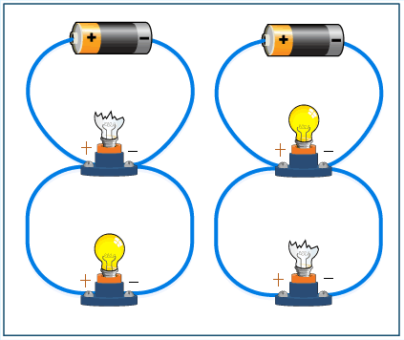
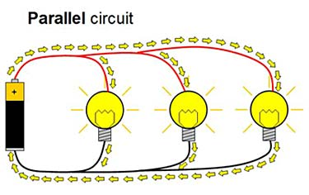
Directions: This is the easiest method used to construct a parallel circuit. Connect the lamps parallel to each and the battery using the jumper wires and terminal strips. Your circuit should look like figure 9 below. In a parallel circuit, if one of the lamps or load is broken, the other lamps or loads will still light due to the fact that there is more than one path for current to flow. Figure 10 below clearly illustrates this concept.

Figure 10: Examples of how a parallel circuit operates (ThingLink, “Parallel Circuit”, Retrieved 03/2016)

Figure 9: Parallel Circuit (Science Buddies, “Squishy Circuits Project 2: Add Even More Lights”, Retrieved 03/2016)

Second Method: Parts/Materials
Breadboard Three LEDs Three 330 ohm resistors Four AA batteries Jumper wires
Directions: In any electronics course, this method would be the correct way to construct a parallel circuit. This circuit is constructed under the assumption that you apply the rules of a breadboard.
- Place two jumper wires on the power terminals on the breadboard; one on the positive terminal and the other on the negative terminal of the power terminals.
- Connect the three resistors and three LEDs in parallel to their respective power terminals.
- Connect the jumper wires on the power terminals of the breadboard to the AA batteries. Your constructed series circuit should look like figure 11.
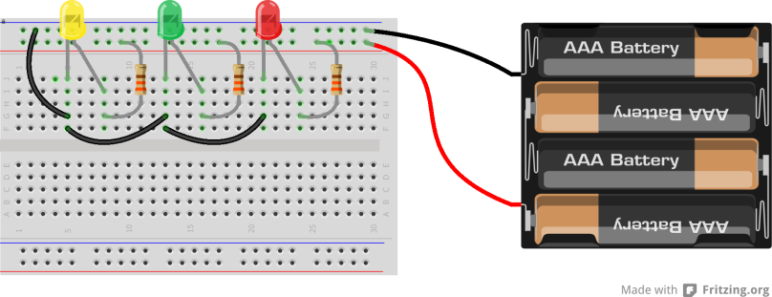
Figure 11: Parallel circuit on a breadboard (Backward Workshop, “The LED- Christmas Lights”, 2013)

How is voltage affected in a parallel circuit?
In a parallel circuit, two or more components are connected across a voltage source. The voltage is the same across components. The parallel arrangement is used to connect components that require the same voltage.
The formula used to solve for total voltage in a parallel circuit is V_{T} = V1= V2 = V3 =…
What does this equation mean? The equation means all the voltages are the same.
The formula used to solve for total voltage is also the Ohm’s Law voltage formula:
E_{T} (volts) = I_{T} (amperes) * R_{T} (ohms). (t representing total)

How is current affected in a parallel circuit?
In a parallel circuit, all the current must come from one side of the voltage source and return to the opposite side for a complete path. Therefore, the total current is equal to the amount of current of each branch. This applies to any number of parallel branches, whether the resistances in the branches are the same or not. (Grob, Parallel Circuits, 1997)
The formula used to solve for total current in a parallel circuit is I_{T}= I₁ + I₂ + I₃...
What does this equation mean? The total current is equal to the amount of current of each branch.
The formula used to solve for total current is also the Ohm’s Law current formula:
I_{T} (amperes) = E_{T} (volts) / R_{T} (ohms). (t representing total)
How is resistance affected in a parallel circuit?
In a parallel circuit, the combined equivalent resistance across the main line can be found using ohm’s law. That formula is (Grob, Resistance in Parallel, 1997):
R_{T} (ohms) = E_{T} (volts) / I_{T} (amperes).
When solving for the individual resistance of each component, the formula used is called the reciprocal formula. The formula is as follows:
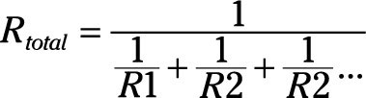
Figure 12: (Dummies, “Electronics Components: Parallel Resistors”, Retrieved 2016)

Or
When there are two parallel resistance and they are not equal, it is quicker to calculate the equivalent resistance using the method:

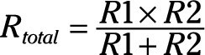
Figure 13: (Dummies, “Electronics Components: Parallel Resistors”, Retrieved 2016)

Each resistor can have any value but this method only work with two resistors in parallel.

Let’s look at a problem: In a circuit, three 1k ohm resistors connected in parallel, their combined equivalent resistance would be?
In order to solve for equivalent resistance, use the formula in Figure 12.
Now, substitute the values of all the resistors, R1, R2 & R3 which are 1k ohms.
The equivalent resistance or resistance total of the circuit is 333 ohms.
Chapter 5: Breadboards
Figure 14: (Spark Fun, “How to Use a Breadboard”, Retrieved 2016)

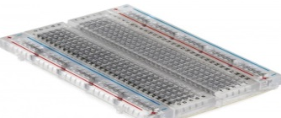
What is a breadboard?
The purposes of breadboards are the following (Spark Fun):
- Solder-less breadboard: Making temporary circuits and prototyping.
- Test circuits reaction under a given set of parameters, build simplest & complex circuits.
- Troubleshooting: duplicating customer problems & testing new parts.
What are the frameworks of a breadboard?
Terminal Strips  (Spark Fun) | Power Rails (Spark Fun) | Rows and Columns (Spark Fun)
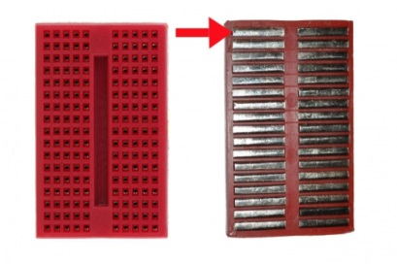  (1)Contains horizontal rows of conductive metal strips. This allows a wire or a component to be inserted in the holes on a breadboard to hold it in place.  Figure 15: (Spark Fun, “How to Use a Breadboard”, Retrieved 2016)  (2) Once inserted an electrical connection is made. Only 5 components can connect in 1 section of the board.  (3)Each horizontal row is separated by a space in the middle of the breadboard. It isolates both sides of a given row & isn’t electrically connected. | 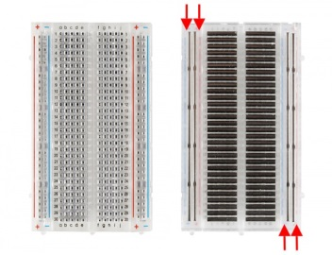  (1)Metal strips that are all connected. The rails give access to power when needed. They are usually labeled (+) and (-) and have a red, blue or black strips to indicate the positive and negative side.  Figure 16: (Spark Fun, “How to Use a Breadboard”, Retrieved 2016)  (2)Note that the rails on each side are not connected, so it you want the same power source on both sides, you will need to connect the two sides with wires. | (1)Numbers and letters are marked on rows and columns.  Figure 17: (Spark Fun, “How to Use a Breadboard”, Retrieved 2016)  (2) Use as a guide when building circuits. Circuits can get complicated and all it takes is for one component to be wired incorrectly for your circuit not to work.  (3)The row number and column makes it simple to retrace your steps to fix wiring error.
Chapter 6: Digital Multi-Meter
What is a digital multi-meter?
A digital multi-meter known as a DVOM (Digital Volt-Ohm Meter) is a device that is used to measure multiple variables such as voltage, resistance, current, capacitors and diodes on electrical circuitry. There are two types of digital multi-meters. There are two types of digital multi-meter. The first type is called a switched range DVOM. This multi-meter manually switches between ranges to get the most accurate reading. The second type is called an auto range DVOM. This multi-meter switches between ranges automatically for the best reading.
Type 1: Switched Range DVOM Type 2: Auto Range DVOM
Figure 18: (Slide Share, “How to Use a Digital Multi-meter”, Retrieved 2016)

What are the purposes of the test leads on the digital multi-meter?
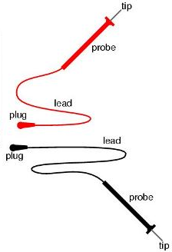
The following components are guides used for measuring qualities with a DVOM:
(1) Red meter lead (positive connection): connects to the voltage/resistance or current port.
(2) Probes: the handles are used to hold the tip on the tested connection.
(3) Tips: the end of the probe and provides a connection point.
(4) Black meter lead (negative connection): always connected to the COM (common) port.
Figure 19: (“Safe Multi-meter Usage: Electrical Safety”, Retrieved 2016)

What are the settings on the digital multi-meter?
The following are the key concepts of the settings that should be used as a guide to measuring the appropriate quality and getting an accurate reading:
- Digital display: shows measured value.
- Meter dial: turn dial to change functions to appropriate measuring unit.
- Panel indicator: shows each function and setting range to turn dial to.
- Probe connection: port that connects to the meter test leads.
Figure provides a more detail illustration of the settings on a DVOM.
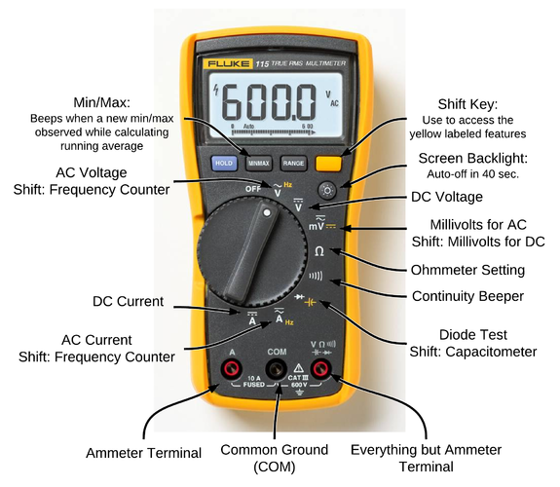
Figure 20: (“How to use a Multi-Meter when Troubleshooting a Fire Alarm”, Retrieved 2016)

What are the symbols on the digital multi-meter?
Common symbols on the digital multi-meter include:
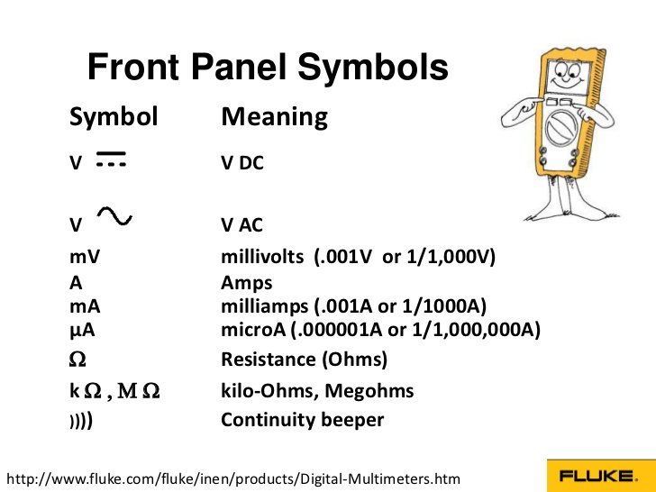
Figure 21: (“Digital Multi-meters- Basic Guide”, Retrieved 2016)

Chapter 7: Measuring Voltage with a Digital Multi-Meter

How voltage is measured using a digital multi-meter?
Voltage (V) is the potential difference needed to cause current to pass through resistance. Voltage is broken up into two sections: alternating current and direct current. Alternating current (AC) is predominately the voltage that comes out of the wall (120V). Direct current (DC) is predominately the battery voltage. (Circuits)
When using an auto range digital multi-meter, just turn the knob to the voltage setting when conducting measurements. But, when using a switched range digital multi-meter, use one voltage setting higher than your expected value. The reason this is recommended is to receive an accurate measurement and to avoid the circuit fuse from blowing up.

How to measure voltage in a series and parallel circuit?
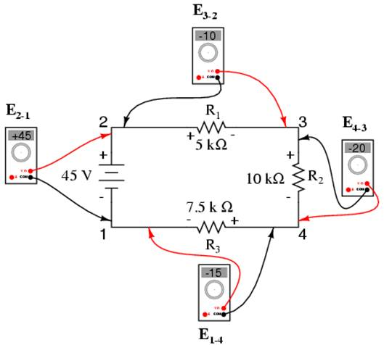
When measuring voltage in a series and parallel circuit, connect the leads in parallel between the two points where the measurement is to be made. The digital multi-meter provides a parallel path so it needs to be on a high resistance to allow as little current flow through as possible. The following is an example of how voltage is measured in a series and parallel circuit. Notice how the probes of the digital multi-meter are measuring the components in the circuit in parallel.
Figure 22: (“Lessons in Electric Circuits”, Retrieved 2016)

Chapter 8: Measuring Current with a Digital Multi-Meter
How current is measured using a digital multi-meter?
Current (I) is the flow of electrical charge through a component measured in amperes. There are a few general rules that should be taken into considerations. Those rules are as follows:
- Disconnect the power source before testing.
- Disconnect the completed circuit at the end of the circuit.
- Place the digital multi-meter in series with the circuit.
- Reconnect the power source and turn the circuit on.
- Pick the highest current setting and keep selecting a lower range for an accurate reading.
When using a digital multi-meter, these are the steps that are used to measure current:
- Before current is measured, make sure current is flowing in that current.
- Plug the black and red test leads into the meter in their appropriate ports for measuring current.
- Turn the dial on your multi-meter to alternating current (AC) or direct current (DC).
- Replace the wires that connect the component being measured from the circuit.
- Connect the red lead to the high potential side of the circuit and the black lead to the resistor.
How to measure current in a series and a parallel circuit?
The following illustrates how current in measured in series with a series and a parallel circuit.
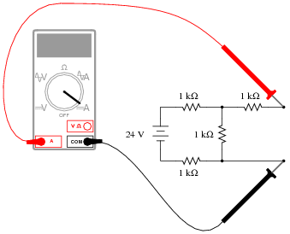
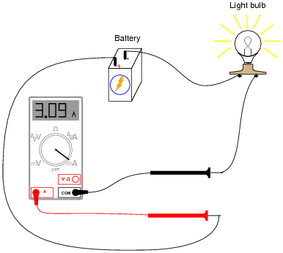
Series Circuit Parallel Circuit
Figure 24: (“Measuring Current in a Parallel Circuit” Retrieved 2016)

Figure 23: (“Measuring Current in a Series Circuit”, Retrieved 2016)

Chapter 9: Measuring Resistance with a Digital Multi-Meter
How resistance is measured using a digital multi-meter?
Resistance (R) is the opposition to current and is measured in ohms. When measuring resistance with a digital multi-meter, the following steps are required:
- Turn the dial to the resistance setting.
- Measure the resistance of the component starting at the lowest value and increase the setting if necessary to receive the most accurate reading.
How to measure resistance in a series and parallel circuit?
The following steps are required when measuring resistance in a series and a parallel circuit:
- Disconnect the power source of the circuit before testing.
- Remove the component or part that is being tested from the system.
- Measure the resistance starting at the lowest value and if the display screen shows OL (overload), move the dial to the next level for an accurate reading.
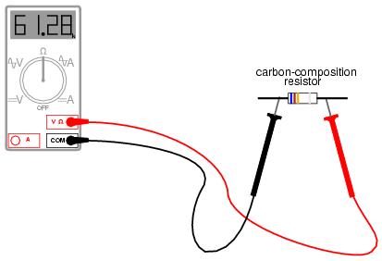
Figure 25: (“Measuring Resistance” Retrieved 2016)

How continuity is measured using a digital multi-meter?
Testing continuity of a circuit is another way of testing the resistance. Continuity verifies if the circuit, wire, or component is complete with no opens. Audible continuity on a multi-meter allows an alarm to sound if the circuit is complete. If there isn’t an audible alarm, the resistance value will be indicated. Resistive values from 1 ohm-0.1 ohms mean that the circuit is complete.
Note from the Author
This guide provides detail instructions and information for circuit construction and testing. It covers a wide range of topics so that students have all the necessary information before constructing and testing. Enjoy building and testing!
Warning: When constructing circuits and testing, abide by all required safety precautions.
References of Pictures
BBC. (2014). BBC- Higher Bitesize Pysics- Resistors in Circuits Revisions [Digital image]. Retrieved March 14, 2016, from http://www.bbc.co.uk/staticarchive/3e2fc6e6c5581b62ab7420303a351cc9e3499759.gif
How to use a Multi-Meter when Troubleshooting a Fire Alarm [Digital image]. (n.d.). Retrieved March 21, 2016, from http://2.bp.blogspot.com/-iOx35Jz-xeE/Uzrj4uq50lI/AAAAAAAADuM/jP22mzkeNVQ/s1600/575px-Multimeter.png

Hunt, W., & Phillips, J. (2013). The LED – Christmas Lights. Retrieved March 14, 2016, from http://www.backward-workshop.com/electronics/breadboard-curriculum/led/
Learning Electronics. (n.d.). [Measuring Current in a Parallel Circuit]. Retrieved April 4, 2016, from http://www.learningelectronics.net/images/quiz/03228x03.png
Lessons in Electric Circuits [Digital image]. (n.d.). Retrieved April 4, 2016, from www.ibiblio.org
Lieff, J. (2013). Neuroplasticity Learning and Brain Circuits. Retrieved February 09, 2016, from http://jonlieffmd.com/blog/neuroplasticity-learning-and-brain-circuits
Ohm's Law and How to Solve It [Ohm's Law Formula]. (n.d.). Retrieved March 08, 2016, from http://tinkernow.com/wp-content/uploads/2014/12/OhmsLaw.gif
Safe MultiMeter Usage: Electrical Safety [Digital image]. (n.d.). Retrieved March 21, 2016, from http://www.zrd.com/faq/01.jpg

Simple Circuit [This simple circuit in one loop lights one bulb.]. (n.d.). Retrieved March 08, 2016, from http://science.jrank.org/kids/article_images/light_p25.jpg
SlideShare. (n.d.). Digital Multi-Meters-Basic Guide [Digital image]. Retrieved March 21, 2016, from
http://image.slidesharecdn.com/fluke-india-digital-multimeters-presentation-22-08-2012-120903025550-phpapp01/95/digital-multimeters-basic-guide-3-728.jpg?cb=1346641218

SlideShare. (n.d.). How to use a Digital Multi-Meter [Digital image]. Retrieved March 21, 2016, from http://image.slidesharecdn.com/howtouseadigitalmultimeter-100726083407-phpapp01/95/how-to-use-a-digital-multimeter-3-728.jpg?cb=1280133295

Squishy Circuits Project 2: Add Even More Lights [Series Circuit]. (n.d.). Retrieved March 12, 2016, from http://www.cdn.sciencebuddies.org/Files/4890/7/series-circuit-diagram-2_img.jpg
Squishy Circuits Project 2: Add Even More Lights [Parallel Circuit]. (n.d.). Retrieved March 12, 2016, from http://www.cdn.sciencebuddies.org/Files/4889/7/parallel-circuit-diagram_img.jpg
SysRecon. (2014, August 13). SysRecon. Retrieved March 14, 2016, from http://www.sysrecon.com/tag/resistors/
ThingLink. (n.d.). Parallel Circuit [Digital image]. Retrieved March 14, 2016, from http://s4.thingpic.com/images/mn/AM7rKnhpFgKmAbdzUYTkvC5Q.gif

What's Ohm's Law? [Ohm's Law Formula]. (n.d.). Retrieved March 08, 2016, from http://media.fluke.com/images/6004178-dmm-whatis-ohm-top-715x360.jpg
Work Cited
All About Circuits. (n.d.). A Very Simple Circuit. Retrieved March 14, 2016, from http://www.allaboutcircuits.com/textbook/experiments/chpt-2/a-very-simple-circuit/
All About Circuits. (n.d.). Basic Ammeter Use. Retrieved April 04, 2016, from http://www.allaboutcircuits.com/worksheets/basic-ammeter-use/
All About Circuits. (n.d.). Safe Meter Usage. Retrieved April 04, 2016, from http://www.allaboutcircuits.com/textbook/direct-current/chpt-3/safe-meter-usage/
Dummies. (n.d.). Electronics Components: Parallel Resistors. Retrieved March 14, 2016, from http://www.dummies.com/how-to/content/electronics-components-parallel-resistors.html
Grob, B. (1997). Basic electronics (8th ed.). New York: McGraw-Hill.
Chapter 3: Ohm's Law Page 68-77

Grob, B. (1997). Basic electronics (8th ed.). New York: McGraw-Hill.
Chapter 5: Parallel Circuits Page 123-126

Grob, B. (1997). Basic electronics (8th ed.). New York: McGraw-Hill.
Chapter 5: Parallel Circuits Page 127-132

Grob, B. (1997). Basic electronics (8th ed.). New York: McGraw-Hill.
Chapter 4: Series Circuits Page 102-103

R. (n.d.). The Simple Circuit. Retrieved March 11, 2016, from http://www.regentsprep.org/regents/physics/phys03/bsimplcir/default.htm
Sparkfun. (n.d.). How to Use a Breadboard. Retrieved March 14, 2016, from https://learn.sparkfun.com/tutorials/how-to-use-a-breadboard

