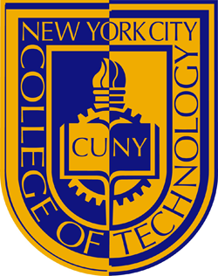
New York City College of Technology
Paralegal Studies & Law Program
Basic Guidelines to Adapting to College Life!
Advancing your education after high school into college is a big and intimidating step. Being a City Tech student in the Paralegal Studies & Law program is hard work. As a new student of the program the first semester is crucial. First semester students are guided through the process of selecting the required classes needed in the first semester. These classes teach you the basics about being a paralegal and laws pertaining to the field of law that interest you. Any incoming students in the Paralegal Studies and Law program should know that their first semester will be the easiest from the upcoming semesters.
Tips to become acquainted with City Tech and its culture?
As an incoming student the population and culture at City Tech can seem overwhelming at first.
Here are some tips to help:
- Always keep your City Tech ID available to enter the campus and use library and lab resources.
- The first week of the semester City Tech have students available on the first and ground floor to answer questions and give directions.
- The Paralegal Studies & Law lab can be used for printing, researching, and answering questions about your academic year.
- Use the Student Center located on the 1st floor for any assistance with information about the college and to set up accounts associated with City Tech.
Problems you may encounter transitioning into a college student:
- Time management is always a problem the first semester when you have three or more different assignments due the same week.
- Writing down important information in class during lectures.
- Staying updated with the reading that needs to be done for the next class.
- Researching using accurate sources needed to back up your assignments.
For a student in the Paralegal Studies & Law program your typical first semester includes easier classes. In the first semester students are required to take at least 3 law classes. During the law classes’ students will be able to become acquainted with reliable sources used to find statues and cases, such as Lexis Nexis, McKinney’s, West Law, and more. During the first semester professors in the Paralegal Studies & Law program are more willing to take the necessary steps to ensure you understand all the information they teach. The first semester of the Paralegal Studies & Law program you become familiar with your future professors in the program.
Resources to make use of ASAP:
- Cuny Portal
- Cunyfirst
- Financial Aid Office
- Paralegal & Law Studies Lab
- City Tech Library
- Admissions Office
Be Resourceful and Plan Out All Coursework Before Its Due !!!

