COMD 1112-Digital Media Foundations
Patonn Francois
Final logo Research Writing Assignment

BMW
BMW is one of the most well-known automobile brands in the world. According to BMW.com from 1917 to 1922, BMW was the successor to Bayerische Flugzeugwerke AG, which was founded in 1916. BMW was first incorporated into Knorr-Bremse AG during 1920 before becoming BMW AG in 1922.Karl Friedrich Rap is the face behind the successful logo; I believe BMW is one of the most important brands used in modern day society. You can never go wrong investing in one of these refined elegances yet blistering performance cars.
My paper will demonstrate the significance of the BMW logo. I chose this logo because I’m very invested and fascinated by the production of them. Each car is built differently to fit each person's wants, and needs, but I got to say out of every car ever made BMW has always caught my attention. I want to inform everyone about why BMW should be everyone’s top choice. BMW SUVs and coupes are just a few of my favorite models, but who's to say that's just it. A car's color and shape does not make it the best but it’s how it's designed to work. The speed, the smoothness as it glides on the road feeling like you're in a never-ending dream is what matters. I’ve always questioned how the owner created the BMW emblem and made it immensely distinct from other automobile brands. The story behind the BMW emblem is quite intriguing, and I believe it's great to learn about it. The BMW logo design was a fantastic idea that before they even knew, was going to make millions.
Many people don’t know that BMW is an abbreviation for Baverische Motoren Werke. BMW has the most distinctive logo in the automobile industry. Many people used to believe that the BMW logo depicted the whirling propeller of an airplane. As shown in a 1929 BMW advertisement, the BMW symbol is shown in a spinning airplane propeller, complete with the four colored quadrants, which is a fascinating fact about BMW. The design, although reflecting the company's history as a manufacturer of aviation engines, is really a nod to its roots in Bavaria, Germany. Pretty great, right? Each of the colors on the logo have a meaning behind them, the white and blue are the colors of the German state of Bavaria, where BMW is based.
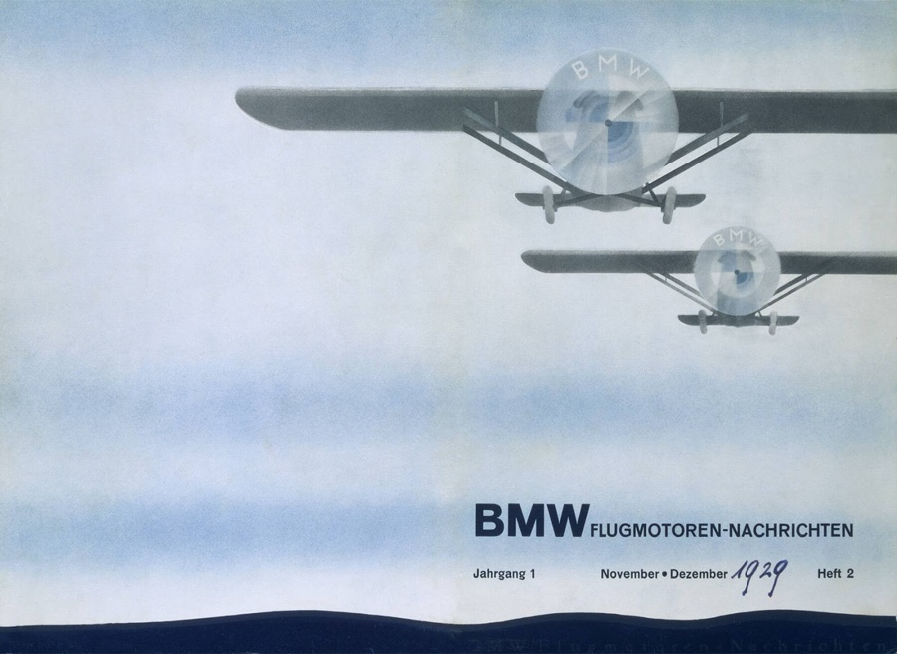
There was no corporate logo when the name BMW was initially registered in the commercial registry in July 1917. Similarly, there was no BMW badge or logo in the first commercial from the same month. It did, however, display, alongside aviation engines, its future intended product range: engines for autos, agriculture, and watercraft. BMW arose from the company Rapp Motorenwerke GmbH. (1913-1917). This is also seen in the initial BMW logo, which appeared in October 1917 and followed Rapp's tradition of a black ring around it.
The original founder of BMW, Karl Rapp, one of the three men who created the BMW vehicle brand and emblem founded Rapp Motorenwerke , a company that makes airplane engines. This company was renamed BMW AG, and many regard him to be an unofficial founder of BMW. The Rapp Motorenwerke was the inspiration for the current BMW logo. Another important figure that played a role in the making was Franz Josef Popp, he was the first General Director of BMW AG, serving from 1922 to 1942. He was crucial in creating the basis and stability for the company. Lastly Camillo Castiglioni was well-known as BMW's financier and the wealthiest person in Central Europe. The BMW went through five phases making the BMW logo. The BMW logo always looks similar from the original to the new update one.
In 1917 -1936, RAPP Motorenwerke may be a corporation whose capabilities would subsequently cause the emergence of this automobile industry's behemoth. A horse emblem surrounded in a very circle is the corporate logo. According to logo-world.net 1917-1936 the brand for the primary iteration is predicated on an insignia that was passed down from BMW's progenitor — the firm RAPP. It absolutely was a circle with a horse within the center, encircled by a broad strip with the company's name engraved thereon. The text layout and typeface stayed unchanged from the prototype. But the image of the horsevanished, replaced with modified airplane blades within the colors of the Bavarian flag. BMW uses the font name Helvetica

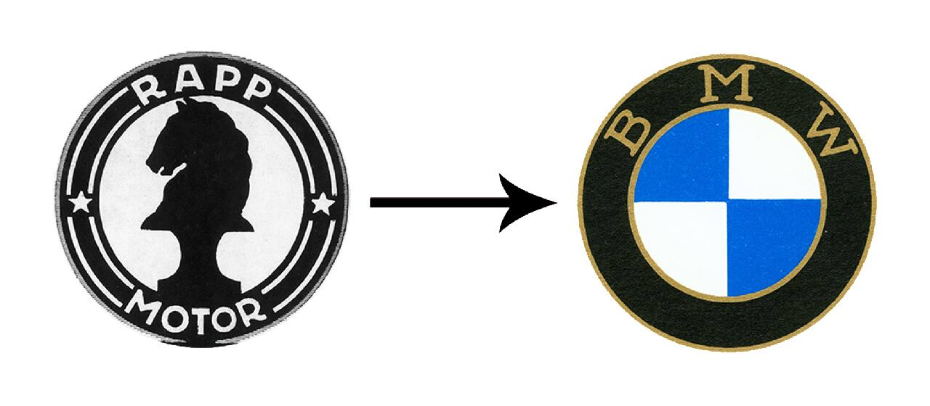

From 1923-1953 The first significant logo makeover was attempted. Each piece is surrounded by a dark golden border. In addition, the blue has become more vibrant, and the typeface has become wider and bolder. between 1936 and 1963 The surrounding lines were modified to thin white lines, which aesthetically lightened the design. and that they redefined the abbreviation's color by using sky blue rather than blue, giving it a stark brightness against a dark background. From 1963 through 1997, this emblem was given a distinctive typography and an almost cobalt hue. between 1970 and 1989 During this time era, BMW, which participated in sports racing, used a distinct logo to differentiate the game from the corporate mainstream. Between 1997 and 2020, the illusion of a convex-volume center and a metallic shine on the black ring's edge was created. The 3D effect was achieved by using small lines in the center, which resulted in the glitter at the letter "B." in 2020 BMW logo have the most significant alterations have occurred in the contemporary edition. Instead of a big black stripe, a light silver stripe is now shown. The volume element has vanished. A narrow frame encircles the ring The blue color is boosted once more.
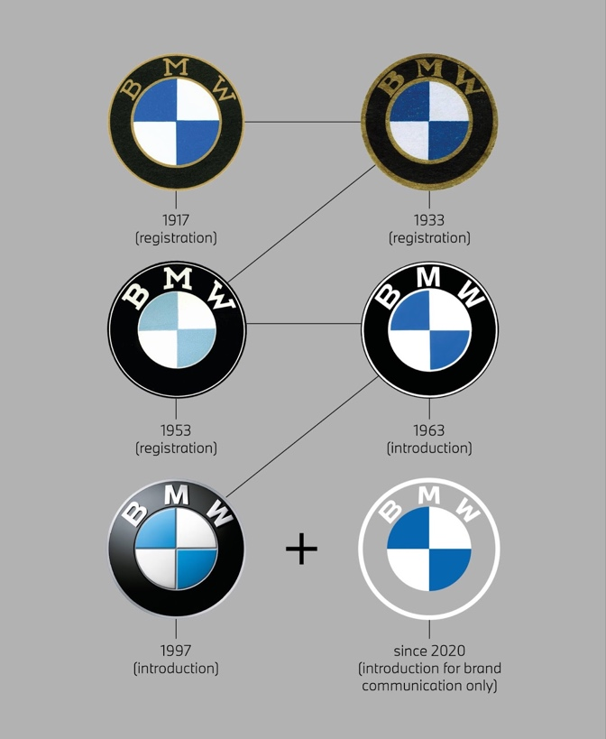
BMW never fails to please its consumers. With a focus on innovation, the company aims to build the best cars possible fitting never before seen features to continue to build its reputation. According to ar-corral.com BMW introduced its 'i series', a sub-brand of the company focused on adopting advanced technology into its cars to help preserve the environment. It is a sub-brand of BMW. Its cars produce fewer emissions and even embrace the electric trend of cars. This series of BMW cars offers unwavering performance with a positive impact on the environment. So, at this point why not turn your head to BMW, lately the world has been undergoing serious global issues and suffering; why not take that next step into making the world we live in a better place. BMW is next in line to Tesla and other companies that are trying to create a better living environment. This is just the cherry on top of the cake, I know for a fact BMW will never fail to impress.
To conclude its proven that BMW is one of the best brands ever created, many could agree. Ever since it was just a thought the brand was known to become successful, the amount of work put into it to continue to grow its consumers and show out shows the dedication and efforts made. The brand and business has continued to be socially responsible and aware of incorporating problems that need to be solved into their plan. You can never go wrong with choosing a BMW over any other car brand.

Citations
Bmw. “The Circuitous History of the BMW Name and Its Rise to a Global Brand.” How the BMW Name Was Created | BMW.com, BMW, 15 Dec. 2021, https://www.bmw.com/en/automotive-life/BMW-name-meaning-and-history.html.
Admin, Joe - LMW. “Joe - LMW Admin.” LogoMyWay, 18 Feb. 2021, https://blog.logomyway.com/bmw-logo/.
Bmw. “From Propellers to Mixed-up Colors - How the BMW Logo Was Really Born.” What Does the BMW Logo Mean? | BMW.com, BMW, 14 Dec. 2021, https://www.bmw.com/en/automotive-life/bmw-logo-meaning-history1.html.
“Reasons to Own a BMW over Other Car Brands.” Howie's Car Corral, 2 Sept. 2020, https://car-corral.com/blog/reasons-to-own-a-bmw-over-other-car-brands/.
“Social Responsibility.” BMW Group Plants, https://www.bmwgroup-werke.com/spartanburg/en/responsibility/social-responsibility.html#:~:text=Over%20the%20last%20two%20decades,Am%20presented%20by%20SYNNEX%20Corporation.
Nigrenji, Robert. “Car Emblems - Car Symbols.” Car Logos, Publisher Name Robert Nigrenji Publisher Logo, 1 Dec. 2020, https://car-logos.net/.

