Fabienne Joinvil
Jessica Penner
English composition 2
Date: 04/02/2020
Words count: 2255
Music
Part 1: General Analysis and Focused Analysis
History and social impact
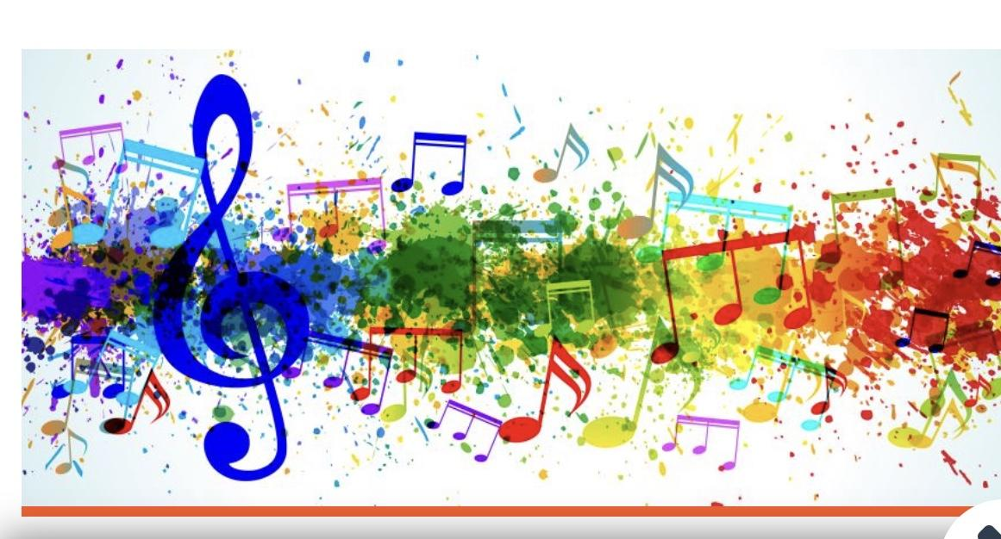
Music is defined in many ways. It is defined as an art of sound that expresses idea and emotions in significant forms through the elements of rhythm, melody, or harmony. It is something that is common across gender, generations, culture and civilisations. All of us, regardless of training, can recognize and appreciate a good rhythm or beat. There are many theories regarding when and where music formed. Many agree that music began even before man existed. Researchers also point out that there are six periods of music such as classical period, Medieval, renaissance, baroque, Romantic and contemporary also known as R&B, Rock, Hip Hop, Soul etc...and each period has a certain style of music that made what music is today.

Hip hop:
Hip-hop stands for “High Infinite Power Healing our people.” Hip Hop originated in the predominantly African American economically depressed South Bronx section of New York City in the late 1970s. The first ever rap music song recorded by hip hop artists was “ Rapper's Delight” by a hip hop music group called “ the Sugar Hill Gang'', also in 1979, but out shortly after the Fatback band’s own rap record.

R&B:
R&B stands for “ rhythm and blues. It is a term used to describe the blues-influenced form of music which has been predominantly performed by African-Americans since the late 1930s. The term “'Rhythm and Blues” was first introduced into the American lexicon in the late 1940s: the name's origin was created for use as a musical marketing term by Billboard magazine.
It is also a bunch of love songs.

There are various reasons as to why it is important in society or people's lives in general. However, the most fundamental and logical one that most people would agree on is the following: Music is a very efficient way to relay a message or teach a lesson while entertaining the consumer or the listener. Some people use it as a way to release stress or meditate, others use it to teach something, and that “something “ could literally be anything”. Even in Pre-k or kindergarten, lessons are taught through /with music or some kind of melodic structure, that way the students/kids can easily capture the lesson and eventually memorize it.
Music plays an important part in our life because it is another way to express our feelings as well as emotions. Many people consider music as a way to escape from the pain of life. It gives people relief and allows them to reduce the stress. It helps people decrease stress and anxiety while increasing overall health. Music can help people increase happiness .
I personally believe that music is everything. For instance, When I feel lonely I listen to music, when I’m doing homework, I use music, it helps me clear my mind and helps me focus. It also helps me sleep better, if I have something playing in the background, I can fall asleep in a few minutes. It helps me through some rough times such as pain time, sad times. It just brings me comfort on everything.
Growing up with an extremely musical background it was in my genes. Playing music has helped me become the person I am by being a release for my anger, broadening my future and making new friends. Music has been a part of my life for as long as I can remember. It is one of the essential components in our lives. It gives us entertainment and relaxation when we feel stressed. The beautiful rhythm of Classical music not only can release our stress, but also can bring us pleasure. After a long day of studying, I listen to some Pop melodies
by myself. Although some of those melodies contain Rock-and-Roll beats, it still can make me feel calm and comfortable. Also, music can heal my tiring by soothing it with rhythms. Some people even found that they couldn’t live without music, and I happen to be one of those people. Music plays a vital role in my life. I love listening to music and it’s become one of my hobbies since I was In primary school. I can say that music has become part of my life. I believe that music has the ability to convey all sorts of emotion. Whether the emotion is joy and happiness or sadness and despair through rhythms, harmonies and the lyrics music show it. Music is not just pleasing esthetically, but it also has benefits for our mental well being. Many people in recovery from addiction have made music therapy become a part of the need of their lives because hearing music makes people feel peaceful and happier in life. It is loved and enjoyed by all people around the world in different ways.

The well-known people who have worked with this genre are Rihanna, Kanye west , Jay-Z, Nicki Minaj , Drake , Eminem, etc… These people are known well in the hip hop industry.
For R&B, Ray Charles was one of the most versatile recording artists of all time. Rock and roll, country , gospel, and blues. He won 17 Grammy Awards. Furthermore, There are Michael Jackson , Usher, Christ Brown, Whitney Houston, Beyonce etc…

Musicians, singers, managers and dancers , they all belong to the same discourse community; they usually reach out to each other as a group of people who share a set of basic goals and have their own opinions, thoughts and their own way of communicating about those goals. They all have different instruments to learn and specific aspects to each instrument. They use music to express themselves and challenge themselves to accomplish more.

Music’s goal is to convey and adjust emotions. It is enjoyable. Whether people enjoy it because it moves them , or people enjoy it because it is uplifting. There are seven main functions of music listening: “music in the background , memories through music, music as diversion, emotions and self-regulation through music, music as reflection of self and finally social bonding through music.” Across all sub-samples the self-regulation function was the most important personal use of music, bonding was the most important social use of music and the expression of cultural identity was the most salient cultural function of music regardless of listeners’ cultural background.
Music is often used as a background, it can also fill gaps and help pass the time, it can bring back memories of events, life stages, relationships and emotions or memories of loved ones. Music is also used for feeling good and enjoying oneself, it has the capacity to convey emotions and to trigger emotions or emotional and physical reactions. It can help to relax and relieve stress and to enhance creativity and intellectual focus. Listening to music can reduce loneliness, while offering a means of escape. Certain music can assist in venting frustration and aggression, it allows for the expression of a person’s individuality and lifestyle. It expresses and influences values and attitudes.

In agreement with a team of neurologists at the university of St Andrews, (Scotland), 2016, In children’s brains, musical activity increases cognitive and motor skills and children who have three years or more of training with musical instruments have better motor coordination and auditory discrimination skills, learn vocabulary more easily, and have better non-verbal reasoning skills, which implies better understanding and analysis of visual information, such as identifying relationships, similarities and differences between shapes and patterns.

As stated by the pianist Robert Jourdain in the book “Music, the Brain and Ecstasy: How Music Captures Our Imagination,” it overcomes the symptoms because it “relaxes the cerebral flow,” while “stimulating and coordinating the activities of the brain.” For him, this “magic” happens to
everybody. “Music lifts us from our frozen mental habits and makes our minds move in ways they ordinarily cannot,” he said.

As a primary communication within the community, Loudness or volume can convey intensity and power of an emotion, as well as anger. A musical piece's melody can also communicate emotions. Complimenting harmonies show happiness, relaxation and serenity, and clashing harmonies communicate excitement, anger, or unpleasantness.

This discourse community communicates the outside the community by using melodies and lyrics in order for them to express their feelings and to tell their story to the audiences, to project a musical discourse from a source which is the singer to a recipient which is the listener. The sounds made are meant to represent the speech patterns .

The roles or forms of the genre are to create a sense of unity and make the song feel ordered and memorable. It also used to convey a certain idea or emotions. Music provides identity and the opportunity to tell others who you are because sometimes some people rather use words such as letters, or using a phone to communicate via text messages than face the reality. It’s just another way for them to express their thoughts. That is one of the main reasons why some people use music, to let the world know about them and what they want to accomplish in their life because they know that music has no limit. No matter where they are or no matter where they go, or no matter what they do, music will always follow them. The entire world can hear someone throughout music.
The main message of my chosen example is that music plays a very important role in our society and it is also a popular form of entertainment that can also teach information, highlight problems, express emotions , and even inspire people to change injustices in society. Music also helps people communicate how they feel inside when they just can't find the words to say it. It also helps people communicate how they feel inside when they just can't find the words to say it. Sometimes, in our lives, it is difficult to say how we feel to other people, but with music we find the words that are missing and the messages that we are trying to tell people. We all can find the words that we are looking for by either writing songs or just listening to different songs on the radio or anywhere we are.
People who write songs can express messages that are important to them through stories , statements, and metaphors in their words and music. However, they don’t have the same kind of message, there are places where they diverge.

The author of this example of this genre is composer which means a musician, who is an author of music in any form , including any music vocal and instrumental music. Composers usually convey their works in a written musical score by using musical notation. The goal of this example is to help tell a story, to arrange and also produce various types of media entertainment and create music .

The intended audience is their current fan, the assembled spectators or listeners. The audience is those who come to bring their support . Musicians and artists need their fans in order to succeed . Usually The artists who tend to have fleeting levels of success are often those who deviate from the people who make it possible for them to succeed. And also in making a song, the artists need to know their audience and so it’s made in a way that will interest them. It is
impossible to create music without thinking about The intended audience because the audiences are those who can help them succeed.
According to Bjorn Merker and Willem Zuidema, there are five fundamental constraints that are also involved in music . Firstly, cultural transmission brings the formal power of culture as contrasted with the evolution to bear its contents. Secondly , generativity, it produces infinite patterns of diversity by finite Means. And vocal production learning, this includes human singing , without it , there can be no human singing. The Fourth is the entrainment with perfect synchrony. There is neither rhythmic ensemble music nor rhythmic dancing to music without it. And finally, the universal propensity of humans gather occasionally to sing and dance together in a group.

Expressing yourself without music would be nearly impossible. It can be a pastime for some of us , however, it can be a lifestyle for others. One of the great things about music in general, and in particular concert music, is that playing it opens up a whole new world of experience that further enhances the mind, physical coordination, and expression. In our society and culture, the role of arts and music fill a void that we all need in order to enrich ourselves and our culture. They provide alternate infinite experiences, and they also further enhance the skills we use in other disciplines and professions.

To sum up, music is really important in our world. It can bring back memories. A song can remind us of a time in our life and brings back all the memories that go with it. It always seems to know what we are feeling. If we are sad, there is a song out there that describes what we are feeling. If we are happy, there is also a song out there that blares the enthusiasm that we feel. Music can put things into words, the feelings that we are not able to describe.
Cited
Tomasino, Anna. Music and culture, Oklahoma, OK: Cengage Learning, 2005. Print
Robert Jourdain in the book “Music, the Brain and Ecstasy: How Music Captures Our Imagination,” 2006.
Gilbert Galindo, November 2003, revised July 2009

