Multimodal Project
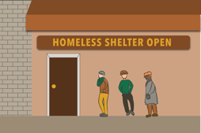

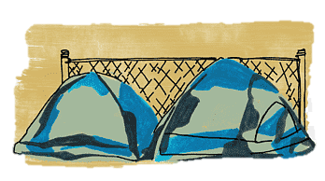
As the weather begins to get colder, there will be more houseless folks in need of help in the streets of New York City. Often the homeless shelters are overpacked so many people resort to sleeping on the streets. In 2019, the budget for New York City's homeless crisis was 3 billion dollars. However, according to a man featured in the video "New York's Homeless Epidemic, he and his partner were fed moldy food and when they reported the incident they were removed from the shelter. This just does not add up. If the money was being allocated properly why are people being fed moldy food and sleeping on the trains? As Jenny Holzer once said, "The abuse of power comes to no surprise". Therefore, it is important for non-profit groups such as the Time Square Alliance to exist because they are approaching this problem in a more personable way by creating a sense of community. Their team consists of people who have experienced homelessness before therefore they are more empathetic and knowledgeable on what a homeless individual may be feeling. In this way, a more permanent solution can be created by showing there is a way out of their situation. It can create jobs for other people who are homeless and then they can do the outreach next. Moreover, this pushes the focus on rehabilitation rather than temporary answers. The end goal should be to have these people be able to renter and contribute to society again. According to the article "New York grapples with growing presence of homeless in midtown Manhattan", the writers write, "Several of the more than a dozen Democrats running for mayor in next Tuesday's primary election also have called for converting hotels into housing for the homeless". While some agree with this proposition others worry what this will do to the safety of the neighborhood. Therefore, on top of housing for the homeless there needs to be resources for mental health and addiction.

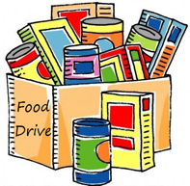
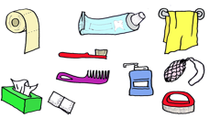
As college students and citizens of New York City, we need to volunteer at help the people in need. There are many things that you can do to give back during this time. Shelters are often looking for donations. Items such as canned foods, feminine hygiene products, personal hygiene products, and warm jackets are some things that are wanted during this season. It would be best to reach out to your local shelters and ask what items they are short of before you donate. Our time is another way we can give back by physically volunteering at shelters or food banks. It is unfortunate that people who are less fortunate get discriminated against because of their circumstances. In addition, we can vote for people who will be responsible in funding these resources so that the money will be spent properly. All in all, we are morally obligated to help as much as we can because we are all living in this city that has the
potential to be so much greater. This is all in efforts to create a better place for future generations.

