The genre I choose for my research is a Twitter thread, and it’s a series of connected Tweets from one person. With a thread I can provide additional context, an update, or an extended point by connecting multiple Tweets together. The reason why I chose this genre is I think it’s the good way to reach out to my audience. My audience are teenagers or high school students, and social media is the best way to reach out to them. the research I did was on the real reasons behind the Iraq war. it’s been a long time since the Iraq War, and I don’t think students known much about the Iraq war and why that war happened it’s important for them to know that, even if they know I’m sure that they don’t know the real reasons behind that war, they might be thinking that it was a good decision made by U.S. government but it’s actually not.
Traits of twitter thread
- Twitter threads can help you resurface an old tweet or follow up on events. For example, you can create a thread to remind your audience about an upcoming sale or a webinar or thank them for attending a past event f you are hosting a giveaway, consider announcing the winner by replying to the original tweet, like Kahoot!:
- You can use Twitter threads to curate information in one place by creating an extensive list of resources. Alternatively, you can also create a thread of quotes. Bullet points contain bite-sized bits of easily digestible information, which is why listicles as threads are a huge success.
- Not every campaign needs a separate ad. For some, a well-crafted thread is enough. Threads allow you to create campaigns in the form of a narrative. So, make use of it as creatively as possible. Threads also allow you to highlight the entire campaign every time you add a new tweet to the thread. For example, Quip, a toothbrush brand, used a thread to connect to their audience by relating their products with Rihanna’s outfits:
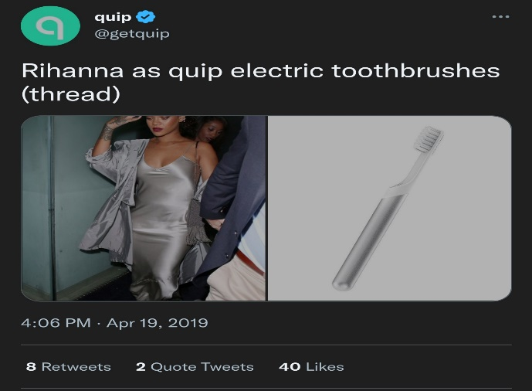
- Do you have a top-performing blog loved by your audience or a blog packed with valuable insights? Such blogs make the best kind of threads. Repurpose them into tweets as they are or provide context and background information.
- Do you have a launch, sale, or event coming up? You can build this up by putting out one tweet every day leading up to the release. Use Twitter threads to get your audience excited. Give previews just enough for them to come back for more.

