**Article Tittle:**

Antimicrobial and Antibiofilm Coating of Dental Implants—Past and New Perspectives

**Peizhen Zhang**

**Class Section: 2C**

**Date: 4/ 18/ 2023**

**Summary of the article**

The article *“Antimicrobial and Antibiofilm Coating of Dental Implants—Past and New Perspectives”* discusses the importance of dental implants and complications that can occur after implant placement, which can lead to implant failure, peri-implantitis, and even systemic infections. To prevent these issue, various type of coating materials with their mechanisms of action has been used in the past, including silver, copper, zinc, and some antibiotics. These coating materials are effective at reducing bacterial adhesion. The article describes several new perspectives on the effectiveness of these coatings in preventing implant-associated infections, including antisense oligonucleotides (ASOs), bacteriophages, and antimicrobial photodynamic therapy. The article also discusses the potential drawbacks of these coatings in the past and new perspectives, such as the cost of fabrication, toxicity, antibiotic resistance, loss of osteointegration, and duration of the effect. The authors suggest that more research for future dental implants should focus on promoting osseointegration and antimicrobial and antibacterial effect.

**Article information**

The article *“Antimicrobial and Antibiofilm Coating of Dental Implants—Past and New Perspectives”* By Guilherme Melo Esteves, João Esteves, Marta Resende et al. conducted a review analysis of various types of coatings used in the past and discuss new perspectives for future coatings on dental implants, but it does not involve any original research or experimentation. Instead, it summarizes and synthesizes existing knowledge in the field of dental implant coatings.The study was published in PubMed Central in February 2022 (<https://www.ncbi.nlm.nih.gov/pmc/articles/PMC8868456/> )

**Study analysis:**

The article is a review article, and there is no experimental design involved. The authors do not conduct any original research or experimentation in this article. Instead, they review and synthesize existing knowledge in the field of dental implant coatings, including different types of coatings that have been used in the past, and their drawbacks. Also they provide the new perspectives for future coatings. The article does not involve any data collection or statistical analysis, and it is based on a literature review of previously published studies and research articles by using the keywords of “Antimicrobial” “Antibacterial” “Titanium implants” and et. with a focus on research article from 2012 to 2022 in MEDLINE, Scopus, Web of Science and SciELO.

The purpose of the article is to provide an overview of past and current research on dental implant coatings, which aimed at preventing bacterial infections and biofilm formation. The article discusses the drawbacks of targeted coatings such as bacterial resistance to antibiotics and poor antimicrobial efficacy. This article aims to use a series of studies to determine the optimal antimicrobial and antibiofilm coating material for dental implants, which is a way to prevent these infections.

The study findings show the two main effects of coating surface: bacteriostatic and bactericidal. There are several advantages and disadvantages for each coating material. The authors make the evidence in Table 2 (Esteves et al., 2022).

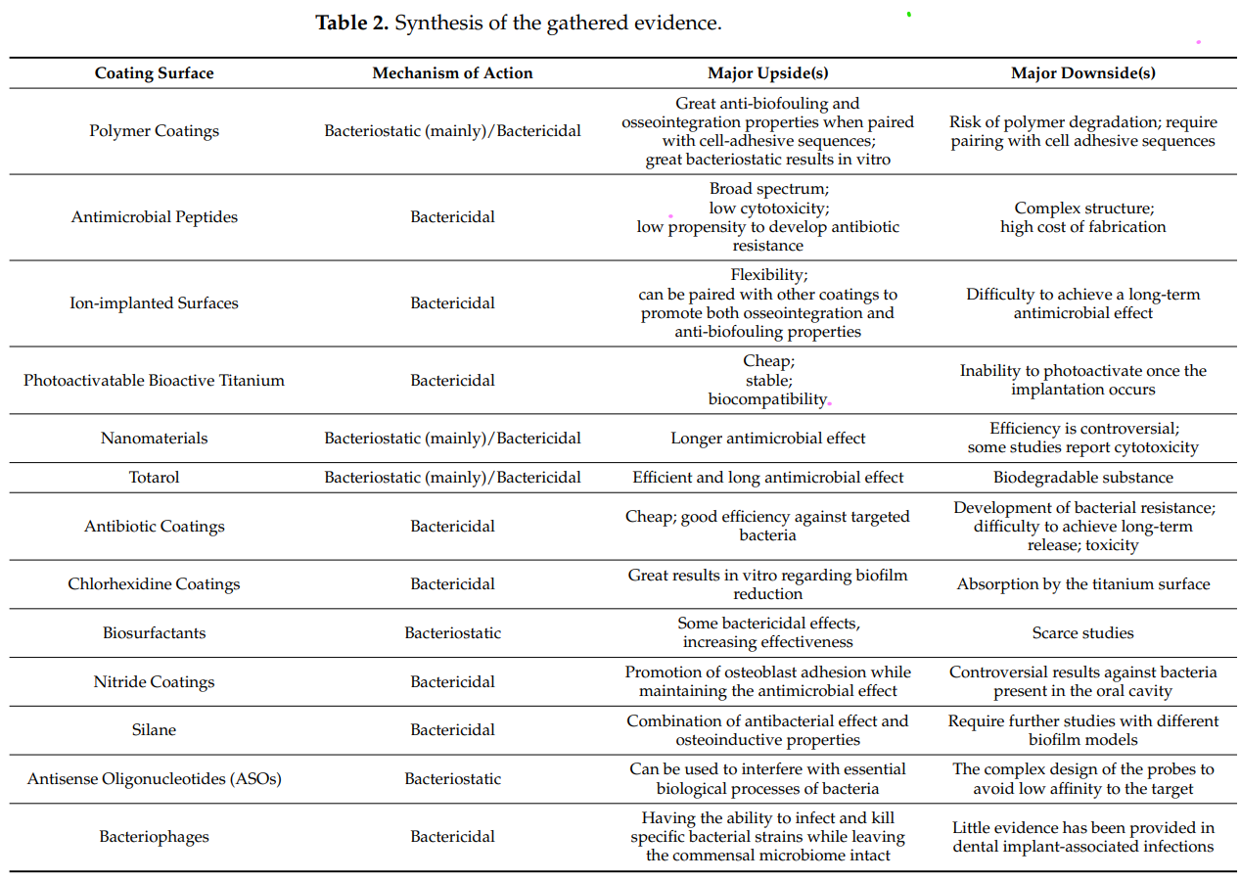

These coating materials for dental implants have essential efficacy in inhibiting bacterial growth and biofilm formation. However, the article reports that these coatings have limitations due to their long-term effectiveness and the potential for cytotoxicity and antibiotic resistance after implantation. In addition, its high cost， biocompatibility, and loss of osseointegration should be considered in future dental coating to prevent periodontal disease. The article also mentions that antibiotic coatings are the most widely used for dental implants because they have good antimicrobial properties with antifouling and antibiofilm, even if it has the drawbacks of antibiotic resistance.

The article concludes that dental implant coatings are a tool for preventing bacterial infections and biofilm formation. While the study states that each coating has drawbacks, future coatings should improve the technique and design for preventing bacterial adhesion and promoting osseointegration through more research in clinical testing and the application of dental implant coatings. The authors suggest that continued research in this area will improve the development of coatings and provide better outcomes for patients with dental implants.

Over the years, dental implants are becoming increasingly popular in dentistry as an advanced technique. Also, dental implants increase the patient's treatment possibilities due to missing teeth. As dental hygienists, we should understand the structure of each part of the implant and educate patients on proper oral hygiene techniques and monitoring their oral health. After reviewing this article, I learned the knowledge of the various types of coatings used in dental implants and their properties, as this can impact the patient's oral health. Additionally, when dental hygienists clean and scale around the implant site, we must consider which type of dental implant coating a patient uses and perform the appropriate cleaning techniques. In conclusion, knowledge of dental implant coatings is essential for dental hygienists to provide proper dental implant care and maintenance.

**Reference:**

Esteves, G. M., Esteves, J., Resende, M., Mendes, L., & Azevedo, A. S. (2022, February 11). *Antimicrobial and antibiofilm coating of dental implants-past and new perspectives*. Antibiotics (Basel, Switzerland). Retrieved April 18, 2023, from https://www.ncbi.nlm.nih.gov/pmc/articles/PMC8868456/