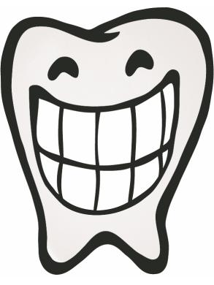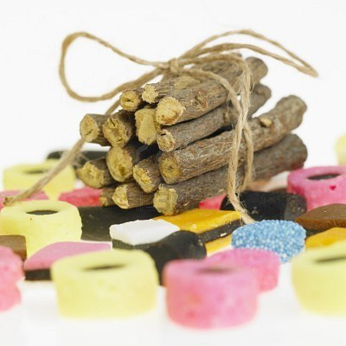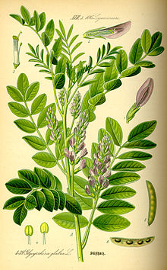

# PRECAUTIONS

Excessive regular consumption (50 grams a day) of concentrated licorice extract may be toxic to the liver and cardiovascular system, and may produce hypertension and edema. Take precautions and ask your physician if licorice is safe for your health.

**Benefit Oral Health???**

## REFERENCES

## ~ Comprehensive periodontics for the dental hygienists/ Mea A. Weinberg, 3rd edition, 2010.

## ~ Oral Diseases Journal, Vol 18, 2012. ‘Licorice and its potential beneficial effect in common oro-dental diseases’ by C. Messier, F. Epifano, S. Genovese, D. Grenier.

## ~http//www.emaxhealth.com Licorice Lollipops May Reduce Tooth Decay in Kids, by D. Mitchell

## ~ http//www.ncbi.nih.gov Liquorice Health Check, Oro-Dental Implications, and a Case Report by Louis Z. G. Touyz

## ~ http//www.thecheckup.com Licorice Root could Help Prevent Tooth Decay, by S. Wright

## ~http//www.medicinenet.com Licorice Root May Cut Cavities, Gum Disease, by Matt McMillen

🙞 🙜

**licorice**

**Can**

Prepared for NYCCT Dental Hygiene Department by

Volha Patel

Belina Kasa

Parbatie Dhanraj

2012

***Licorice***

# Someday your dentist may advise three things for good oral health: brushing, flossing and licorice root.

* speeds healing of mouth sores by limiting irritation to the damaged tissue
* reduces dental caries by anti-bacterial activity against the cariogenic bacterium S. mutans
* impacts the dental caries by stimulating salivary flow, which protects, cleanses and helps to remineralize teeth
* therapeutic for treating oral candidiasis by inhibiting to grows of Candida albicans
* has potential to inhibit growth and formation of biofilm by acting on periodontopathogens

## Effects of licorice on oral health

The leading causes of tooth loss among children and adults worldwide are tooth decay and gum disease.

***Dental caries:*** is a complex and chronic disease that is associated with a progressive destruction of the hard tooth structures by the action of biofilm bacteria (specifically Streptococcus mutants and Streptococcus sobrinus).

***Periodontal diseases:***  which include gingivitis and periodontitis, involve a specific group of Gram-negative anaerobic bacteria that interact with host immune cells.

***Oral candidiasis***: is an opportunistic infection of the oral cavity caused by an overgrowth of Candidda albican species

***What is Licorice?***

Licorice, or Liquorice, is a uniquely tasting herb derived from *Glycyrrhiza glabra* (a.k.a. Sweet Root)*.* The edible and sweet root of licorice has been used in food and medicine for thousand years.

***Active Ingredients and***

***Properties.***

* active chemical ingredients imparting the unique liquorice taste are glycyrrhizic acid and glycyrrhizin, which are 50 times sweeter than sucrose, inhibits the adherence of bacteria to teeth
* licoricidin and licorisoflavan A are strong antimicrobials that prevent the growth of bacteria and have antifungal properties