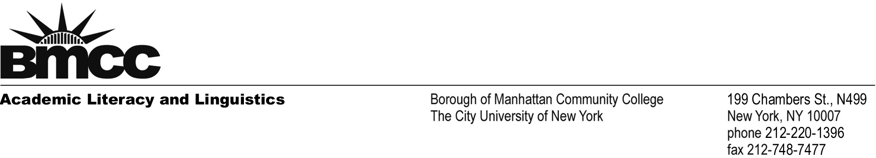

March 4, 2022
Dear Members of the Search Committee,

I am writing to apply for the Assistant Professor of English position at New York City College of Technology. I am very enthusiastic about the prospect of working at City Tech, teaching a diverse group of students, focusing my time and energy towards mentoring students, collaborating with colleagues, developing innovative, effective assignments and activities, and continuing my research on student writing processes and activities in digital environments. For this position, I offer more than five years of teaching academic writing and ESL (English as a Second Language) courses, as well as decades of higher education administration experience working with multilingual/ESL students, which has included curriculum construction, daily student interaction and co-learning, and student writing assessment.

In addition to my position as Adjunct Lecturer in English at City Tech, where I am currently teaching English 1101 ML, I have designed and taught several introductory composition and literature classes, and most recently, in July of 2020, I designed the syllabus and curriculum for an online freshman writing class in a CUNY School of Professional Studies course called Online Teaching Essentials. While in recent years I have been focusing on finishing my PhD coursework, composing my dissertation, and working full time as the ESL Lab Coordinator at Borough of Manhattan Community College, I have also served as sole instructor and curriculum designer for several introductory writing courses. My doctoral research, about which I have been recently presenting at conferences, is a process study that explores multilingual student writer activities using their digital devices. I am eager and excited to apply my research and recent classroom teaching experience, as well as knowledge and experience overseeing successful intervention programs to help prepare students for credit-bearing writing courses at BMCC, to future teaching and research.

In my years of teaching and working with students in academic writing support programs, I have encountered students from many different cultural backgrounds, including immigrant and international students, and students who possess a wide range of learning styles and writing abilities. My classes and support programs have been designed with diverse groups of student writers in mind because each class and program has drawn on students’ own linguistic and cultural experiences as sources for conversation, writing, and research. In my composition classes, for example, the first major research paper included an auto-ethnography and academic genealogy, which allowed students to develop their own voice and sense of authority by asking them to write about their own language and culture and experience with academic writing— subjects on which they are experts. I then asked students to expand their cultural conversations by doing research on elements related to their lives and aspirations. Cathy Davidson, with whom I’ve worked and collaborated at the CUNY GC, has written with admiration about my teaching methods, both in the Chronicle of Higher Education and her book The New Education.

I have always been passionate about teaching reading and writing, and I bring that energy into the classroom, encouraging my students to see each step of the writing process as a dynamic way to develop their ideas and to express their individual strengths. Writing is such a critical skill for all students to succeed, and I therefore concentrate on helping students to develop individual writing goals and then adapt our evolving class goals accordingly. I approach student writing from a myriad of perspectives by addressing sentence-level and essay-structure issues and challenges, and encourage students to consider their own strategies for communication and meaning-making. I believe that by providing students with a better understanding of both structural grammar (without over-burdening with specialized jargon and technical terms) and specific writing task expectations that can change from context to context, students discover and gain a broader access to many academic and professional institutions.

I have also served as the Coordinator of the ESL Lab at BMCC for over a decade, and in this role I have overseen all pedagogical and administrative aspects of the lab: hiring, training and supervising all writing instructors, technicians, tutors and student aides; submitting all payroll records; training faculty and students in computer use; writing grant proposals and reports detailing the lab activities; and creating new curriculum for the immersive writing tutorial programs. In addition, I built an interactive Wiki page for multilingual students with English language and academic writing resources, and I created and coordinated the ESL e-tutoring page which was linked to the BMCC college site.

Teaching and supporting students are the highlight of my career. They inspire and motivate me, and I want to devote my time to working with students and helping them to develop, express, and exchange their ideas. The goal of extending educational opportunities to students from diverse backgrounds, including first generation college students, ESL and immigrant students, and students with a wide range of educational experiences and goals never ceases to inspire me. I have been honored to be part of the process of making college more accessible and manageable for a myriad of students, and I believe I will continue to do so at New York City College of Technology.

Sincerely,
Joshua Belknap
Joshua Belknap
ESL Lab Coordinator
BMCC/CUNY S510J
jbelknap@bmcc.cuny.edu
212-220-1422

