Pamela Consuegra

COMD1112

Prof. T Bauer

Domino's Pizza

A logo that has been incredibly successful and effective is that of Domino's Pizza. Of course, the logo is the same item as the name of the chain store. The name of this shop came from a former employee of a pizza shop named "DomiNick's Pizza". 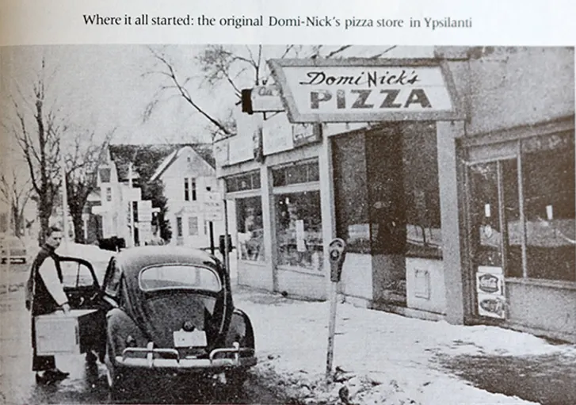After trying to create his own brand in order to expand the franchise, Tom Monaghan shortened the name to Domino's instead. Since the name of the new establishment was now Domino's, it seemed fitting to incorporate the logo into the theme as well. To answer a widely asked question, the franchise logo came from the Domino's name. The household name was made to resemble the original DomiNick's restaurant name. The similar sounding names worked to Tom’s favor, giving Dominoes the credibility held by the previous shop and a more memorable and recognizable name.

The logo for Domino's Pizza originated in the 1960's and hasn't changed much to present day. The original design was a single domino piece and the brand name was displayed on the side. The domino piece catches the attention over the actual name of the restaurant in this first design. Although it does this, the actual name of the item we are looking at is a Domino and therefore it will still represent the brand very well. Originally the domino was created with three dots because they represented the three chain stores that were already opened. When the business started booming, the owners realized that they could not possibly add every single store and left it at three.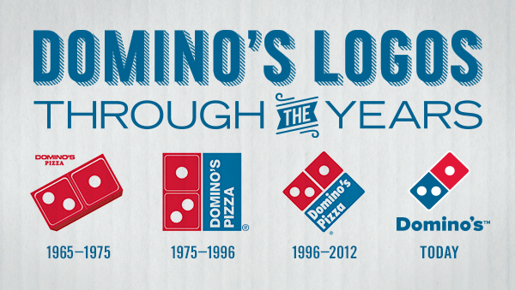

Around 1975 was when the logo underwent the biggest change, and since then it has pretty much stayed the same. It is a square with the left half of the square being the domino and the right half of the square displaying the name of the restaurant. In this new logo, the name of the chain is a lot bigger and more visible, while still showing off its original design of a domino. In the 90's the chain decided to rotate the brand logo and round the edges of the design in order to seem more appealing and less rigid. The words also become bolder, intensifying the association of the logo and the brand name. The change of font went well with the new logo and was also less stiff than the previous all-caps font.

In 2013, Domino's swapped out their square logo for something simpler yet effective. After nearly 50 years, the domino stands alone once again. After years of being placed next to the blue brand name block, the effect of the game piece had almost faded. However, this logo is recognizable to the masses enough that the actual name of the chain is not needed anymore. In the official logo, the name is still included however in their stores, the logo is sometimes displayed by itself. 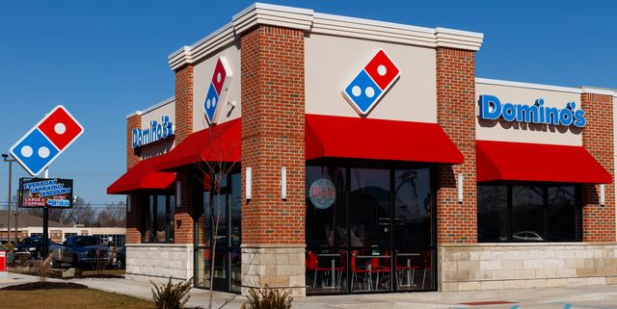

The restaurant itself displays the company name but the actual restaurant sign is the domino game piece standing alone. The restaurant sign is put up to attract people from blocks away. The fact that the logo can stand by itself and still attract attention and be recognized speaks volume to how iconic and effective their branding has been.

Throughout all of the changes however, there is one thing that has always remained the same. The bright red and blue colors that Domino's is famous for using. Originally the domino piece was simply red because it was made to look like a real piece. When the logo was changed to something more flat, the bright blue was added to contrast the bright red and to make sure that it caught the attention of potential customers. Blue is a color that promotes trust and dependability. Having the name in blue while keeping the original red domino establishes the brand name to be reliable and familiar.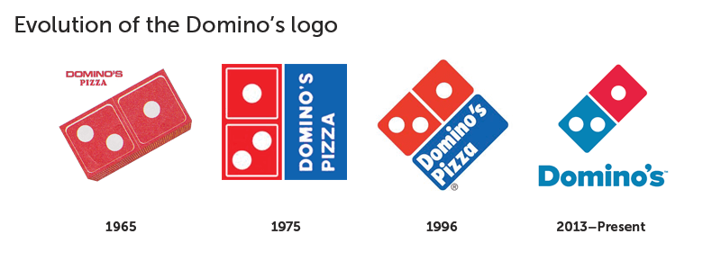

The first font that Domino’s used was similar to Futura Condensed ExtraBold. Although easy to read, there was nothing eye catching about the typeface.

In 1996, the font was switched to a typeface more closely favoring Futura Condensed ExtraBold. 

In 2012 Domino’s got another typeface when they made their final logo change. They also took advantage and dropped the “pizza” from their name. This thick new typeface is more appealing and fits better with their logo.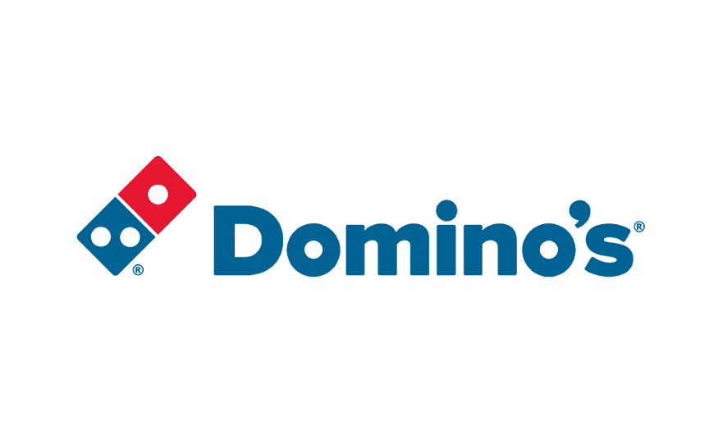

Just a year after their logo redesign, the company decided they were ready to solidify their brand in the design community. Graphic Artist Terrance Weinzierl created a custom typeface specifically for the use of the Domino’s company. The typeface is called Pizza Press. Although they do not use this font in their logo, they use it all over their packaging and restaurants.Pizza Press is an all caps font and comes in regular, inline, fill, outline, shadow, antique, and antique display, according to fontsinuse.com. 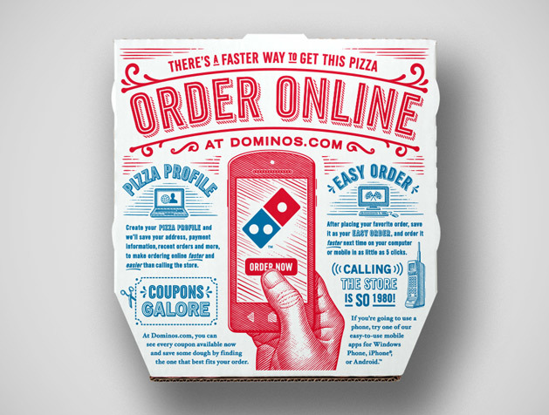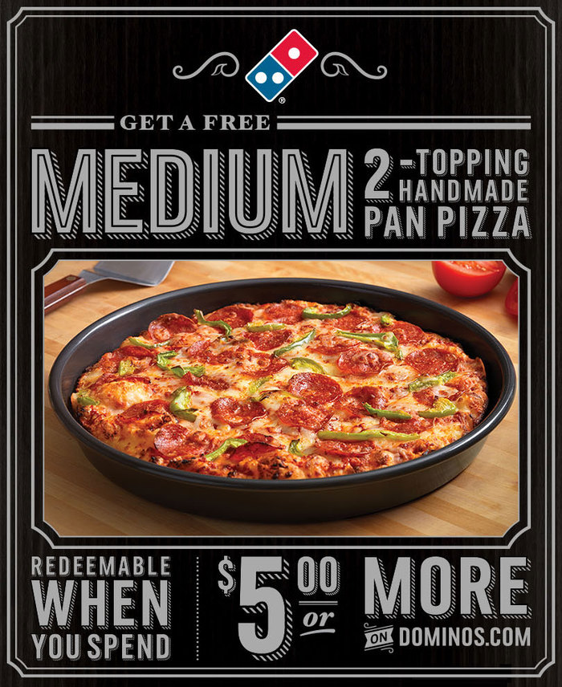

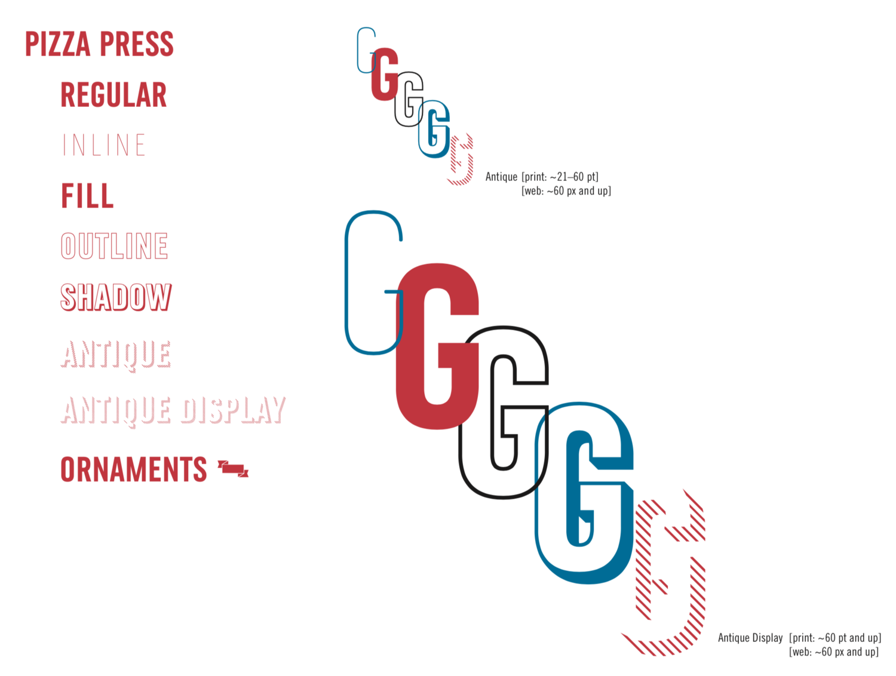

From the very beginning, Tom Monaghan has used branding to his advantage. Using the name that was similar to Dominicks was part of his strategy to gain customers and credibility. Partnering the name with such a visual logo was also brilliant marketing. Finishing off the brilliant design and concept is the font choice. Creating a personal type that will be associated with your business was the last step Domino’s needed to complete their iconic brand. Not only is Domino’s Pizza a household name, they are widely recognized by their logo, colors and overlined and fun style choices.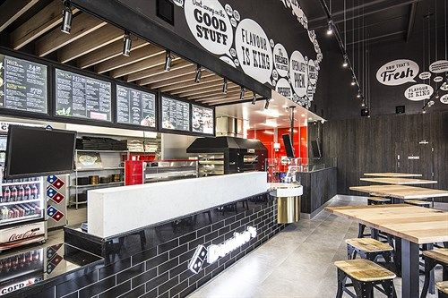

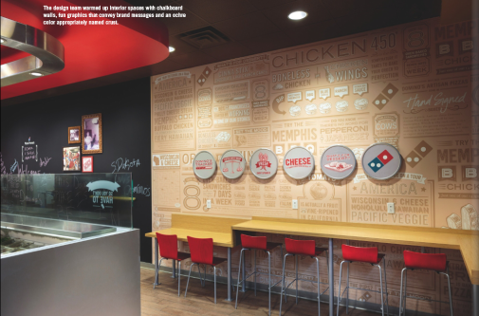

Works Cited

1. Admin. “Domino's Logo.” *1000 Logos The Famous Brands and Company Logos in the World Dominos Logo Comments*, 6 Aug. 2020, 1000logos.net/dominos-logo/#:~:text=Font,created by Hannes von Dohren.
2. Design, Inkbot. “History Of The Domino's Logo Design - What Does It Mean?” *Medium*, Medium, 21 Jan. 2020, medium.com/@inkbotdesign/history-of-the-dominos-logo-design-what-does-it-mean-dc3436df1fbb.
3. “Domino's.” *Terrance Weinzierl*, typeterrance.com/custom-fonts-for-dominos2.
4. “Domino's Pizza.” *Fonts in Use*, 5 May 2014, fontsinuse.com/uses/6746/domino-s-pizza-1#:~:text=Since 2014, Domino's Pizza uses a custom typeface named Pizza Press.&text=The typeface series started as,alongside the existing Trade Gothic.
5. R, Pearl. “LOGO UNRAVEL- DOMINO'S THREE DOTS.” *Mapemond Resources*, 9 May 2019, mapemond.com/2019/05/10/branding-firm-in-port-harcourt/.
6. Roman Rogoza. “Domino's Logo: What Domino Has To Do With Pizza.” *Logaster Blog*, Roman Rogoza, 27 Mar. 2020, www.logaster.com/blog/dominos-logo/.