Raver’s Blazer
Video
Description – The Raver’s Blazer is the must have blazer for your night out. Be the light of the party with the push of a button. With one simple click the Raver’s Blazer will activate making your lapel, sleeves, pockets, and breast pocket light up with near 100 super bright LEDs. Colors and patterns are always changing keeping the the blazer as fresh as the music all night. If you run out of juice for the just plug it into your cell phone charger and keep the party going.
This blazer is lined with LED strips on the pockets, lapels, breast pocket, and around the sleeves. The leds are powered by a usb battery located within the blazer. The patterns and colors are regulated by an Arduino board also located within the blazer.
Team (Credits):
Dennis Zepeda – wired blazer, supplied battery, wiring and arduino housing
Dwayne Carolina – maintained budget, supplied battery and led strip
Michael Sauder – supplied Arduino, wiring, and tools, did bulk of programming
Randi Sobhan – supplied led strip and battery, supplied media for video,
Budget PDF
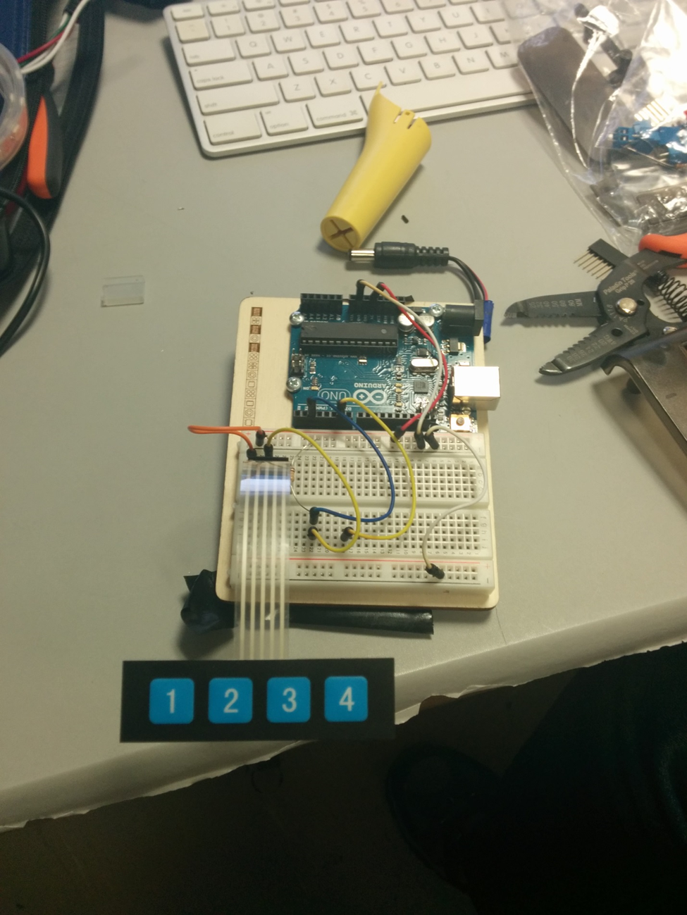
Tools:
Phillip Screwdriver
Crimper
Wire Stripper
End Nippers
Solder Gun and materials
Dremel
Gaffers Tape
Electical Tape
Heat Gun
Scissors
Hot Glue Gun with Glue Sticks
Code
Frtizing
Wiring Diagram
Animated GIF

Obstacles
Power Supply – We had difficulty finding a portable battery that could power the LED strips as well as the Arduino board. The battery could not add too much weight to the jacket and also had to have the right amperage to to power the blazer. Our solution to this problem was using a portable usb charger. The battery could be recharged via usb which made easy for anyone to power on.
Blazer – The blazer needed to have multiple pockets that could carry the external batteries and Arduino. Also it needed to be thick enough so one cannot see an outline of the wiring, leds, and batteries.
Metallic Lame – Metallic lame is a highly reflective clothlike material. It would cause the lights to seem much brighter. It is very conductive as well which made us hesitant to line the blazer with it since the is a lot of wiring with the blazer. After some research we concluded it would be much of an issue.
Single Core vs Stranded – The blazer was initally wired with single core cabling. We soon realized that single core cabling is not as flexible and caused and loss in some signal. We then replaced the cabling with stranded wire.
LED Selection – The LEDs needing to be RGB and be very flexibled due to the movement of the user. Each LED needed to be individually controllable as well.
Sound Activation - The blazer was initially going to be sound active but due to time contraints we had to bypass this feature.
mr.dwaynec@gmail.com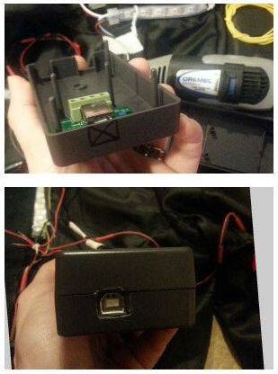

Arduino Enclousre
